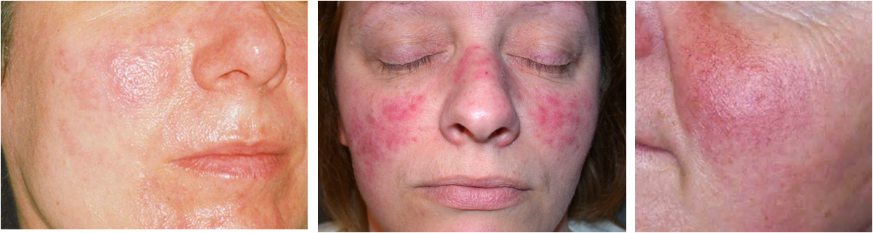

Rosacea
- Is a condition characterized by facial erythema (redness) and sometimes pimples.
- Rosacea affects all ages and has four subtypes, three affecting the skin and the fourth affecting the eyes (ocular type, shich can cause a persistent burning and feeling grittiness in the eyes or inflamed & swollen eyelids)
- Left alone, it usually worsens over time.
- Traditional medical treatment in the form of topical steroids can aggravate the condition
- Rosacea affects both sexes, but is almost three times more common in women.
- It has a peak age of onset between 30 and 60.
Symptoms:
- Rosacea typically begins as redness on the central face across the cheeks, nose, or forehead, but can also less commonly affect the neck, chest, ears, and scalp.
- In some cases, additional symptoms, such as semi-permanent redness, dilation of superficial blood vessels on the face (called telangjectasia), red domed papules (small bumps) and pustules, red gritty eyes, burning and stinging sensations, and in some advanced cases, a red lobulated nose (called rhinophyma)
- the skin tissue can swell and thicken and be tender & sensitive to touch - reness can come and go, but may become permanent
Causes:
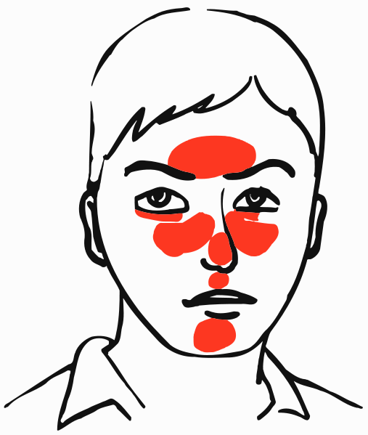
- Harmful ingredients in skin-care products
- Side effects of medications (often NSAIDS)
- Intestinal challenges ... low microflora ... sluggish bowel ... yeast
infections
- Alcohol consumption
- Compromised immune system
- Nutritional deficiencies
- Food Allergies
- Extremes of temperature (Sun exposure, Wind, Cold weather)
- frequently triggered by the bacterium (Helicobacter Pylori)
- Stress

Recommendations:
- Address intestinal wellness (Shaklee Optiflora, Herb-Lax)
- Address nutritional needs (at least: Shaklee Vita-Lea, Alfalfa)
- Have food allergy testing done to determine if foods are triggering the situation
- Nourish the skin externally with toxin-free skin care which contains optimal vitamins & minerals (Shaklee Nutrition Therapy Skin Care – Enfuselle).
- Use Shaklee Calming Complex
- Bismuth Hydrate in "Pepto-Bismol" will usually get rid of the Helicobacter Pylori issue

Suggested Supplements:
Step 1: Optiflora
B Complex
Alfalfa
Stress Relief Complex (if high stress is an issue)
Step 2: Vitalizer (which includes B Complex & Optiflora)
Soy Protein
OmegaGuard / GLA / Flaxseed Oil Capsules
Step 3: CarotoMax
Extra Vita C
Zinc (helps heal skin)

Herbs of Benefit:
- Garlic - natural antibiotic
- Liver DTX - Liver Detoxification
- Herb-Lax - Bowel Conditioner

Rosacea Testimonies
- I started using Optiflora over a month ago. I cannot say I am the best example of consistency. I often find myself skipping days without intending to do so. Even so, the product has done miracles for me! Several years ago, I started having problems with a Rosacea type of rash on my face. At first, I did nothing about it. I did not want to be on medication constantly. I finally, after a couple of years, did ask a doctor for some relief. I had found out from my sister Ellen that they say due to my Scandinavian background, we are susceptible to this type of rash because of our fair skin. My doctor prescribed a topical form of erythromycin, an antibiotic. But, I found that if I did not use it every day, the rash would reappear within a couple of days. I also did not like the idea of being on antibiotics constantly, even if it is only applied topically. It still is absorbed by the body and I find that to be very hard on the immune system. Once I started using Optiflora, the rash disappeared within days and hasn't reappeared yet! Shaklee has done it once again! - Ruth
- Enfuselle does wonderful things for the skin, including Rosacea. However, from my own personal experience, plus clients -- Rosacea ceases to be a problem when GLA & OptiFlora become part of the nutritional regimen. Esther J. Davison, San Diego
- My mother had a very bad case of Rosacea and she was told by her doctor that she will have to be on a certain medication her entire life. Then I did some research and found out that Rosacea is an inflammation of the blood vessels of the skin, which is most of the times triggered by stress. Yes, my mother had a lot of stress. We put her on a great Shaklee program and her skin is absolutely beautiful. This is the program she takes: (I don't know how much she takes of each ... Vita Lea, Protein, Vita E, GLA, EPA, Alfalfa, and OptiFlora. Hope this info helps. Sarah Stauber
- My aunt who is now 86 has had Rosacea for over 45 years - she'd tried all kinds of prescription meds and creams - still could not find relief. When Enfuselle was introduced, I invited her to try it - risk free. She e-mailed me within three days to tell me Enfuselle; especially the C and E repair had done the trick. Not only that, but her sisters and friends were remarking on how lovely her skin looked. She's an avid golfer, is in the sun in Florida every day and she looks about 70 years old. You can bet I'll be faithful to my Enfuselle skin care program after seeing the difference in her skin and my own. Deb Sales

