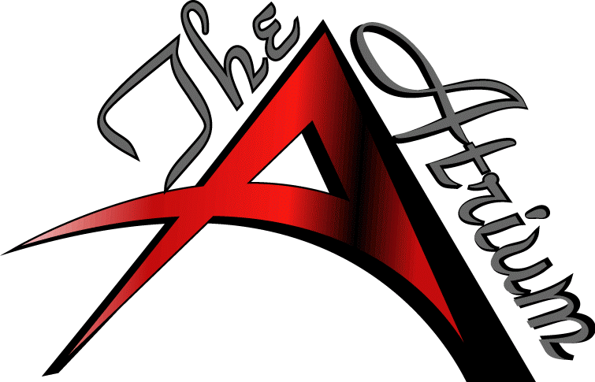

Bar: Yes/No

Projector: Yes/No

Speaker: Yes/No

Client Name:___________________ Event Date:________ Arrival Time:_______ Event Type:_____________

60”/48” Tables: _____ # of chairs per table: ______ Hi Boys:______ 6ft tables:_____ Linen: ______________

**PARAGON ROOM FLOOR PLAN**



**NOTES**

________________________________________________________________________________________________________________________________________________________________________________________________________________________________________________________________________________________________________________________________________________________________________________________________________________________________________________________

**ENTRANCE**

**Maintenance: ________________**

**Checked by: _________________**

**WARMING KITCHEN**

**BAR**