TREATMENT AUTHORIZATION

SERVICE SITE: EMERGENCIES OR AFTER HOURS:
IMPERIAL VALLEY OCCUPATIONAL MEDICINE LIFE THREATING CALL 911 OR GO TO
1850 W. MAIN ST STE E. EL CENTRO, CA 92243 EL CENTRO REGIONAL MEDICAL CENTER
P: (760) 370-0020 F: (760) 370-0220 1415 ROSS AVE EL CENTRO, CA 92243
P: (760) 339-7100

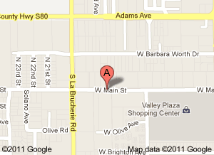

HOURS OF OPERATION: MONDAY- FRIDAY 8:30AM TO 5:00
CLIENT INFORMATION SERVICES REQUESTED:
________________________________________ Medical service date of injury________
EMPLOYEE NAME Instant Drug Screen (5, 9, 10)
________________________________________ PFT (Respiratory test)
COMPANY NAME DMV Physical
________________________________________ Pre- Employment Physical
PHONE# FAX# Audiogram
TB
Mask Fit (N-95 or Filter Mask)
Other____________________________
EMPLOYER AUTHORIZING SIGNATURE
________________________________________
PRINT NAME AND TITLE
________________________________________
Date
________________________________________

