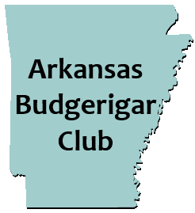
LABOR DAY WEEKEND SHOW!

September 4, 2021 BAA Panel Judge: Julie Willis
All Divisions: Rare, Junior, Novice, Intermediate, Champion
Entry Fee- $3 per bird ($30 max fee)

LOCATION: Tyndall Park Gene Moss building
ADDRESS: 913 E. Sevier St. Benton, AR 72015

Schedule of Events:
Friday- September 3, 2021
12:00pm- Show Hall opens for show setup/bird check in.
6:00 pm-Dinner (a la carte) at local restaurant.
Saturday- September 4, 2021
7:00 am- Show Hall opens
9:00 am- Bird check in and entries complete. Staging of birds.
10:00am- Judging begins
12:00pm- Lunch: provided by club. (Sides, desserts, drinks, etc. would be appreciated.)
1:00 pm- Bird Auction (Donated birds and items for the auction are greatly appreciated.)
2:00 pm- Raffle Item winners are selected
Hotel Information:
Best Western (Pet Friendly)
Address: 17036 I-30 Benton, Ar 72019
Phone #: 501-778-9695
*Mention Arkansas Budgie Club for special rate of $79.00*

For any other information contact: Bill McLean Jr.
Phone #: 501-922-5656 Email: billmclean@att.net
**Email entry forms to Show Secretary: Joshua Anthony- joshda12101984@gmail.com**

