Special COVID19 November Order form – Pen Coed Publishing

As we are back into extra measures for COVID19, start your Christmas Shopping online here and support a Welsh Small Business.

“SPECIAL OFFERS: £5.00 off every title if you order during November 2020”

Order any of the titles listed below direct from Pen Coed Publishing – email the form (a jpeg or pdf or word document) to jackiepencoed@gmail.com – for payment by Debit or Credit Card and next day distribution.

Make sure you add your contact details and postal address at the end of the form, or in the email message.

TITLE | RRP Price | November price each | How many?
CRAFTS:
“Peg Loom Weaving – all you need to know to get started”  J Jeynes (spiral bound) Companion book to Felt Making  ISBN: 978-0-9926100-0-5  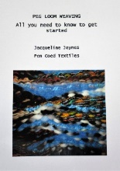 Practical guide on peg loom weaving | £12.50 | £7.50  (can be ordered with a Peg Loom as a great gift)
“Felt Making – all you need to know to get started” J Jeynes (spiral bound) Companion book to Peg Loom Weaving  ISBN: 978-1-9998352-4-8  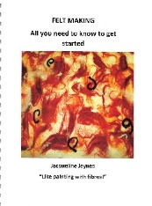 Practical guide on wet felt making | £12.50 | £7.50  (no equipment needed, just fleece fibres)
SOCIAL HISTORY:
“Before Hiroshima: Forgotten Prisoners of War in Japan, Burma and the Far East” J Jeynes (bound soft cover)  ISBN: 978-0-9926100-9-8  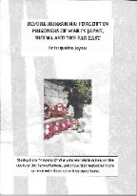 History of WWII in the Far East and personal stories from POWs and Internees captured by the Japanese. Perfect gift for anyone interested in Military History | £16.00 | £11.00  (£1 of price will go to British Legion)
“Badly Chopped Carrots & Everyday Dinners” by Anita Rogers Burrell  ISBN: 978-1-9998352-2-4 (A4 bound & illustrated)  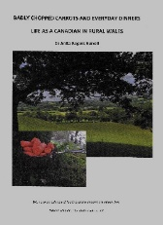 Stories from a Canadian living in rural Wales | £25.00 | £18.00  (extra discount)
BUSINESS:
“Planning for Early Retirement” by Gary Evans (bound soft cover)  ISBN:978-1-9998352-9-3  Based on author’s experience, a guide to planning for early retirement NEW 2020 | £12.50 | £7.50  (available for despatch middle November)
“Walking Wales: The Art Lover’s Guide to Wye Valley Way” (spiral bound, full colour) J Jeynes  ISBN: 978-0-9926100-3-6  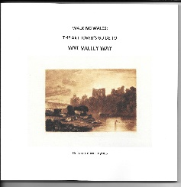  Follow the route with Jacqueline and Jenni, 136 miles from Chepstow to Plynlimon, including old paintings of places along the way and details of how to plan a long trek. | £15.00 | £10.00
TOTAL ORDER |  | £
+p&p £3.50 for 1-3 books  OR +p&p £7.50 for 4 or more books |  | £
 |  | £

Name
Email
Delivery address:

We look forward to hearing from you – thank you for your order
Pen Coed Publishing, Ceredigion, Wales www.pencoedpublishing.co.uk

