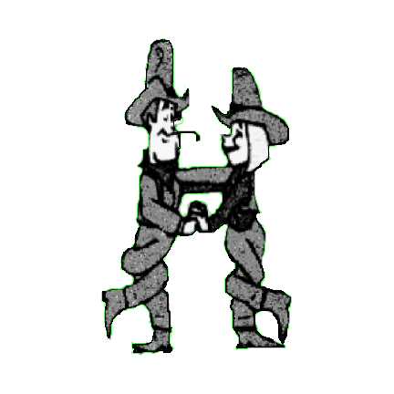COUNTRY CHOICE PARTNER DANCERS

**AIN’T NO ANGEL**

Choreographed by Chris & Andy Malpass. Qualified Instructors. 01606 883862 email [chrisandy-partners@hotmail.co.uk](mailto:chrisandy-partners@hotmail.co.uk)

Description 64 count partner dance. Start holding inside hands, facing L.O.D.

Opposite feet throughout. Gent’s steps given, except where stated

Music No Angel by Sarah Gayle Meech C.D. One Good Thing

01 – 08 SIDE, TOGETHER, FORWARD, HOLD, ROCK, RECOVER, 1/4 TURN, HOLD

01 – 04 Step left to left side, step right next to left, step forward on left, hold

05 – 08 Rock forward on right, recover onto left, step 1/4 right on right, hold (Lady step 1/4 left) Gent F.O.L.O.D Lady F.I.L.O.D

*(on count 7 join in double open hand hold)*

09 – 16 CROSS ROCK, SIDE, HOLD, CROSS ROCK, 1/4 TURN, HOLD

09 – 12 Cross rock left over right recover onto right, step left to left side, hold (Lady cross rock right behind left)

13 – 16 Cross rock right over left, recover onto left, step right 1/4 right, hold (Lady cross rock left behind right) F.R.L.O.D

*(on count 15 release gent’s right, lady’s left hands. Inside hands joined)*

17 – 24 STEP, PIVOT 1/2 TURN, PIVOT 1/4 TURN, HOLD, WEAVE - BEHIND, SIDE, IN FRONT, HOLD

17 – 20 Step forward on left, pivot 1/2 right, pivot 1/4 right stepping onto left, hold Gent F.O.L.O.D Lady F.I.L.O.D

21 – 24 Cross right behind left, step left to left side, cross right over left, hold

*(on count 18 release hands. On count 19 join in open double hand hold)*

25 – 32 WEAVE – SIDE, BEHIND, 1/4 TURN, HOLD, STEP, PIVOT 1/2 TURN, PIVOT 1/4 TURN, HOLD

25 – 28 Step left to left side, cross right behind left, 1/4 turn left stepping onto left, hold F.L.O.D

29 – 32 Step forward on right, pivot 1/2 left, pivot 1/4 left, hold. Gent F.O.L.O.D Lady F.I.L.O.D

(on count 27 release gent’s left, lady’s right hands. Inside hands joined)

(on count 29 release hands. On count 30 join in open double hand hold)

33 – 40 GENT - BACK ROCK, 1/4 TURN, HOLD, WALK, WALK, WALK, HOLD

LADY - BACK ROCK, 1/4 TURN, HOLD, 1/2 TURN, HOLD

33 – 36 Gent - Rock back on left, recover onto right, 1/4 turn left stepping onto left, hold F.L.O.D

Lady - Rock back on right, recover onto left, 1/4 turn right stepping onto right, hold F.L.O.D

37 – 40 Gent - Walk forward on right, left, right, hold

Lady - 1/2 turn right on left, right, left, hold into closed western position F.R.L.O.D

*(on count 36 release gent’s right, lady’s left hands as the lady turns right under remaining joined hands into Closed Position)*

41 – 48 SIDE ROCK, CROSS, HOLD, SIDE ROCK, CROSS, HOLD

41 – 44 Rock side left on left, recover onto right, cross left over right, hold (Lady crosses right behind left)

45 – 48 Rock side right on right, recover onto left, cross right over left, hold (Lady crosses left behind right)

49 – 56 STEP, SLIDE, STEP, HOLD, ROCK FORWARD, RECOVER, STEP BACK, HOLD (LADY ROCK BACK, RECOVER, STEP FORWARD)

49 – 52 Step forward on left, slide right next to left, step forward on left, hold

53 – 56 Rock forward on right, recover onto left, step back on right, hold (Lady rock back, recover, step forward)

57 – 64 GENT - STEP BACK, PIVOT 1/2 TURN, STEP FORWARD, HOLD, STEP FORWARD, PIVOT 1/2 TURN, STEP FORWARD, HOLD

LADY - PIVOT 1/2 TURN, STEP BACK, STEP BACK, HOLD, ROCK BACK, RECOVER, STEP FORWARD, HOLD

57 – 60 Gent - Step back on left, pivot 1/2 right stepping onto right, step forward on left, hold F.R.L.O.D

Lady - Passing right shoulders, pivot 1/2 left on left stepping back on right. Step back on left, right, hold. On gent’s left side F.L.O.D

61 – 64 Gent - Step forward on right, pivot 1/2 left stepping onto left, step forward on right, hold F.L.O.D

Lady - Rock back on left, recover onto right, step forward on left, hold On gent’s right side F.L.O.D

*(on count 57 release gent’s right hand, lady’s left. Lady turns under joined hands, passing right shoulders)*

*(on count 60 release joined hands and pick up inside hands)*

**Keep Smiling**