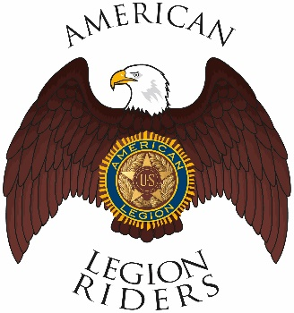

American Legion Riders Chapter 3, Hanford, CA
Minutes for August 10, 2021
Meeting called to order: The meeting was called to order @ 6:37pm. Prayer, Pledge of Allegiance and Preamble was said.
Officers Present: President Charles Beard, Vice-President Frank Pightling, Treasurer Geni Lefler, Secretary David Darrow, Judge Advocate Pat O'Brien, Sgt-At-Arms Jack Alford and Road Captain Robert Stover Excused: Chaplain Filly Reynolds

Members Present: Jon Bailey, Mike Calderon, Kathleen McClary, Dan Rushing, Richard Garcia
Guests Present: , Ron Riley, Gustie Compton, Scott Day
Review of Minutes: Motion to accept minutes for July 13, 2021, was proposed by Robert Stover and seconded by Pat O’Brien and ratified by members.
Committee Reports: Fireworks sales still waiting on final audit.
Treasurer's Report:
Chaplain Report: Filly and Husband got Covid-19 her husband is in the hospital. Frank Silva had back surgery and is hoping to be back with us soon. Charles Beard foster father is now cancer-free.
Unfinished/Old Business:
Bunko Bash went well
Sept 11th is the 20th anniversary; we will be doing a law enforcement and first responder dinner 5pm show 6pm eat. Help is needed at 4 to 4:15 pm for setup and cleanup
Poker Run to Tahachapi on 11 Sept.
Reminder to visit www.alrhanford.com for updates.
New Business:
Bylaws: directed to change President and Vice President to Director and Vice Director.
Department of California now only allows elected officers the ability to vote.
Robert and Frank visited the VA hospital and handed out suicide awareness material to the members.
March 22 a day ride raised over $10,000 last year
Riders Bylaws are due by 19 November.
Charles Beard moving to Texas and resigned as Chapter 3 President, Vice President to fill position until elections can be held.
Good of the Riders:
Remember to Ride Safe

Meeting adjourned 7:30pm

