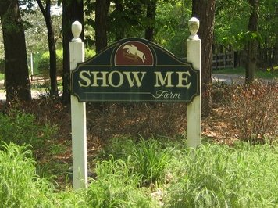

Show Me Farm

1356 Hendon Road

Woodstock, GA 30188

“Show me Thy ways, Oh Lord, teach me Thy paths” Psalm 25:4

Welcome to Show Me Farm! We are glad you have decided to join our family. Show Me Farms provide classical and proper training for both the horse and rider. Show Me Farm Woodstock is conveniently located on a small farm nestled in Woodstock, Georgia and provides all the amenities of a show barn. You will find unsurpassed care and attention to all the details to provide the best environment for the rider to develop and the horse to perform at the best of its ability.
The barn features large 12 x 12 stalls and grass turnout with three-board fencing. You will find a lighted all weather-riding ring, a cozy climate controlled lounge, laundry facilities, and a full bath for the rider as well as safe and clean surroundings for your horse. Our goal at Show Me Farm is to provide a clean, safe and fun environment where we all can become better equestrians!

Barn Rules
- All lessons take top priority for ring use.

- All minors must wear a hard hat when mounted.

- Please do not ride alone. Please make sure someone is at the barn and aware that you will be riding.

- No jumping outside of lessons unless instructed by trainer. Then, you should only ride with adult supervision.

- It is encouraged that only boarders and their immediate family ride their horses. If you bring a guest to ride your horse, you must have a guest parent sign the Waiver Form. It is your responsibility that the guest is capable of riding. The rider will agree to assume ANY AND ALL RISKS INVOLVED IN OR ARISING FROM THEIR USE OF OR PRESENCE UPON SHOW ME PROPERTY AND FACILITIES. Boarders may not give lessons. Friends may only ride your horse with a signed waiver. Waiver forms are located in the office at Woodstock and in the Tack Room at Ball Ground.

- Show Me reserves the right to prohibit anyone from riding on its property if deemed necessary.

- No one should feed any horse other than the scheduled feeder. If you feel your horse needs an extra helping, please discuss this with Barn Manager and arrangements will be made.

- We welcome supplements that you feel your horse needs. You are responsible for supplying them and clearly marking the container with instructions. Please explain how to administer to Farm Manager. The Woodstock barn keeps Rice Bran, Beet Pulp, and Electrolytes and will pro-rate according to those individuals desiring for their horses to be on these supplements.

- Please clean up grooming area and wash rack after using.

- Each boarder is responsible for his/her own possessions. Keep them marked clearly and in your tack trunk. Do not use tack or supplies other than your own without first seeking permission.

- In order for the farrier or dentist to work on your horse, an open check must be left on bulletin board. If barn check must be written, there will be a $5.00 charge.

- Wipe off tack, clean bit, and figure eight all bridles.

- All bills are to be paid upon receipt. The board is due five days after the invoice date. It is imperative that it is paid on time. In the event that payment is overdue by ten days, manager will assess a late fee of $5.00 per day for every day the board is past due. Please do not ask for exceptions. Place checks in the Show Me Farm box located on the door to the office. Barn hours are from 8:00 am until 9:00 pm Monday through Saturday and 1:00 p.m. until 9:00 p.m. on Sunday. If the need arises for you to be at the barn outside of these hours, please notify us of your intentions.

- As fans are a fire hazard, we ask that you supply only a metal fan.

- Please leave stall doors completely closed, as stall guards can be a hazard. In the past, we have had horses hurt, and the owners have incurred vet bills because of stall guards.

- If you are under 14 years of age, you must have one of your parents or guardian present. If your parents or guardian give you permission to ride without them, we ask that your parents or guardian complete and sign the permission form found in the office.

- Parents must be present at all times when minor children, who are boarders, are at Show Me Farm, unless written permission is given by parents for children to stay at the barn alone. Permission forms can be found in the office.

- Boarders are financially responsible for all damage done to premises by you or your horse.

- All gates must be closed and latched at all times.

- If you bring your horse in from being turned out and only one horse is left in turnout, please bring in both horses to prevent stress to the horse left behind.

- Water must be turned off and hose rolled up when finished.

- Smoking should be done outside of the barn because of hay stored in loft. No alcohol or drugs are permitted.

- Georgia State Law requires a yearly Coggins Test. The test must be negative when arriving at Show Me Farm. The Barn will schedule the yearly Coggins Tests and vaccinations in January of each year.

- In an emergency, the Barn Manager or worker will make every attempt to contact the owner. If the owner cannot be contacted, we will call the vet.

- Please turn out the ring lights when finished as well as any barn lights when you leave.

- Please dismount when entering the barn. The floors can be slippery and the ceiling is too low to ride inside the barn.

- Please do not leave horses unattended in the wash rack or aisle. If you need to leave them for a few minutes to get something, please have someone keep an eye on them.

- When grazing your horse around the barn, please keep a halter and lead rope on your horse and stay with him or her.

- If your horse cribs, we ask that you supply a cribbing collar. Boarders may be asked to pay for new feed tubs, stall boards, or fences if wood chewing becomes extensive.

- Please remove halters when turning your horse out.

- When double layering is necessary, stable blankets will be placed over turnout rugs.

- For shared leases, $25 will be added to the board of each party in the lease.

- No one should climb or be in the loft unless helping with the feeding of the horses.

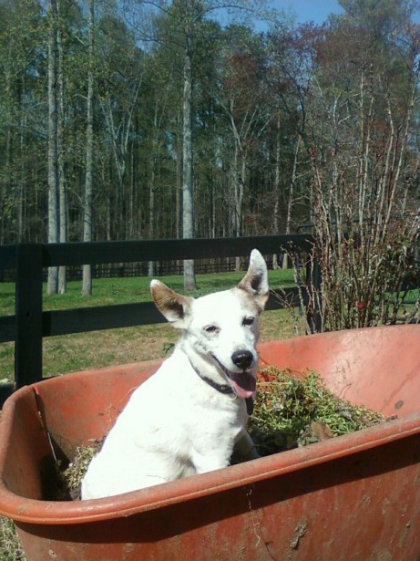
Boarding Options
Complete Full Board $650 for Horses
$575 for Ponies

- One matted 12 X 12' stall
- Hay feed at least 3 times a day
- Daily turnout--weather permitting
- Stall cleaned at least 3 times each day.
- Management worms all horses as recommended by Vet, which is an additional $12 fee.
- A night check will be done daily to check on your horse's well being. Water will be checked and hay provided for late night snack.

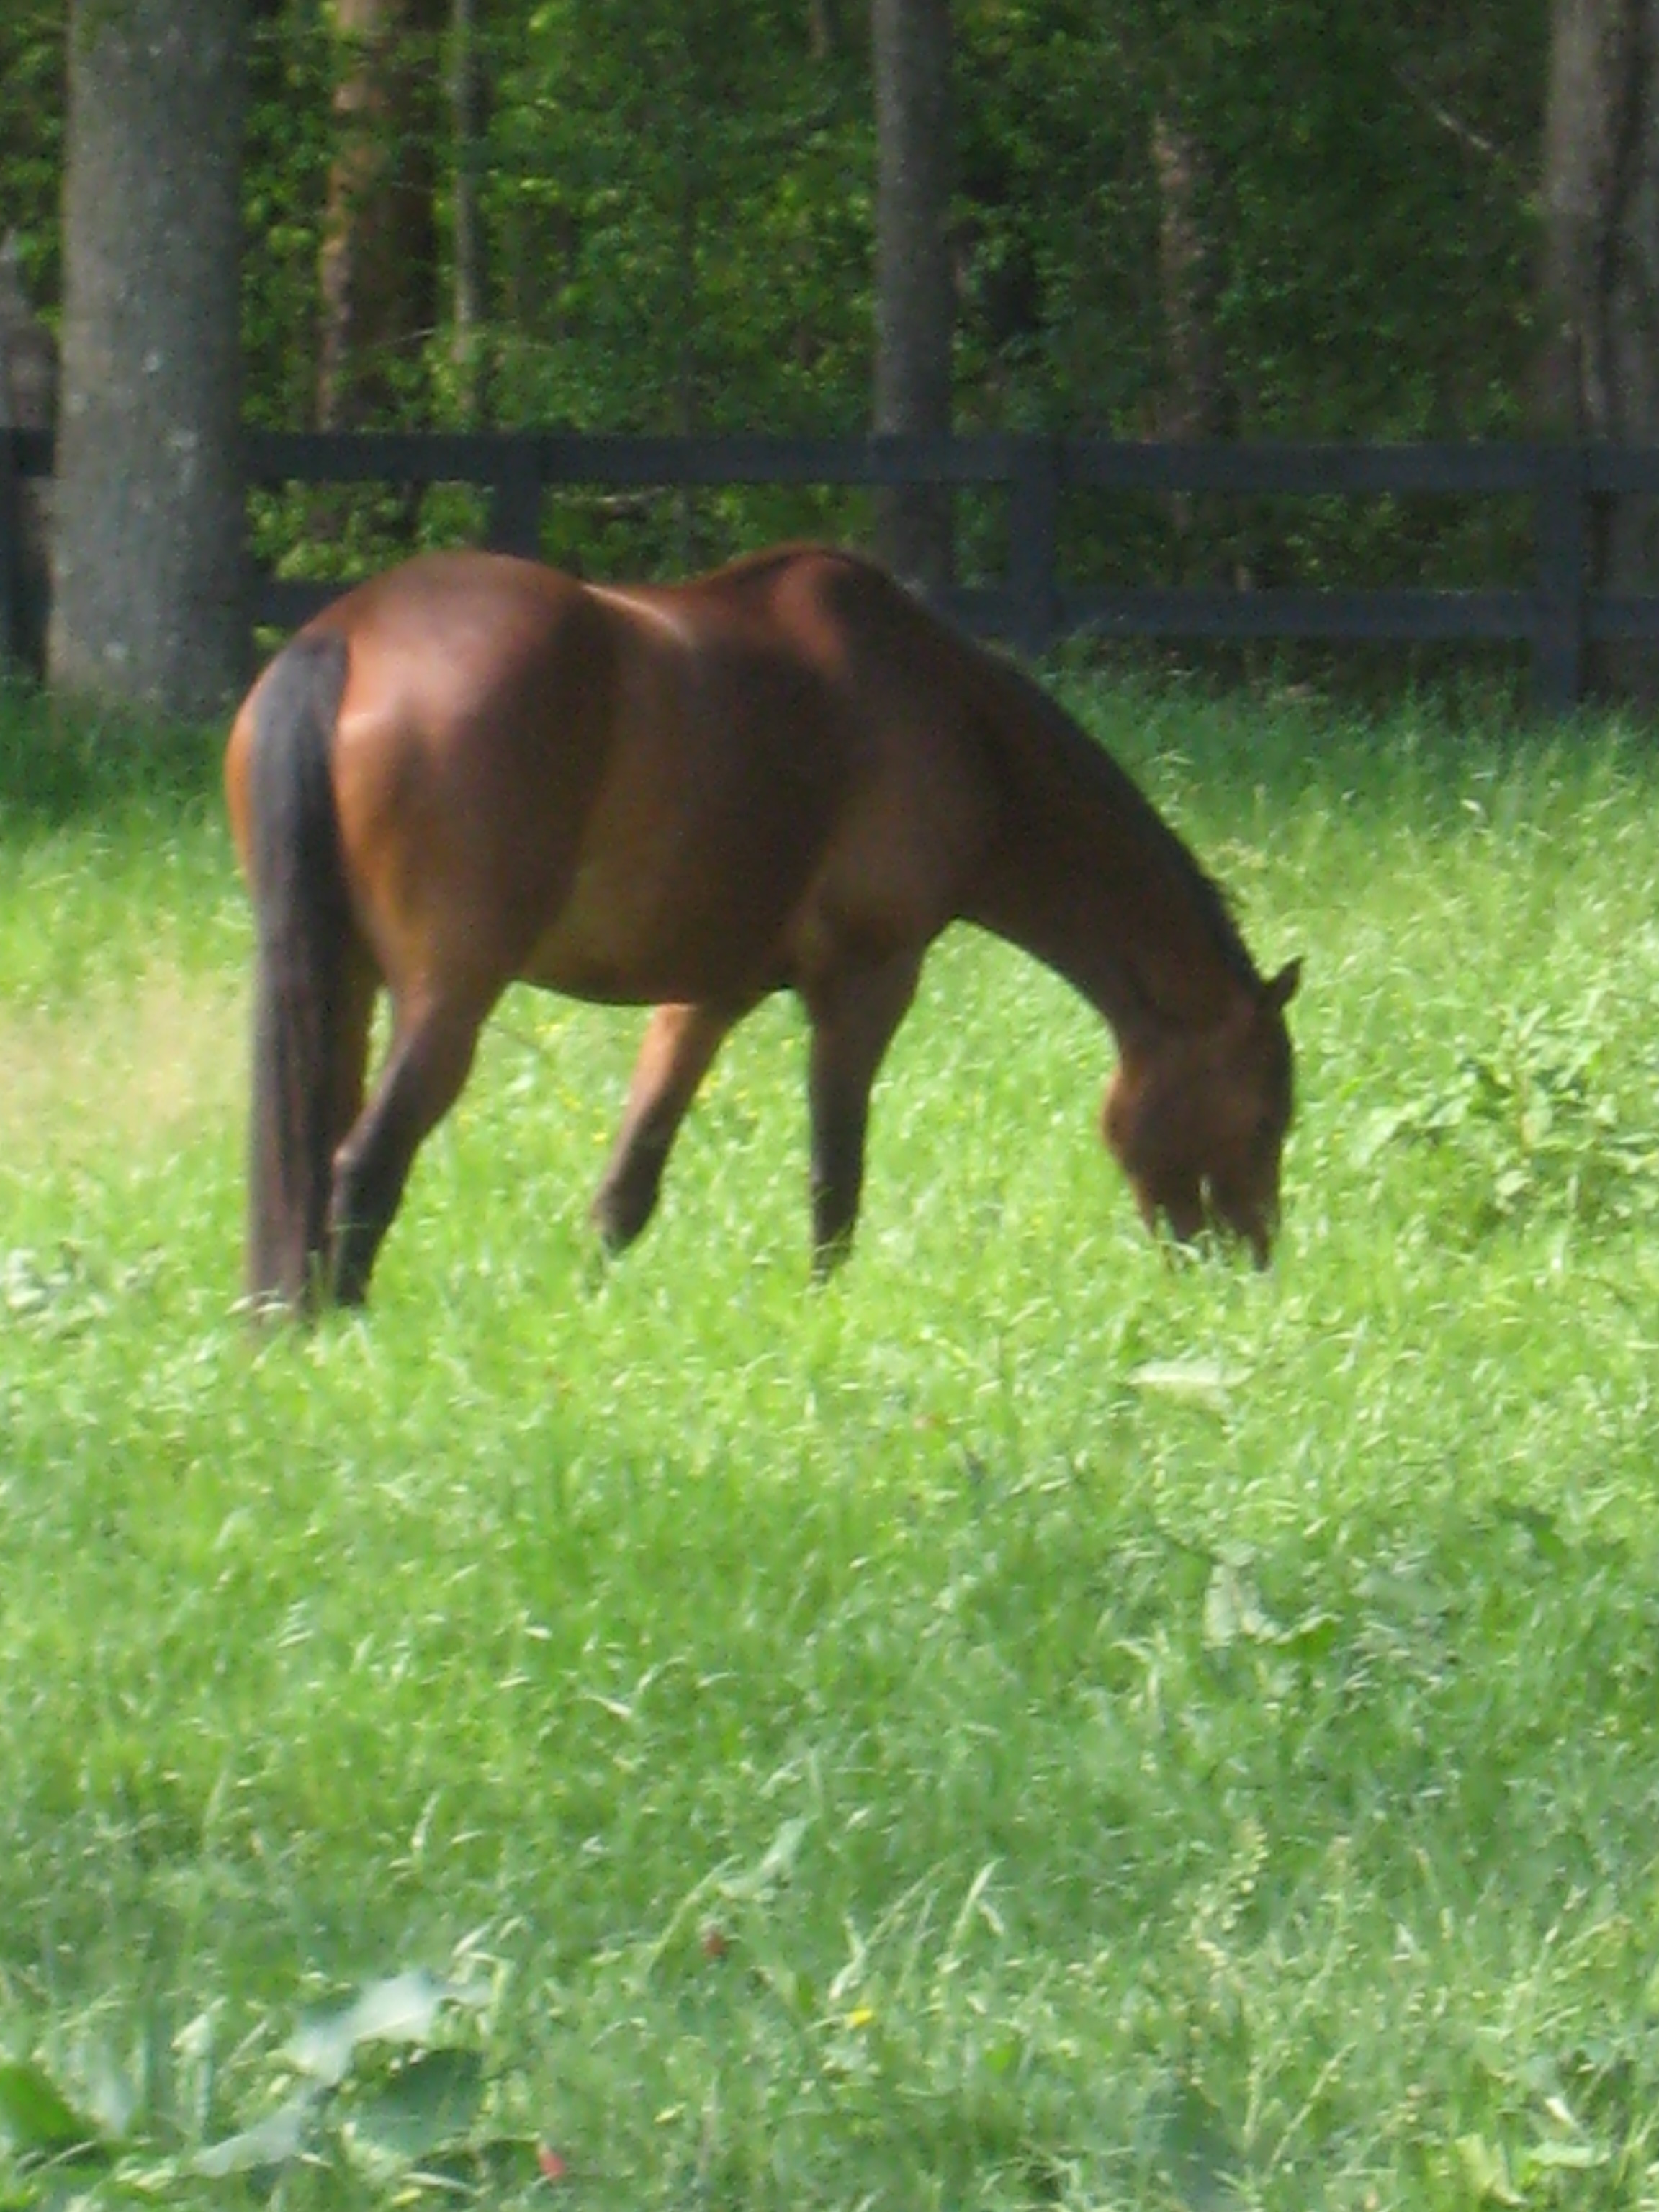

Special Services

The following items are available as needed. Please let us know if you would like to take advantage of any of the following.

Farrier/Vet/Dentist:

Owners are responsible for leaving a check for services or making their own billing arrangements. A $5.00 charge will occur if check is written from barn account to cover services.

Extra Feed: Varies

Extra feed is figured on a per quart basis. For example, if your horse requires an additional six quarts each day. (Six quarts are included in the board) The extra charge would be calculated as follows: 6 quarts x 31 days = 186 quarts per month divided by 50 (quarts in a bag of feed) = 3.72 bags. Four bags @ $18.00 = $72 additional per month.

Extra Hay: Varies

If you desire extra or different hay, we will be glad to order it for you. You will be asked to pay the difference between the hay provided by the barn and the cost of the different hay.

Extra Blanketing $15

You horse's stable blanket will be taken off in the morning and your turnout rug put on before turnout. In the evening, your horse's turnout rug will be removed and your stable blanket put on. Otherwise, stable blankets will be placed directly over turnout rugs.

Legs wrapped $5.00 per time

Standing wraps, shipping wraps, exercise wraps, bandage wrap is are available. Boarder will need to supply wraps.

Clipping:

Full-Body Clip $150.00
Hunt Clip $90.00
Ears/Face/Fetlock Clip $20.00

Medicine Administration: $1.00 per dose

Medicine such as pills, shots, topical solutions, paste or liquid doses due to injury or chronic problem will be administrated at the per dose charge.

Hand Walking/Cold Hosing: $10.00 per time

If a horse is recovering from an injury, we will be glad to cold hose or hand walk if notified.

Extra Shavings: $5.00 per wheelbarrow

All stalls typically get four wheelbarrows of shavings each week. Those who wish to have stalls bedded extra-deep may purchase additional shavings.

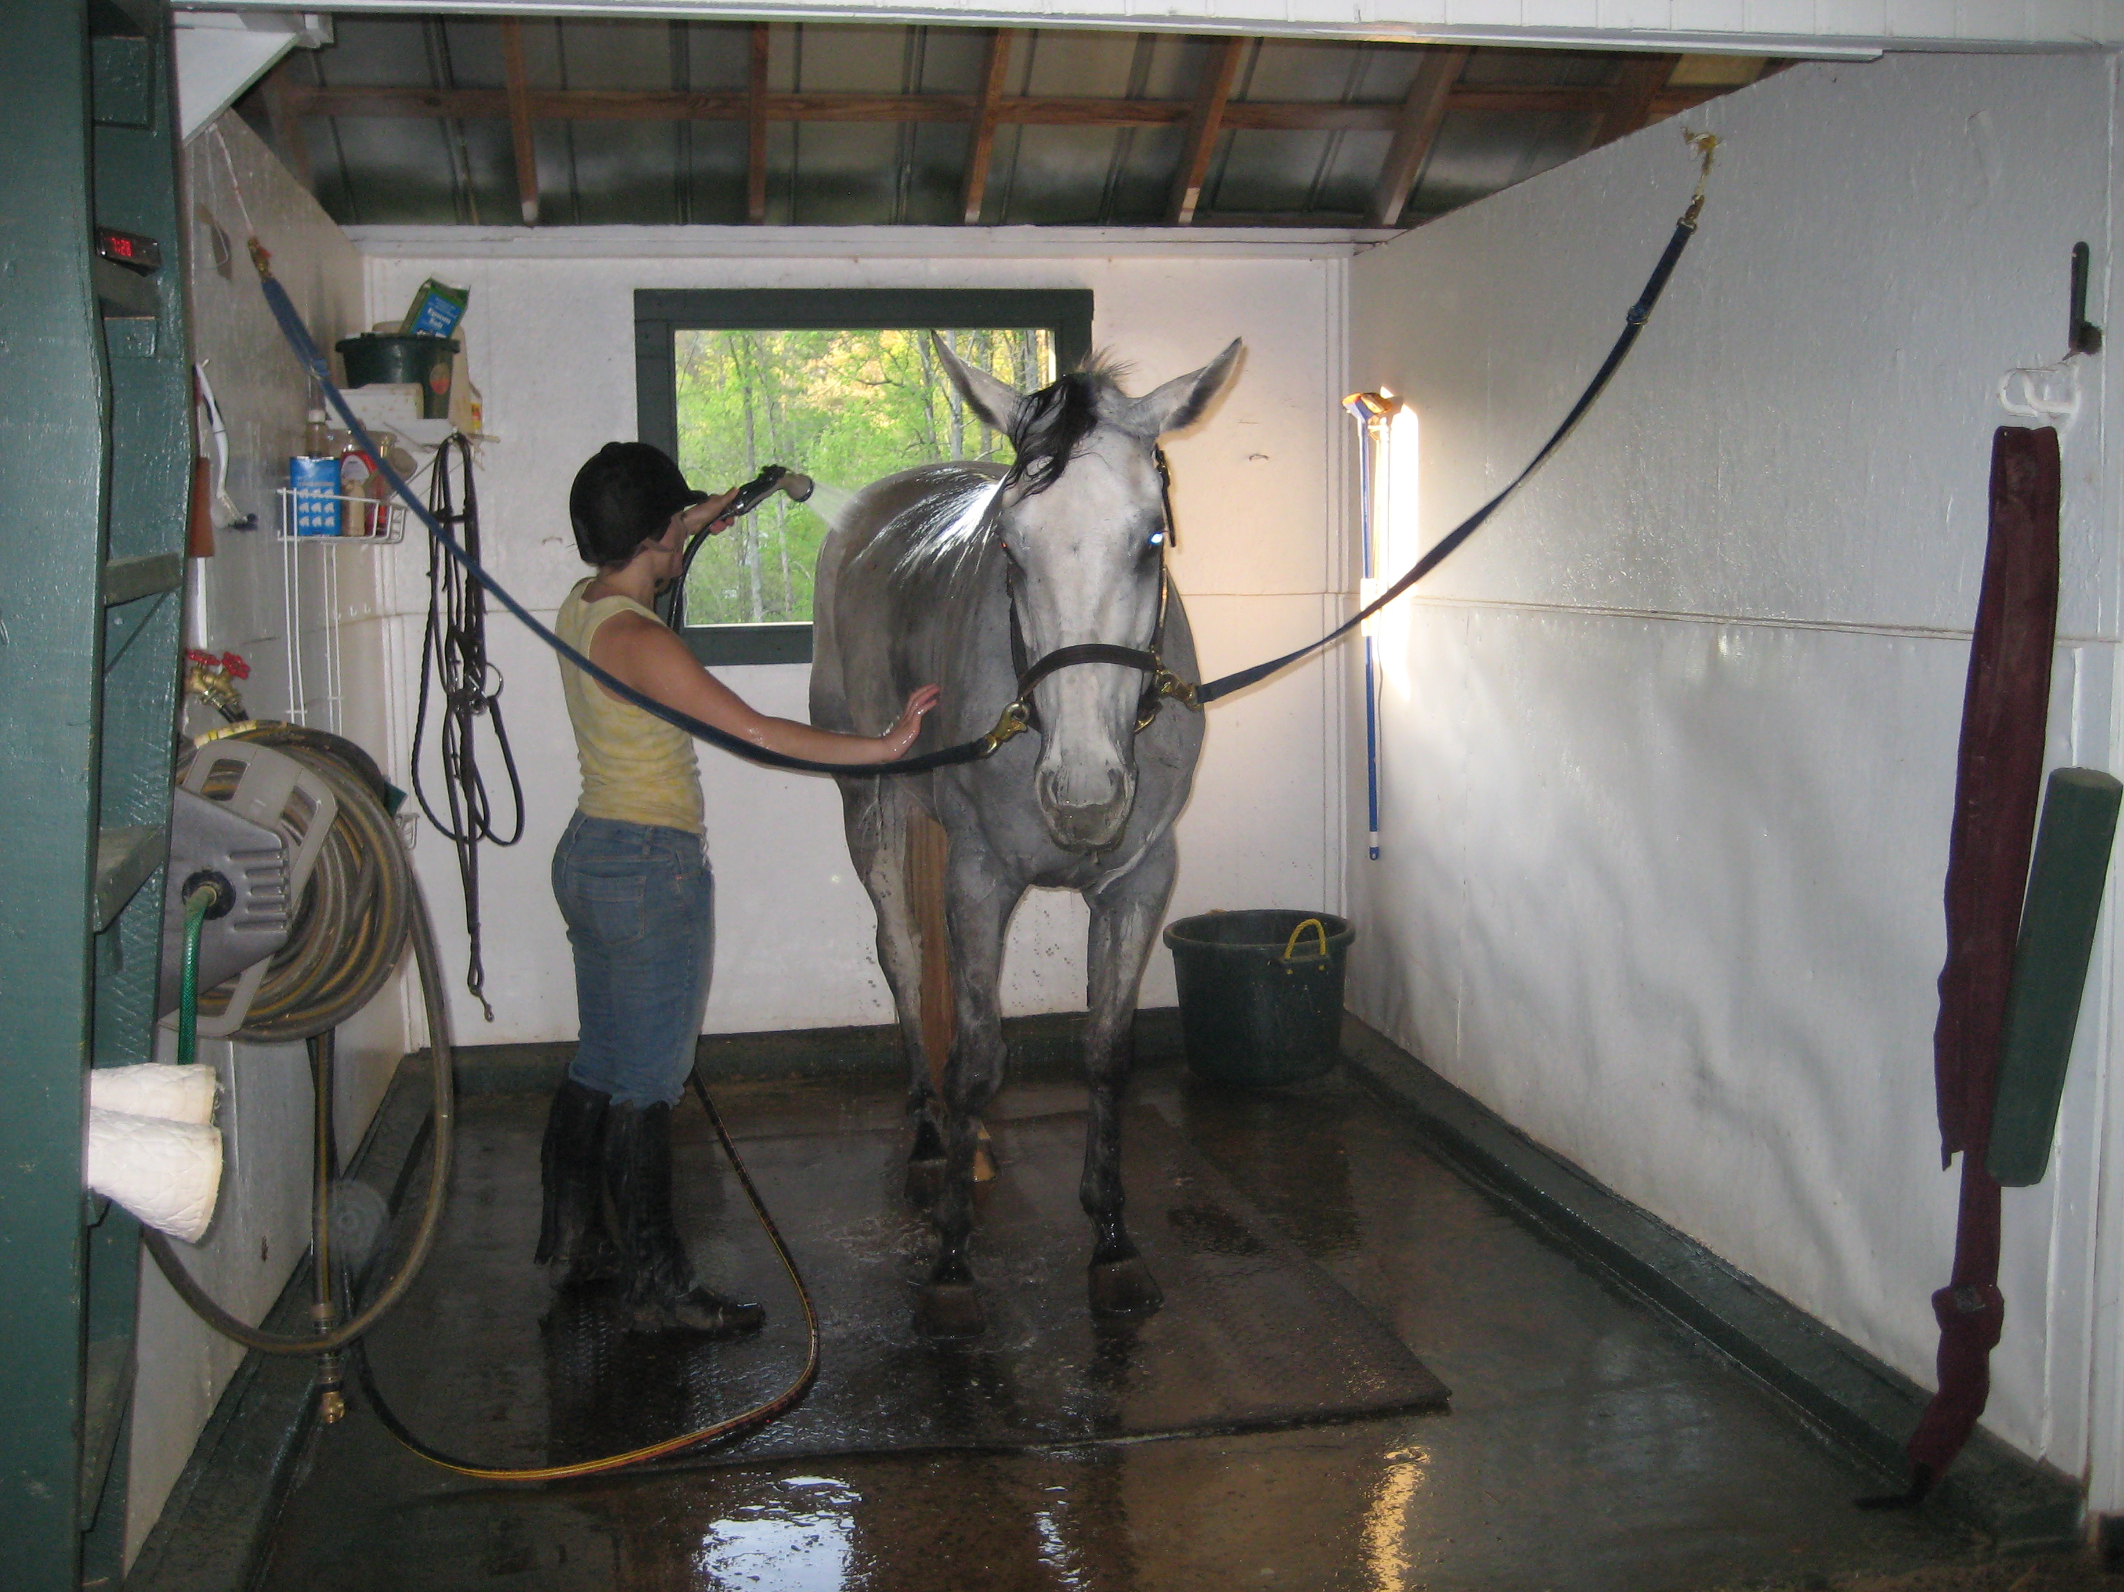

Show Me Farm

“Show me Thy ways, Oh Lord, teach me Thy paths” Psalm 25:4
Boarding Contract
This Boarding CONTRACT is made and entered into on this ___ day of , 20__, by and
between Robert Roebuck of Show Me Farm, hereinafter designated "Manager," and
___________________________ hereinafter designated "Owner," and if Owner is a minor, Owner's
parent or guardian ______________________. Manager agrees to accept Owner's
horse_____________________________ , Reg.No. _________ for boarding; and, it
is the plan and intention of the Owner to board this horse. For and in consideration of the
agreements hereinafter set forth, the Owner and the Manager mutually agree as follows:
- There shall only be one horse per stall except in the case of mare with foal.
- Owner agrees that Manager, Show Me Farm, their agents, and employees are not liable for death, sickness and/or accident including consequential damages caused to the horse. Owner agrees to hold Manager completely harmless and not liable for any injury whatsoever caused to Owner, and/or any loss or damage to any personal property. Under Georgia law, an equine activity sponsor or equine professional is not liable for an injury to or the death of a participant in equine activities resulting from the inherent risks of equine activities, pursuant to Chapter 12 of Title 4 of the Official Code of Georgia Annotated. Equine activities are defined as boarding equines.
- Owner will be held financially responsible for all damage done to premises by you or your horse.
- It is the responsibility of the Owner to carry full insurance including coverage on his/her horse and all personal property.

- Owner shall pay the Manager for boarding services, as described below. This shall include the following:
  - Stall, bedding and cleaning of stall
  - Stall and bedding
  - Use of facilities
  - Feeding 2 times a day
  - Hay times a dayTurn out--warranting weather
  - Blanketing with limits

- The boarding fee is due five days after the invoice date. It is imperative that it is paid on time. In the event that payment is overdue by ten days, Manager is entitled to a late fee of $5.00 per day for every day the board is past due. Manager is entitled to a lien against the horse for the amount due and shall be entitled to enforce lien according to the appropriate laws of Georgia. No horses will be permitted to leave premises with money still owed to Manager.

- The horse shall be free from infectious, contagious or transmissible diseases. The following are required:
  - Current negative Coggins Test
  - A worming and immunization record—Shots should include Strangles, West Nile, Eastern/Western Influeneuz, and Tetanus. Rabies vaccination is strongly recommended.
- Manager reserves the right to refuse horse within seven days of arrival if not in proper health. In addition, it is understood by the Owner of the horse that continued board is dependent upon maintaining a yearly Coggins test and keeping vaccinations current.

- Regular veterinarian and farrier attention is the responsibility of the Owner. In the event of sickness and/or accident to the horse, after reasonable efforts have failed to contact Owner, Manager has permission to contact a veterinarian for treatment. The Owner is held responsibility for all bills incurred.

If the horse dies, is sold, or upon thirty (30) days written notice to the Manager, the Owner may terminate this contract for any reason. In such case, the Manager shall be paid for all fees incurred up to the termination date. After all fees have been paid in full, this Contract is concluded.
- Only Owners and persons authorized by Owners in writing shall be permitted to enter or remove horse from stall or premises. The authorized person must have experience in the handling of horses.
- Only boarders and their immediate family are allowed to ride their horses. Boarders may not give lessons or are not encouraged to bring friends to ride. All individuals not owning a horse must sign a waiver form obtained from the Manager.
- Parents must be present at all times when minor children, who are boarders, are at Show Me Farm, unless written permission is given by parents for children to stay at the barn alone.
- ALL GATES must be closed and latched at all times. Water must be turned off and hose rolled up when finished.
- After grooming, please clean up after yourself, keep supplies, and tack in proper place. Please help keep barn and surrounding areas clean by placing trash in trashcans. Please "coke" cans in recycle containers.
- SMOKING should be done outside of the barn because of hay stored in loft.
- NO ALCOHOL OR DRUGS ARE PERMITTED ON PREMISES.
- This contract is non-assignable and non-transferable.
- This contract represents an agreement between the parties. No other agreements or promises, verbal or implied, are included. Additional agreements should be separately signed by each party. This contract is made and entered into the State of Georgia, and shall be enforced and interpreted under the laws of this state.
- Owner will give Manager 30 days notice if he or she decided to move his or her horse.
- When the Manager and Owner (or Owner's parent or guardians, if Owner is a minor) sign this contract, it will then be binding on both parties, subject to the above terms and conditions.

We will abide by all rules as stated in this document.

___________________________________________________________ Owner's/Parent/Guardian Signature
____________________________________________________________________Street Address

_________________________________________________________________City, State, and Zip Code
_________________________________________________________Cell Phone

_________________________________________________________Work Phone

_________________________________________________________Home Phone

_____________________________________________ Robert Roebuck, Show Me Farm

Boarder and Student Questionnaire
Name of Person to be billed
Street Address:
City/State/Zip:
Phone Numbers:
Home:
Cell:
Name of Horse:
Age: Color: Height: Sex:
Breed:
Veterinarian name and phone number:
Farrier name and phone number:
Vaccination Schedule
Worming Schedule
For Horse Show Purposes
Owner to be listed on Entry Blank:
Rider Information: Name Birth date SS#
Please indicate Membership Numbers in the following organizations for Rider and owner
AHSA # GHJA # ____________________________________
ASPCA # NCHJA#
SCHJA # USET # _____________________________________
Horse Registration Number: AHSA GHJA _______________________
Please include a photocopy of both the GHJA and/or AHSA horse or pony measurement card. If you have an Amateur Owner card, please include a copy of that, also.

Show Me Farm

“Show me Thy ways, Oh Lord, teach me Thy paths” Psalm 25:4

Treatment Authorization
I, , do hereby give my permission for_____ (Veterinarian) or a veterinarian chosen by Robert Roebuck or Show Me Farm if the above veterinarian, cannot be contacted, to treat my horse(s): _______________________,
In the event of an emergency, Rob Roebuck, has my permission to make decisions in the best interest of the animal, and shall not be held liable for such a decision. In my absence, and should colic arise, my wishes for treatment are to:
- Do everything to save the animal
- Put the animal down
Should any other injury that is threatening to the animal life occur, my wishes for treatment are to
- Do everything to save the animal
- Put the animal down

In the event of an emergency, I agree to pay all charges incurred. The authorization consent form is valid starting, ____________________ and ends when the above named horse(s) is no longer under the care of Rob Roebuck and Show Me Farm.

Authorized Contacts:
Owner _______________________________ Phone: _______________________
Owner Address:
Agent/Trainer:
Barn: Phone: _______________________
Date: _____________ Owner Signature: __________________________
Witness:
Warning!
Under Georgia law, an equine activity sponsor or equine professional is not liable for an injure or the death of a participant in equine activities resulting from the inherent risks of equine activities pursuant to Chapter 12 of Title 4 of the Official Code of Georgia Annotated
THE UNDERSIGNED HAS READ THE FOREGOING RELEASE AND
FULLY UNDERSTANDS ITS TERMS:

Signature Date

Parent or Guardian if Minor

Witness
Witness

Show Me Farm

“Show me Thy ways, Oh Lord, teach me Thy paths” Psalm 25:4
Trailer Parking Release of Liability and
Transporting Policy
AGREEMENT AND RELEASE OF LIABILTY
I have applied for permission to park my horse trailer at Show Me Farm located at 1356 Hendon Road, Woodstock, Georgia. I understand that parking at Show Me Farm involves a risk of personal property damage and/or theft of the horse trailer. I also understand that Show Me Farm conducts equestrian farm activities on the premises, which may also involve a risk of personal property damage to my horse trailer.
As lawful consideration for permission to park my horse trailer at Show Me Farm, I agree that I will not make a claim against or sue Show Me Farm, or its owners, managers, or employees for any injury or property damage arising from the negligence or acts, however caused, by Show Me Farm or its owners, managers, or employees.
In addition, I hereby release and discharge Show Me Farm and its owners, managers, and employees from all actions, claims, or demands that we or our heirs, personal representatives, or assigns may have for injuries, theft, or property damage resulting from parking of horse trailer at Show Me Farm. I agree that this release includes injury, theft, or damage caused in whole or in part by owners, managers, or employees.
I further understand that as a boarder, I will use my trailer for the transport of my horse/s and will not transport other horses boarded at Show Me Farm unless asked by management. It is the policy of Show Me Farm that the farm will transport boarders without trailers. If Show Me Farm is unable to transport a horse, the owners or managers may ask boarders, who own trailers, if they would transport for Show Me Farm. If such event were to occur, Show Me Farm would then bill all transportation costs. The boarder requesting transportation would have the fee added [amount depends upon location] to his or her monthly board. The boarder doing the transportation would receive a credit [amount depends upon location] on his or her monthly board.
I HAVE CAREFULLY READ THIS TRAILER PARKING RELEASE OF LIABILITY AND TRANSPORTING POLICY. I UNDERSTAND THAT IT IS A COMPLETE RELEASE OF LIABILITY AND A PROMISE NOT TO SUE. I AM AWARE IT IS A CONTRACT WITH SHOW ME FARM.

Make/ Model/Color and Year of Trailer___________________________________________________________________

DATE:_________________________________________________________________________________________________

SIGNATURE OF OWNER/S:__________________________________________________________________________________

DATE:_________________________________________________________________________________________________

MANAGER OR OWNER’S SIGNATURE:_____________________________________________________

