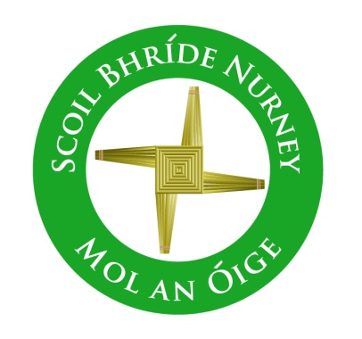
Scoil Bhríde,
Nurney,
Principal – Dr. Vinny Thorpe
Dep. Principal – Catherine Owens

County Kildare.
Tel/Fax: (045)526767
Email: sbnurney@gmail.com
www.nurneyns.com
Roll no: 16345A

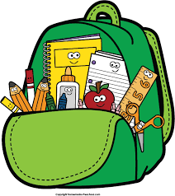
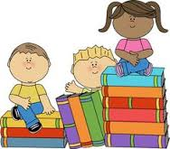
Junior Infants 2022 – 2023
Additional requirements

- Items to be purchased and labelled by parents in advance of September 2022:
(We have also indicated in brackets the ‘likely’ costs of these required items at best value stores)
- 1 colouring book (€3)
- 4 triangular (tripod) grip pencils (Faber Castell) (50 cent each)
- 2 plastic A4 folders (button down type) (€2 each)
- 2 x 40g Pritt/Glue sticks (€1.99 each)
- 2 rubber (labelled) (99 cent)
- 1 scrapbook (A3 size) (€1.99 each)
- Old shirt/T-shirt for art (labelled) (€5)
- Please label all lunch boxes, drinks containers, school bags, tracksuit tops, jumpers, rubbers and glue

Regarding schoolbags: Please do not purchase a bag with wheels and ensure that the bag you buy is adequately big to accommodate A4 size folders and your child’s lunch.

- €50 to be paid to class teacher or online by mid-September 2022 (if paying by cash/cheque this should be in a sealed envelope with your child’s name and class printed clearly on it)

This amount will be allocated to cover the cost of copies, pencils, notebooks, art and craft supplies and photocopying throughout the year ahead.
Please label all of your child’s belongings, stationery, uniform and tracksuit tops, coats etc.
Books will be provided under our Book Rental Scheme for those who have fully paid up and will be in your child’s classroom in September. Please impart to your child the importance of taking care of these books as any damage to Book Rental Books will be charged to you at the end of the school year.

Thank you for your co-operation and looking forward to a great year ahead!

___________________
Class Teacher

