KNITTED FRINGE
(Make 2 strips)
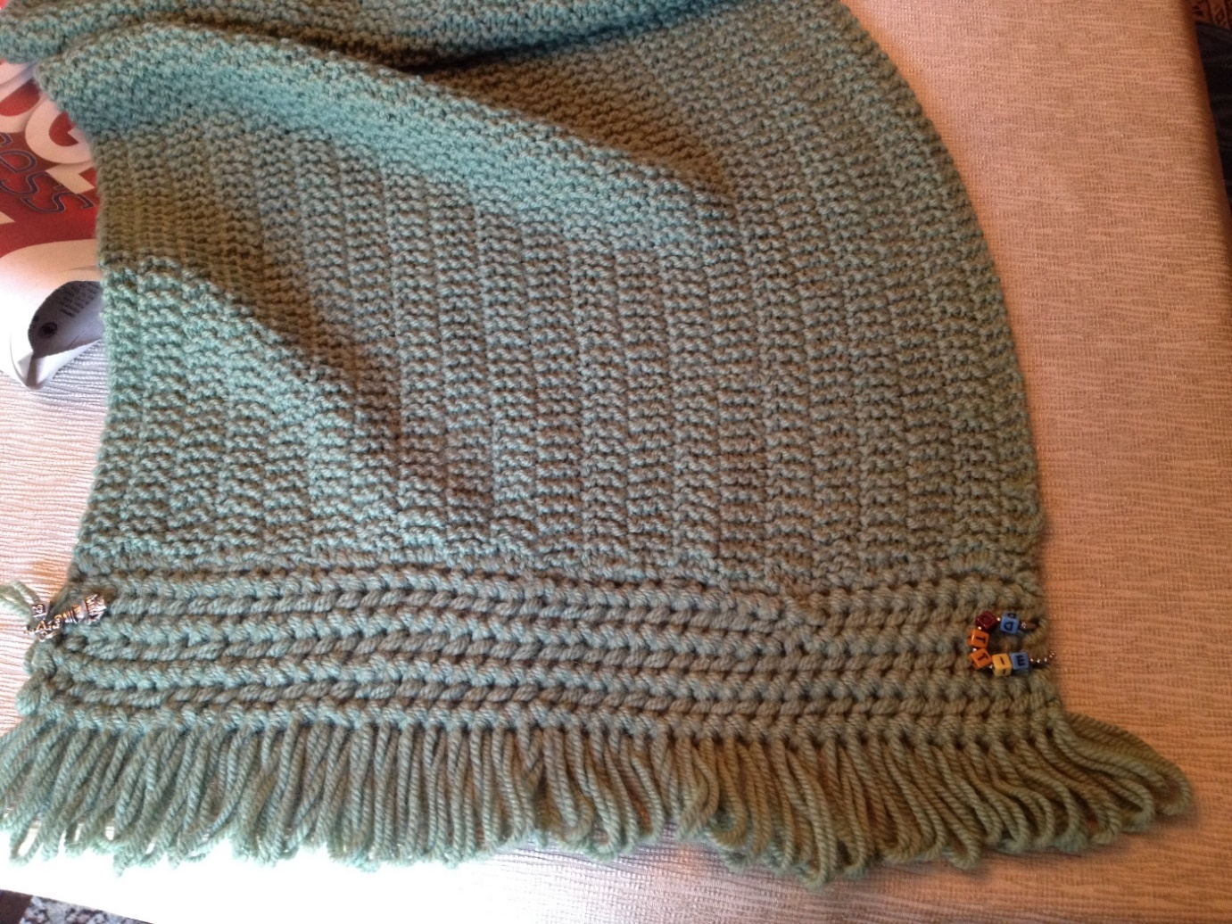
YARN OVER (YO) PEARL (P) TOGETHER (TOG) STITCHES (STS)

With 2 strands of yarn held together (TOG), cast on 8 stitches.
Row 1: YO (wrap yarn around right needle), P2TOG, (YO, P2TOG),
3 times. Repeat Row 1 until same length as lower edge of afghan.

Next Row: Work 6 sts and drop last 2 sts from left needle without working
(to form loops when raveled). Turn and bind off 6 sts loosely.
Pin long side (opposite fringe) to edge of afghan and weave in
same manner as with squares. Ravel fringe and steam lightly.
Do not cut.

