glazing of the chapel, the building of the chair stores and the provision of the central dias in the Nave. Some of the little “extras” we would have wished to add-in at this time may well have to wait. We really do need to keep the money coming in over the next few weeks.
Having said that – our fund raising “Appeal Dinner” scheduled for later this month at the Davenport Park Hotel has been cancelled (for now) and will most likely be held in a slightly different format around January/February. Time for us to make all the necessary arrangements, to promoting the event and sell tables (in particular to the business sector) has unfortunately overtaken us, especially as we need to prepare for our busy Christmas programme. We still have our Appeal Concert on the 15th November and other events and opportunities over the next couple of months to raise some money – any fund raising you can do would be most appreciated. Keep an eye on the Parish Magazine and if you can our web-site on www.stmarysinthemarketplace.com where you will find all the details of planned activities.
General Notes:
Next week we remember those who have fallen in conflict – Remembrance Sunday (11th November). Please support the Royal British Legion Poppy Appeal – the box is in Church – near the book of remembrance.
The following week (18th November) the blessing of the boxes for Operation Christmas Child. Could everyone who is preparing a show-box have them delivered to St Mary’s by that date please.
Plea for help….. can anyone spare a few hours a week (or as holiday cover) to provide additional cleaning/caretaker support at St Andrews? With the usage nowadays once a week cleaning is insufficient and some key-holder assistance would also be appreciated - especially for one-off hire events.
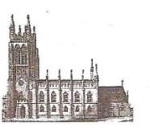
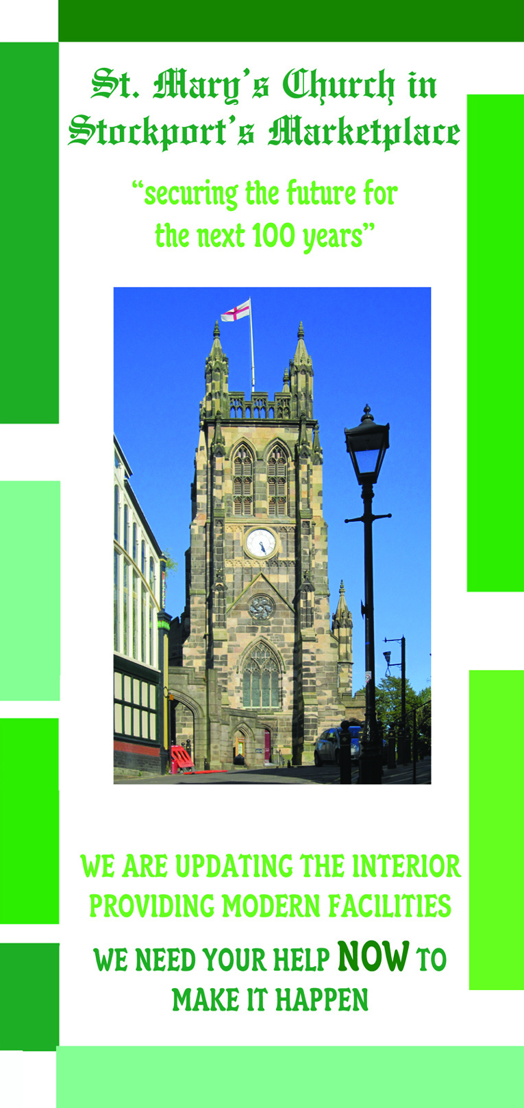
St Mary’s in the Marketplace.
Issue No 16 (4th November 2012)

“Securing the future for the next 100 years”
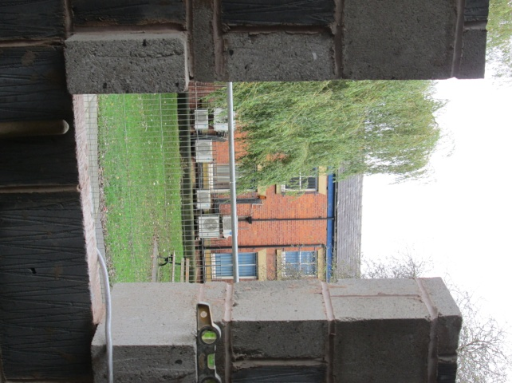
A room with a view – a sign
that the walls will soon be in place
for the new toilets. Our contractors
remain busy building the internal
walls ensuring everything is correctly
in place. For those who thought this
would never happen – we are well
on the way now to having modern
facilities at St Mary’s.
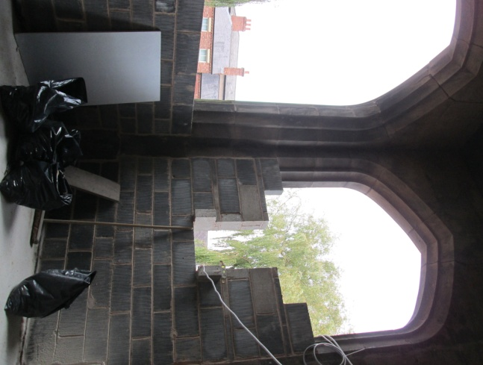

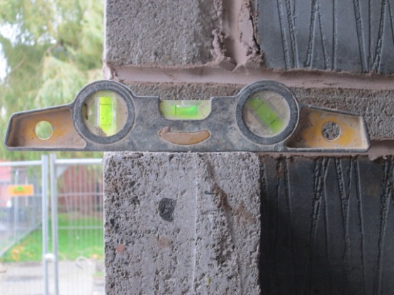

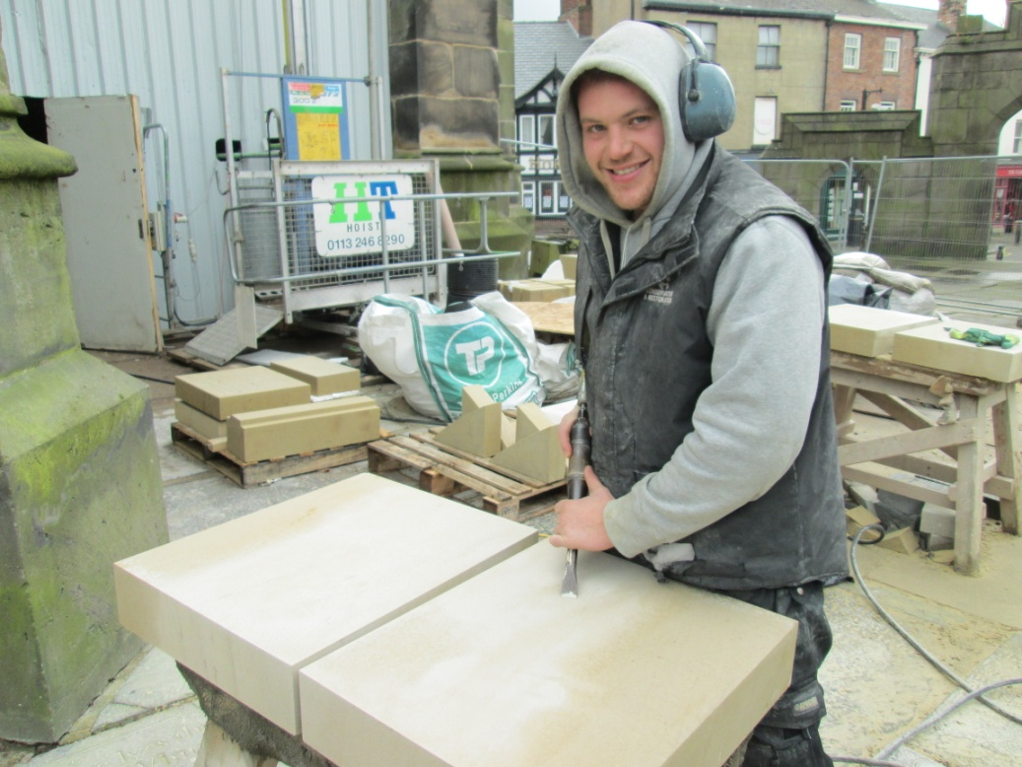
From a slab of stone the surround for a window or an arch appears (and with a smile in spite of working outside on a chilly November day). Large and small precision-cut blocks of stone. It is truly wonderful to see these pieces take shape and eventually take their place on our Grade 1 listed Church – securing the future for the next 100 years – and beyond! What skill….. we certainly do have the team to do the job.
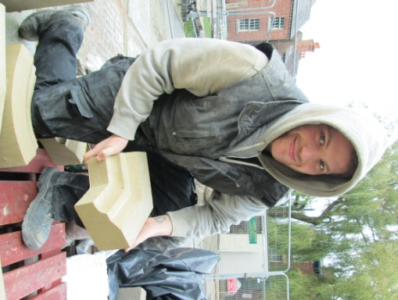
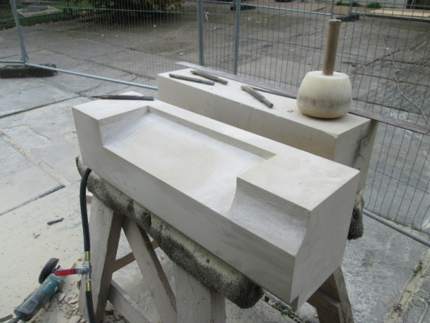

There is a lot to be said for good planning of course, precision drawings and measurements – checked and double checked. There are - behind the scenes - plans and drawings on the walls, on the floor, and of course in the site office.
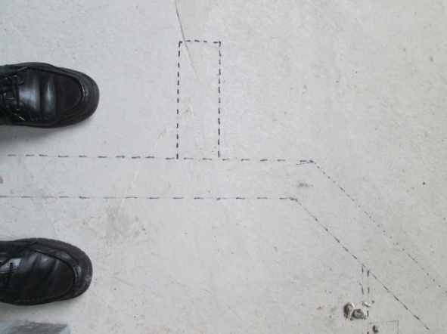
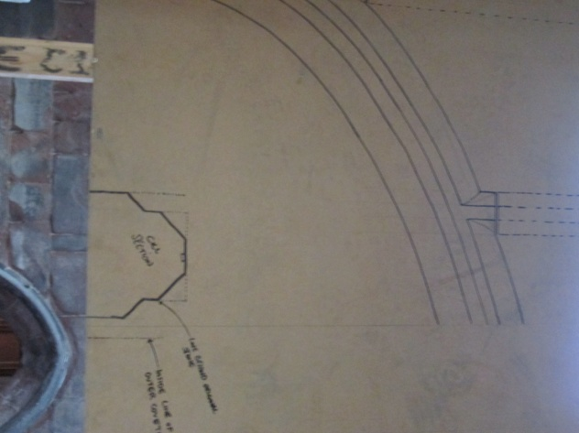

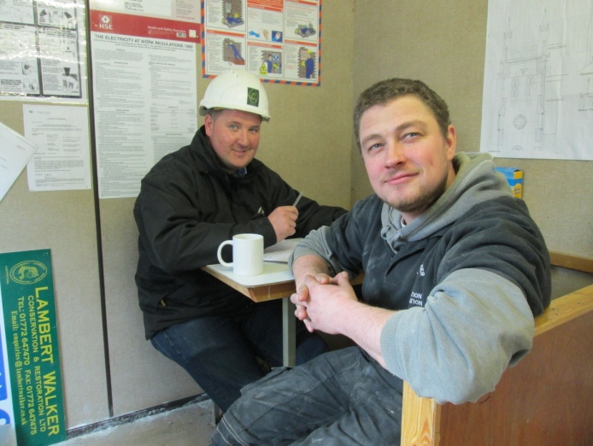
We continue monitoring progress and
the bank accounts (for both Phase 5
Tower and the internal reordering).
We unfortunately have
some unexpected costs
to find (although we do
have a small contingency
figure) e.g. works on the
temporary vestry roof
likely to be more costly
than we would have
wished.
We still have a shortfall - if we are to complete all the works we have permission to undertake at this time – we will need to make a decision shortly and decide if we are able to ask our Architects to authorise the

