Coroner: 28 overdose deaths in Franklin County in 10 days
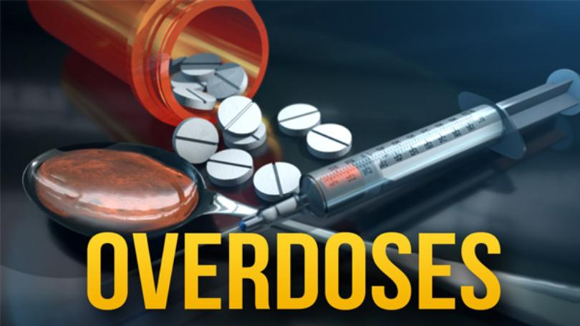
By Associated Press |
Posted: Mon 11:44 AM, Feb 10, 2020
FRANKLIN COUNTY, Ohio (WSAZ) -- A coroner says nearly 30 people died of drug overdoses in the past 10 days in Ohio's Franklin County.
Coroner Dr. Anahi Ortiz wrote in a Facebook post Sunday that there were 23 fatal overdoses from Jan. 31 to Friday and then five on Saturday.
She says that “most of these folks most likely died from fentanyl.” WCMH reported that Ortiz previously cited 10 overdose deaths on Jan. 31.
Ortiz encouraged people to use fentanyl testing strips and to carry the overdose antidote naloxone if they feel they need to use drugs.

