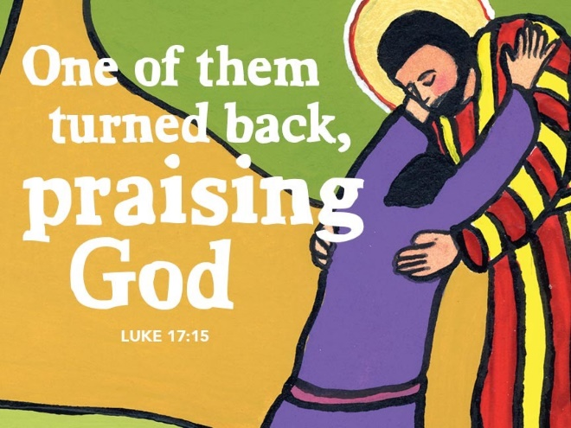

The Secret to a Joyful Life
20191013
Luke 17:11-19

Grace and peace to you from God our Father and from the one who makes us whole, Jesus Christ, our Savior, amen.
Do you know the secret to a completely satisfying and joyful life? What do you think? Is it too much to suggest that the secret to a content and joyful life lays at the heart of our faith and is contained in this brief passage? The key to both contentment and joy is tucked away in a deceptively simple observation: They’re all made well! All the lepers in this story, that is. They are all made well. Did you notice that? All ten of them. No one was left out. Not a single one!
Alright, so let’s back up just a bit, slow down just a little, and see what we might notice together. At the outset of this relatively short story from Luke’s Gospel, there are ten men who are suffering from some form of skin disease. It’s named as leprosy, which can be confusing, as what we today call leprosy – Hansen’s disease – is totally different. Leprosy in Biblical days included a wide variety of skin disorders. Anything from acne to open infected sores to much more severe diseases. Any form of Leprosy made them ritually unclean, which meant they couldn’t participate in the Temple services and rituals at the center of their faith, they had to be segregated from other people or they would contaminate them, making them also ritually unclean and unable to be part of society. Unable to practice their faith, these men stood on the outside of their community as well, likely feeling alone, abandoned, and desperate. They tended to stick together for safety reasons near the roads-close enough to beg for alms from those kind folks as they passed by. So, as St. Luke tells us, when these ten men realize Jesus is coming near them, they call out to him, not simply for comfort or companionship or someone to listen to them, but instead asking if he would have mercy on them and cure them. To their surprise, he does. All of them. As St. Luke writes, “When Jesus saw them, he said to them, ‘Go and show yourselves to the priests.’ And as they went, they were made clean.” All of them. Luke continues, “Then one of them, when he saw that he was healed, turned back, praising God with a loud voice. He stretched himself on the ground at Jesus’ feet and thanked him. And he was a Samaritan”
Cool. Except…. Well, except that it’s only one. Jesus notices that immediately, asking, “‘Were not ten made clean? But the other nine, where are they? Was none of them found to return and give praise to God except this foreigner?’” Jesus’ response, is pretty understandable. He just cured ten men, instructing them to go to the Temple – something they have not been able to do for who knows how long – and show themselves to the priests so that they might return to their faith, their community, and their families. Jesus, in other words, did exactly that they asked him to do and yet, of the ten he made clean, only one bothers to come back and thank him.
At this point in the story, I’m curious: is Jesus confused, do you think? Or hurt? Is he a little peeved, or disappointed, or even angry? Frankly, we don’t know for sure. What we do know is that he gets over it pretty quickly, shifts his attention to the one in front of him at his feet, and then offers this blessing, saying, “‘Get up and go on your way; your faith has made you well.’”
Again, cool. Except…. Well, except that, like I already said, Jesus healed all the men. All of them. St. Luke was really clear about that. So, why does Jesus say, “your faith has made you well” if they’ve already all been made well? As it turns out, it all comes down to how you translate a single Greek word. That word – sozo (pronounced more like sod-zo) – can be translated as “made well,” in the sense of being healed, but it can also be translated as “saved,” in the sense of being brought through mortal danger. It can be translated as “made whole,” in the sense of being completed and made to be what you were meant to be all along. So, ten were men in total were made clean, but only one was saved. Ten were made clean, but only one was made whole. Ten were made clean, but only one recognized the source of the healing and gave thanks and, in giving thanks, became what God had intended all along.
And that my dear Church Family, I believe, is pretty much the secret to life: gratitude. Noticing God’s grace, seeing God’s goodness, paying attention to God’s healing, and stopping to take in the blessing, and then giving thanks for the ordinary and extraordinary graces of our life together. This is the secret to a good life and the heart of saving faith. This is the secret to living completely whole and joyful no matter what circumstances sin, the world, or the devil throws your way.
Look, I know, I know, these things I’ve mentioned – noticing blessing and giving thanks – can seem like such small things, and yet I swear to you that they make all the difference. And I know this because I’ve seen it. In new parents and those in Hospice care, in the face of a child receiving an unexpected treat as well as the expression of a very ill patient recognizing the extraordinary care of a nurse. I’ve seen it in reverse as well. The person who is never satisfied. Who gets a break and complains it wasn’t bigger or better. The person who compares their lot in life to everyone else and is never satisfied because so and so has more… True joy isn’t found comparing your situation to someone else’s but, rather in seeing the blessings you have as pure gifts from an amazing God who has given much more than you could ask for or ever deserve.
Which is what I find so amazing – this gratitude which restores and heals and completes and saves… it’s available to us at every single moment of our lives. In our health or with those who are caring for us when we aren’t well. In those near and far who have contributed to who we are. In the fellowship we share in our congregation and for the people and programs that bring them to life. In both the rain and sunshine! – People who are filled with gratitude enjoy their lives. When you open your eyes to look, blessing is all around. To answer my earlier question, I don’t think Jesus is angry or upset with the nine who didn’t come back. I think his heart aches for them. They were made clean, but they weren’t yet brought through the peril of an ungrateful life. They had not yet been made whole and had not yet become the people God hoped for them to be.
So there it is – the secret to a completely whole and joyful life, the heart of gratitude. We were made for gratitude. We were made to give thanks and praise to God. Giving thanks to God completes us. It saves us and transforms us and makes us whole. The one who returned to give thanks knew that. Jesus knew that and now you know it too.
I said at the start this passage offers us the key to a content and joyful life and it does, but I believe grateful people are only the second most joyful people on earth. Do you want to know who the most joy filled people are? This characteristic flows from from grateful hearts. It’s generous people. I believe generous people are the most joy filled people on earth. Thank you for all your good works, for your generous and abundant faith, and for your witness to the grace of God that not only showers us with blessing, but gives us the eyes to see it and hearts eager to respond in gratitude and generosity. God blesses us with so much and allows us the freedom to be grateful or not; to be generous or not. How will you choose to live you life? I, for one, will try to count my blessings and remember to return to give Jesus my thanks every day.
May we always be the grateful, generous people God created us to be. May we show our thanks by returning to Jesus and worshiping him as often as we are able. May our generosity shine before all so that God is glorified and praised. May we come to understand that in giving our thanks to God we are made whole, which is way better than just being cured of some disease. May God continue to bless each of us with the faith to trust in his saving grace through our Savior, Jesus Christ, amen.

