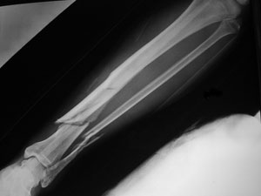
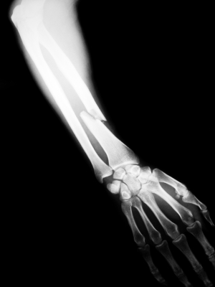
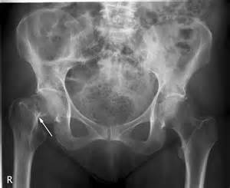

Broken Bones
Broken bones take a varying amount of time to heal, mostly depending upon the type of bone broken, the age of the person, and the way in which the bone is broken. Additionally, diseases that degenerates bone tissue, like osteoporosis, may cause one to have far longer healing times for broken bones. As well one may need more complicated treatment like surgery.
- In general, small broken bones with simple fractures take about four weeks to heal in small children.
- In teenagers and adults, small bones — like a finger or wrist bone — with a simple fracture, will take about six weeks to heal.
- Larger broken bones, for example the bones in the thigh, would take a great deal longer to heal, usually six weeks to three months in the average healthy adult.
When healing is taking place, it is essential to keep the cellular tissue optimally hydrated. It would be very wise to drink Performance (Shaklee’s hydration sports drink) at least twice per day.
When the body has to repair and recover, it uses up far more nutrients than daily maintenance. Therefore, anyone with a fracture or a broken bone would be wise to optimize the following nutrients for the duration of the healing time. Usually, at least double or triple the usual amount is recommended ...
- Protein: Bones are 65% protein
- Alfalfa: a smorgasbord of minerals
- Vitamin C: essential to knit the new bone together
- Calcium/Magnesium
- Vitamin D3: always keep this vitamin at optimal levels
- Zinc

