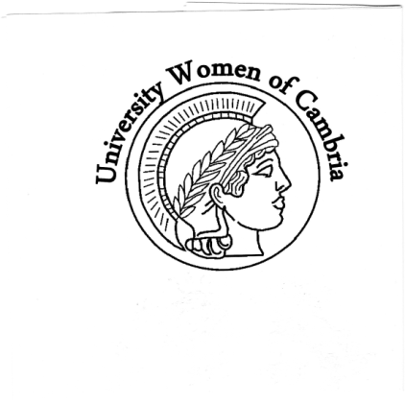

University Women of Cambria

PO Box 1621

Cambria, CA 93428

[www.universitywomencambria.com](http://www.universitywomencambria.com)

 Our Mission Statement

The purpose of the University Women of Cambria is to encourage and enjoy the pursuit of higher education. To this end, the organization awards annual scholarships to qualified graduating seniors of Cambria high schools, promotes and participates in community endeavors with an emphasis on education, and fosters fellowship among its members.

**Scholarships**

University Women of Cambria will award 10 individual scholarships of $1,000 each between Coast Union and Leffingwell High Schools at our annual Scholarship Award Luncheon on May 15 at the Cambria Pines Lodge beginning at 11:00am.  Our holiday fundraiser proceeds this year totaled $6660. Our thanks to Cindy Bitto and her team who headed up the successful event. Five students from Coast Union and Leffingwell high schools did a cracker-jack job of awarding the Merchant Raffle prizes. The UW Board thanks the members of the Scholarship Committee lead this year by Chair Jean Chinnici. The selection process is always challenging. Committee members include Carolyn Pye, Donna Crocker, and Sue Nash. Members of the Scholarship Committee and members of the UW Board will be attending commencements at Coast Union and Leffingwell High Schools in early June.

**New Member Drive**

We welcome more new members who have joined us this year during our ongoing membership drive. They are: Maureen Hubbell, Heather Markham, Helen Pitton, Hilary Townsend, Rhea Wong, Rosemary Flamion, and Kathleen Marlo. Since September 2015 we have added 16 new members! A New Member Tea was held in January at the home of President Lee thanking them for joining and getting to know each other. A good time was had by all!   Two of our long-standing members passed away this year: Gloria Ohlendorf, former UWC Treasurer and Joen Kommer former Cambria librarian. Both ladies actively supported our mission, were an absolute delight to be around, and will be deeply missed. 

**2017-2018 Election Cycle Begins**

The current UW Board members will complete their 2-year Board positions serving our organization. In accordance with the By Laws, we have a Nominating Committee in place, Donna Crocker, Chair; Eunice Wilson and JoAnn King members. They will be busy over the next 6 weeks recruiting members to serve. Elections will be in May and installation in June. On the enclosed Dues Renewal sheet you can indicate your interest for an officer or serving on a committee. The vitalization of any organization depends on fresh ideas and energy. 

**2016-2017 Monthly Programs**

Margie Sesser, 1 VP, assembled a fantastic line-up of well-attended monthly programs. PG&E’s John Lindsey spoke on climate change. We toured Linn’s Fruit Bin facility in Tin City, which has really expanded. On a beautiful fall day we went to Pasolivo Olive Farm off Vineyard Drive and sampled their olive oils and picnicked. Gayle Jenkins of A Matter of Taste and Chef Chris Lum prepared an Asian Inspired lunch for members consisting of 4 different items. By special request, Dr. Kirk Azevedo returned to speak on Scientific Research and Your Health. Rounding out the year will be the Pewter Playhouse production of “Educating Rita” and dinner at Harmony Café and lastly, a panel discussion “Advocacy & Support for Student Success”.

**Interest Groups**

University Women Interest Groups are open to all our members. We have two book groups and a bridge group. New members are always welcome. Both book groups meet on the 1 Monday of the month. The morning group reads a mutually agreed upon book for everyone to discuss. Kathy Hurrle is the facilitator (927-2271). The afternoon group is a free-read; members report on books they have recently read and recommend. Diane Young is the facilitator (927-8798). Our last interest group is social Bridge. They play on the 2 and 4 Mondays at 1 pm. Call Dianne Dougherty for information (927-5093). They welcome members who want to join – substitutes are always needed.

**Candidate Forum**

Last fall, University Women sponsored a very well-attended forum for candidates for the Coast Unified School Board of Trustees, moderated by the League of Women Voters. This endeavor supports our mission of participating in community educational events. Our thanks to Jean Chinnici for coordinating the event.     I want to extend a personal thank you to all our members, friends, and contributing merchants who have made this another outstanding year. My special thanks goes to each of our UW Board members who contribute their time and effort to support UWC’s mission statement.   Margie Sesser, 1 V.P. (Programs) Cindy Bitto, 2 V.P.  (Fundraising) Emily Penfield, Secretary Valerie Eastman, Treasurer Kristi Jenkins, Past President Dianne DePasquale, Parliamentarian

**Sincerely,** Cynthia **Lee President, University Women of Cambria**