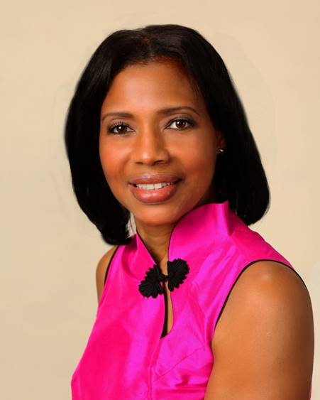
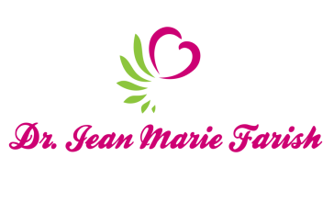

LOVE LIGHT NewsLetter

I am excited to host my VoiceAmerica Empowerment Show-LOVE LIGHT with amazing Guests to cultivate a lifestyle of love and wholehearted connections through worthiness. My show is aligned with my mission to live an altruistic and heart centered life.

MEET LOVE LIGHT GUEST

DEBBIE JOHNSON
Psychic/Medium

JUNE 26, 2020
“Heaven on Earth: The Angelic Love Connection”

ABOUT DEBBIE JOHNSON

Debbie is a Psychic/Medium with a special connection to the Angelic Realm and has been working with clients all over the world for over 18 years. She brings messages from your Angels to you by channeling Archangels, passed loved ones, spirit guides, a and healing. These messages include information about your future, your health, and any other subject where guidance is needed.

She began to see spirits as a small child, but when she spoke about it, she was told to stop making up stories because no one saw what she saw. Being raised in a Southern Baptist household, her gift was repressed. It started to come back in her 20s when she began to write music and then got even stronger when she studied Reiki. During Reiki sessions, Debbie not only saw and heard human spirits, she also witnessed the magnificence of the Archangels and their abilities to help others. She would not have believed it, had she not seen it with her own eyes. At that time, she began to work along with the Angelic Realm.

Debbie not only delivers messages, but she is able to see into the spirit and physical body if needed and channel powerful healing energy that clears blockages and entities that can sometimes be the cause of physical and mental illness. She works with the Angelic realm to bring healing that is safe and gentle for all.

https://www.angelicmessages.com

“An empowered self is a loving self and keep your love light shining”

