Party Invitation Policy
2015+

Board of Management Scoil Bhríde Nurney
2015+
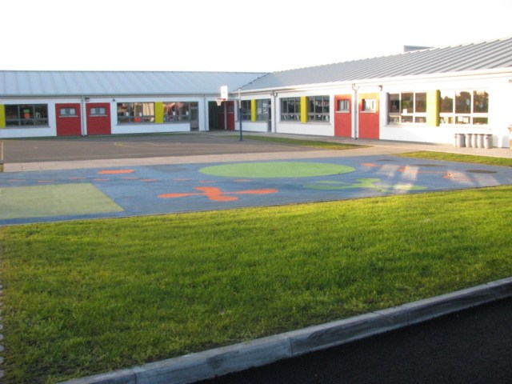
Scoil Bhríde

Party Invitation Policy

Introduction:
A Party Invitation Policy exists in Scoil Bhríde under the remit of the Board of Management to maintain pupil wellbeing by reducing the distress and anxiety caused to individual children. The Board of Management is also very wary of the increased workload this can put on staff.

Rationale:
The purpose of this policy is to regulate the distress caused to individual children who are not invited to parties. The Board of Management recognizes the very serious negative impact that non-invitations to a party can have on the lives of pupils and their well-being, and is therefore fully committed to a positive school culture and climate which is welcoming of difference and diversity and is based on inclusivity. School staff also has enough workload in terms of teaching the curriculum and have ill little time to be distributing materials on behalf of parents, consoling upset children and dealing with upset parents. The school’s role is a place of teaching and learning and has no place in organizing parties and invitations on behalf of parents.

General Principles:
It is school policy that birthday or party invitations are not given out in the classroom or anywhere on school grounds. If parents wish to invite pupils to your party please do so privately. The BOM, Staff and many parents are very concerned about the distress caused to individual children who are not invited. We therefore appeal to you to co-operate with us in this matter: please do not give your children invitations for distribution coming to school. Please note that school staff members cannot be involved in the circulation of such invitations, nor are they able to provide a listing of names and contact details of other pupils in the class (in keeping with our school’s policy on Data Protection), nor are they to be involved in the sharing of birthday cakes/party bags in the classroom (This is to allow our staff follow best practice guidelines laid down to them by the HSE in terms of a healthy eating policy and food allergies).

Implementation Arrangements, Roles and Responsibilities:
The School Principal is assigned the role of co-ordinating implementation of this Party Invitation Policy and for ensuring that all members of the school community are familiar with the Policy.

Monitoring the implementation of the Policy:
Staff and Board of Management members will satisfy themselves on an on-going basis that the actions/measures set down under the Policy are being implemented.

Reviewing and evaluating the Policy:
Ongoing review and evaluation of this Policy will take cognisance of changing information or guidelines (e.g. from the HSE (psychological services, healthy eating guidelines etc.), Department of Education and Skills), legislation and feedback from parents/guardians, students, school staff and others. The Policy will be revised as necessary in the light of such review and evaluation and within the framework of school planning.

Success Criteria:
Practical indicators that will be used to gauge the impact and effectiveness of the policy will include the extent to which:
- Students, staff and parents/guardians are aware of the policy
- Requests for Party invitations to be distributed are dealt with effectively
- Requests for Party food to be distributed are dealt with effectively
- Requests for Personal data are dealt with effectively

Ratification of Party Invitation Policy

This policy was adopted by the Board of Management on _________________

Signed: _________________________ Signed: __________________________
Chairperson of Board of Management Principal

Date: __________________________ Date: __________________________

Date of next review: __________________

