May/June Holiday Programme  www.the-greenfield-club.co.uk |  |  | The Greenfield Club is a non-profit making charity, set up in 1996 to provide out of school care, for children aged 4-11 years. We are open from 7:45am until 6pm every week day during the school holidays, except for Bank Holidays. We are accepting children who start Reception class in September so please come along and visit us to book your sessions!
May | Mon 30th | Mon 31st | Weds 1st June | Thurs 2nd & Fri 3rd | Mon 6th
Open 7:45am | Anxiety Busting Session | Dodge Ball | 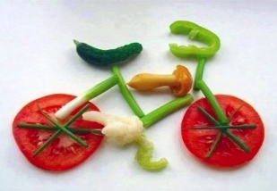  Veggie Art | Bank Holidays –  Club Closed | Bull Dog
9:30am |  |  |  | Fruit Kebab Making  All week for Snack time!
12:00pm | Drawing Pad Time  Get Creative! | Healthy packed lunch with ice pack for 12pm dinner each day please! |  |  | Fruit Salad Pudding Bowls
 |  | 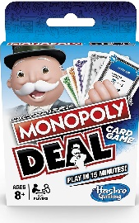  Card Games | Yoga | Heathy Lunch Boxes  As part of our Healthy Eating, we are providing healthy meal choices for our Holidays, Activities & Food Programme funded children.  Is your lunch box deemed as healthy?  School food standards - School Food Plan  https://www.bbc.co.uk/food/collections/  healthy_packed_lunch_ideas
1:00pm |  |  |  |  | Parachute Games
2:30pm | Skipping Challenges  Join in the fun! | Watermelon Fruit Lollies | Circus Skills | Healthy Eating  You can find healthier swaps for next time you shop
4:00pm  Close 6pm |  | Tennis |  |  | Meditation Session  Learn how to listen,  improve your memory  & reduce stress
Don’t miss out! …
The booking deadline is Friday 13th May
May/June 2022 Holiday Club Programme - Booking Form
Date  Please tick your selected sessions | Morning Session  (7:45am-1pm)  £15.00 |  |  | Afternoon Session  (1pm-6pm)  £15.00 |  |  | All Day Care  (7:45am-6pm)  £25.00
Mon 30th May
Tues 31st
Weds 1st June
Thurs 2nd | CLUB CLOSED BANK HOLIDAY CLUB CLOSED
Fri 3rd | CLUB CLOSED BANK HOLIDAY CLUB CLOSED
Mon 6th
Please note that trips are compulsory and there will not be an option of staying at Club.
We welcome suggestions for competitively priced trips and visitors to continue to keep fees low.

By booking certain dates, you are giving your consent for The Greenfield Club staff to take your child/children off Club premises, to travel by mini-bus/coach, to the stated trip destination or take part in a particular activity.
Name/s of Children: |  |  |  |  | Age/s during the May/June Holidays:
Name of parent/carer: |  |  |  |  | Telephone number:
Home Address:
(House number & Post-code)
Are you requesting booked dates that are funded by the Holiday, Activities & Food programme? If so, would your child like:
A healthy packed lunch box containing fruit & veg, a cheese / or ham sandwich, a fruit yogurt/fromage frais, breadsticks and raisins , beans on toast , cheese on toast , jacket potato with cheese and or beans
Email address: |  |  |  |  | School:
Please circle payment type: |  | BACS | Childcare Vouchers |  | Cash no longer accepted | Cheques no longer accepted
Signature: |  |  |  |  | Date:

The booking deadline is Friday 13th May - Don’t miss it!
Want to cook healthy meals at tea time? … Recipes - Healthier Families - NHS (www.nhs.uk)

