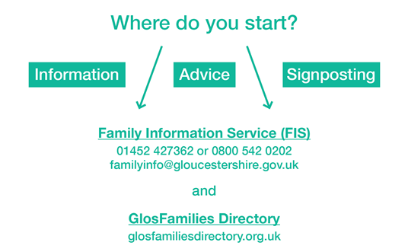
W: www.glosfamiliesdirectory.org.uk
T : 0800 542 02 02 | 01452 427 362
E : familyinfo@gloucestershire.gov.uk
You can also find us on Facebook

They can also provide information on:
- Family support and general family advice – where to find support with behaviour, routines, counselling, mentoring, relationships, addictions and anything else a family might need support with.
- Childcare – advice on the types of childcare funding available, how to find childcare near you, and apply for childcare funding.
- The Key Disability Register- provides families and children with additional needs with a newsletter three times a year, advising of any support and financial help families might be entitled to and also entitles the child with a disability to a free swimming pass to attend their local leisure centre.
- Activities – things to do with babies and toddlers, clubs and groups for children and young people, fun days, school holiday activities and events.
- Parenting Courses – please visit our Training and Workshops section on www.glosfamileisdirectory.org.uk/training to search for available dates and locations and call the Family Information Service to book.

Early Help - Advice, Guidance and Support
Early Help is about providing support to potentially vulnerable children, young people and their families as soon as problems begin to emerge, or when there is a strong likelihood that problems will start in the future. It is also about providing support at any and every stage of a child's life: pre-birth, during pregnancy, childhood or adolescence.
In Gloucestershire, we believe that families are best supported by practitioners who are already working with them, as well as other organisations and services within their local community. These organisations include health services, schools, learning providers, councils, charities and voluntary groups, children and family centres, the police, housing providers and many others.
Children, young people and families with additional needs will be supported through the use of the Graduated Pathway of Early Help and Support.

The Early Help practitioners include:
- Early Help Co-ordinators who provide support for practitioners who are working with children and families to meet their needs through the Graduated Pathway
- Community Social Workers work with organisations to provide a social work perspective on families they are supporting. This supports practitioners to ensure families receive the right level of support and act as a link between Children’s Social Care and the community
- Early Help Partnership Managers support partnership work between organisations in communities to support the development of resources available to children and families. They attend District Community Safety Partnerships (CSPs) to make sure there is a focus on Early Help for vulnerable families alongside wider community safety concerns.

Early Help Contacts in your locality
Cheltenham | 01452328160 | cheltenhamearlyhelp@gloucestershire.gov.uk
Cotswolds | 01452328101 | cotswoldsearlyhelp@gloucestershire.gov.uk
Forest Of Dean | 01452328048 | forestofdeanearlyhelp@gloucestershire.gov.uk
Gloucester | 01452328071 | gloucesterearlyhelp@gloucestershire.gov.uk
Stroud | 01452328130 | stroudearlyhelp@gloucestershire.gov.uk
Tewkesbury | 01452328250 | tewkesburyearlyhelp@gloucestershire.gov.uk​

