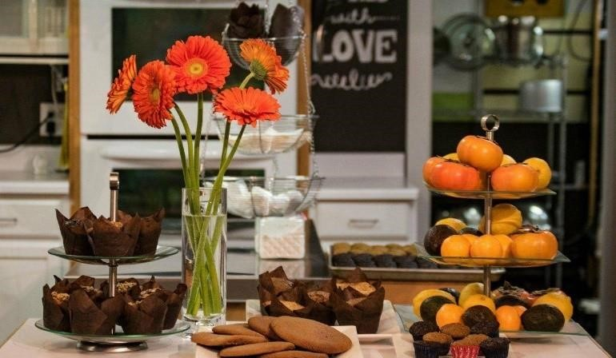

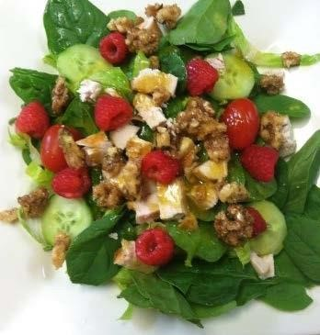

Salads
Organic Spinach & Berry………………….13.54
Spinach, Seasonal Berries, Cucumber, Feta, & Candied Walnuts. Drizzled with our Balsamic Dressing.
Vegan Caesar……………………………………… 11.78
Organic Greens with Cucumber & G.F. Croutons.
Topped with our Nut Free Vegan Caesar Dressing.
Albacore Tuna Salad…………………………14.48
Albacore Tuna, with –or– without Mayo, on a bed of Organic Greens with Cucumber & Tomato. Topped with our Lemon Dressing.
Turkey Taco Salad…………………………..…15.62
Seasoned ground Turkey on a bed of greens. Topped with Jalapeno, Olives, Tomato, Salsa & G.F. Tortilla Chips.
Chef’s Special
Ask about or Chef’s Special

Soups
G.F./Vegan Organic Broccoli Soup Cup..…8.25 - or - Bowl…..10.64
Served with Organic Sweet Potato Crackers & Fresh Fruit
Soup Du Jour
Ask about our soup of the day
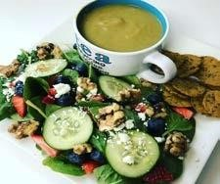

Sandwiches & Wraps
Served on G.F. or Organic Bran Bread…
Spinach or Whole Wheat Wrap – Add $1.00 All served with Fresh Fruit
Egg Salad…………………………..……………….12.72
Egg Salad seasoned with Dijon, Mayo & Salt. Topped with Tomato & Spinach.
Albacore Tuna Sandwich………………..14.48
Albacore Tuna, with –or– without Mayo. Topped with Tomato & Spinach.
G.F. Turkey Vegetable Meatloaf………15.52
Ground Turkey loaded with vegetables. Topped with Tomato & Spinach.
G.F. Turkey Pesto………………………………14.48
Natural Turkey Breast with our Organic Spinach & Artichoke Pesto. Topped with Tomato & Spinach.
Vegan Hummus Wrap………………………13.94
Our fresh made hummus wrapped with Spinach, Cucumber, Tomato and Seasonal Avocado.
(Not available in the ½ Sandwich Combo)

Combos
Soup with ½ Sandwich
Sandwich of your choice served with Fresh Fruit.
Cup..…14.01 - or - Bowl…..16.56
Soup with Full Sandwich
Sandwich of your choice served with Fresh Fruit.
Cup..…17.60 - or - Bowl…..19.67
Soup & Salad
Our Organic Berry Salad with Your Choice of Soup.
Cup..…15.52 - or - Bowl…..17.60
Sandwich & Salad
Our Organic Berry Salad with Your Choice of Sandwich.
½ Sandwich..…15.52 - or - Full…..17.60

Muffins
No Dairy, Oil, Butter or Soy!
All Natural limited ingredient muffins and baked goods.
Gluten Free…………………………………………….3.64
Daily Flavors:
- Apple Walnut ( seasonal)
- Almond
- Banana Chip
- Banana Walnut
- Blueberry
- Carrot Walnut
- Chocolate Zucchini
- Double Chocolate Chip
- Peanut Butter Chip
- Pineapple Coconut
- Pumpkin
- Pumpkin Chip
- Zucchini Carrot
Vegan (Ask for daily flavor)….…………….3.90
Paleo (Flavor - Almond) special order!
Muscle (Flavor - Almond) special order!
KETO (Ask for daily flavor)….…………….4.16
9 Box of Muffins………………………………Varies
Choose from our Daily Flavors listed above. A $2 savings!
Special Order
48 Hour advanced notice required.
We are able to alter our ingredients for those with specific allergies.

Cookies  Cakes  Brownies  Poppers 
Single Cookie…...……………………… 3.62 - 5.00
Dozen Cookies.………………………….……varies
Single Cake Slice……5.15 not always available daily!
Brownie (Vegan Black Bean)…4.16
Poppers (Regular or Vegan)…………………3.00
House poppers (peanut & chocolate)
Vegan (almond, chia & coconut)
(360-337-1313) – Please allow at least 15 minutes for all phone orders to be ready for pick-up

Breakfast
Monday–Saturday 8:30-12:00
Mediterranean Breakfast Sandwich…11.94
G.F. or Bran bread with artichoke & sundried tomato spread, scrambled eggs. Topped with Tomato & Spinach. Served with fresh fruit.
Yogurt Berry Parfait…..…………………… 8.80
Non-fat Greek Yogurt topped with our in-house Berry Bake & G.F. Vegan Granola.
Keto Scramble…………………………………..13.95
Scrambled eggs, Spinach, Mushroom, Onion, Tomato, Turkey Bacon, Bell pepper.
Texas Scramble…………………………………13.95
Scrambled eggs, Taco Meat, Tomato, Onion, Cheese and Avocado. Salsa on the side.
Bacon Egg Sandwich……………………….. 9.95
Bacon Egg Bagel………………………………… 9.84
Bagel and Cream Cheese…………………. 6.74
Avocado Toast……………………………………. 5.72 Sides
2 Slices G.F. or Organic Bran Toast…...3.95
2 Hard Boiled Eggs……………………………….3.12
Cheese or Avocado…………………………………1.50
2 slices or Pepper Jack or Cheddar, Avocado is Seasonal.
Fresh Seasonal Fruit Cup….…………..…….4.16
(360-337-1313) – Please allow at least 15 minutes for all phone orders to be ready for pick-up

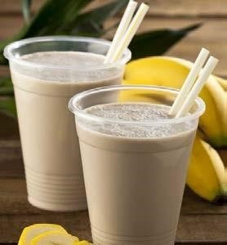

Kid’s Menu
Peanut Butter & Jelly Sandwich….……7.76
Full Peanut Butter & Jelly Sandwich served with Fresh
Fruit & Gluten/Dairy Free Popper
Almond Butter & Jelly Sandwich.……7.76
Full Almond Butter & Jelly Sandwich served with Fresh
Fruit & Gluten/Dairy Free Popper
Child’s Club Sandwich………….…………….8.23
½ Sandwich with Natural Turkey, Cheddar Cheese,
Tomato & Lettuce. Served with Fresh Fruit &
Gluten/Dairy Free Popper
Childs Smoothie…..……………………………….6.15
12oz. Strawberry & Banana. Add $0.50 for Non-Dairy
Green Apple Smoothie………………………….5.15
12oz. Apples, Organic Apple Juice, Green Grapes,
Spinach & Cinnamon
Organic Juice Box…......................................2.03

Smoothies
20oz. Smoothies blended with Vegan Protein Powder All Ingredients can be modified to your preference
Misty’s Special……………………………………….8.25
Organic Spinach, Blueberries, Banana, Almond Milk
Apple Spice…………………………………………….8.50
Organic Apple, Grapes, Spinach, Cinnamon, Almond Milk
Pumpkin Spice……………………………………...8.25
Pumpkin, Apple, Ginger, Cloves, Cinnamon, Almond Milk
Chocolate Banana…………………………………8.25
100% Cacao, Banana, Berries, Turmeric, Rice Milk
Almond Butter Chocolate…………………....8.75
Almond Butter, 100% Cacao, Apple, Banana, Chia Seeds & Almond Milk
Peanut Butter Chocolate…………..………….8.75
Peanut Butter, 100% Cacao, Apple, Banana, Chia Seeds & Almond Milk
Green Smoothie……………………………………..8.75
Pineapple, Grapes, Organic Spinach, Coconut Milk
Optional Add-Ins…………………………....0.52/ea
Apple, Banana, Blueberry, Triple Berry, Pineapple,
Tropical Fruit, Carrot, Cucumber, Spinach, Almond
Butter, Peanut Butter, Flaxseed, Chia Seed
Power Up Add-Ins………………………...1.04/ea
MCT Oil, Green Zone, Collagen, BCAA Protein

All prices and items subject to change.

(360-337-1313) – Please allow at least 15 minutes for all phone orders to be ready for pick-up

