|  |  |  |  |  |  |  |
| --- | --- | --- | --- | --- | --- | --- |
| **June 2021** | | | | | | |
| Sunday | Monday | Tuesday | Wednesday | Thursday | Friday | Saturday |
| 30 | 31    **(No Burgers)** | 1 | 2 | **3** | 4 Barry’s Bingo  12:00-2:00 pm  **Wings 5-7 pm** | 5 |
| 6 | 7  **Burger Night**  **5-7 pm** | 8  Home Board   Meeting – 4 pm | 9  Post and Auxiliary   Meetings – 7 pm  Department Convention | 10  Department Convention | 11  Barry’s Bingo  12:00-2:00 pm  Department Convention | 12  Department Convention |
| 13 | 14  **Burger Night**  **5-7 pm**  **OIP.o6qGMJjK3eeBHQYMGaV3pQHaEC.jpeg** | 15 | 16 | 17 | 18  Barry’s Bingo  12:00-2:00 pm  **Aux Dinner 5-7 pm** | 19 |
| th-3.jpeg20 | 21  **Burger Night**  **5-7 pm** | 22 | 23 | 24 | 25  Barry’s Bingo 12-2p | 26 |
| 27 | 28  **Burger Night**  **5-7 pm** | 29 | 30 | 1 | 2  Barry’s Bingo 12-2p | 3 |

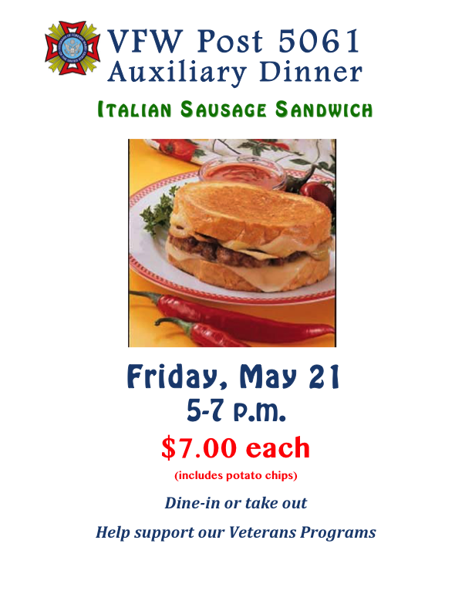­­Future Events: July 4th picnic July 16 - Karoke July 31 – Very Fine Western Shindig

