Schizophrenia
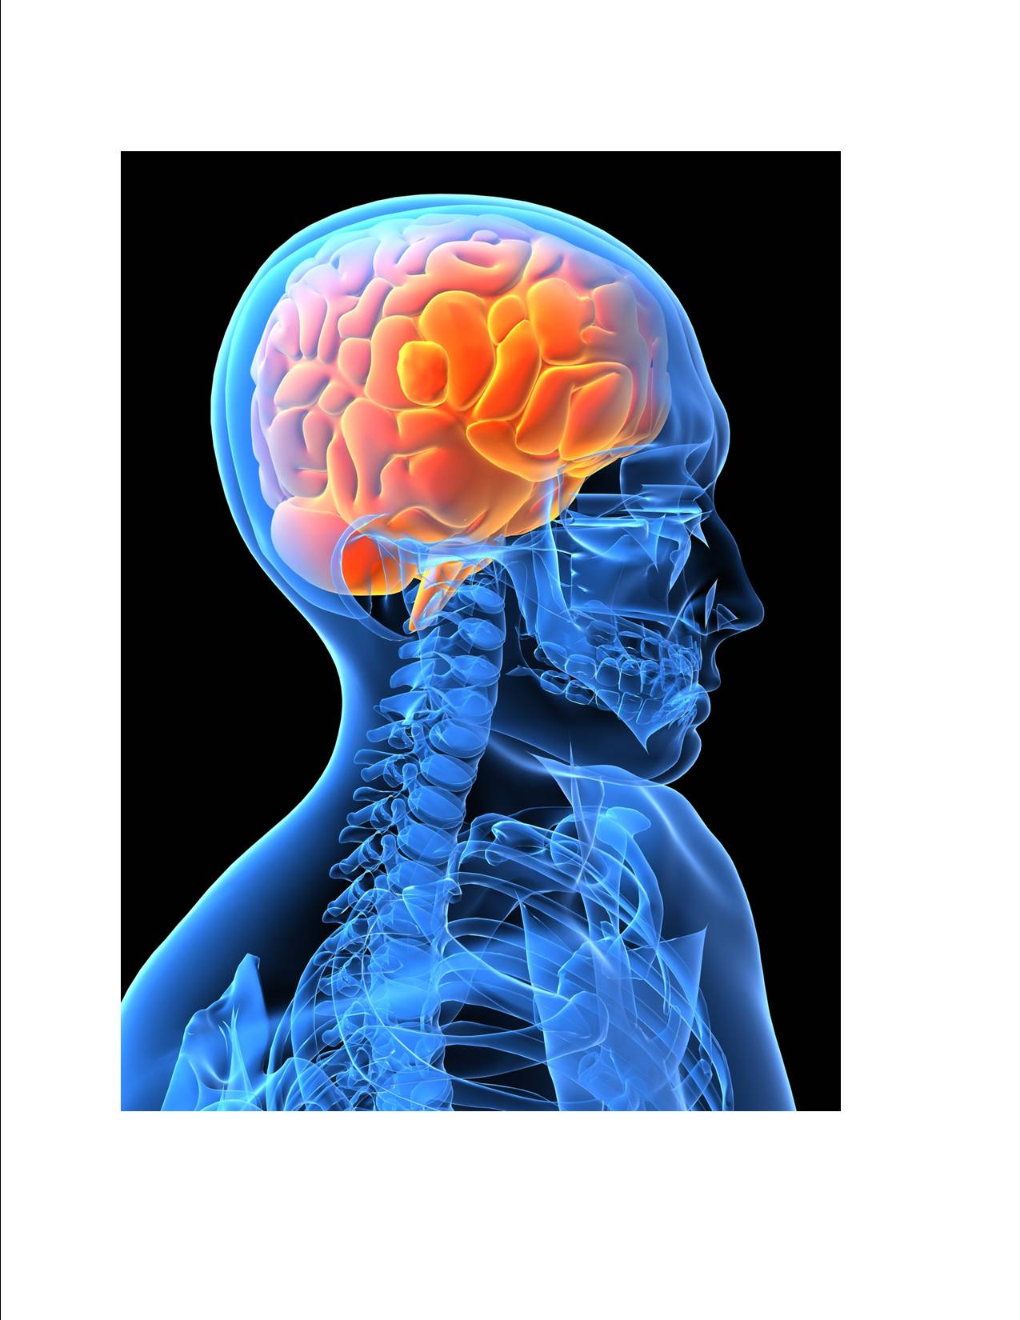
Many health care professionals divide mental illness into two basic categories:
- Mood disorders
- Schizophrenic disorders
  - The mildest form of schizophrenic disorder is schizotypal personality
disorder
  - The most severe is chronic deteriorating schizophrenia

Symptoms:
- Disordered thinking and perception
- Emotional changes such as tension and/or depression
- Behavioural disturbances ranging from catatonia (stupor) to violent outbursts
- Delusions and loss of contact with reality (withdrawn into his or her own world)
- Hallucinations are not uncommon

Causes: The underlying cause or causes remain a mystery, and can be different from one individual to another. There are many theories regarding causes, some of which include:
- a chronic stressful life event may be the trigger point
- in inherited defect in body chemistry in which brain neurotransmitters malfunction
- complications during birth
- head injury
- reaction to a virus
- accumulation of environmental toxins and/or accumulated heavy metals
- nutritional factors
  - High copper levels (which causes a depletion in zinc and vitamin C)
  - Zinc deficiency (may cause damage to the pineal area of the brain
  - Vitamin D deficiency
  - Magnesium deficiency
  - Lithium deficiency

Suggested Natural Health Options:
- Get a hair analysis done to check for:
  - Accumulated heavy metals (follow an appropriate detox program if results are undesirable)
  - Mineral deficiencies (address the specific issues that are identified)
- Diet:
  - Remove sugar and artificial sweeteners from the diet
  - Remove coffee and alcohol from the diet
  - Eat according to the Healthy Body Diet (see below)
  - Drink adequate water (1/2 oz per pound of body weight daily)
- Optimize the following nutrients:
  - Essential Fatty Acids
    - Omega 3s (Shaklee OmegaGuard)
    - Omega 6 (Shaklee GLA)
    - Lecithin
  - Zinc
  - Magnesium
  - Lithium
  - Vitamin D3
  - Iodine
  - Protein (a raw soy protein smoothie is recommended at least once per day to provide a guaranteed supply of the 9 essential amino acids daily to manufacture neurotransmitters) ... Shaklee Soy Protein
- Provide a daily smorgasbord of the following nutrients:
  - Multi-Vitamin
  - B Complex
    - Maintain bright yellow urine with daily intake of B Complex
    - Investigate B12 levels ... some require additional support
- Ensure that Bowel Frequency is functioning optimally.
  - Daily probiotics are recommended (Shaklee Optiflora)
  - Bowel Conditioners have proven beneficial for many (Shaklee Herb-Lax)
- If the blood pH is not alkaline, implement green drinks and/or Shaklee Alfalfa
- Get complete bloodwork done and have it analyzed by a Natural Health Care Professional.
- Investigate blood sugar issues
- Investigate blood circulation to the different regions of the brain. In some cases, the following nutrients have been found to be very helpful
  - optimizing Vitamin E to support better circulation
  - support blood circulation with Ginkgo Biloba
- Investigate Thyroid function
- Experiment with Ashwaganda ... an herb that increases the ALPHA waves in the brain ... it has been helpful for many.

Healthy Body Diet
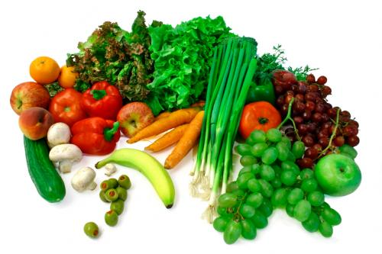
Choose Foods from this List
Fowl with skin removed
Ocean Fish
Low-fat dairy products (yogurt, cottage cheese)
All the veggies you want
Lots of fruit
Legumes - beans, lentils, peas, etc.
Whole grain products - pasta, cereal, etc.
RAW nuts & seeds
Cold-pressed vegetable oils ONLY
Always choose foods made with whole, natural ingredients whenever possible
Use stevia, honey, molasses, pure maple syrup or fructose when a sweetener is needed
Drink a minimum of 8 glasses of water per day (purified water only)

Reduce/Eliminate

Red meat…limit to once a week if eaten at all
Processed meat of any kind
Organ meats … liver, kidney, brains, and such
Skin of fowl
Fried foods
High-fat dairy products
ROASTED nuts and seeds
All heat pressed vegetable oils
Alcohol, coffee, and black tea
White flour
Heavily processed foods
Pre-salted prepared foods
Non-prescription, street drugs, or self-medications
Soft drinks/ phosphate seltzers/ mineral water
Limit salt intake

Notes:
- 51% of your diet should be RAW for health maintenance … aim for 80% if you are ill
- Provide variety in your food choices
- Eat food as close to nature as possible (unprocessed and unrefined)
- Consume ADEQUATE protein on a daily basis – 30% of the diet should be protein
- Avoid foods you are allergic to
- When you eat, divide your plate into quarters:
  - half of your plate should be vegetables
  - one quarter of your plate should be protein
  - one quarter of your plate can be starch or grain foods
(eg. sweet potatoes, brown rice, baked potato,
whole grain bread, etc.)
- The appropriate amount of calories for your weight …
  - Up to 150 lbs – 1,200 calories
  - 151 to 200 lbs – 1,500 calories
  - 201 to 250 lbs – 1,800 calories
  - 251+ lbs – 2,100 calories

Common Pharmaceuticals recommended for Schizophrenic Disorders:
- Olanzapine
- chlorpromazine (Largactil)
- haloperidol (Serenace)
- trifluoperazine (Stelazine)
- risperidone (Risperdal)

