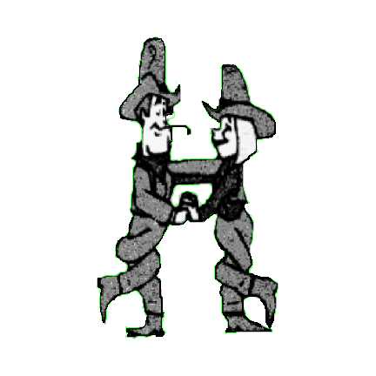COUNTRY CHOICE PARTNER DANCERS

Chris & Andy Malpass

Qualified Instructors

D&G N.T.A G.P.T.D IF YOU DIDN’T LOVE ME

Choreographed by Chris & Andy Malpass 01606 883862 email – [chrisandy-partners@hotmail.co.uk](mailto:chrisandy-partners@hotmail.co.uk)

Description 64 count partner dance, starting in Sweetheart Position, facing L.O.D. Same feet throughout

Music I Wouldn’t Want to Live, If You Didn’t Love Me by Don Williams 120 bpm. C.D. The Definitive Don Williams -

His Greatest Hits

01 – 08 BOTH - STEP, LOCK, STEP, BRUSH, STEP, LOCK, STEP, BRUSH

01 – 04 Step diagonally right on right foot, lock left behind right, step diagonally right on right foot, brush left forward

05– 08 Step diagonally left on left foot, lock right behind left, step diagonally left on left foot, brush right forward

09 – 16 GENT – ROCKING CHAIR, ROCK, RECOVER, STEP, TOUCH LADY – ROCKING CHAIR, STEP, PIVOT 1/2 TURN, STEP, TOUCH

09 – 10 Rock forward on right, recover onto left, Rock forward on right, recover onto left

11 – 12 Rock back on right, recover onto left Rock back on right, recover onto left

13 – 14 Rock forward on right, recover onto left Step forward on right, pivot 1/2 turn left

15 – 16 Step back on right, touch left next to right Step forward on right, touch left next to right

*(on count 13 take right hands over lady’s head and change to Open Double Hand Hold. Gent facing L.O.D. Lady R.L.O.D)*

17 – 24 GENT – STEP, POINT, STEP, POINT LADY – STEP, POINT, STEP, POINT

ROCK, RECOVER, STEP, TOUCH ROCK, RECOVER, PIVOT 1/2 TURN TOUCH

17 – 18 Step back on left, point right out to right side Step forward on left, point right out to right side

19 – 20 Step back on right, point left out to left side Step forward on right, point left out to left side

21 – 22 Rock back on left, recover onto right Rock forward on left, recover onto right

23 Step forward on left On right foot pivot 1/2 turn left stepping onto left *(into wrap)*

24 Touch right next to left Touch right next to left

*(on count 23 lady’s right hand goes over her head into Wrap Position. Both facing L.O.D)*

25 – 32 GENT - WALK , WALK, WALK, TOUCH LADY – WALK, WALK, WALK, TOUCH

STEP, PIVOT 1/2 TURN, STEP, KICK ROCK, RECOVER, PIVOT 1/2 TURN, KICK

25 – 28 Walk forward on right, left, right, touch left next to right Walk forward on right, left, right, touch left next to right

29 – 30 Step forward on left, pivot 1/2 turn right stepping onto right Rock forward on left, recover onto right

31 Step forward on left On right foot pivot 1/2 turn left stepping onto left

32 kick right foot forward Kick right foot forward

*(on count 30 release gent’s right, lady’s left hands. Now holding inside hands, facing R.L.O.D)*

33 – 40 BOTH – BACK, BACK, BACK, KICK, BACK, KICK, BACK, KICK

33 – 40 Walk back right, left, right, kick left forward, walk back left, kick right forward, walk back right, kick left forward

41 – 48 BOTH - ROCK, RECOVER, 1/4 TURN, TOUCH, SIDE, TOUCH, SIDE, TOUCH

41 – 44 Rock back on left, recover onto right, 1/4 turn left stepping onto left, touch right next to left. (Lady 1/4 turn right)

45 – 48 Step right side on right, touch left next to right, step left side on left, touch right next to left

*(on count 44, Open Double Hand Hold. On count 45, change left hand to left hand)*

*(on count 46, as you touch foot, slap hands with person on your right)*

*(on count 48, join right hands above left with partner). Gent is facing O.L.O.D. Lady is facing I.L.O.D)*

49 – 56 GENT - CHANGE SIDES, TOUCH, SIDE, TOUCH, SIDE, TOUCH LADY – CHANGE SIDES, TOUCH, SIDE, TOUCH, SIDE, TOUCH

49 – 52 1/2 turn left on right, left, right, touch left next to right 1/2 turn right on right, left, right, touch left next to right

53 – 54 Step left side on left, touch right next to left Step left side on left, touch right next to left

55 – 56 Step right side on right, touch left next to right Step right side on right, touch left next to right

*(on count 49, changing sides, passing left shoulders, lady turns under both hands. On count 53 release left hands.*

*(on count 54, as you touch foot, slap hands with person on your left. On count 56, join left hands above right with partner)*

*(gent is facing I.L.O.D. Lady is facing O.L.O.D)*

57 – 64 GENT – 1/4 TURN, TOUCH, STEP, PIVOT 1/2 TURN, STEP, STEP LADY – 1/4 TURN, TOUCH, ROCK, RECOVER, 1/2 TURN, STEP

57 –59 1/4 turn left on left, right, left, 1/4 turn right round the back of gent on left, right, left

60 Touch right next to left Touch right next to left

61 – 62 Step forward on right, pivot 1/2 turn left Rock forward on right, recover onto left

63 – 64 Step forward on right, left On left foot pivot 1/2 turn right stepping onto right

Step forward on left

*(on count 57, gent turns under joined hands, now right hands crossed on top, both facing R.L.O.D)*

*(on count 63, lady turns under right hands into Sweetheart Position, both facing L.O.D)*

KEEP SMILING