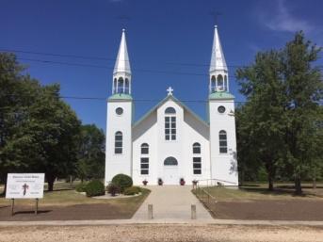
Paroisse St. Denis Parish
C.P. / Box 58
Haywood, Manitoba
R0G 0W0
Our Mission Statement:
LOVE GOD - LOVE OTHERS - TRAIN DISCIPLES

October 11, 2020

Dear Parishioners,

We wish to thank all parishioners for your extra effort in supporting your parish in these hard times. The Sunday and ordinary donations to date are very much in line with our usual collections.

Due to the ongoing pandemic of Covid-19, we have had to cancel the Spring Bazar and the Fall Concert, our two main fundraising events. Over the last four years these events have produced an average of $5,900.00 in profit for the church which happens to be almost exactly what the parish needs to pay the Taxes and Insurance.

Therefore we have organized a collection to raise funds to cover these expenses. We are appealing to our parishioners for donations which are non-taxable to the diocese, meaning that all the money donated remains in the parish, and you will receive a tax receipt at the end of the year.

Please make your donation payable to “St. Denis Parish” and mark on your envelope “Taxes and Insurance Donation” and write your envelope number on the envelope. Please include your name and address if you do not have an envelope number. Deposit your donation in the Sunday collection basket between now and the end of the year or hand it to one of the trustees or to Father Peter.

Peace and blessings in Christ,

The Trustees of St. Denis

