Free Delivery in Westmount & Southwest*
The boutique is open ONLINE !
Please visit our website, email and/or call us to order chocolates
www.culturechocolat.com

leonidasculturechocolat@gmail.com
Tel: 514 653 3050
*order over $40

LIST of PRODUCTS
Chocolate Bars: 100g - $6.99
Chocolate Bars: 50g - $3.99
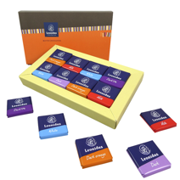
Box of 16 Napolitain Chocolates : $14.99
Leonidas Biscuit box: $9.99
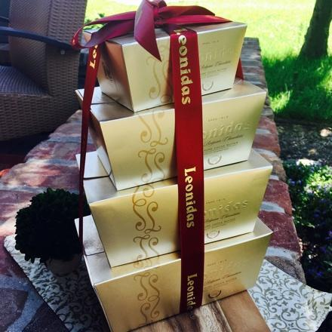
Boxes of assorted chocolates:
- 125g , 7_+ pc, $16.00
- 256g, 15_+pc, $30.00
- 375g, 22_+pc, $45.00
- 500g, 30_+pc, $55.00
- 750g, 45_+pc, $80.00
- 1000g, 60_+pc, $105.00
Square paper boxes :
-9 pc of fresh chocolates $25.00
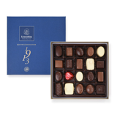
-16 pc of fresh chocolates $40.00
Square metal boxes:
      - 16 pc of fresh chocolates $45.00
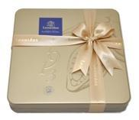
      - 25 pc of fresh chocolates $65.00
Rectangular metal boxes:
      - 8 pc of fresh chocolates $25.00
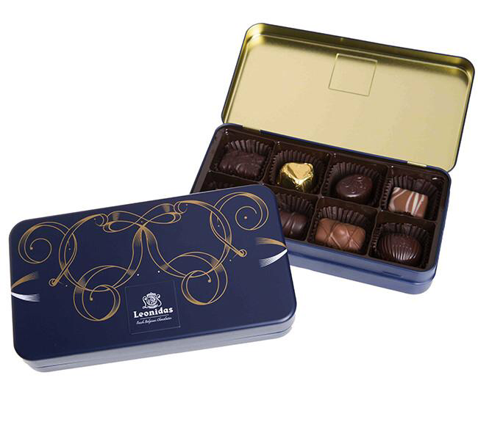
      - 20 pc of fresh chocolates $55.00
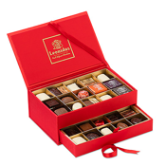
Elegant jewellery box of fresh chocolates , 30 pc. $85:00
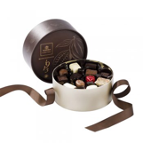
Elegant round box of fresh chocolates, 22 pc. $65.00
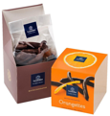
Box of orangette , 150g $22.00

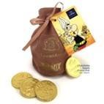
Asterix Coin Bag: 20pc, $15.00
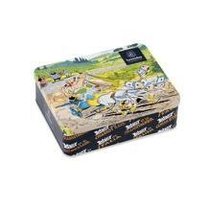
Astérix metal box: $20.00

