Water~Wise in Waukesha County
Charting the Course for Our Water Future
Co-Sponsored by the Waukesha County Environmental Action League
Nearly 150 people gathered at Carroll College in Waukesha on Saturday, March 17th, to listen, learn and network about water issues affecting Waukesha County, the southeast Wisconsin region, and the planet.
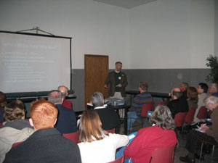
Carroll College Professor and Water-Wise Presenter, Joseph Piatt explains how pharmaceuticals get into our water and what damage they can cause.

Peter Annin, author of The Great Lakes Water Wars, and Water-Wise keynote speaker addressed a nearly full auditorium about the history and controversy surrounding regulation of the Great Lakes water use, beginning before 1885 when plans were made to divert Lake Michigan water to the growing city of Chicago. He traced diversions from and to the Great Lakes up to the signing of the Great Lakes Compact in December 2005 and then to the present: the battle of Wisconsin's legislature to adopt or avoid adoption of the Great Lakes Compact.
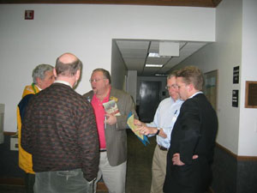

Paul Lincoln, Peter McAvoy, Waukesha Mayor Larry Nelson, Water-Wise Planner Jim Bouman and Peter Annin informally discuss the water issue.

Conserving water, improving water quality, maintaining our water supply and advocating around water issues were the four Water-Wise workshop tracks. Workshops ranged from High Efficiency Toilets to Restoring the Great Lakes. Other offerings included: Recycling Water--Gray Water Systems; Pharmaceuticals in the Water supply; Open Records-Public Meetings; The Mukwonago River; Rain Gardens and Landscaping for Storm water Management; and How to conduct a Home Water Audit.
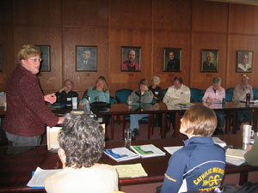

Constance Lindhom, Green Building Alliance, talks about "green," sustainable building concepts to Water-Wise attendees as past Carroll College presidents beam approvingly from the wall.

At the end of the information-packed day, many conference attendees socialized while enjoying a green beer in celebration of St. Patrick's Day. Drawings were held for a natural landscaping treatment, a wooden rain barrel and two low-flow, dual flush toilets.
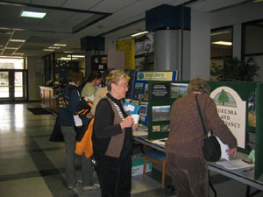
Waukesha Land Conservancy President, Ellen Gennrich (foreground) obtains another signature of support for the state Stewardship Fund which enables the purchase and protection of environmentally significant lands, including water table recharge areas..

