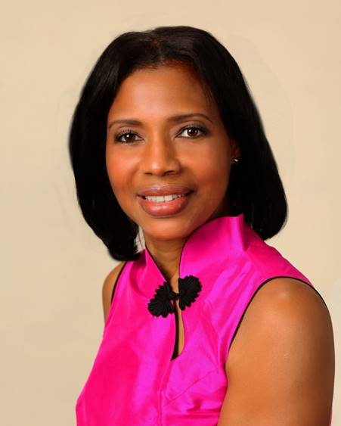
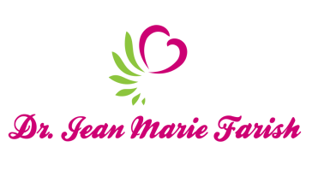

LOVE LIGHT NewsLetter

I am excited to host my VoiceAmerica Empowerment Show-LOVE LIGHT with amazing Guests to cultivate a lifestyle of love and wholehearted connections through worthiness. My show is aligned with my mission to live an altruistic and heart centered life.

MEET GUEST AUTHOR
Dr. Igor Iwanek

International Certified Yoga of Sound, Composer, Founder, SoundMind
June 5, 2020

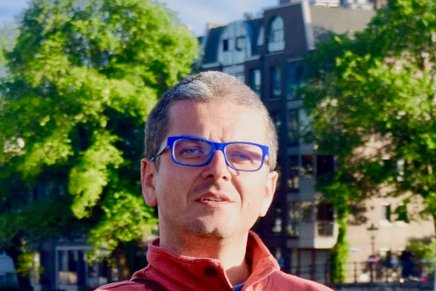

“Self-Love, Self-Care with SoundMind”

ABOUT Dr. Igor Iwanek

Dr. Igor Iwanek is a composer, left- handed pianist/keyboardist and an NPR featured sound and well-being diplomat. A versatile performer, he feels at home both in Western and Indian classical musical traditions. As an internationally certified Yoga of Sound instructor, Dr. Igor has a keen appreciation for sound-mind-body interconnectedness and deep reverence for treasures of world’s contemplative traditions.

Dr. Igor trained in Indian Raga under the amazing violinist Smt. Kala Ramnath and the legendary Gundecha Brothers. His compositions won competitions in USA, Japan and Europe. As a well-being diplomat, Dr. Igor helps people use their innate listening skills to explore the infinite wellspring of awareness and improve their quality of life.

Dr. Igor is a cerebral hemorrhage survivor who understands the frailty and uniqueness of every moment. He taught at MIT and a variety of educational institutions across the USA. His articles appeared in the Clavier Companion as well as the academic press. His motto, Be well, Live well, and Play well.

http://www.thinkartmusic.com/index.html

http://www.sound--mind.com/index.html

“An empowered self is a loving self and keep your love light shining”

