Glock Model 23
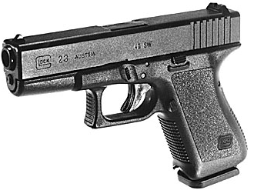
Action: | Semiautomatic
Caliber: | .40 S&W
Length: | 6.85 in.
Height including magazine: | 4.88 in.
Width: | 1.18 in.
Length between sights: | 5.98 in.
Barrel length: | 4.02 in.
Barrel profile: | Hexgonal profile w/  right hand twist
Length of twist: | 15.75 in.
Magazine capacity: | (Now)13+1 rounds
Mass (weight): | 21.16 oz. (Without magazine)
Muzzle velocity *: | ~948 fps
Muzzle energy *: | ~386 Ft. Lbs.
Trigger pull: | ~5-8 lbs.
Trigger Slack travel (taking up  tension and releasing safety): | 0.2 in.
Trigger travel to discharge: | 0.5 in.

