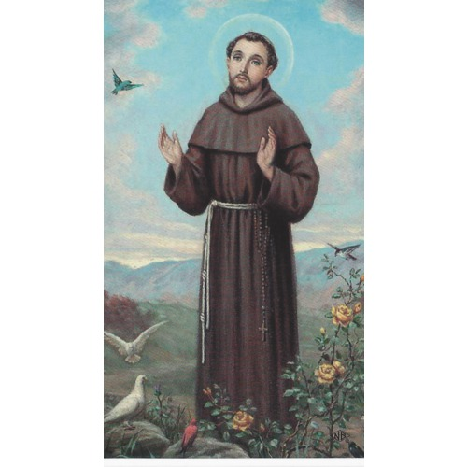
Violence
October 8, 2017
Matthew 21:33-46
Grace and peace to you from God Our Father and from the true heir of the Vineyard, Jesus Christ our Lord, amen.
It’s been almost a week since the horrendous mass murders in Las Vegas. The images of human carnage and the pure evil will never be forgotten. I confess I’ve had a very hard time getting beyond those images and sounds from the horrific shooting in Las Vegas. They’ve been on my mind and imagination relentlessly, and perhaps they have for you, too…
Violence. More specifically, random violence is more and more becoming almost a regular occurrence. The randomness of these evil actions makes them even more frightening. Not only is it becoming clear that there is no easy way to protect vulnerable crowds, but also in this Las Vegas case the authorities are unable to discover the motive, which simultaneously makes this act of horrific violence more random and harder to understand and also makes us all feel more vulnerable. Who next? What next? When, not if, will the next one occur?
The violence in Las Vegas pushed me to think about this week’s Gospel reading a little differently. It, too, is violent. The violence of the tenants, the assumed and anticipated violence of the landlord. This week’s events pushed me to focus on the answer to Jesus’ question at the end: “Now when the owner of the vineyard comes, what will he do to those tenants?” As he is referring to the tenants who beat, stoned, or killed two sets of servants who came to collect the vineyard owner’s due and then murdered outright the owner’s son and heir, the Pharisees have no difficulty in answering: “He will put those wretches to a miserable death.”
Jesus’ next words, as recorded by Matthew, seem at first glance to confirm this instinct to respond to violence with yet more violence. Jesus quotes Psalm 118:22 where the “The stone that the builders rejected has become the chief cornerstone.” In this parable Jesus exposes how those who oppose and reject him are missing God’s plan for salvation and therefore losing the kingdom. God doesn’t slam the door to His Kingdom in the face of anyone, but those who reject Jesus slam the door in their own face… Christianity today is looking more and more like the Church back in the first and second century. Historians have suggested Matthew’s community was made up of mostly Jewish converts. They had just gone through a violent time where they witnessed the destruction of the Temple in Jerusalem and they were perhaps worn down by distress and danger in the wake of all that had happened. Matthew’s community was a minority and oppressed by both the Jews and the Romans. Many in Matthew’s community were contemplating returning to the Jewish faith of their youth and so, Matthew saw the Pharisees as competitors for their loyalty.
When I keep in mind that Matthew’s community was a vulnerable religious minority of the day, I can sympathize with his plight and response. But I still regret it, because when Christianity went from minority to majority religion of the Roman Empire and grew into the most powerful political and cultural force in Europe, these same verses and others like them helped to justify centuries of mistreatment of Jews by Christians. Violence yet again, in the name of Jesus…
Images of the violence in Las Vegas and references to violence in the parable made me, at first, sad because it appears there is no other alternative as violence begets more violence. Then I looked beyond this one small passage and thought about the bigger picture and where Matthew’s story is taking us. Let’s not forget the story of Jesus leads up to one great act of violence: namely the Crucifixion of the innocent Son and heir to the Kingdom of God. Just like in the parable, only with one huge surprise. The true-life story of Jesus doesn’t end with violence begetting more violence, but rather, in the cross of Jesus, God absorbs our violence and responds with life, with resurrection, with Jesus triumphant over death and offering, not retribution, not an angry vengeful God, but peace.
In this world, sometimes it seems violence is always winning and our reaction is revenge, we call justice. Jesus’ actual deeds are quite different. He doesn’t shrink from the sacrifice on the cross. He doesn’t return with vengeance. He doesn’t kick anyone out of the kingdom of heaven. Instead, the resurrected Jesus, having taken on the worst that our violence can inflict, comes back and instructs his disciples to take the good news of the Gospel to the very ends of the earth, promising to be with them always.
For me, this week, that good news means violence does not and will not have the last word. I’m thankful the news media didn’t only focus on the carnage. I know blood and guts makes ratings, but in the midst of all the pain and suffering I also saw stories of incredible bravery and sacrifice. I saw play out on the streets of Vegas exactly what Jesus offered as the new paradigm for the Kingdom of God. Instead of an eye for an eye and a tooth for a tooth, I saw wounded people helping other wounded people. There was one story of a young man using his body as a shield to protect two women he had never met and didn’t know. He took a few bullets that would have hit them. This week I saw demonstrated that there is another way. The only response to violence is not more violence. Tragedy and death and loss and hatred are no match for love and life and forgiveness and peace.
We may never know what motivated the gunman in Las Vegas. And there’s a lot of work to do to figure out how to make people safer from all violence and terrorism. In the meantime, we have the promise that even when it looks like violence is the only outcome possible – “He will put those wretches to a miserable death.” – is not the way of Jesus. That’s all the religious authorities in the story could imagine, or maybe it was all Matthew the Evangelist could imagine. Maybe at times it’s all our leaders can imagine, and perhaps all we can imagine, too. But there is another way. While Jesus’ words, Matthew’s words, and our words all matter, Jesus’ deeds matter even more, as Jesus’ death and resurrection creates more possibilities than those we can see, including the possibility of peace.
In John’s Gospel Jesus said, “Peace I leave with you; my peace I give to you. I do not give to you as the world gives. Do not let your hearts be troubled, and do not let them be afraid.” (John 14:27)… Earlier in Matthew’s Gospel in the Sermon on the Mount He said, “Blessed are the peacemakers, for they will be called children of God.” (Mt. 5:9)… In the book of Romans Saint Paul reminds us, “Rejoice with those who rejoice, weep with those who weep. Live in harmony with one another; do not be haughty, but associate with the lowly; do not claim to be wiser than you are. Do not repay anyone evil for evil, but take thought for what is noble in the sight of all. If it is possible, so far as it depends on you, live peaceably with all.” (Rom. 12:15-18)… Finally, Jesus last words to his disciples just before He ascended back into Heaven were these, “And remember, I am with you always, to the end of the age.” (Mt. 28:20).
This does not erase our grief or lessen our call to act to make such atrocities less likely, but it does offer us hope, and hope is the birthplace of faithful action, loving compassion, and committed resolve. We certainly live in a time where there are way too many wicked tenants, but we have the opportunity to make a difference and show the world a different, better way. Instead of calling for stricter gun control maybe we can spend our time in prayer or working for better mental health accessibility for everyone. Maybe we can play a part by toning down our own rhetoric and asking our friends to do the same. I don’t know about you, but I’ve stopped listening to many of the opinion shows and I try to watch only the hard news. I’ll continue to do that until the opinion shows also tone down their rhetoric and people on all sides start to have real civilized dialog. As long as left and right are entrenched and dug in there can never be a lessening of the tension in our country.
This week marks the commemoration of Saint Francis of Assisi. Besides being known for his love of animals, he is credited with this beautiful prayer:
Lord, make me an instrument of Your peace. Where there is hatred, let me sow love; where there is injury, pardon; where there is doubt, faith; where there is despair, hope; where there is darkness, light; where there is sadness, joy. O, Divine Master, grant that I may not so much seek to be consoled as to console; to be understood as to understand; to be loved as to love; For it is in giving that we receive; it is in pardoning that we are pardoned; it is in dying that we are born again to eternal life.
Amen.

