BIBB BAPTIST ASSOCIATION

ONE- HUNDRED- TWENTIETH

ANNUAL MEETING
NOVEMBER 6-8, 2022

RANDOLPH BAPTIST CHURCH
RANDOLPH, ALABAMA

OFFICERS
2021-2022

ACTING MODERATOR Rev. David Grisham
(Pondville)

ACTING VICE MODERATOR Vacant

CLERK Mrs. Judy Elliott
(Haysop)

SECRETARY/ Mrs. Traci Lowery
TREASURER (Lowerytown)

DIRECTOR OF MISSIONS Dr. Bill Russell
(Four Points)

2022
SPRING RENEWAL MEETING

May 22-24, 2022 Bethel Baptist Church

2022
ANNUAL SESSION
November 6-8, 2022 Randolph Baptist Church

2023
SPRING RENEWAL MEETING
April 23,2023 Mt. Carmel Baptist Church

Table of Contents
ASSOCIATION OFFICERS 2020-2021………………………………………………………………………………….....1
TABLE OF CONTENTS………………………………………………………………………………………………….....2
ASSOCIATIONAL STAFF 2020-2021……………………………………………………………………………………..3
GENERAL OFFICERS 2020-2021………………………………………………………………………………….............3
ORGANIZATIONAL OFFICERS…………………………………………………………………………….………….3-5
STANDING TEAMS………………………………………………………………………………………….………….....5
ASSOCIATIONAL EXECUTIVE BOARD MEMBERS………………………………………………………….……..6-9
CHURCH PERSONNEL DIRECTORY………………………………………………………………………………....10-14
DEACON CHAIRMAN……………………………………………………………………………………………............15
CHURCH TREASURER………………………………………………………………………………………………..16-17
CHURCH CLERKS………………………………………………………………………………………………………..18
CHURCH MUSICIANS…………………………………………………………………………………….…………..19-20
SUNDAY SCHOOL DIRECTORS………………………………………………………………………….………….....21

REPORTED DISCIPLESHIP TRAINING DIRECTORS…………………………………………………………………22
MEN’S MINISTRIES DIRECTOR (BROTHERHOOD)……………………………………………………………........23
WMU DIRECTORS…………………………………………………………………………………………………….....24
REPORTED VBS DIRECTORS……………………………………………………………………………………..........25

ASSOCIATIONAL MESSENGERS……………………………………………………………………………………26-27

MEMORIAL ROLL…………………………………………………………………….………………………………….28

STATISTICAL TABLES……………………………………………………………………………………… ………29-.31
BIBB BAPTIST ASSOCIATION REVIEW……………………………………………………………………………32-40

CONSTITUTION OF THE BIBB BAPTIST ASSOCIATION……………………………………………………………………………….......41 - 46
MAP………………………………………………………………………………………………………………………...47

ASSOCIATIONAL DIRECTORY

Bibb Baptist Association
Highway 82
P.O. Box 158
Centreville, Alabama 35042
Phone: 205/926-7866

e-mail: assocbibb@gmail.com
website : www.bibbbaptist.com

ASSOCIATIONAL STAFF
2020-2021

DIRECTOR OF MISSIONS Dr. Bill Russell; 51 Commons Drive
Centreville AL 35042 (C-256/738-2791)

SECRETARY/TREASURER Mrs. Traci Lowery; 3925 Riverbend Rd
West Blocton AL 35184 (205/475-5510)

GENERAL OFFICERS

ACTING MODERATOR Bro. David Grisham; 2018 Kerry Circle
Calera, AL. 35040 (205/612-6149)

ACTING VICE MODERATOR/
PARLIAMENTARIAN

CLERK Vacant

ORGANIZATIONAL OFFICERS

VBS DIRECTOR Vacant

SUNDAY SCHOOL Vacant

WOMAN’S MISSIONARY UNION

DIRECTOR Mrs. Caren Jones
West Blocton, AL 35184 (205/718-0724)
Email: cpjones145@gmail.com

TREASURER/SECRETARY Vacant

WOMEN’S MINISTRY & Mrs. Cheryl Rice; 260 Bibbville Rd
WMU MISSION SUPPORT LEADER Woodstock, AL 35188 (205/218-6946)

WMU PRAYER LEADER Mrs. Mavis Boykin; Apt. 602
West Blocton, AL 35184 (205/938-3427)
GIRL’S IN ACTION Vacant

ROYAL AMBASSADORS Vacant

MEN’S MINISTRIES Vacant

DISASTER RELIEF COORINATOR Bro. Danny Russell; 298 Tabernacle Rd
Brent AL 35034 (205/799-5787)

MUSIC DIRECTOR Vacant

PIANIST Vacant

EVANGELISM Bro. David Grisham; 2018 Kerry Circle
Calera AL 35456 (205/612-6149)
Ms. Mavis Boykin; Apt. 602
West Blocton AL 35184 (205/9383427)
Support: Bro. Bill Rowe; 17880 Alecia Drive
Vance AL 35490 (205/266-8061)

SENIOR ADULT DIRECTOR Vacant

CHRISTIAN LIFE MINISTRY Vacant

HISTORIAN Vacant

STATE BOARD OF MISSIONS Vacant

BUILDING & GROUNDS Bro. Jim McSpadden; 5119 River Bend Rd
West Blocton, AL 35184 205/938-2191
Bro. Greg Findley; 206 Thrasher Ln
West Blocton AL 35184 (205/966-3556)
Bro. Clay Williamson; 350 Forest Circle
Centreville, AL 35042 (205/299-2058)
Bro. Bill Russell; 51 Commons Drive
Centreville AL (256) 738-2791
Mr. Jim Rice; 260 Bibbville Rd
Woodstock AL 35188 (205/938-1815)
Mr. Glen Blake; 155 Bearden Ridge Circle
Woodstock AL 35188 (205/938-0972)

EQUIPMENT Mr. Gerald McMillan; 112 Orchard Ln
Centreville AL 35042 (205/926-5451)

STANDING TEAMS

NOMINATING TEAM Rev, K.C. Jackson
Deatsville, AL 36022 (334/799-0025)
Bro. Bill Russell
Centreville, AL 351042 (256/738-2791)

STEWARDSHIP TEAM Mr. Ed Perry; 194 Perry Ln,
West Blocton AL 35184 (205/938-2258)
Mr. Danny Russell; 298 Tabernacle Rd.
Brent AL 35034 (205/799-5787)
Mrs. Traci Lowery, Bro. Bill Russell

TIME, PLACE, PREACHER Vacant

TRUSTEES Mr. Ed Lightsey; Centreville AL 35042
(205/926-6214)
Mr. Greg Findley; 206 Thrasher Lane
West Blocton, AL 35184 (205/966-3556)
Mr. Danny Russell; 298 Tabernacle Rd.
Brent, AL 35034 (205799-5787)

Bibb Baptist Association

ASSOCIATIONAL EXECUTIVE BOARD

ANTIOCH
Rev. Aaron Graff
15835 Bobby Loan Rd.
Duncanville, AL 35456
Phone: 205/579-2877
Email: aegraff1@gmail.com

ASHBY
Rev. Shannon Allen
1748 Main Street
Brent AL 35034
Phone: 205/926-7675
205/361-1925
Email: shannonallen@bellsouth.net

BETHEL
Rev. Scott Peters
11707 Belle Meade Circle
Northport AL 35475
Phone: 205/410-1215
scottlloydpeters@gmail.com
Mr. Danny Russell
298 Tabernacle Rd
Brent AL 35034
Phone: 205/799-5787
Email: russellcatering@bellsouth.net

BETHLEHEM
Interim: Don Harper
Mr. Robert Poe
26265 Hwy 219
Centreville, AL 35042
Phone: 205/926-7130
Email: robertvpoe@aol.com

BIBBVILLE
Rev. Justin Maharrey
22185 Green Pine Dr.
West Blocton, Al 35184
Phone: 205/475-5122
Email: JustinMaharrey@gmail.com

BLOCTON THIRD
Rev. Robert Smith
2212 Bishop Ridge
West Blocton AL 35184
Phone: 205/938-7301
205/790-1798
Email: msbamoulton@bellsouth.net

BRAEHEAD Lucile
Mr. Edward Perry
194 Perry Lane
West Blocton AL 35184
Phone: 205/938-2258
Email: perryed@bellsouth.net

BRENT
Pastor open
Mr. Joe Fowler
207 Hickory Hill Rd
Centreville AL 35042
Phone: 205/340-0222
Email: brentbc@bellsouth.net
Bonnie LeVert
6799 Lightsey Rd.
Centreville, AL 35042
Phone: 205/926-6654

CAHABA VALLEY
Rev. Doug Wilder
5702 Clearbrook Dr
Northport AL 35473
Phone: 205/826-1896

CALVARY
Rev. Mike Allen
226 Alecia Dr
Woodstock AL 35188
Phone: 205/938-1420
Cell: 205/288-5781

CAMP BRANCH
Rev. Jody Hogeland
Phone: 205-821-1311
campbranchbc@gmail.com

CENTREVILLE
Rev. Ken Fuller
PO Box 326
Centreville AL 35042
Phone: 205/926-7069

COMMUNITY
Rev. Eddie Pearce
P.O. Box 95
Brierfield, AL 35035
Phone: 662-516-2960
Email: pearceeddie257@gmail.com
Mr. Gary Smitherman
264 Splawn Dr.
Centreville, AL 35042
Phone: 205/926-6889
Email: jandgpraises@bellsouth.net

EOLINE
Rev. Jeremy Moore
294 County Rd 128
Calera, AL 35040
Phone: 205/500-0702

FBC WOODSTOCK
Rev. Steven Hicks
248 Bearden Ridge Circle
Woodstock AL 35188
Phone: 205/908-6875
Email: stevenehicks6@gmail.com

FOUR POINTS
Pastor: Rev. Taylor Gurley
7511 Hwy 5
Brent, AL 35034
Phone: 256-589-1138
Email: tgurley423@gmail.com
Mr. Paul Creel
107 Commons Drive
Centreville AL 35042
Phone: 205/340-4333

HAYSOP
Rev. Phillip Bonner
Phone: 205/926-4491
Prbonner72@gmail.com
Mr & Mrs. Freeman Elliott
158 Forest Circle
2691 B-ham Rd
Centreville AL 35042
Phone: 205/340-3180

JOHNTOWN
Rev. Timothy Eads
4412 Carroll St
Northport AL 35475
Phone: 205/344-2855
Email: timothyeads50@gmail.com
Mrs. Joyce Morse
14713 N Scottsville Rd
West Blocton AL 35184
Phone: 205/938-7556

LOWERYTOWN
Rev. Roy N. Lowery
3925 River Bend Rd
West Blocton, AL 35184
Phone: 205/260-7124
205/938-3131
Email: loweryrnl@gmail.com

MARVEL
Rev. Stan Dawson
260 Nashua St
Montevallo AL 35115
Phone: 205/665-7218

MT. CARMEL
Rev. K.C. Jackson
251 Old Orchard Rd
Deatsville AL 36022-3187
Phone: 334/799-0025
Email: sonseeker75@aol.com

MT. MORIAH
Pastor: Open

MT. ZION
Rev. Bobby Odell
3694 Bear Creek Rd.
Centreville AL 35042
Phone: 205/361-5348

NEW HEBRON
Rev. Chuck Allen
805 Evergreen Dr
West Blocton, AL 35184
Phone: 205/202-0501
Email: chuck@chuckallen.us

NEW LIFE
Rev. Ken Blake
2690 Bishop Ridge
West Blocton, Al 35184
205-541-7072
Email: ken4givenns@gmail.com

OLD UNION
Bro. Butch Carl Doss
1077 Garnet Dr.
Calera, AL. 35040
Phone: 205/576-6393
Email: Lesterdoss333@gmail.com

PINEVIEW
Rev. Mark Lovett
345 Hunter Run
Centreville AL 35042
Phone: 205/420-8852
205/926-1991
Email: pineviewbaptist@yahoo.com

PONDVILLE
Rev. David Grisham
2018 Kelly Circle
Calera AL 35040
Phone: 205/612-6149
Email: davidgrisham@aol.com
Mrs. Sandra Grisham
2018 Kelly Circle
Calera AL 35040
Phone: 205/612-6149

RANDOLPH
Rev. Tony Reynolds
8590 County Rd 307
Lawley AL 36793-4130
Phone: 334/407-5099
Email: tr61403@aol.com

REHOBETH
Pastor open

SCHULTZ CREEK
Interim: Rev. Mike Bell
361 Pike Rd
Woodstock, AL 35188
Phone: 205-317-3051
Henrymbell267@gmail.com
Jimmy McSpadden
5119 River Bend Rd
West Blocton AL 3518
Phone: 205/938-2191

SHADY GROVE
Interim: Rev. Jim Headley
7207 Crabapple Circle
Tuscaloosa, AL 35405
Phone: 205-792-1955

SHADY GROVE II
Rev. Eddie Walker
2020 Grey Hill Rd
West Blocton, AL 35184
Phone: 205/834-2557

SIX MILE
Rev. Ben Dailey
101 Birdsong Lane
Montevallo, AL 35115
Phone: 205-572-1057
Email: daileybd@gmail.com
Mr. Clay Williamson
350 Forest Circle
Centreville, AL 35042
Phone: 205/299-2058

SMITH HILL
Rev. Tom Conroy
59 Oak Trace Rd
West Blocton, Al 35184
205-242-0172
Email: trconroy2006@gamil.com

THOMAS MILL
Rev. Mike Rice
50 Gabrielle Dr.
Woodstock, AL 35188
Phone: 205-960-1644
Email: bmikerice@gmail.com
Mr. Marlon Leach
Walnut Street
Centreville, AL 35042
Phone: 205-926-4939

West Blocton FBC

Rev. Kyle Hodges
17500 Spencers Cove Rd.
Northport, AL 35475
Phone: 205/737-5052
hodgeskj17@gmail.com

EXECUTIVE COMMITTEE MEMBERS

In the Constitution of the Bibb Baptist Association it states that Executive Committee members consist of; the pastor (or associate pastor) from each member church, associational officers, heads of auxiliaries (such as WMU) of the association and one lay representative from each member church in the association. The lay representative shall be elected by each member church before the meeting of the association each year and reported on the church letter to the association. In the event a church is without a pastor, then the chairman of deacons shall be eligible to fill the pastor’s vacancy on the Executive Committee until the church calls their new pastor. In the event there is a vacancy in either the pastor’s or lay representative’s position, the member must provide a letter to the associational office stating the name, address and telephone number of the person designated to fill the vacancy.

CHURCH PERSONNEL

ANTIOCH
Mailing & Street Address:
185 Church Lane
Centreville AL 35042
Phone:
Pastor
Rev.Aaron Graff
15835 Bobby Loan Rd.
Duncanville, AL 35456
Phone: 205/579-2877
Email: aegraff#1@gmail.com

ASHBY
Mailing Address:
PO Box 22
Brierfield AL 35035
Street Address:
35 Brickyard Pass
Hwy 139
Brierfield AL 35035
Phone: 205/665-1111
Email: shannonallen@bellsouth.net
Pastor
Rev. Shannon Allen
1748 Main Street
Brent AL 35034
Phone: 205/926-7675
Cell: 205/361-1925

BETHEL
Mailing Address:
PO Box 301
Brent AL 35034
Street Address:
5076 Hwy 5
Brent AL 35034
Phone: 205/926-7284
Pastor
Rev. Scott Peters
11707 Belle Meade Circle
Northport AL 35475
Phone: 205/410-1215
Music Leader
Mr. Danny Russell
298 Tabernacle Rd
Brent AL 35034
Phone: 205/799-5787

BETHLEHEM
Mailing Address:
26265 Hwy 219
Centreville AL 35042
Street Address:
Hwy 219
Centreville AL 35042
Phone: 205/926-7130
Email:robertvpoe@aol.com
Pastor
Open
Music Leader
Mr. Robert Poe
26265 Hwy 219
Centreville AL 35042
Phone: 205/926-7130
Church Secretary
Mrs. Teresa Domec
331 McMillan St.
Brent, Al 35034-3728
Phone: 205/928-2480

BIBBVILLE
Mailing & Street Address:
1565 Bibbville Rd
PO Box 315
Woodstock AL 35188
Phone: 205/383-5531
Pastor
Rev. Justin Maharrey
Phone: 205/475-5122
Email: JustinMaharrey@gmail.com

BLOCTON THIRD
Mailing & Street Address:
85 Church Hill Loop
West Blocton AL 35184
Phone: 205/790-1798
Pastor
Rev. Robert Smith
2212 Bishop Ridge
West Blocton, AL 35184
Phone: 205/938-7301
Cell: 205/790-1798
Email: msbamoulton@bellsouth.net
Music Leader
Mr. Erek Goggins
430 Primitive Ridge
West Blocton AL 35184
Cell: 205/910-3390

BRAEHEAD Lucile
Mailing Address:
4525 Lucile Rd
West Blocton, AL 35084
Phone: 205/516-5134
Music Leader
Mr. Edward Perry
194 Perry Lane
West Blocton, AL 35184
Phone: 205/938-2258

BRENT
Mailing Address:
PO Box 246
Brent AL 35034
Street Address:
2446 Main St
Brent AL 35034
Phone: 205/926-7687
Fax: 205/926-7670
Email: brentbc@bellsouth.net
Pastor: Open
Music Leader
Mr. Dennis Stripling
323 Tabernacle Rd
Brent AL 35034
205/926-7537
Family Pastor:
Eddy McBroom
932 McAllister Dr.
Calera, Al 35040
Phone: 423/619-5525
Email: eddymcbroom@gmail.com
Minister of Youth & Children
Bro. Mike Royer
57 Murphy St.
Centreville, AL 35042
Phone: 205/926-7687
Church Treasurer
Bill Faucette
50 Wilson St.
Brent, AL 35034
Phone: 205/926-4925
Senior Adult Leader
Mrs. Barbara Morrison
PO Box 91
Brent AL 35034
Phone: 205/926-1602
Single Adult Leader
Mrs. Nancy Foster
29 Commons Drive
Centreville, AL 35042
Phone: 205/926-7687

CAHABA VALLEY
Mailing Address:
560 Bulldog Bend Rd
Brierfield AL 35035
Street Address:
1245 Little River Ln
Brierfield AL 35035
Phone: 205/926-7447
Pastor
Rev. Doug Wilder
5702 Clearbrook Dr
Northport AL 35473
Phone: 205/826-1896
DKwilder316@aol.com

CALVARY
Mailing Address:
PO Box 152
Centreville AL 35042
Street Address:
133 Oakley Ave
Centreville AL 35042
Phone: 205/926-4079
Pastor
Rev. Mike Allen
226 Alecia Drive.
Woodstock AL 35188
Phone: 205/938-1420
Cell: 205/288-5781
Ministers of Children
Ms. Adrian Smith
44 Jan Ave.
Centreville, AL 35042
Phone: 205/
Ms. Brittany Smith
44 Jan Avenue
Centreville AL 35042
Phone: 205/340-4127
Church Secretary
Mrs. Denise Smith
230 Splawn Dr
Centreville AL 35042
Phone: 205/340-4621
Email: Jajodee@aol.com

CAMP BRANCH
Street Address:
2590 Camp Branch Rd
West Blocton AL 35184
Phone: 205/938-9888
Pastor
Rev. Jody Hogeland
2590 Camp Branch Rd
West Blocton, AL 35184
Phone: 205-821-1311
Email: campbranchbc@gmail.com

CENTREVILLE
Mailing Address:
PO Box 326
Centreville AL 35042
Street Address:
138 Court Sq E
Centreville AL 35042
Phone: 205/926-7069
Email: centrevillebc@bellsouth.net
Fax: 205/926-1814
Pastor
Rev. Kenneth Fuller
PO Box 326
Centreville AL 35042
Phone: 205/926-7069
205/926-0139
Email: centrevillebc@bellsouth.net
Music Leader
Mr. Craig Cargile
138 Court Square E
Centreville AL 35042
Phone: 205/926-7069
Minister of Youth
Mr. T.J. Phelps
P.O. Box 698
Centreville, AL 35042
Phone: 205/926-7069
205/789-5698
Email: tjphelps74@gmail.com
Minister of Children
Mrs. Leah Downs
PO Box 693
Centreville AL 35042
Phone: 205/928-2428
Church Secretary
Mrs. Susan Wilkerson
3914 Pisgah Church Rd
Selma, AL 36701
Phone: 205/926-7069

COMMUNITY
Mailing & Street Address:
147 Abbey Lane
Brierfield AL 35035
Phone: 205/926-6889
Pastor
Rev, Eddie Pearce
P.O. Box 95
Brierfield, AL 35035
Phone: 662-516-2960
Email: pearceeddie257@gmail.com

EOLINE
Mailing & Street Address:
6550 Hwy 82
Centreville AL 35042
Phone:
Pastor
Rev. Jeremy Moore
294 County Rd. 128
Calera, AL 35040
Phone: 205/500-0702
Church Secretary
Mr. Randal E Moses
155 Mooney Creek Ln
Centreville AL 35042
Phone: 205/926-4374

FBC WOODSTOCK
Mailing & Street Address:
2473 Coldwater Rd
Woodstock AL 35188
Phone: 205/938-7479
Email: office@fbcwoodstock.org
Pastor
Rev. Steven Hicks
248 Bearden Ridge Circle
Woodstock AL 35188
Phone: 205/908-6875
Email: stevenehicks6@gmail.com
Associate Pastor
Rev. Greg Findley
206 Thrasher Ln
West Blocton, AL 35184
Phone: 205/966-3556
Music Leader
Mr. Arley Lemley
PO Box 218
Greepond AL 35074
Phone: 205/938-0591
Youth Minister
Matthew Allen
326 2nd Ave. N.
Centreville, Al 35042
Phone: 205-928-4223
Email: amatthew50@aol.com
Children’s Minster
Ms. Amy Rooker
323 Woodstock Estates
Woodstock, AL 35188
Phone: 205/938-1986
Preschool Minister
Mrs. Mary Boles
313 Pinehurst Dr.
Woodstock, AL 35188
Phone:
Ministry Assistant
Mrs. Joan Sellers
287 Worthington Drive
Woodstock AL 35188
Phone: 747/938-7479

FOUR POINTS
Mailing & Street Address:
Maple St
PO Box 637
Centreville AL 35042
Phone: 205/926-7775
Email: 4pointsbaptistchurch@gmail.com
Pastor: Rev. Taylor Gurley
Phone: 256-589-1138
Email: tgurley423@gmail.com
Associate Pastor
Mr. Kason Kyzer
Centreville AL 35042
Phone: 205/926-7775
Music Leader
Mr. Jamie Hiott
14 Dailey Ave
Centreville AL 35042
Phone: 205/349-9689
Senior Adult Coordinator
Mrs. Tammy Foley
P.O. Box 637
Centreville, AL 35042
Phone: 205/340-0044
Student/College Leader
Mrs. Denise Gunter
7780 Hwy 82
Brent, AL 35034
Phone: 205/926-7805
Preschool/Children’s Leader
Mrs. Emily Fondren
2973 County Rd. 52
Moundville, AL 35474
Phone: 205/371-2806

HAYSOP
Street Address:
2420 Haysop Church Rd.
Centreville AL 35042-5604
Mailing Address:
2329 Hwy 82
Centreville AL 35042
Phone: 205/926-9388
Pastor
Rev. Phillip Bonner
2691 B-ham Rd
Centreville, AL 35042
Phone: 205/809-2035
Prbonner72@gmail.com
Music Leader
Mrs. Anne Murphy
3525 Hwy 82
Centreville AL 35042
Phone: 205/926-7511
Church Secretary
Mr. Bill Murphy
125 Wreckless Rd
Centreville AL 35042
Phone: 205/288-1846

JOHNTOWN
Mailing & Street Address:
5201 Vance Rd
West Blocton AL 35184
Phone: 205/938-7556
Pastor
Rev. Timothy Eads
4412 Carroll St
Northport AL 35475
Phone: 205/344-2855
Email: tomothyeads50@gmail.com
Music Leader
Mrs. Joyce Morse
14713 N Scottsville Rd
West Blocton AL 35184
Phone: 205/938-7556
Cell: 205/242-3710

LOWERYTOWN
Mailing & Street Address:
49 Lowerytown Rd
West Blocton AL 35184
Phone: 205/938-2436
Email: lowerytown316@gmail.com
Pastor
Rev. Roy N. Lowery
3925 River Bend Rd
West Blocton AL 35184
Phone: 205/938-3131
205/260-7124
Email: loweryrnl@gmail.com
Music Leader
Mrs. Cami Hammond
2887 River Bend Rd
West Blocton, AL 35184
Phone: 205/999-3625
Preschool/Children’s leader
Mrs. Heidi Chuc
3300 Vance Rd
West Blocton, AL 35184
205/721-4228
Church Secretary
Ms. Jamie L Bruner
721 Vernontown Rd
West Blocton AL 35184
Phone: 205/240-7350
3bruners@gmail.com

MARVEL
Mailing & Street Address:
3082 Eddings Town Rd
Brierfield AL 35035
Phone: 205/665-7218
Pastor Rev. Stan Dawson
260 Nashua St
Montevallo AL 35115
Phone: 205/665-7218
Music Leader
Mr. Bill Allenbaugh
3040 Marvel Rd
Brierfield, AL 35035
Phone:

MT. CARMEL
Mailing Address:
PO Box 355
West Blocton AL 35184
Phone: 205/938-1331
Street Address:
5860 Truman Aldrich Pkwy
West Blocton AL 35184
Pastor
Rev. K.C. Jackson
251 Old Orchard Rd.
Deatsville AL 36022-3187
Phone: 334/799-0025
Email: sonseeker75@aol.com
Music Leader
Rev K.C. Jackson
251 Old Orchard Rd.
Deatsville AL 36022-3187
Phone: 334/799-0025
Youth Leader
Mr. Buddy Holder
204 Terry Ln
West Blocton AL 35184
Phone:
Children’s Leader
Mrs. Joan Jennings
PO Box 355
West Blocton AL 35184
Phone: 205/938-1331

MT. MORIAH.
Street Address:
12495 Mt. Moriah Rd
West Blocton AL 35184
Mailing Address:
19 Little Italy Dr
West Blocton AL 35184
Pastor: Open

MT. ZION
Mailing Address:
PO Box 586
Centreville AL 35042
Street Address:
236 Mt. Zion Church Rd
Centreville AL 35042
Email: dhuey53@yahoo.com
Pastor
Rev. Bobby Odell
3694 Bear Creek Rd
Brent AL 35034
Phone: 205/361-5348
Email: brentbobby@aol.com

NEW HEBRON
Street Address:
5946 Griffintown Rd
West Blocton AL 35184
Mailing Address:
PO Box 782
West Blocton AL 35184
Phone:
Pastor
Rev. Chuck Allen
805 Evergreen Dr
West Blocton, AL 35184
Phone: 205/202-0501
Email: chuck@chuckallen.us

NEW LIFE
Street Address:
694 Dry Hollow Rd E.
Centreville, AL 35042
Pastor
Rev. Ken Blake
2690 Bishop Ridge
West Blocton, Al 35184
Phone: 205-541-7072
Email: ken4givens@gmail.com

OLD UNION
Mailing Address:
1094 Oakley Station Rd
Randolph AL 36792
Phone: 205/665-3573
Pastor
Bro. Butch Carl Doss
1077 Garnet Dr.
Calera, AL 35040
Phone: 205/576-6393
Email: lesterdoss333@gmail.com

PINEVIEW
Mailing & Street Address:
10291 Hwy 5
Brent AL 35034
Phone: 205/926-1991
Email: pineviewbaptist@yahoo.com
Pastor
Rev. Mark Lovett
345 Hunter Run Rd
Centreville AL 35042
Phone: C-205/420-8852
205/926-1991
Interim Music Leader
Mr. Luke Daniel
1414 Antioch Rd.
Centreville AL 35042
Phone: 205/928-1326
Youth Minister
Mr. Matthew Thomas
622 Mychael Lane
Centreville, AL 35042
Phone: 205/928-2542
Children’s Minister
Mrs. Julia Allen
Church Secretary
Mrs. Mary Kinard
59 Ridgeville Lane
Brent AL 35034
Phone: 205/394-7822

PONDVILLE
Mailing & Street Address:
56 Kinard Drive
Brent AL 35034
Phone: 205/926-4368
Pastor
Rev. David Grisham
2018 Kerry Circle
Calera AL 35040
Phone: 205/612-6149
davidgrisham@aol.com
Minister of Music
Mrs. Martha LeCroy
2489 Payne Lake Rd
Brent AL 35034
Phone: 205/393-5924
Minister of Children
Mrs. Martha LeCroy
2489 Payne Lake Rd.
Brent, AL 35034
Phone 205/393-5924

RANDOLPH
Mailing Address:
PO Box 275
Randolph AL 36792
Phone: 334/366-4296
Street Address:
7156 Hwy 36
Randolph AL 36792
Pastor
Rev. Tony Reynolds
8590 County Rd 307
Lawley AL 36793-4130
Phone: 334/407-5099
Email: TR61403@aol.com
Music Leader
Mrs. Hollie Tillery
7693 Hwy 36
Randolph AL 39792
Phone: 205/361-3811

REHOBETH
Mailing Address:
3068 Hwy 36
Randolph AL 36792
Street Address:
11262 Deer Creek Rd
Lawley AL 36793
Phone: 334/518-9899
Pastor
Rev. Kirk Smith
751 Co. Rd. 303
Lawley AL 36793
Phone: 334/518-9899
Email: georgekirksmith@gmail.com
Music Leader
Mr. Stewart Creel
2748 Active Rd
Lawley AL 36793
Phone: 334/366-2907

SCHULTZ CREEK
Mailing Address:
PO Box 706
Centreville AL 35042
Street Address:
Schultz Springs Rd
West Blocton AL 35184
Phone:
Interim: Rev. Mike Bell
361 Pike Rd
Woodstock, Al 35188
Phone: 2059317-3051
Email: henrymbell267@gmail.com

SHADY GROVE
Mailing & Street Address:
113 Shady Grove Loop
Hwy 139
Randolph AL 36792
Email: christ617@bellsouth.net
Pastor: Open
Interim: Jim Headley
7207 Crabapple cir
Tuscaloosa, Al 35405
Phone: 205/792-1955
Music Leader
Mr. Don Lawrence
11097 Hwy 139
Randolph AL 36792
Phone: 205/965-3121
Church Secretary
Mrs. JoAnn Smith
6155 Hwy 36
Randolph AL 36792
Phone: 334/366-4509

SHADY GROVE II
Mailing & Street Address:
7247 Grey Hill Rd
West Blocton AL 35184
Phone: 205/938-0120
Pastor
Rev. Eddie Walker
2020 Grey Hill Rd
West Blocton AL 35184
Phone: 205/938-0639
Cell: 205/834-2557

SIX MILE
Mailing & Street Address
182 W Ashby Rd
Brierfield AL 35035
Phone: 205/926-7139
Pastor
Ben Dailey
101 Birdsong Ln.
Montevallo, Al 25115
Phone: 205/665-2845
Email: daileybd@att.net
Music Leader:
Daniel Parsons
9467 Montevallo Rd.
Centreville, AL 35042
Phone: 205/928-0271

SMITH HILL
Mailing Address:
PO Box 383
West Blocton AL 35184
Street Address:
Little Italy Rd
West Blocton AL 35184
Phone: 205/938-3927
Pastor
Rev. Tom Conroy
59 Oak Trace
West Blocton, AL 35184
Phone: 205/242-0172
Tconroy2006@gmail.com

THOMAS MILL
Mailing Address:
2831 County Rd 41
Clanton AL 35046
Street Address:
4611 Thomas Mill Church Rd
Brierfield AL 35035
Phone: 205/926-6882
Pastor:
Rev. Mike Rice
50 Gabrielle Dr.
Woodstock, AL 35188
Phone: 205-960-1644
Email: bmikerice@gmail.com
Secretary
Teresa McMillan
Email:
confederate.dawn@gmail.com
Music Leader
Mr. Marlon Leach
Walnut St
Centreville AL 35042
Phone: 205/926-4939

WEST BLOCTON FIRST
Mailing & Street Address:
1249 Main St
West Blocton AL 35184
Phone: 205/938-7392
Pastor
Rev. Kyle Hodges
17500 Spencers Cove Rd.
Northport, AL 35475
Phone: 205/737-5052
Email: Hodgeskj17@gmail.com

REPORTED DEACON CHAIRMAN

BETHEL
Mr. Danny Russell
298 Tabernacle Rd
Brent AL 35034
Phone: 205/926-9783
205/926-4858

BETHLEHEM
Mr. Joe Mann
Rt 3 Box 160
Centreville AL 35042
Phone: 205/926-5074

BRENT
Dr. John Meigs Jr
Brent AL 35034
Phone: 205/926-7687

CALVARY
Mr. Sammy Holdsambeck
50 Hailey Dr.
Centreville AL 35042
Phone: 205/926-5127

CENTREVILLE
Mr. Terry Morton
534 Taber Mill Rd.
West Blocton, AL 35184
Phone: 205-316-8848

FBC Woodstock
Brad Rooker

FOUR POINTS
Mr. Jamie Hiott
255 Hickory Hill Circle
Centreville AL 35042
Phone: 205/349-9689
205/926-7739

HAYSOP
Mr. Emil Stamps
2329 Hwy 82
Centreville AL 35042
Phone: 205/926-9388

LOWERYTOWN
Mr. Greg Bruner721 Vernontown Rd
West Blocton, Al 35184

PINEVIEW
Mr. Kevin Desmond
811 McMillan Rd
Centreville, AL 35042
Phone: 205/340-1993
Email: hdesmond2@gmail.com

RANDOLPH
Mr. Danny Scott
163 Tucker Lane
Maplesville, AL 36750
Phone: 334-366-2644

SHADY GROVE
Mr. Jerry Smith
6155 Hwy 36
Randolph AL 36792
Phone: 334/366-4509

REPORTED CHURCH TREASURERS

BETHEL
Mr. James Murphy
1468 Walnut St
Centreville AL 35042
Phone: 205/225-4780

BETHLEHEM
Mr. Robert Poe
26265 Hwy 219
Centreville AL 35042
Phone: 205/926-7130

BIBBVILLE
Mr. Robert Harrell
15505 N Scottsville Rd
West Blocton AL 35184
Phone: 205/239-5828

BLOCTON THIRD
Mrs. Phyllis Smith
2212 Bishop Ridge
West Blocton AL 35184
Phone: 205/616-7024
Email: smith2phyllis@aol.com

BRAEHEAD
Mr. Ed Perry
194 Perry Lane
West Blocton AL 35184
Phone: (205) 938-2258
BRENT
Mr. Bill Faucette
50 Wilson St
Brent AL 35034
Phone: 205/926-4925

CALVARY
Mrs. Denise Smith
230 Splawn Dr
Centreville AL 35042
Phone: 205/340-4621
Jajodee@aol.com

CENTREVILLE
Mr. Donald Perry
PO Box 326
Centreville AL 35042
Phone: 205/926-7069

COMMUNITY
Gary Smitherman
264 Splawn Dr.
Centreville, AL 35042
Phone: 205/926-6889
Email: jandgpraises@bellsouth.net

EOLINE
Mr. Randall Moses
155 Mooney Creek Ln
Centreville AL 35042
Phone: 205/926-4374

FBC WOODSTOCK
Mr. Tracy Smelcer
103 Carriage Ln.
Woodstock AL 35188
Phone: 205/636-8081
Rob Burleson
163 Statesville Rd
West Blocton, AL 35184
Phone: 205-601-2952

FOUR POINTS
Mrs. Vickie Crocker
PO Box 637
Centreville AL 35042
Vickiecrocker1107@gmail.com
Phone:
Mr. David Fondren
617 Dry Hollow Rd
Centreville AL 35042
Phone:

HAYSOP
Mr. Bill Murphy
125 Wreckless Rd
Centreville AL 35042
Phone: 205/288-1846

JOHNTOWN
Ms. Cookie Jones
15586 N. Scottsville Rd.
West Blocton AL 35184
Phone: 205/938-7946
cj.nana@att.net

LOWERYTOWN
Mrs. Jamie Bruner
721 Vernontown Rd
West Blocton AL 35184
Phone: 205/240-7350
Lowerytown316@gmail.com

MT. CARMEL
Mrs. Linda Singleton
PO Box 355
West Blocton AL 35184
Phone: 205/994-5866

PINEVIEW
Ms. Carolyn Johnson
566 Worrell Dr
Centreville, AL 35042
Phone: 205/926-9933

PONDVILLE
Mr. Kenneth Cash
476 Elam Schoolhouse Rd
Brent AL 35034
Phone: 205/928-0066

RANDOLPH
Mr. Earl Lawley
4904 Hwy 36
Randolph, AL 36792
Phone: 334-366-4735

REHOBETH
Mrs. Sharon Creel
2748 Active Rd.
Lawley, AL 36793

SHADY GROVE
Mr. Bobby Epperson
252 Epperson Drive
Brierfield, Al 35035
205/665-7949

SIX MILE
Mrs. Jennifer Parsons
9467 Montevallo Rd
Centreville, Al 35042
Phone 205/928-0271

SMITH HILL
Mrs. Tanya Hicks
PO Box 383
West Blocton, Al 35184
Phone 205/938-2681

THOMAS MILL
Mrs. Cheryl Brown
10471 County Rd 73
Montevallo, Al 35115
Phone 205/665-4521

REPORTED CHURCH CLERK’S

BETHLEHEM
Mr. Roy Terry
129 Maude Tower Rd
Lawley AL 36793
Phone: 205/926-6446

BLOCTON THIRD
Ms. Martha Goggins
429 Primitive Ridge Rd
West Blocton AL 35184
Phone: 205/910-4873

BRAEHEAD
Mr. Edward Perry
194 Perry Ln.
West Blocton, AL 35184
Phone: 205/938-2258

BRENT
Mrs. Barbara Kornegay
1963 Abercrombie Rd
Centreville AL 35042
Phone: 205/

CALVARY
Mrs. Georgia Maguorik
4512 Deer Haven Rd
Centreville, AL 35042
Phone: 205/926-4079

CENTREVILLE
Mrs. Simone Gardner
380 Circlewood Dr
Brent AL 35034
Phone: 205/331-8081
Email: simonegardner2@aol.com

COMMUNITY
Gary Smitherman
264 Splawn Dr.
Centreville, AL 35042
Phone: 205/926-6889
Email: jandgpraises@bellsouth.net

EOLINE
Mr. Randal Moses
155 Mooney Creek Ln
Centreville AL 35042
Phone: 205/926-4374

FBC WOODSTOCK
Mrs. Betty Brooks
11526 Woodland Dr
McCalla AL 35111
Phone: 205/938-2376
205/410-4280

FOUR POINTS
Mrs. Rhonda Lawley
1264 Montgomery Hwy
Centreville AL 35042
Phone: 205/926-1711

HAYSOP
Mrs. Anne Murphy
3525 Hwy 82
Centreville AL 35042
Phone: 205/926-7511

LOWERYTOWN
Mrs. Jamie L Bruner
721 Vernontown Rd
West Blocton AL 35184
Phone: 205/560-7201
Cell: 205/240-7350
Email: lowerytown316@gmail.com

MT. CARMEL
Mrs. Donna Ellis
1621 Bearden Farms Rd
Woodstock AL 35188
Phone: 205/938-1374
Email: x.attgal@gmail.com

PINEVIEW
Mrs. Stacey Cochran
Route 3 Box 225
Centreville, AL 35042
Phone: 205/926-7586

PONDVILLE
Mrs. Shirley Kinard
77 Kinard Dr
Brent AL 35034
Phone: 205/926-9435

RANDOLPH
Beth Merchant
2895 Old Randolph Rd
Maplesville, AL 36750
Phone: 337-288-4566
Email: bethmerchant@gmail.com

REHOBETH
Natalie Northcutt
254 Six Mile Run
Centreville, AL 35042
205-535-2207

SHADY GROVE
Mrs. Bridget Epperson
252 Epperson Dr
Brierfield AL 35035
Phone: 205/665-7949
SIX MILE
Mrs. JoAnn Tucker
9591 Montevallo Rd
Centreville, AL 35042
Phone: 205-926-6415

SMITH HILL
Mr. Rick Locke
PO Box 383
West Blocton AL 35184
Phone:
Mrs. Tanya Hicks
PO Box 383
West Blocton AL 35184
Phone: Phone: 205/938-2681

REPORTED CHURCH MUSICIANS

Pianists

BETHEL
Mrs. Candice Peters
11707 Belle Meade Circle
Northport, Al 35475
Phone: 205/410-1215

BLOCTON THIRD
Mr. Erek Goggins
430 Primitive Ridge
West Blocton AL 35184
Phone: 205/910-4873

BRENT
Mrs. Molly Meigs
PO Box 289
Brent AL 35034
Phone: 205/926-7079
Ms. Allie Moody

CALVARY
Mrs. Sally Foster
PO Box 284
Brent AL 35034
Phone: 205/926-4444

CENTREVILLE
Mrs. Cynthia Fuller
2931 Co. Rd. 324
Maplesville, AL 36750
Phone: 205/926-7069
Mrs. Beth Downs
448 Cruise Ave
Centreville AL 35042
Phone: 205/926-7778

COMMUNITY
Mrs. Brenda Sisco
147 Abbey Ln.
Brierfield, AL 35035

FBC WOODSTOCK
Mrs. Carol Cargile
PO Box 111
Woodstock AL 35188
Phone: 205/706-3388

FOUR POINTS
Mrs. Stephanie Miller
Hwy 25
Centreville AL 35042
Phone: 205/926-1966

HAYSOP
Mr. Brian Logan
262 Serty Boyd Rd
West Blocton AL 35184
Phone: 205/938-9385

JOHNTOWN
Ms. June Fountain
11706 Vance Blocton Rd
Vance, AL 35490
Phone: 205/242-7870

LOWERYTOWN
Mrs. Caren Jones
3453 River Bend Rd
West Blocton AL 35184
Phone: 205/938-7479
Mrs. Cami Hammond
2887 River Bend Rd
West Blocton AL 35184
Phone: 205/999-3625

MT. CARMEL
Mrs. Tammy Prather
19606 Hwy 5
West Blocton AL 35184
Phone: 205/641-0424

PONDVILLE
Mrs. Sandra Grisham
2018 Kerry Circle
Calera AL 35040
Phone: 205/612-6149
Mrs. Lisa Salcedo
56 Kinard Dr
Brent AL 35034
Phone: 205/926-4368
205/316-0055
Mrs. Barbara Hallman
56 Kinard Dr
Brent AL 35034

RANDOLPH
Ms. Sherry Brown
7693 Hwy 36
Randolph AL 36792
Phone: 334/366-2819

SHADY GROVE
Mrs. Denay Jackson
2478 Shady Grove Rd
Randolph AL 36792
Phone: 334/366-2773

SIX MILE
Mrs. Angie Gibson
182 West Ashby Rd.
Brierfield, AL 35035

SMITH HILL
Mrs. Tanya Hicks
PO Box 383
West Blocton AL 35184
Phone: 205/938-2681

ORGANISTS

BRENT
Mrs. Margaret Dowdle
145 Lecroy Circle
Brent AL 35034
Phone: 205/926-9274

CENTREVILLE
Mrs. Susan McCalla
235 Schultz Creek Rd
West Blocton AL 35184
Phone: 205/938-2586

REPORTED SUNDAY SCHOOL DIRECTORS

BETHLEHEM
Mr. Joe Mann
Rt. 3 Box 160
Centreville AL 35042
Phone: 205/926-5074

BLOCTON THIRD
Mr. Tim Bush
Truman Aldrich Pkwy
West Blocton, AL 35184
205/809-2435
BRENT
Mr. Larry Deavers
Phone: 205/926-7687

CALVARY
Mr. Tommy Worrell

CENTREVILLE
Mr. Tim Fondren
336 Cruise Ave
Centreville AL 35042
Phone: 205/316-8780

COMMUNITY
Mr. Gary Smitherman
264 Splawn Dr.
Centreville, AL 35042
Phone: 205/926-6889
Email: jandgpraises@bellsouth.net

FBC WOODSTOCK
Rev. Greg Findley
206 Thrasher Ln
West Blocton AL 35184
Phone: 205/966-3556

FOUR POINTS
Mr. Clay Ingram
320 Steele St
Centreville AL 35042
Phone: 205/926-5865

HAYSOP
Mr. Mack Dunkin
72 BMC Drive
Centreville AL 35042
Phone: 205/316-8799

MARVEL
Bill Allenbaugh
3040 Marvel Rd
Brierfield, Al 35035

PINEVIEW
Mr. Russell Bamberg
PO Box 11
Brent AL 35034
Phone: 205/926-5570
205/337-2064
Mr. Gary Lippeatt
307 Vance Rd
West Blocton AL 35184
Phone: 205/938-1220
205/566-3188

RANDOLPH
Mr. Jeff Thompson
6982 Hwy 36
Randolph AL 36792
Phone: 334/366-5624

REHOBETH
Mr. Brad Brown
5042 Hwy 36
Randolph, Al 36792

SHADY GROVE
Mr. Jerry Smith
6155 Hwy 36
Randolph AL 36792
Phone: 334/366-4509

SIX MILE
Mr. Dale Glass
182 West Ashby Rd
Brierfield AL 35035
Phone:

REPORTED DISCIPLESHIP TRAINING DIRECTORS

CALVARY: Mr. Arion Smith
Phone: 205/926-1747
230 Splawn Dr; Centreville AL 35042
Tommy Worrell

FOUR POINTS: Mr. Braxton Gunter Phone: 205/926-7805
7780 Hwy 82 Centreville AL 35042

HAYSOP: Mr. Phillip Bonner Phone: 205/926-4491
2691 Birmingham Rd Centreville AL 35042

LOWERYTOWN: Mr. Chris Murphy
Phone: 205/938-7077 205/393-3529207 Brady Dr; West Blocton AL 35184

PINEVIEW: Mr. Heath Johnson
Phone: 205/926-3995
10291 Hwy 5; Brent AL 35034

RANDOLPH: Mr. Tony Reynolds
Phone: 334/407-5099
8590 Co Rd 307 Lawley AL 36793

REPORTED MEN’S MINISTRIES

BRAEHEAD: Mr. Robert Jackson
4671 Lucile Rd, West Blocton, Al 35184

CENTREVILLE: Mr. Wade Fondren
Phone: 205/316-8780
326 2nd Ave. N; Centreville AL 35042

FBC WOODSTOCK: Greg Findley
Phone: 205-966-3556

LOWERYTOWN: Chris Murphy
Phone: 205/938-7077 205/393-3529
207 Brady Drive, West Blocton, AL 35184

PINEVIEW: Mr. Ronnie Leonard
Phone: 205/826-5219
5011 Riverbend Rd, West Blocton AL 35184
Mr. Ernest House
Phone: 205/454-5136
65 Rolling Hills; West Blocton AL 35184

RANDOLPH: Mr. Tony Reynolds Phone: 334/407-5099
8590 County Road 307; Lawley, AL 36793

WMU DIRECTORS

BRENT: Mrs. Sharon George Phone: 205/926-7127
151 3rd Ave N.; Centreville AL 35042
Mrs. Denise McMillan
Phone: 205/926-9416
4814 Montevallo Rd. Centreville AL 35042

CALVARY: Mrs. Frances Moses Phone: 205/926-7554
205/340-1008
68 Jan Ave; Centreville AL 35042

FBC WOODSTOCK: Mrs. Sandra Canterbury Phone: 205/996-3120
1493 Frog Level Rd; West Blocton AL 35184
Email: scanterbury@aol.com
Mona Piper
Phone: 205-602-6026
1370 Big Springs Rd
Woodstock, AL 35188

JOHNTOWN: Mrs. Joyce Morse Phone: 205/938-7556
14713 N Scottsville Rd; West Blocton AL 35184

LOWERYTOWN: Mrs. Caren Jones
Email: cpjones145@gmail.com
3453 River Bend Rd; West Blocton AL

MT. CARMEL: Mrs. Donna Ellis Phone: 205/938-1374
1621 Bearden Farms Rd; Woodstock AL 35188

RANDOLPH: Mrs. Beth Merchant Phone: 337/288-4566
2895 Old Randolph Rd
Maplesville, AL 35750
Phone: 337-288-4566
Email: bethmerchant@gmail.com

WOMEN’S MINISTRY COORDINATOR

BRENT
Mrs. Sharon George
Phone: 205/926-7127
151 3rd Ave N; Centreville AL 35042

CENTREVILLE
Mrs. Tracy Griffin
P.O. Box 514
Centreville, AL 35042
Phone: 205-340-1579

FBC WOODSTOCK
Mrs. Betty Brooks
Phone: 205/410-4280
11526 Woodland Dr.; McCalla AL 35111

FOUR POINTS
Mrs. Tammie Foley
Phone: 205/340-1600
PO Box 637, Centreville AL 35042

LOWERYTOWN
Mrs. Traci Lowery
Phone: 205/475-5510
Email: lowerytdl@gmail.com
3925 River Bend Rd; West Blocton AL 35184

MT. CARMEL
Mrs. Donna Ellis
Phone: 205/938-1374
1621 Beardens Farm Rd; Woodstock AL 35188

REPORTED VBS DIRECTORS

BRENT: Mrs. AmiAnn Royer; 57 Murphy Street, Centreville, AL. 35042 Phone: 205/926-7687

CALVARY: Mrs. Melanie Worrell; 1433 Montgomery Hwy, Centreville, AL 35042 205/316-9791

CENTREVILLE: Mrs. Leah Downs; PO Box 693; Centreville AL 35042 Phone: 205/928-2428

FOUR POINTS: Mrs. Emily Fondren; 2973 County Road 52; Moundville AL 35474-2627 Phone: 205/371-2806

JOHNTOWN: Mrs. Joyce Morse; 14713 N Scottsville Rd; West Blocton AL 35184 Phone: (205) 938-7556

LOWERYTOWN: Mrs. Heidi Chuc; 3300 Vance Rd, West Blocton AL 35184 Phone: (205) 721-4228

PINEVIEW: Mrs. Magan Pearce: Phone: 205/240-9607

RANDOLPH: Mrs. Renee Reynolds; 8590-4130 County Road 307, Lawley AL 36793 Phone: 334/419-0990

SHADY GROVE: Mrs. Rachel Norris; 67 Lovelady Ln; Lawley AL 36793 Phone: 334/366-4528
Cell: 205/288-8070

ASSOCIATIONAL MESSENGERS

ANTIOCH: Rev. Aaron Graff

ASHBY: Rev. Shannon Allen

BETHEL: Rev. Scott Peters, Mr. Danny Russell

BETHLEHEM: Rev, Don Harper (interim), Mr. Robert Poe, Mrs. Dorothy Poe, Mr. Roy Terry

BIBBVILLE: Rev. Justin Maharrey

BLOCTON THIRD: Rev. Robert Smith, Mr. Erek Goggins,

BRAEHEAD: Mr. Edward Perry, Mr. Robert Jackson

BRENT: Mrs. Jean Johnston, Mr. Joe Fowler

CAHABA VALLEY: Rev. Doug Wilder

CALVARY: Rev. Mike Allen, Mrs. Judy Rodgers

CAMP BRANCH: Rev, Jody Hogeland

CENTREVILLE: Rev. Kenneth Fuller

COMMUNITY: Rev. Eddie Pearce, Jesse Smitherman, Gary Smitherman

EOLINE: Rev. Jeremy Moore

FBC WOODSTOCK: Rev. Steven Hicks, Rev. Greg Findley, Mrs. Kelly Hicks, Mrs. Ruth Mann, Mrs. Billie Dailey, Mr. Michael Johnson

FOUR POINTS: Rev. Taylor Gurley, Mr. Paul Creel

HAYSOP: Rev. Phillip Bonner, Freeman Elliott

JOHNTOWN: Rev. Timothy Eads, Mrs. Joyce Morse

LOWERYTOWN: Rev. Roy Lowery, Mrs. Jamie Bruner, Mr. Greg Bruner,

MARVEL: Rev. Stan Dawson

MT. CARMEL: Rev. K.C. Jackson, Kristy Jackson

MT. MORIAH:

MT. ZION: Rev. Bobby Odell

NEW HEBRON: Rev. Chuck Allen

OLD UNION: Rev. Butch Doss

PINEVIEW: Rev. Mark Lovett

PONDVILLE: Rev. David Grisham, Mrs. Sandra Grisham

RANDOLPH: Rev. Tony Reynolds, Mr. Denny Moore

REHOBETH:

SCHULTZ CREEK: Rev. Mike Bell (interim)

SHADY GROVE: Mr. Don Lawrence, Mrs. Gail Lawrence

SHADY GROVE II: Rev. Eddie Walker

SIX MILE: Rev. Ben Dailey, Mr. Clay Williams

THOMAS MILL: Rev. Mike Rice, Mr. Marlon Leach

WEST BLOCTON FIRST: Rev. Kyle Hodges

NUMBER OF MESSENGERS AUTHORIZED FOR EACH RECOGNIZED
MEMBER CHURCH OF THE BIBB BAPTIST ASSOCIATION

NUMBER IN NUMBER OF
MEMBERSHIP MESSENGERS
1 to 50 3 plus Pastor
51 to 75 4 plus Pastor
76 to 100 5 plus Pastor
101 to 125 6 plus Pastor
126 to 150 7 plus Pastor
151 to 175 8 plus Pastor
176 to 200 9 plus Pastor
201 and up 10 plus Pastor

The Book of Reports and the Associational Calendar of Activities are separate documents. These were distributed at the Annual Meeting. Additional copies can be obtained by writing or calling the Bibb Baptist Associational Office.

MEMORIAL ROLL

“I am the resurrection, and the life; he that believeth in Me,
though he were dead, yet shall he live.” John 11: 25

BETHLEHEM: Mrs. Rita Griffin, Mr. Roy Colburn, Mr. Luther Jones, Mr. George Smith

FOUR POINTS: John Stewart

HAYSOP: Ms. Shelby Hubbard

JOHNTOWN: Joe Sparks

LOWERYTOWN: Mrs. Betty West 10/27/21, Mrs. Gloria Creel 11/26/21, Mrs. Jean Jones 12/27/21

PINEVIEW: Johnathan Breland, Frank Sewell

RANDOLPH: Ginger Beams Sellers, Gail Frith

SHADY GROVE: Becky Lamonica 7/30/21

SIX MILE: Bill Jones, Willie Brown

SMITH HILL: Mrs. Karen Locke

THOMAS MILL: Mr. Billy Cash

BIBB BAPTIST ASSOCIATION FINANCIAL INFORMATION
FOR ACP YEAR 2022

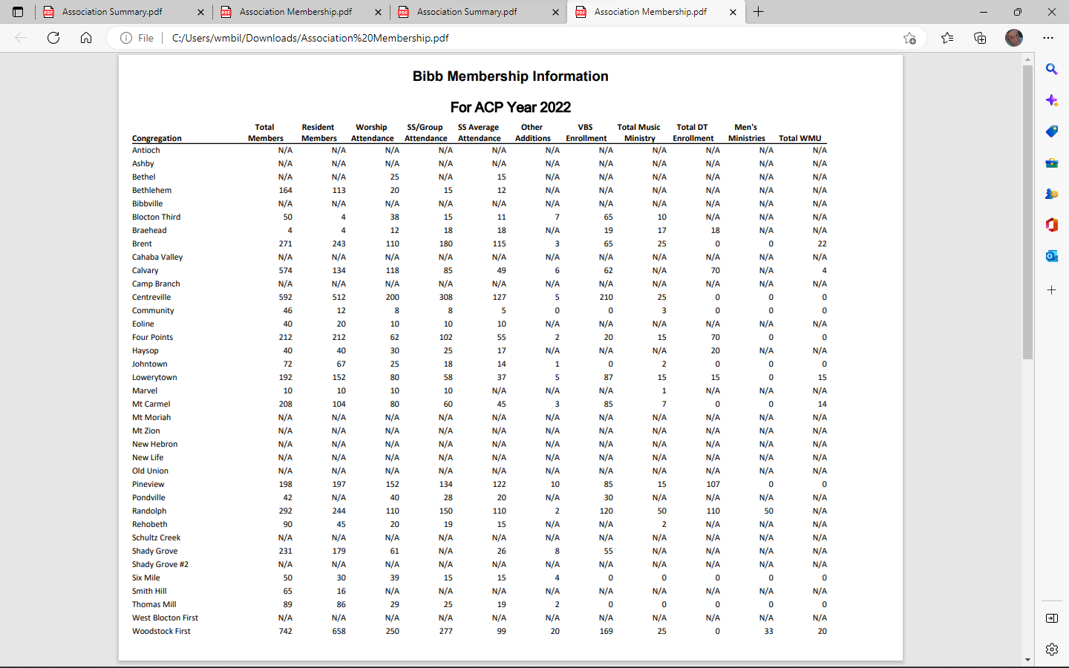
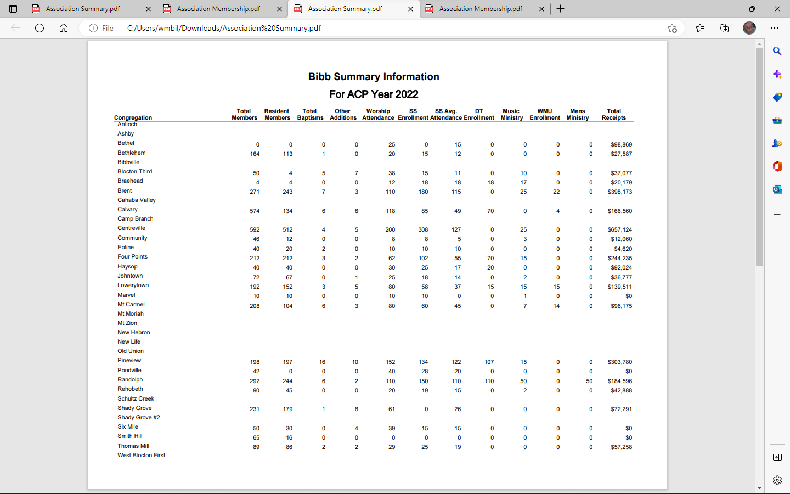

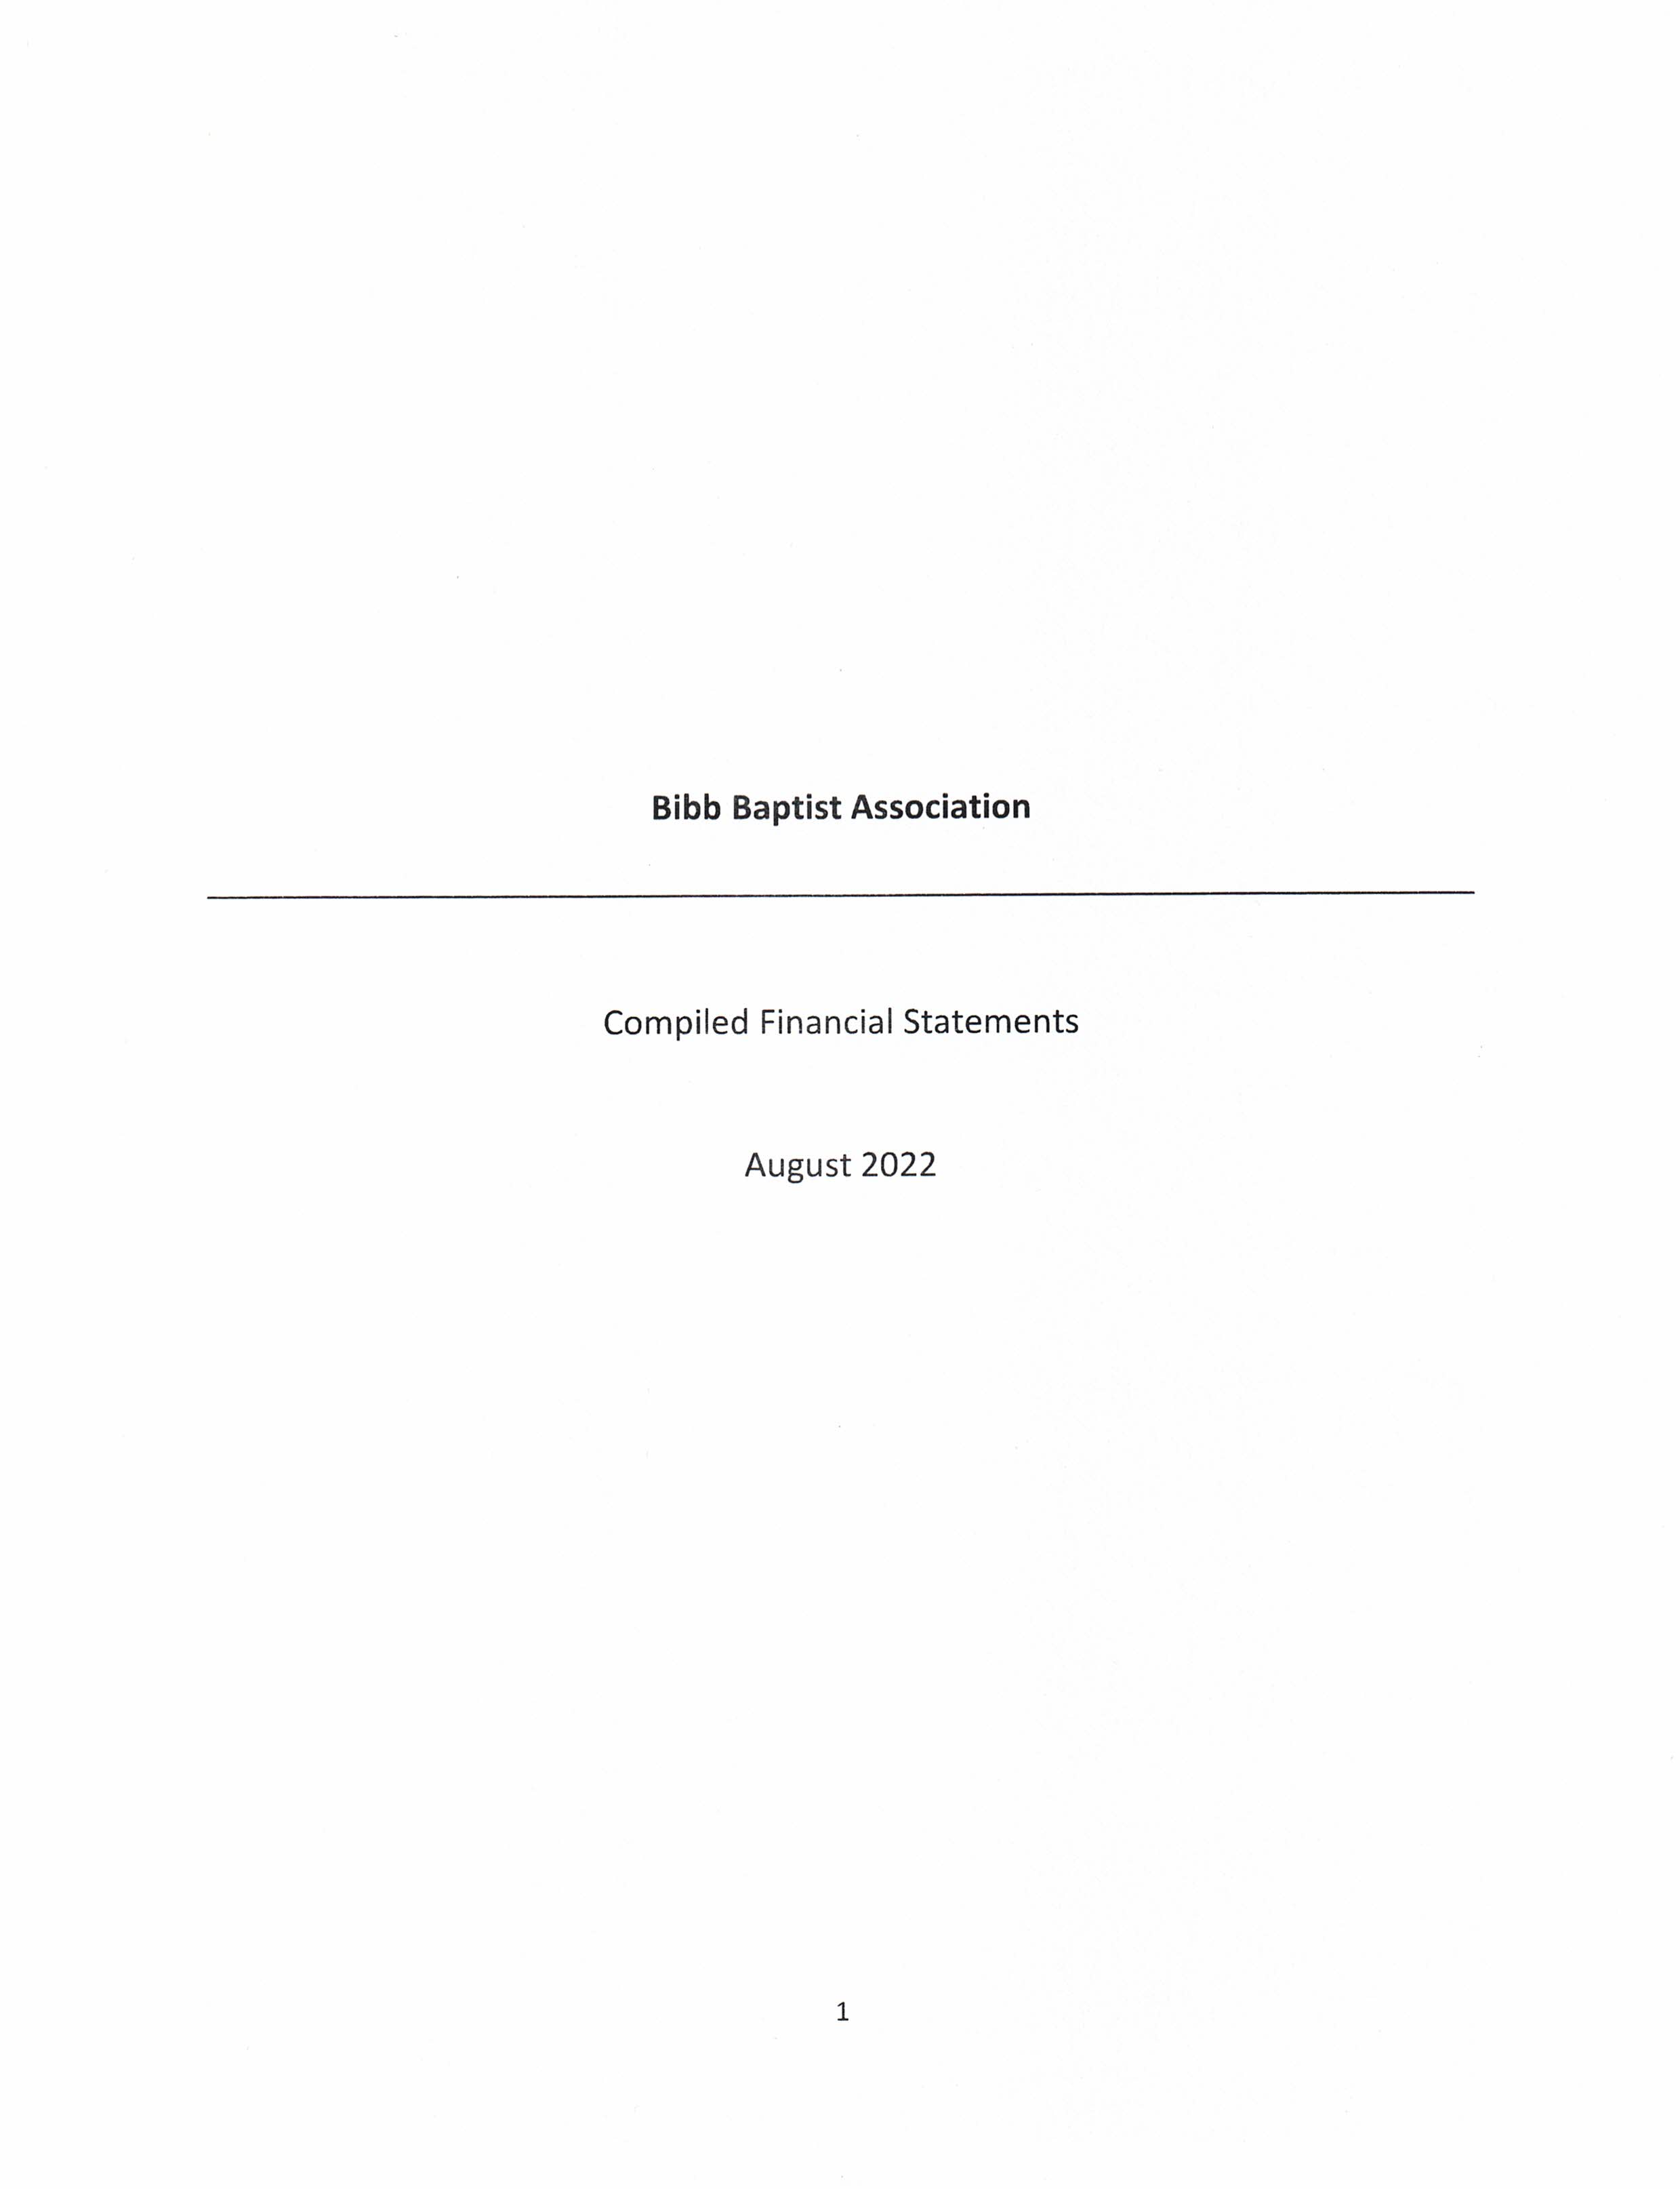

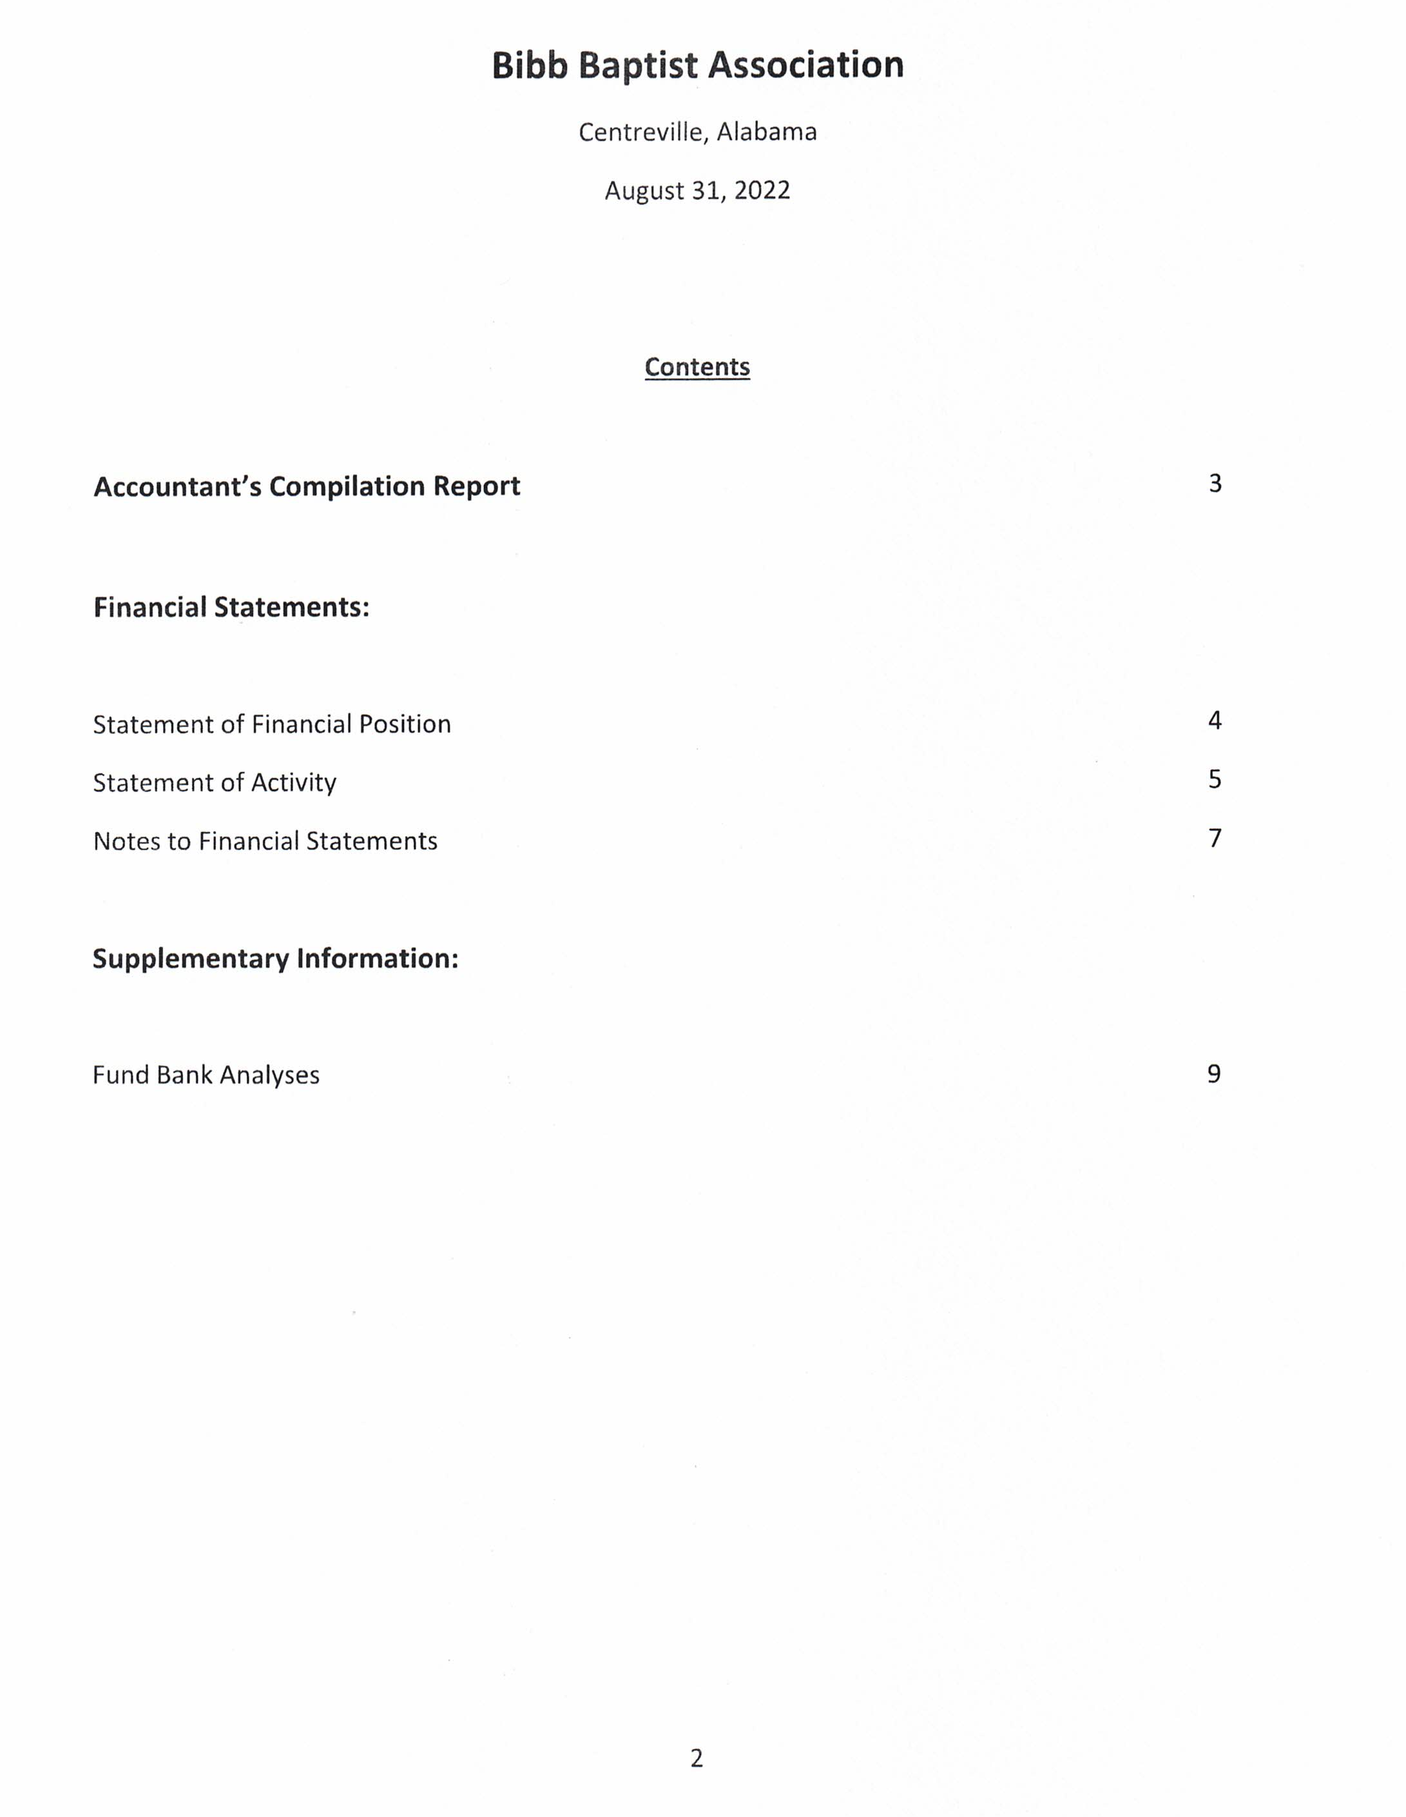

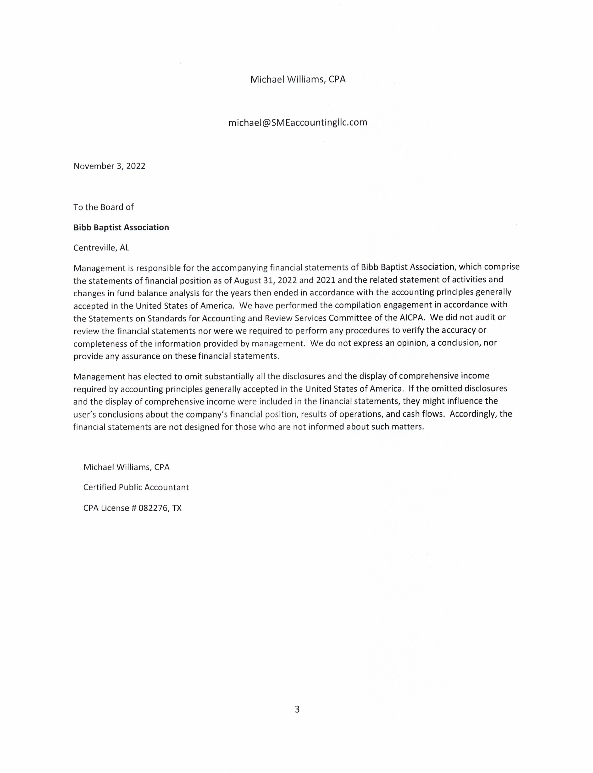

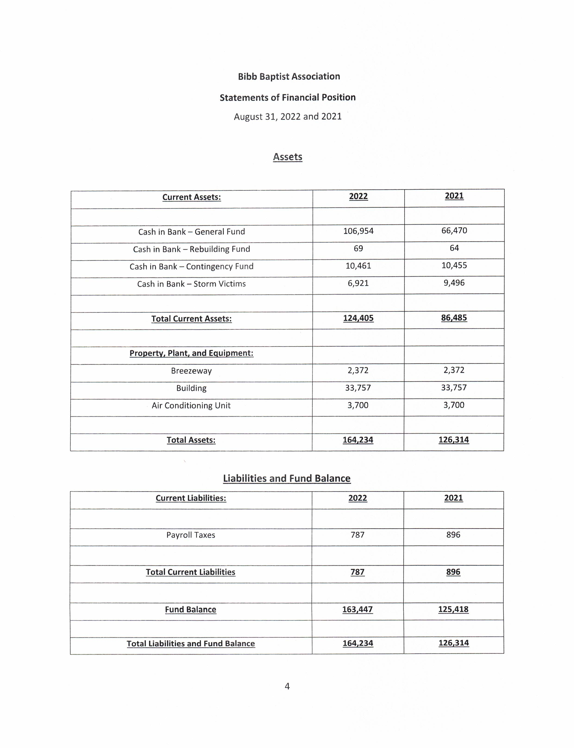

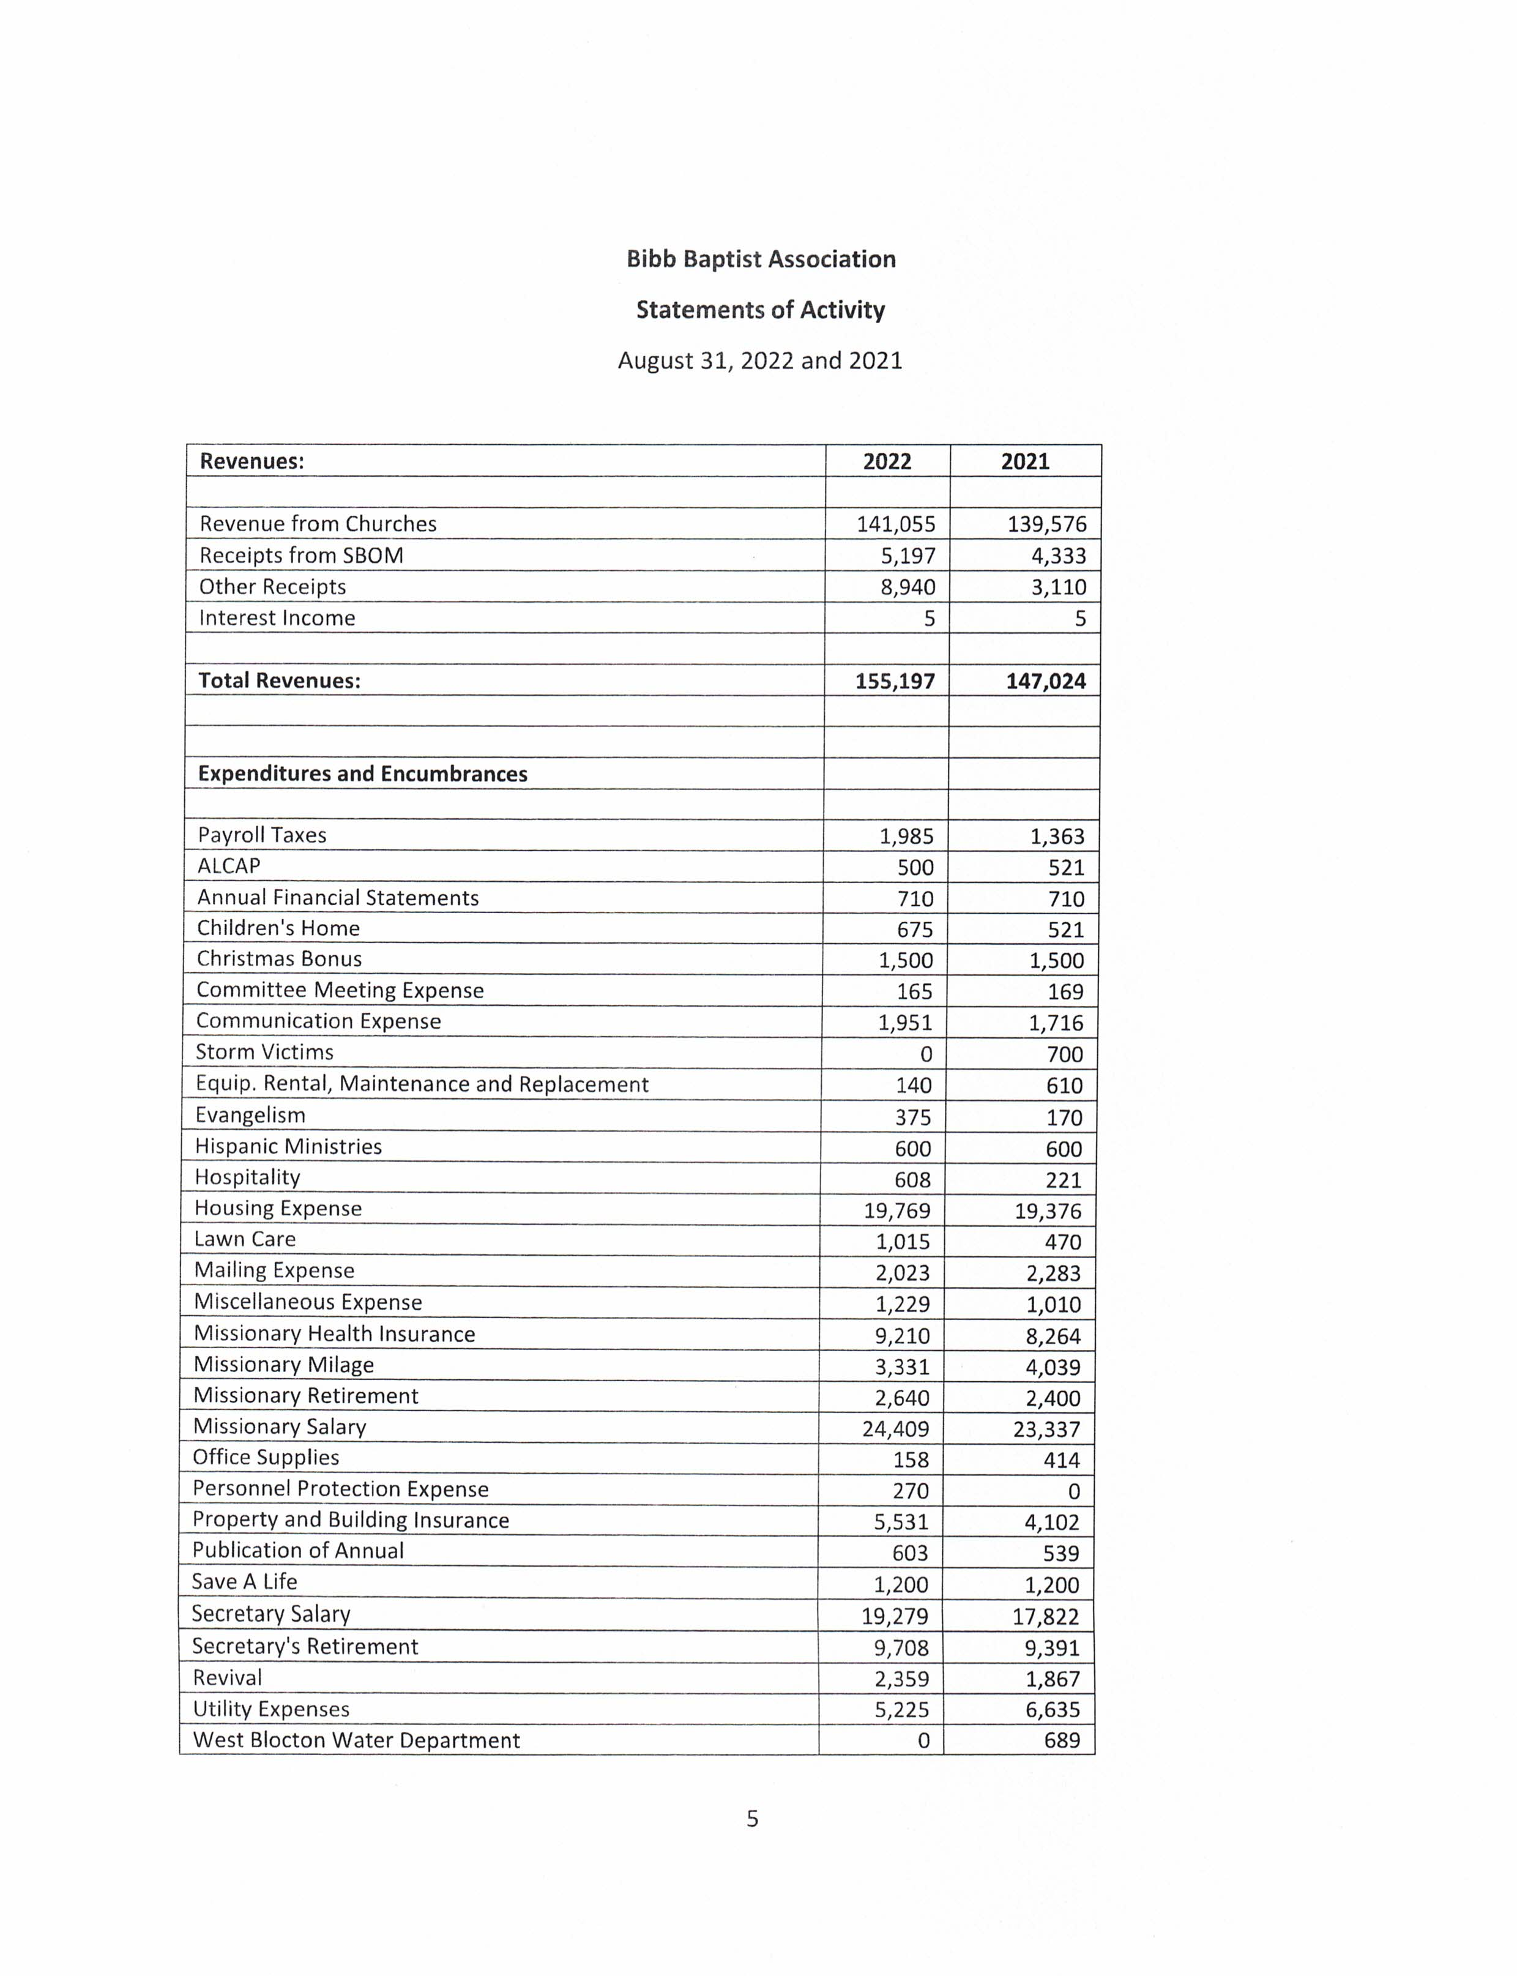

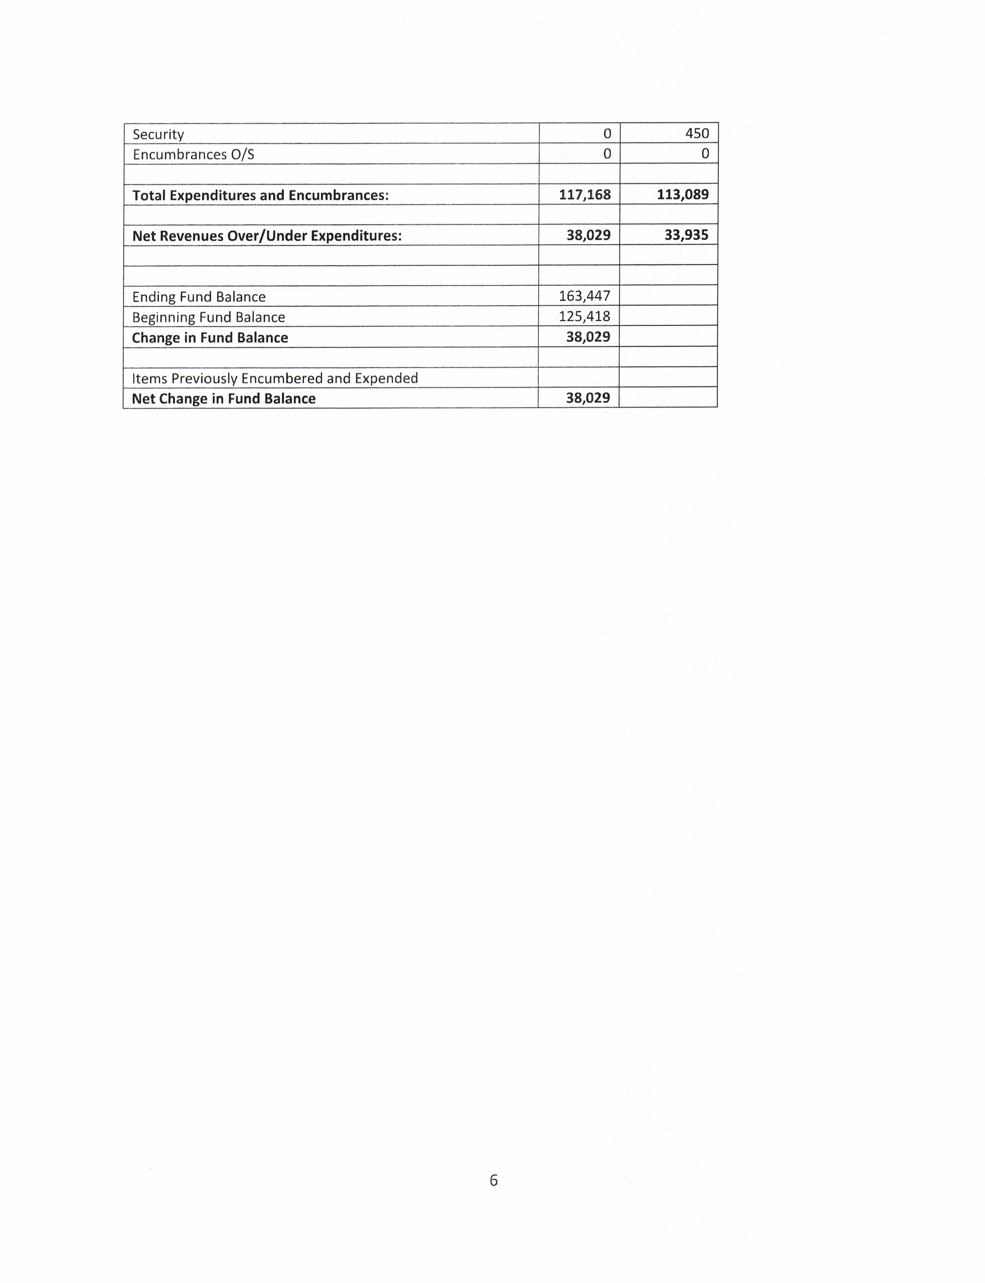

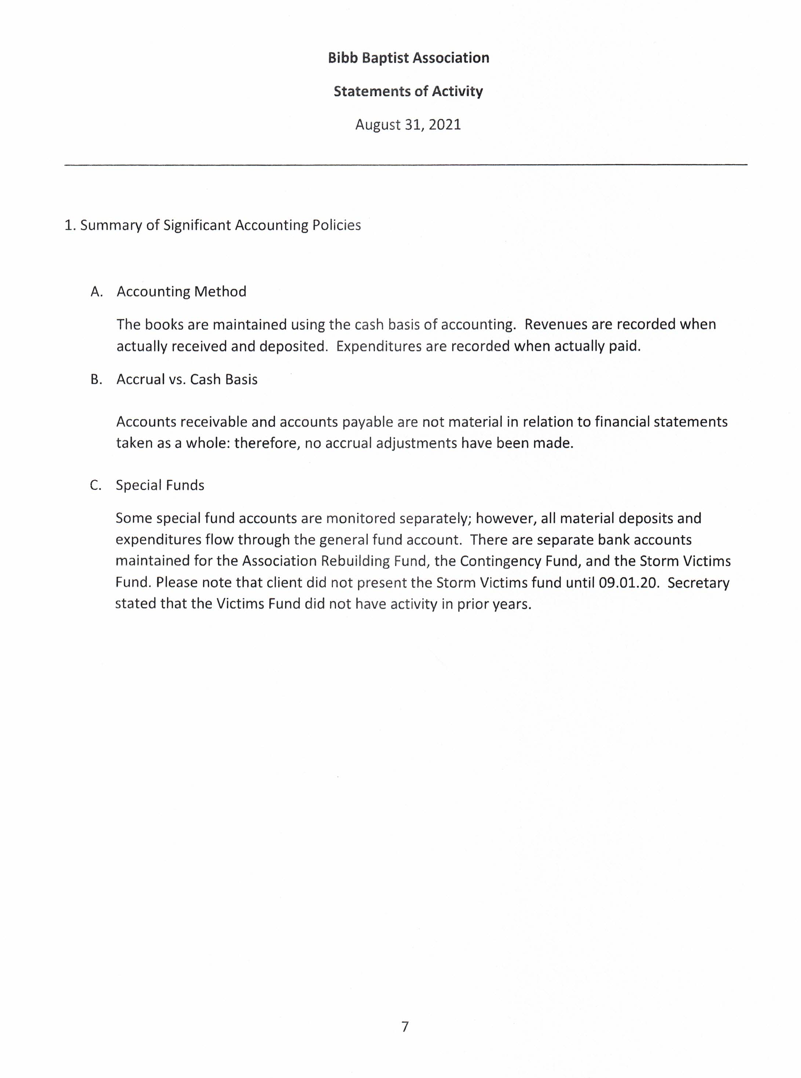

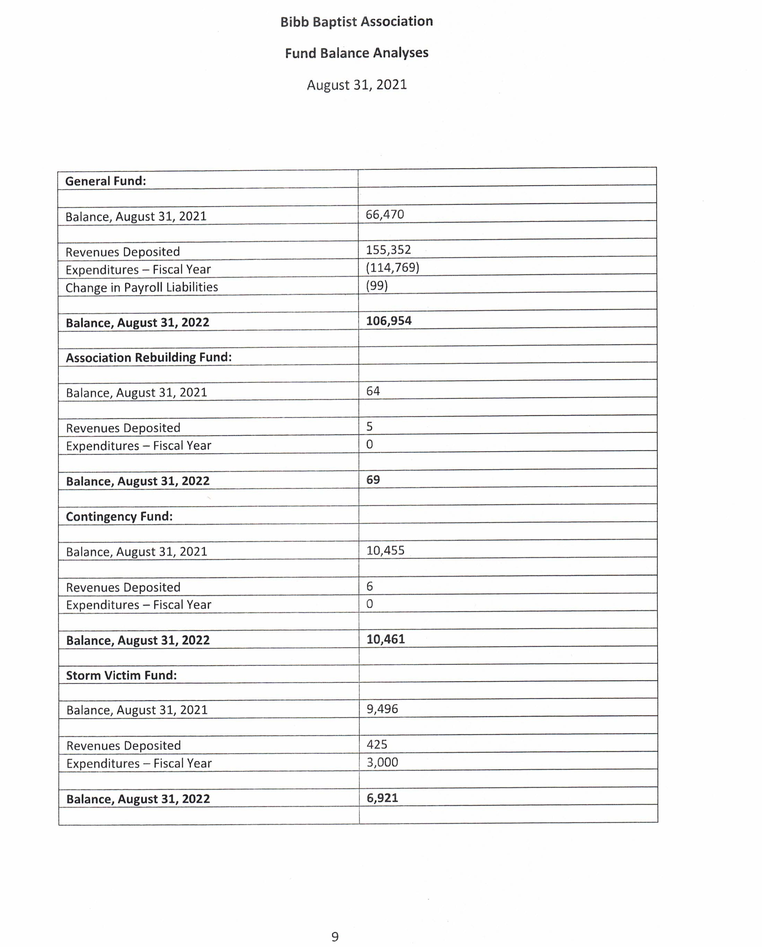

CONSTITUTION
OF THE BIBB BAPTIST ASSOCIATION

ARTICLE ONE: NAME: This association shall be known as the Bibb Baptist Association.

ARTICLE TWO: PURPOSE: The purpose of this association shall be to promote Christian fellowship and cooperation among the churches affiliated with the association; to uphold the doctrines and principles of our Baptist faith and to encourage the churches to be loyal to and practice these doctrines and principles; to promote the preaching and teaching of God’s Word; the enlisting and training of all Christians for service; to promote missions, benevolence, stewardship, Christian education, and the winning of all men to Christ to the ends of the earth; cooperate with the Alabama Baptist State Convention and the Southern Baptist Convention in a world mission program.

ARTICLE THREE: MEMBERSHIP:
SECTION 1: This association shall be composed of messengers from the member churches duly represented by letters of recommendation which shall give the names of the messengers with statistics and their work since the last session, which may be read and minuted.

SECTION 2: Every church shall be entitled to three messengers and one for every twenty-five, or major fraction thereof, above its first fifty members, not to exceed ten messengers from any one church. Pastors of churches in the association, associational officers and heads of departments shall also be members of the body.

SECTION 3: Churches desiring to affiliate with this association shall present a written formal request for admission to the Executive Committee a minimum of thirty days prior to the annual meeting in October. Upon approval of the Executive Committee, the request will be referred to the Missions Development Committee and the Associational Credential Committee for their careful investigation during the watchcare period (a minimum of 12 months). During this watchcare period the applying church shall demonstrate their understanding of “The Baptist Faith and Message” and prove their willingness to cooperate by actively participating in and supporting the programs of the association and the Cooperative Program for the period while under watchcare. While the church is under watchcare it will cooperate with the sponsoring church in developing its organizational structure and operating guidelines. As necessary and feasible the Associational Credentials Committee will lend assistance to help the church become a legally recognized entity. At the next annual meeting (unless otherwise approved by the body at the annual meeting) based upon favorable reports from the sponsoring church, the Associational Credentials Committee, and the closest cooperating associational affiliated Southern Baptist Church to the applying church and upon receiving a favorable two-thirds (2/3) vote of the messengers present, the applying church will be accorded full associational privileges.

SECTION 4: This association holds no authority over any church nor right to interfere with its internal concerns, but it does have the authority to exclude from its fellowship any church that may violate or depart from the principles of the association which indicates a departure from the common bond of “Like Faith and Order” and or fail to display a spirit of cooperation and support of the total associational missions program. Each affiliated church (to include churches under watchcare) shall present a properly completed Uniform Church Letter to the associational designated individual not later than ten (10) working days prior to the first session of the annual fall meeting. Failure to report such communication after contact by the Moderator and the Associational Director of Missions shall be referred to the Associational Credentials Committee for appropriate action. Any church failing for three consecutive years to make the annual report to the association and/or failing to demonstrate a cooperative and supportive attitude for the total associational missions program shall be considered as having withdrawn from the association and shall be recommended for deletion from the roll of affiliated associational churches. After presentation of pertinent data to the body during the annual meeting, and upon receipt of a majority vote favoring withdrawal of membership, the church shall be deleted from the roll of affiliated association churches.

SECTION 5: All visiting members of Southern Baptist Churches shall be entitled to be seated but not to vote.

ARTICLE FOUR: ARTICLES OF FAITH: The Articles of Faith adopted by the Bibb Baptist Association are the Southern Baptist Convention Article of Faith and may be printed in the Associational Minutes.

ARTICLE FIVE: OFFICERS:
SECTION 1: The officers of this association shall be the General Officers, Heads of Departments and such other special officers as the association may deem to be necessary.

SECTION 2: GENERAL OFFICERS:
A. MODERATOR: The Moderator shall call to order and preside over the meetings of the association and the executive committee and direct the affairs of the association in an orderly manner and Christian spirit.
B. VICE-MODERATOR: The Vice-Moderator shall preside in the absence of the Moderator or at the request of the Moderator.
C. CLERK: The Clerk shall keep an accurate record of all the proceedings of the association and executive committee, supervise the printing and distribution of the minutes, and attend such others work as belongs to that office.
D. TREASURER: The Treasurer shall receive all funds of, and for the association, not otherwise designated; shall disburse all funds in accordance with the adopted associational budget or the specific instructions of the association, and upon receipt of a bill or voucher properly authorized. He shall keep accurate records of all monies received, with sources and designations of the same. He shall make mimeographed reports to the regular meetings of the executive committee and annual meeting of the association and have the same approved. The Executive Committee shall have the treasurer’s reports audited at the close of the fiscal year, and report the same to the annual association for approval.
E. HISTORIAN: The Historian shall write in orderly form the events of the association beginning with its organization. He shall make a record of current events each year and read his annual chapter to the association for adoption.
F. TRUSTEES: The Trustees shall consist of three persons presented by the nominating committee and elected by the association. They shall be elected for an indefinite period of time and affirmed annually in the fall associational meeting. Once elected they shall serve for as long as they are able or until they are replaced. The trustees shall be the agents, as required by law, to act for the association in matters duly appointed by the association and/or Executive Committee. They sign all deeds of conveyance, execute all notes, bonds, or mortgages, and intervene in all suits, by authority of the association. The trustees shall meet as often as needed to perform their work, and shall keep a written record of their actions. A copy of this written record will be placed on file in the Association Office. The trustees shall report, when necessary, to the Association and to the Executive Committee.

Section 3: DEPARTMENTAL HEADS:
A. SUNDAY SCHOOL DIRECTOR: His duties are to promote Sunday School work in the association; to keep his associational officers working and his programs well planned; to promote the regular meetings and to secure complete reports. He would lead the churches to develop Standard Sunday Schools and should seek to organize a Sunday School in any church without one. In collaboration with the other officers, he will plan associational programs of training for all Sunday School workers, lead in enlargement for all schools, promote Vacation Bible School work, and encourage the establishment of mission Sunday Schools where they are needed. He would lead the churches to make effective use of the Weekly Officers and Teachers Meeting and Six Point Record System.
B. DISCIPLESHIP TRAINING DIRECTOR: His duties are to promote the associational program of Discipleship Training work; to direct all associational Discipleship Training officers in their functions; to lead every church in the association to have Discipleship Training; to assist the churches in having better Discipleship Training and to cooperate with the State Discipleship Training leadership in all programs of work and will secure and make complete reports.
C. W.M.U. PRESIDENT: The association, along with the Women’s Missionary Union organization, should work out a procedure for electing the president of the Associational Woman’s Missionary Union in a way to give her status as an ex-officio member of the Associational Executive Committee.
D. BROTHERHOOD PRESIDENT: His duties are to study the whole program of the association and lead the men to support it; to make reports on Brotherhood work; to encourage men to attend all meetings of the association and to help all Associational Brotherhood officers in the effective promotion of Brotherhood work in all churches. He will be cooperative with the Moderator and all the associational organizations in coordinating and promoting associational and denominational projects.
E. MUSIC DIRECTOR: He shall have charge of the music for the associational meetings and serve as chairman of the Associational Music Committee; he shall attempt to improve the type and grade of music in the churches; conduct quarterly meetings of the music committee; teach schools of music in the churches and promote the associational music activities.
F. YOUTH RALLY PRESIDENT: He shall promote an Associational Youth Rally; prepare programs, project a calendar of activities for the coming church year; preside at the meeting of the Youth Rally and the Youth Committee.

Section 4: OTHER OFFICERS:
A. ASSOCIATIONAL MISSIONARY: The Executive Committee shall be empowered to employ an Associational Missionary who shall be approved at the next annual session and shall hold office so long as mutually agreeable. He shall maintain an associational office and shall, under the direction of the executive committee, promote the missionary, benevolent and educational work of the association. He shall be an ex-officio member of all boards and committees with the power to make recommendations and to enter into discussions of all matters but without the power to vote in committees except the Executive Committee. He shall be allowed two weeks vacation with pay and two weeks work outside the association in denominational activities (revivals, stewardship campaigns, schools of missions, etc.) not including attendance at assemblies, workshops, clinics, conferences or conventions. The vacation and outside work shall not be taken consecutively.

Section 5: ELECTION OF OFFICERS:
A. General Officers and Departmental Heads shall be nominated annually previous to the annual meeting of the association by the Nominating Committee and the Executive Committee, subject to approval of the association at the Annual Meeting. The floor of the Annual Meeting shall be opened for additional nominations.
B. Other associational officers shall be employed by the Executive Committee, subject to approval of the association at the Annual Meeting. The floor of the Annual Meeting shall be opened for additional nominations.

Section 6: AUTHORITY: The association is an autonomous body and therefore reserves the right to determine its own policies and direct its own business; it may refuse to seat messengers who are not in fellowship or doctrinal agreement with the body, or whose churches are not. However, this body, or the executive committee shall never exercise any authority over, or give direction to, any church or churches which are affiliated with it or which may have been affiliated with it; but the association will stand ready to lend any assistance or counsel to any church making request for such help.

Section 7: ORGANIZATIONS: This body shall encourage and promote such associational organizations as Sunday School, Discipleship Training, W.M.U., Brotherhood, Music and other organizations which are in keeping with the purpose of the association, with their full staffs of officers and programs necessary for the promotion of the work. The chief officers of each organization shall be elected or approved by the association and shall function as an officer of the association.

ARTICLE SIX: COMMITTEES:
Section 1: EXECUTIVE COMMITTEE: The executive committee of the association shall be composed of the following members; the pastor (or associate pastor) from each member church, associational officers, heads of auxiliaries of the association and one lay representative from each member church in the association, which said lay representative shall be elected by each church before the meeting of the association each year and reported on the church letter to the association. In the event a church is without a pastor, then the chairman of deacons shall be eligible to fill the pastor’s vacancy on the executive committee until the church calls their new pastor. In the event there is a vacancy in either the pastor’s or lay representative’s position, the member church must provide a letter to the associational office stating the name, address and telephone number of the person designated to fill the vacancy. The duties of the executive committee shall be to aid and advise the churches, to carry on all necessary business of the association between the annual sessions of the association and to recommend the members of the standing committees to the association for the ensuing year. Those members of the executive committee present after due notification, provided there shall be seven or more, shall constitute a quorum for transacting the business of the committee. All action taken by the executive committee shall be reported to the association in annual session for consideration and approval.

Section 2: MEETINGS: The association shall meet annually at such time and place as it may designate. The executive committee may call extra meetings of the association if necessary, or change the time and place of the stated meeting of the association when it feels it is inexpedient at the time and place appointed. The executive committee shall hold 12 meetings per year, monthly, at such a time as designated by the committee and such additional meetings as it may feel to be necessary to the proper conduct of business of the association.

Section 3: An Amendment to the Article Section is recommended by a committee that the association shall have the following standing committees named by the Moderator and Executive Committee on or before the last meeting of the executive committee preceding the annual meeting of the association and recommended for election at the business session of the first day of the association, to serve until the close of the next Annual Session of the Associational Meeting.
A. PROGRAM COMMITTEE: This committee shall arrange and promote the program of the annual meeting of the association including place of meeting, time of meeting, and speaker and alternate for doctrinal, missionary and youth sermons.
B. NOMINATING COMMITTEE: This committee shall nominate for presentation to the annual meeting of the association the following: Moderator, Vice-Moderator, Clerk, Treasurer, Historian and Departmental Heads and shall fill all vacancies as they may occur between annual sessions.
C. CREDENTIAL COMMITTEE: It shall be the duty of this committee to receive the petitionary letters from any church seeking fellowship with the association. At the first session or subsequent sessions of the annual meeting they shall make recommendations concerning same for action. They shall also consider any questions of the fellowship of messengers from any church and make such recommendations as may be deemed advisable to any session of the annual meeting of the association, or called session thereof.
D. BUDGET COMMITTEE: This committee shall give general supervision to the entire associational finance program; shall prepare and recommend an annual budget to the executive committee of the association for presentation and approval by the annual meeting and shall encourage the churches to make regular and liberal contributions to the associational work.

Section 4: SPECIAL COMMITTEES: The special committees of the association may consist of the following: Christian Life, American Bible Society, Baptist Student Union, Brotherhood, Children’s Home, Christian Education, Church Music, Cooperative Program, Denominational Literature, Evangelism, Memorial, Missions, Annuity Board, Baptist Foundation, Sunday School, Discipleship Training, Auditing, W.M.U., Youth Rally and Resolutions and such other committees as may be deemed to be needed, to be nominated as in Section 3. The duties of these committees shall be to present to the annual session of the association the reports of their respective organizations.

ARTICLE SEVEN: AMENDMENTS: This constitution may be amended at any regular annual session of the association by a two-thirds majority of the messengers present, provided notice of such change has been given at the previous annual meeting and provided it is read in the first session of the annual meeting and voted on before the last session.

Map of the Churches

