TRINITY UNITED METHODIST CHURCH
Pastor Doug Benton ___ Minister
August 1, 2021 Greeter: Clarissa Hendrix Color: Green
TENTH SUNDAY AFTER PENTECOST
"We welcome you to our service this morning and pray that your time with us will be a blessing to you"
THE ORDER FOR WORSHIP
Prelude Phyllis Sanders
Let us silently prepare our hearts and minds for worship.
Welcome and Announcements Grady Senn
Chiming of the Hour Phyllis Sanders
Candle Lighting and Processional
Call to Worship Grady Senn
Opening Prayer Grady Senn
Children’s Time Lynn Mohler
Hymn of Adoration: “He Keeps Me Singing” (Cokesbury Hymnal) Page 110
*Apostles Creed Page 881
*Gloria Patri: “Glory Be to the Father”
Praises, Concerns and Prayers Grady Senn
Pastoral Prayer/Lord’s Prayer Grady Senn
Tithes and Offering Ushers / Grady Senn
*Doxology: “Praise God From Whom All Blessings Flow”
First Reading: Psalms 100:1-5 Frieda Kesler
Second Readings: Psalms 89:1 and Colossians 3:16 Freida Kesler
Old Fashion Hymn Sing
*Returning of the Light

*The Benediction Grady Senn

*Three-Fold Amen Phyllis Sanders
*Going Forth Phyllis Sanders
*Stand if able. God’s altar is open to you following the sermon.
Technician: Bryan Waldrop

The Altar Flowers are given by Clarissa and David Hendrix
to the Glory of God and in honor of Holly Myers’ birthday.

Next Sunday – August 8

Altar Flowers: Barbara Rogers; Greeter: TBD; Scripture Reader: Foster Senn; Technician: Josh Pitts

Our Faithfulness

Worship Attendance for July 18, 2021: 43 (correct #)
Worship Attendance for July 25, 2021: 52
Total Budget for 2021: $ 149,647.00
Weekly Offering Needed: $ 2,877.83
Offering Received July 25, 2021: $ 1,847.00
2021 Average Weekly Offering YTD: $ 2,208 .00

The Concerns of Trinity
Our Known Hospitalized:
Recent Hospitalizations and/or Surgeries:
Nursing Home: Gloria Brehmer (Springfield Place)
Continued Prayers: Shirley Berry, Frances Pitts, Wade Pitts, Robert Pollard
Family and Friends of Trinity: Blake Hendrix, Phillip Sanders, Wilson Bowles, Charlotte Berry, Megan Wainwright, Neil Thomas, Francis Leopard, Kinsley
Bouknight
White Oak Manor Rehabilitation Center: James Poag
Richland Rehabilitation Center: Jeannette Poag

Communion will resume in September.

A Big Thank You to all those who helped in any way
with making VBS an awesome experience.

Available in the Narthex:
Please be advised that a 2021 Altar Flowers Chart can be found
on the wall closest to the choir robes. Please notify Peggy Bogart
with the wording you wish to have printed.

WELCOME VISITORS

Thank you for coming today! We are delighted you are here! We hope
you will join us again as we continue to discover the difference God’s love makes in our lives. If you have questions or desire to become a member of Trinity UMC, please speak to pastor. We are blessed because you’re here.

Trinity United Methodist Church Please visit our website for bulletins & newsletters:
1160 Trinity Church Road www.trinityumcnewberry.net
Newberry, SC 29108
Rev. doug benton, Pastor
803-276-1245 (Church Office)
803-768-7687 (Church’s cellphone)
803-543-0082 (Pastor’s Cell)
dobenton@umcsc.net
Upcoming Events at Trinity

August 2: Trinity Women’s Club – 6:30 pm
August 4: Trinity Men’s Club – 7:30 pm
August 7: Reception for Pastor and Mrs. Doug Benton – 3:00 p.m.
August 8: Youth Sunday – 11:00 a.m. service
August 9: Administrative Council meeting – 6:30 pm in the Fellowship Hall
August 15: Back to School Blessing during 11:00 a.m. Service

Trinity
United
Methodist
Church

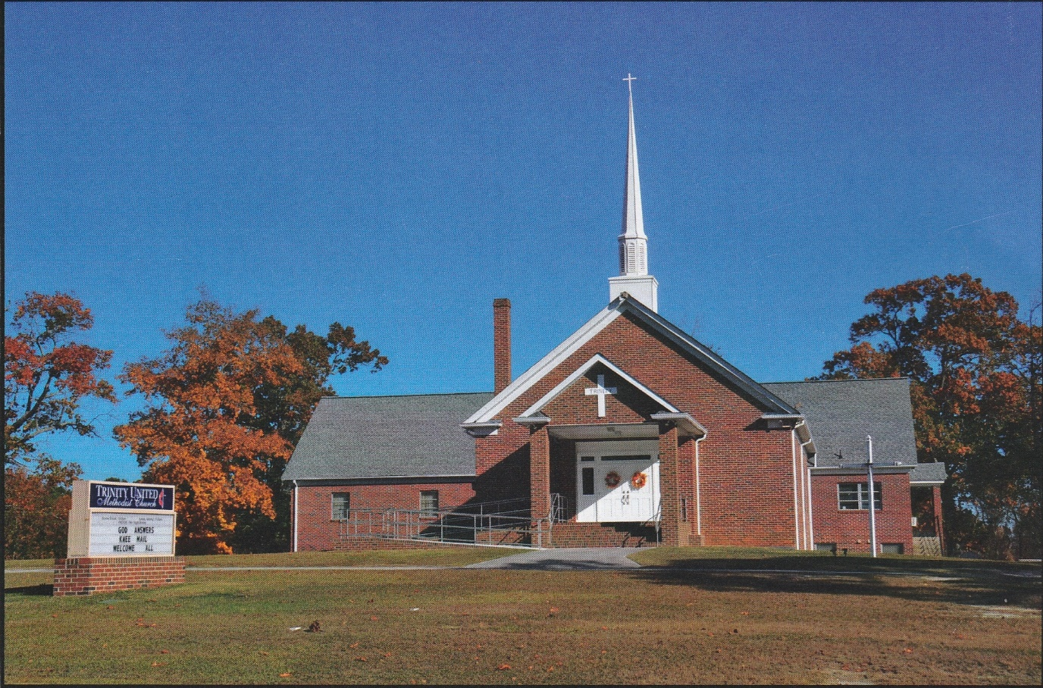

1160 Trinity Church Road
Newberry, SC 29108
Trinityumcnewberry@gmail.com

