LB’s Catering

owner chef Lathette B Brooks
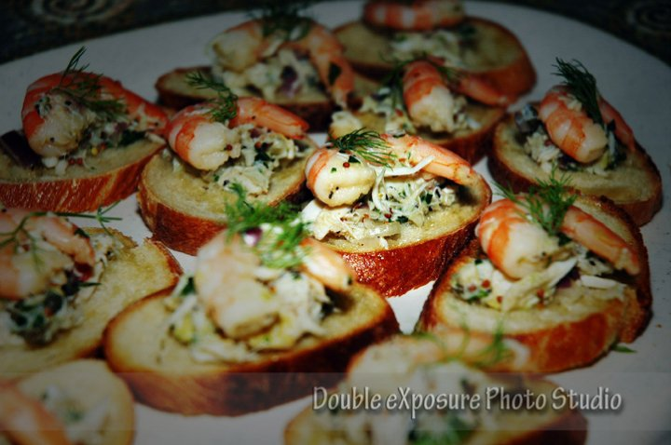

*Hot Buffet Menu/ Cold Buffet Menu

*Wild Mushroom Demi Brisket
white cheddar mac and cheese
roasted tomato haricot vets
classic caesar salad
*Sage Pecan Pesto and Wild Mushroom Lasagna
grilled and roasted veggies
classic baby spinach salad
rosemary focaccia
* Roasted Turkey Breast
roasted corn poblano smashed yukon potatoes
grilled and roasted veggies
hearts of romaine salad
*Grilled Chicken Parmesan Medallions
basil mint pesto alfredo rigatoni
roasted red bell haricot vets
classic caesar salad
*Maple Bourbon BBQ Smoked Brisket
twice baked potato casserole
tomato pecan haricot vets
goat cheese spinach salad
*Ancho Lime Crusted Chicken Parmesan
cilantro pesto penne alfredo
grilled and roasted veggies
hearts of romaine salad
*Lemon Sage Grilled Chicken Medallions
rosemary smashed yukon potatoes
broccoli hearts of palm
mediterranean green salad

*Grilled Chicken Artichoke Piccata Medallions
sunset rice blend
grilled/roasted veggies
classic signature green salad
*Rubbed Roasted Brisket Enchiladas
roasted corn and pecan basmati rice
grilled and roasted veggies
classic southwest caesar salad
Maple Bourbon Roasted Turkey Breast
artichoke wild rice
pecan tomato haricot vets
butternut field green salad
Orange Manchego Salmon Medallions
sundried tomato orzo
broccoli hearts of palm salad
classic signature green salad
Oregano Basil Grilled Chicken
lemon feat roasted Yukon potatoes
dill tomato haricot vets
classic baby spinach salad

Individual Boxed Meals

Wrap Sandwiches
grilled chicken or salmon caesar
oven gold turkey bacon avocado
diablo chicken gorgonzola
chicken pimento green apple
classic dill chicken, egg or tuna
boars head deli trio
turkey pastrami gouda
grilled chicken pesto
beef pastrami and swiss
honey ham provolone
roast beef and horseradish cheddar
grilled veggies and hummus
chef’s daily pasta OR veggie creation
fresh fruit salad

15 persons minimum. Menu available Monday-Friday.
Each hot or cold buffet menu comes with Dessert Tray.
You may substitute a fresh baked cookie for an additional $0.75 per person.
We will increase the guest count until 12 p.m. the business day prior to delivery.
All orders and guest count increases placed after 12 p.m. the business day prior will be charged an additional $2.50 per guest. email bestcatererlvlb@gmail.com

Classic Hoagie
Turkey, honey ham, salami, provolone, lettuce, tomato
and an olive relish on a classic hoagie bun
Grilled Chicken Pesto
tomato, baby spinach, fresh mozzarella
and basil mint pesto on focaccia bread
Grilled Chicken or Salmon Caesar
romaine lettuce, tomato,
and a smoky caesar dressing on a kaiser bun
Turkey Avocado
apple wood smoked bacon, tomato and lettuce
with red pepper aioli on an pullman bun
Classic Salad: Dill Chicken, Tuna, Pimento or Egg
with lettuce and tomato on honey wheatberry bread
Honey Ham
honey ham, gouda cheese, baby arugula, and tomato
with deli mustard on an onion bun
Fresh Mozzarella and Roma Tomato
baby arugula with basil pesto on rustic focaccia bread
Turkey or Beef Pastrami
Swiss cheese, baby spinach, tomato,
with roasted shallot mayo on an onion bun
Roast Beef
smoked gouda, baby arugula, tomato,
with horseradish aioli on honey wheatberry bread
Classic Trio
roast beef, smoked ham and oven gold turkey with herb
mayonnaise, cheddar, lettuce, and tomato on a wheat berry bun
Roasted Portobello and Peppers
roasted shallot mayonnaise, baby arugula, manchego,
and tomato on a sourdough
Grilled Chicken Signature Green
grilled chicken, oranges, bleu cheese, toasted nuts,
seasonal fruit and raspberry vinaigrette

Goat Cheese Spinach
eggs, tomatoes, toasted pecans, roasted corn,
sundried fruit, red onions, and raspberry vinaigrette
Taco Salad
field greens topped with your choice of grilled chicken or beef
with peppers and onions, tomatoes, roasted corn, black beans,
corn tortillas strips and a cilantro lime vinaigrette
Classic Chicken or Salmon Caesar
romaine lettuce, radicchio, parmesan cheese,
house-made croutons and a house made caesar dressing

Grilled Veggie Cobb
grilled veggies, tomatoes, garbanzo beans, eggs, olives,
toasted nuts, feta cheese and a raspberry dressing on fresh greens
Mediterranean
tomatoes, calamata olives, cucumbers, pepperoncini’s, red onions,
bell peppers, feta cheese, and a lemon basil vinaigrette
Blackened Chicken
romaine lettuce, feta cheese, roasted corn, black beans,
sunflower seeds, and a Smokey raspberry dressing
Butternut Squash Manchego
baby arugula and fresh greens with sunflower seeds,
toasted manchego, tomatoes, sundried fruit,
and a maple-dijon vinaigrette
Chicken Salad
choose one of your favorites; curry, lemon tarragon,
southwest, or dill chicken salad on fresh greens
Veggie
cherry tomatoes, mushrooms, carrots, celery,
house made croutons, gorgonzola crumbles,
and a vinaigrette dressing

Specialty Paper & Plastic
Paper plates, napkins and utensils are available for $1.75 per person.
Lucite plates, napkins and utensils are available for $2.50 per person.

Beverages
Assorted 12oz Canned Soft Drinks $1.00 each
20 oz. Bottled Water $1.00 each
The following are available by the gallon $5.00 each
Lemonade
Limeade
Fresh Brewed Ice Tea

*Any specialty diets can be ordered upon request

15 persons minimum.
Each boxed lunch comes with fresh baked cookie.
You may add a fresh baked cookie for an additional $0.75 per lunch.
We will increase the guest count until 12 p.m. the business day prior to delivery.
All orders and guest count increases placed after 12 p.m. the business day prior will be charged an additional $2.50 per guest.
email bestcatererlvlb@gmail.com

Non-Profit-Organization
LB’s Catering proudly supports all non-profit organizations by taking a $1 off of each person in your order. Each organization should be able to provide their non-profit tax- exempt form in order to receive credit for this discount.

Delivery
A small delivery charge is applicable. LB’s Catering provides all serving pieces at no additional charge and complimentary pick up of serving pieces, serving pieces may be picked up the same day of delivery no charge. Should you require an additional return give us a call or email (bestcatererlvlb@gmail.com), an additional delivery fee will be charged.

Guest Count and Cancellations
We request a guaranteed minimum guest count at the time of the order placement.
48 HOURS NOTICE FOR ALL CANCELLATIONS
All orders placed within 24 hours of delivery time are considered confirmed and finalized.
We will increase the guest count until 12:00 p.m. the business day prior to delivery. All orders and guest count increases placed after 12:00 p.m. will be charged an additional $2.50 per guest.

