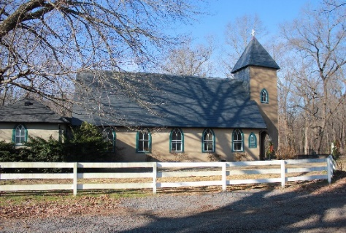
Grace Church Lane
Grace Episcopal Church
Casanova, Virginia 22728
e-mail: gracechurchcasanova@gmail.com website: www.gracechurchcasanova.org

Happy New Year!
It is probable that you are reading this and thinking “Yes! This has to be a Happy New Year; 2020 was rough!”
The New Year can often bring a mixed bag of emotions and memories for many of us. Some may have just experienced the best year ever and look forward to an even greater one looming ahead. Others may have just trudged through one deep struggle after another. The fresh calendar year brings desperate hope for things to be better, with an ache for the still-fresh wounds to slowly begin their process of healing.
Whether you’ve just walked through the greatest year of your life, or are incredibly glad to see this one finally over, one truth still rings clear amidst it all. You are not alone. Not ever.
Our God is a “with us" God. On the heels of the celebration of the birth of our King, that reminder has the power to carry us right into a fresh, new start. He is Immanuel, God with us. And though things and people around us shift and change, our God never changes.
Debbie McDaniel
https://www.crosswalk.com/blogs/debbie-mcdaniel
NEWS!

Clergy Webinar

December 8, 2020

Summary of Bishop Goff’s remarks:
1) The numbers of new cases are increasing dramatically. No locality is currently eligible for in-person indoor worship per the health markers. Some nearby dioceses have issued a blanket “no” to all indoor gathering for the next several weeks.
2) We are directing you to cease outdoor gatherings immediately.
3) With Christmas Eve and Christmas Day approaching, many in our Diocese are hoping for some way to gather. From a risk standpoint, it is the same whether it is Christmas Eve or December 21st. But because of the pressure you may be feeling to do something in-person for Christmas Eve, we are offering you the option to do outdoor services on Christmas Eve or Christmas Day, following all the protocols we have already laid out for outdoor worship, such as distancing, masks, no congregational singing and no touching.

Diocesan-Wide Worship Sunday, December 27
The Bishops encourage congregations to use this Christmas Festival of Lessons and Music as their December 27 Sunday service, so that all members of the Diocese can share in the joy of the diocesan-wide gathering. Bishop Goff will preside and the service will feature Scripture readings and music from congregations across the Diocese.
thediocese.net

UPDATE!
AN UPDATE FROM YOUR DISCERNMENT COMMITTEE
As explained in our monthly update, we’d like to keep you informed as we continue to work toward the goal of finding a new “sheepdog.” The normative process for transition is:
- Vestry converse with Diocese Transition Ministry Office
- All say goodbye to departing priest
- Vestry call an interim priest (see Senior Warden’s Report)

- Vestry call a Search Committee (referred to by the Diocese as a Discernment Committee (DC))
- DC perform self-study of the seeking church with input from all
- Publish a Vestry- and Bishop-approved Community Ministry Portfolio (overview of Grace church) [published for 8 weeks]
- Improve church website, where needed, and keep updated for the benefit of potential candidates
- DC receive names and select a finalist, based on Office of Transition Ministry vetting [posting will remain open for 8 weeks]
- Vestry vote on finalist and, if affirmed, Vestry extends a call
- Vestry and candidate negotiate terms and set out in a letter of agreement
- Senior Warden and Bishop sign letter of agreement
- Vestry and new priest conduct Mutual Ministry Review after first year of service
Last month, we reported that the Portfolios for our churches were in the process of being posted on the Diocese website for potential candidates to view and while we were told this would be accomplished within the seven-day period after our meeting with them, it still had not been posted. We are happy to report that they have finally been posted and will remain open for 8 weeks. Thank you for your patience and prayers.
Sincere love and blessings,
Judy Ball, Pat Williams, Kathlene Bilger, Linda Winslow, Tom Bilger, & Mary Neal
Your Discernment Committee (DC) aka Search Committee

SENIOR WARDEN’S NOTES
We will be kicking off the New Year with a Congregational Meeting at some point in January. Stay tuned to your e-mail for the virtual event. More to come…

Peace,
Mary Neal on behalf of:
Bryan

TREASURER’S REPORT – NOVEMBER 2020
Income for the month of November was $7,954.27 (budget $10,423.75). Expenditures totaled $3,320.29 (budget $10,193.42), resulting in income for the month of $4,633.98.
Interest earned on our Roof/Rectory Renovation Fund during the month of November was $0.11. $118.75 was paid for labor involved in removing the carpet in the Rectory. The balance in the fund at the end of the month was $12,241.05
The book value of our endowment fund is $60,073.49.
Please continue to pray for Grace Church that it will grow spiritually, financially and numerically. If you have any questions about this report or any financial matter, please contact me.

Judy Ball, Treasurer

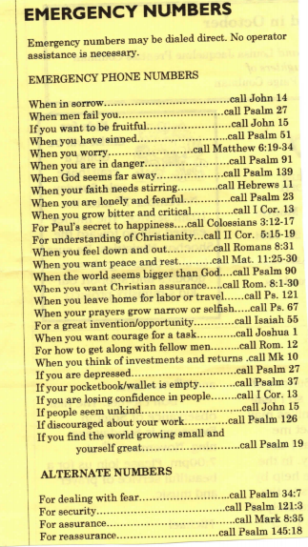
“I want to quit (fill in the blank) in the new year.”
“Did you know that the best determinate of success in quitting something is how much you ‘want to’?”
What’s your resolution? Weight loss, you say? And nothing seems to work for you. Try this:
calories in < calories out = weight loss…. and be honest with yourself about every tablespoon you consume.
Another year is beginning and you resolve to (fill in the blank.)
Try the “emergency numbers” for help!
submitted by Diane Gulick

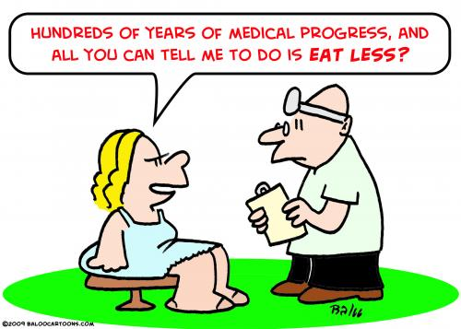

FEED MY SHEEP
We continue to need the funds that our parishioners have been so generous to provide. This gives us the opportunity to provide our families with fresh products i.e.: meats, dairy products. Monies can be mailed directly to: Grace Church, PO Box 18, Casanova, VA 20139 OR put in an envelope and left in the collection plate on Sundays. Please make payable to Grace Church with a notation on checks “for FMS.” Thank you for your continued support.
Carol Grove

A DIFFERENT PHOTO CHALLENGE
Can you find Stella?

Photo submitted by Stephanie Butler

DATE  2021 | DAY | LESSONS
January  3 | 2 Christmas | Jeremiah 31:7-14  Psalm 84  Ephesians 1:3-6, 15-19a  Matthew 2:13-15, 19-23 or  Luke 2:41-52 or  Matthew 2:1-12
January 10 | 1 Epiphany | Genesis 1:1-5  Psalm 29  Acts 19:1-7  Mark 1:4-11
January  17 | 2 Epiphany | 1 Samuel 3:1-10, [11-20]  Psalm 139:1-5, 12-17  1 Corinthians 6:12-20  John 1:43-51
January 24 | 3 Epiphany | Jonah 3:1-5, 10  Psalm 62:6-14  1 Corinthians 7:29-31  Mark 1:14-20
READINGS FOR JANUARY

COVID-19 IN STATUS OF FAUQUIER
The local status of COVID-19 is being shared here for informational purposes.
Quoted & paraphrased from Fauquier Times news

In Fauquier, the number of total positive cases since the beginning of the pandemic is 2,109 as of December 22nd. Fauquier reported 29 new cases on December 21st and 27 cases on December 20th. Forty-six cases were reported on December 19th; that was the second-highest one-day total for Fauquier.

Fauquier’s average number of new daily cases in the last seven days is 28.
In the Rappahannock-Rapidan Health District, the positivity average is at 8.9%.

Richard and Carol Payne | 3-Jan
Shannon Perreault | 4-Jan
Brandon Dawson | 11-Jan
Stacey Yacoub | 11-Jan
Louie Warren | 11-Jan
Richard Payne | 12-Jan
Judy Ball | 13-Jan
Will Shipe | 21-Jan
Deborah O'Meara | 30-Jan

This Photo by Unknown Author is licensed under CC BY-NC-ND

AMAZON SMILE
FOR GRACE CHURCH

Don’t forget to sign up with Amazon Smile to have 0.5% of the purchase price of eligible items given to Grace Church at no cost to you! You can also go to the Grace Church website home page and click on the link there.

*******AmazonSmile Shopping App for Android Users Now Available******
You can now support Grace in the Amazon shopping app on your Android device! Simply follow these instructions to turn on AmazonSmile and start generating donations to Grace from your Android device.
- If you have the latest version of the Amazon Shopping App, open the App on your Android device.
- View Settings and select AmazonSmile.
- Follow the in-App instructions to complete the process.
AmazonSmile is not currently available for IOS users – we’ll let you know when it becomes available.

