# Class 1 – Teaching Plan Example -Preparing for Labour

*Who are you?*

Introductions.



Why are we here?

Class objectives and structure.

What’s your experience of pregnancy?

Discussion of common discomforts of late pregnancy.

What’s actually happening during labour?

The Anatomy and Physiology of Labour: Cervical Changes, Baby’s Position.

What can I do to affect these processes?

Optimal Fetal Positioning. How you sit now affects the baby’s position in labour.

How will I know I’m in labour?

Onset of Labour: some signs that your baby may be on its way.

Are there problems I should be watching out for?

Warning Signs in Late Pregnancy.

Relaxed Abdominal Breathing

What should I eat and drink in late pregnancy?

Nutrition. Avoidance of Harmful Substances.

Are there exercises I can do to help prepare my body for labour?

Conditioning Exercises and Body Mechanics

Why is there pain in labour? What makes it worse? What makes it better?

Some theories about Pain, and the purpose of coping techniques.

Homework: Practice exercises and slow paced breathing.

Read: discussion of First Stage Labour

Week 2: Labour. Comfort Techniques for Coping with Labour.

Week 3: Birth. Labour Support.

Week 4: Hospital Procedures. Pain Medication., Postpartum Recovery. Labour Rehearsal

Week 5: Labour Variations, Medical Interventions, C-section.

Week 6: Breastfeeding and Newborn Care.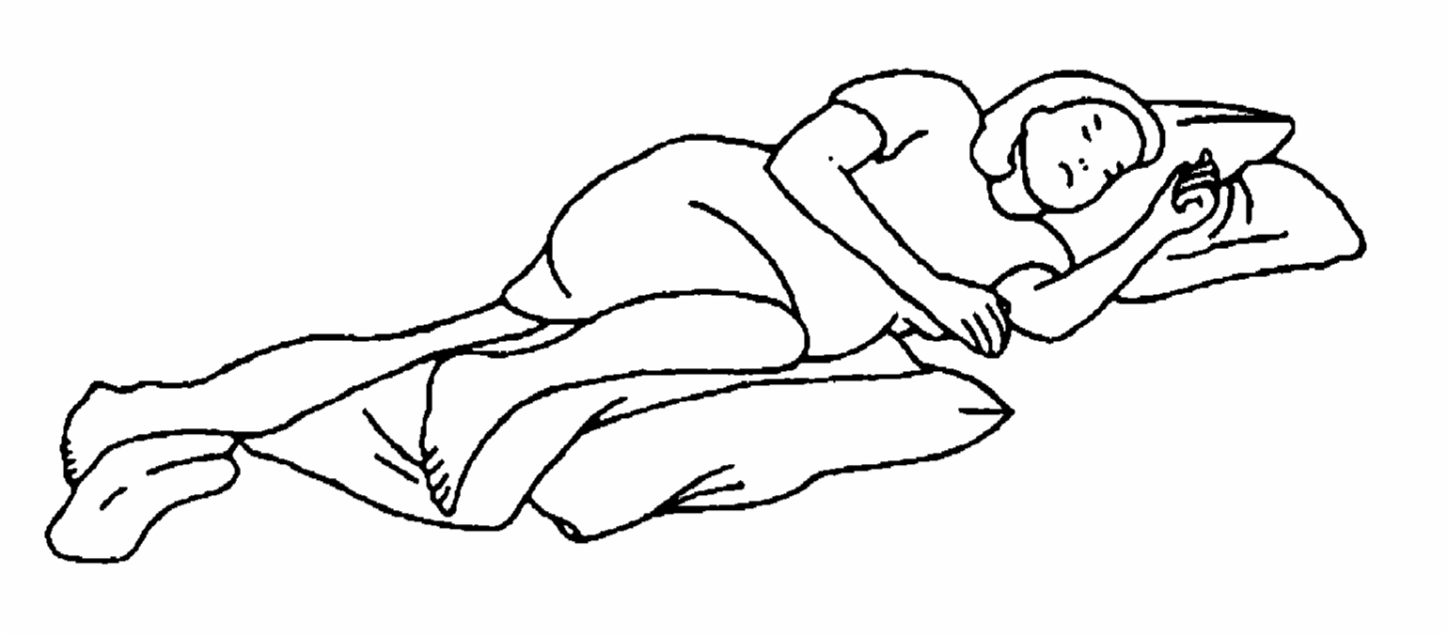

Warning Signs in Late Pregnancy.

**Call your doctor if you see any of these signs.**

* Bleeding. Bleeding (especially bright red blood from your vagina) at any time during pregnancy should be reported to caregiver immediately.
* Headaches, blurred vision, swelling of arms, hands, or face, pain right under your ribcage
* Sudden, unexplained weight gain.
* Decreased fetal movements.
* Signs of Labour before 37 weeks. For example, contractions of your uterus (four or more in an hour). Menstrual-like cramps. Dull ache in your lower back. Pressure in your pelvis, groin, or thighs. Increase / change in vaginal discharge, especially a gush of fluid.

Signs that Labour May Begin Soon / Has Begun*.*

*Possible Signs.* These symptoms do not necessarily mean that labour is going to start right away. It may be days or weeks before labour begins.

* Backache: Not the type of backache you have in late pregnancy that changes when you shift position, but an on-going dull ache that makes you restless and irritable.
* Cramps. Cramping in your belly that is mild to moderate in discomfort.
* PMS symptoms: crabby, irritable.
* Nesting Urge. A sudden irresistible urge to clean, or do projects to prepare for baby.
* Frequent, soft bowel movements or diarrhoea. Flu-like symptoms.

Preliminary Signs that labour may be about to begin.

* Bloody show. Pink mucus ‘plug’ or just thin, mucous discharge on toilet paper. If there is more blood than mucus, call caregiver. (Note, it’s common to have a brownish discharge within 24 hours of a vaginal exam, or intercourse.)
* Water breaks in a trickle or a gush.
  + Pay attention to what time it breaks, write down its colour, odour, etc.
* Braxton-Hicks Contractions. Also called “pre-labour” or “false labour” contractions. They don’t dilate the cervix, but they help cervix soften, thin, and move to anterior position.
  + Pre-labour contractions don’t progress: they may be irregular, or may stay same length, strength, and frequency. May last for a short time, or for several hours. Some women even start to develop a pattern: with contractions every 6-7 minutes for 2-3 hours, which then stop again.
  + Discomfort is mostly felt in the front of the abdomen, as muscles tighten up. May feel like your belly is a basketball.
  + Contractions may stop if you walk, change position or change activity, eat, drink, or empty bladder.

*Positive Signs of Labour. Labour has begun.*

* Gush of amniotic fluid from vagina.
* Progressing contractions: Get longer, stronger, and/or closer together with time. Are usually described as ‘very strong’ or ‘painful’, felt in the abdomen, back, or both. May start in the back, and radiate around to front. Usually increase if you walk.
* Dilation of cervix seen in vaginal exam.

**Class 2 – First Stage Labour**

Four-Breath Relaxation Technique (and a 2-Breath for when you need to relax in a hurry!)

Intros: What is your experience with labour and birth? Have you been with someone during labour and birth? Have you seen one on T.V.?

Early Labour

What does it feel like? What does it look like?

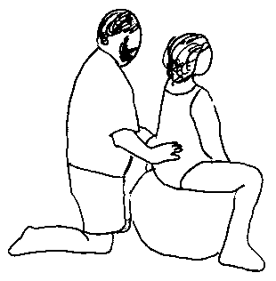Frequency and intensity of contractions. Mom’s mood.

How do I know if I’m making progress?

Timing contractions. Reminder of 6 ways to progress.

What should I do during early labour?

Alternate rest, relaxation, distraction, and labour-enhancing activities.

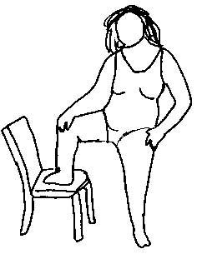An Early Labour Card Game

Active Labour

What does it feel like? What does it look like?

When is it time to go to the hospital?

What can I do to cope with labour and reduce pain?

Breathing Techniques: Hee-Hee. Hee-Hee-Blow.

Comfort Techniques: Brainstorming Exercise with Feedback.

Positions: Hands-On Exploration to figure out which ones work best for you.

Transition

What does it feel like? What does it look like?

What does mom need?

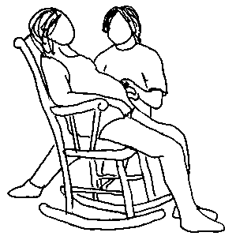What can help moms cope with transition?

Breathing technique: Variable Breathing

Take Charge Routine

Surrender to the Process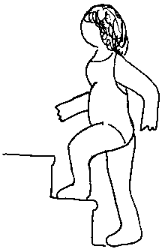

Break………………………

Video: Stages of Labour.

What choices can I make about my birth? How can I communicate those?

Birth Plans and Informed Consent.

What might my labour be like?

A dice game to explore possible labour scenarios, and think how you’d react.

Homework. Practice breathing techniques and positions

Discuss with partner: plans for early labour: where would you like to be? What do you want to do? What will help you remain calm and relaxed?

**Early Labor.** Cervix effaces from 50-100%, dilates to 4 cm. Contractions 5-30 minutes apart, lasting 15 to 45 seconds. Mom may want to focus during contractions, but *can* walk or talk if necessary. Can relax and chat between contractions. Early labor lasts 2-24 hours or more.

*Breathing techniques*: Don’t do any special breathing until you need to! When you feel like the contractions are starting to challenge you, begin basic breathing. Begin and end contractions with a deep cleansing breath, use deep abdominal breathing thru contraction.

*Comfort Techniques*: If it’s night-time, try to rest! (A warm bath might help you feel sleepy. If it’s daytime: be active for part of the time (go for walks, dance, go shopping, and work on a hobby you never have time for), but remember to rest too, so you don’t exhaust yourself.

*What should support people do:*

* Encourage mom to alternate rest, distracting activities, and labor-enhancing activities.
* Encourage mom to eat, drink, and go to the bathroom at least once an hour. Focus on easily digested carbohydrates, like bananas, nonfat yogurt, cooked cereal, eggs, graham crackers, toast, noodles or rice. Avoid fatty foods and acidic foods. Drink as much as possible; mostly water and unsweetened tea, since sweet drinks can cause nausea.
* Every few hours, or when labor seems to have changed: Time 5 contractions in a row, record when each began, how long it lasted, and how long since the *start* of the last one

**Active Labor**. Cervix fully effaced, dilates from 4-8 cm. Contractions 3-5 minutes apart, 40-70 seconds long, more painful. Active labor may last 30 minutes to 10 hours.

*Change in Mom’s mood:* During contractions, mom is not able to walk or talk, and is focused on contraction. In between, mom wants to focus on labor, and does not want distraction.

*When to go to the hospital*: Contractions no more than 4 minutes apart, lasting 1 minute, with that pattern established for at least 1 hour, *and* mom’s mood has changed.

*Breathing Techniques*: Deep abdominal breathing for as much of the contraction as is comfortable. Over the peak of the contraction, use hee-hee breathing or hee-hee-blow.

*Comfort Techniques for Active Labor*: Warm bath. Touch: Massage, Effleurage, Double Hip Squeeze Counter pressure. Hot/Cold: Heating Pads on back or belly, Ice Packs, cool cloths on her forehead and back of neck. Making noise: Singing, Moaning. Sensory Distraction: Music, Aromatherapy, Picture to focus on. Relaxation Techniques: Touch Relaxation, Visualization, Breathe in Energy and Strength, Breathe out Tension. Encouragement.

*What should support people do*? Remind mom to drink after each contraction, and go to the bathroom once an hour. Help with Comfort Techniques. Establish rituals by doing the same thing on each contraction. Let her rest sometimes, but remind her that being active can help labor to progress. Phrase things as positive suggestions, not criticisms.

**Transition**. Cervix dilates to 10 cm. Contractions 2-3 minutes apart, 60-90 seconds long. Intense. May be discouraged, scared, overwhelmed. May be trembling, hot/cold, and nauseous.

*How long will it last?* 10 minutes to 2.5 hours. Average is 1-1.5 hours in first time moms.

*Breathing Techniques*: Hee-hee breathing or hee-hee-blow. Counted hee-hee-blow, where partner tells mom how many hee-hees to do before each blow. Partners breathe with her.

*Comfort Techniques*: Any of the techniques and positions from active labor. Follow her cues.

*What should support people do*? Stay very close to mom, establish eye contact. Give short and simple directions; don’t ask a lot of questions. Speak calmly. This is the most intense part of labor for many moms, and mom needs lots of support and reassurance!

**Class 3 – Delivery. Labour Support**

Intros: Tell me some of your normal techniques for coping when sick or stressed.

Stage 2 Labour: Pushing and Birth

What does it feel like? What does it look like?

How will I know when to start pushing?

What are some helpful ideas for Stage 2 Labour?

Breathing Techniques: When pushing. When you are asked *Not* to push.

Spontaneous versus Directed Pushing.

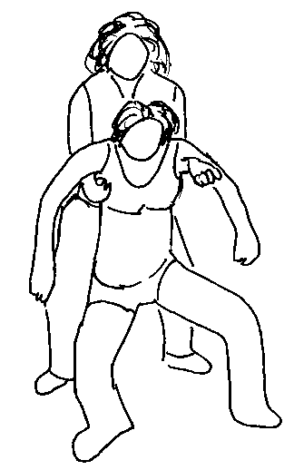Positions for Birth: Hands-On Practice and Evaluation.

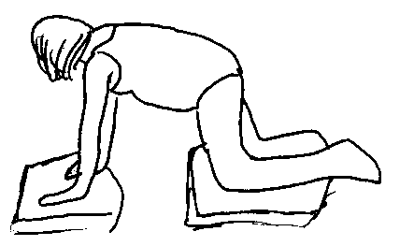What happens immediately after the baby is born?

Stage 3 Labour: Delivering the Placenta

Repair of Tears or Episiotomies

Initial Newborn Procedures

Labour Support

Who will support me during labour? What can they do to help?

Who: Partners, friends and family, doula, nurse.

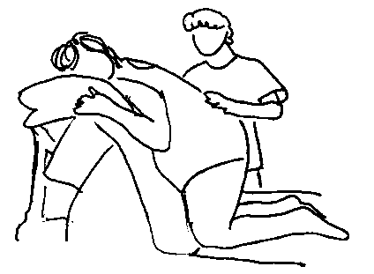What is labour support?

What is not helpful labour support?

Break

Video: Labour Support

Putting it into Practice: Labour Rehearsal

Relaxation Technique

Homework: Practice positions and breathing. Read chapter 12. Discuss, or explore through art or journaling: “What are my fears about labour and birth?”

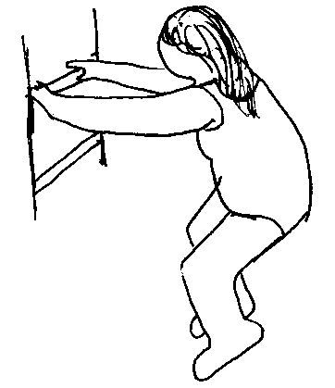Next week: Hospital Procedures, Pain Medication.

**Second Stage Labour: Pushing**

*What’s Happening*: Cervix has dilated, baby has descended and is ready to be delivered. Contractions continue, 3-5 minutes apart, lasting 45-90 seconds. Contractions may be accompanied by a strong urge to push. (May feel like a need to have a bowel movement.) Mom’s vocalizations may change to deep grunts or groans.

*How long will it last*? Anywhere from a few minutes to three hours. Typically 1-2 hours.

*When should mom start pushing*? Check with nurse or doctor before starting to bear down.

*Breathing Techniques and Bearing Down*: Caregivers will guide you. But generally: With each contraction, take in a deep breath, tuck your chin down, then bear down for five to seven seconds, while exhaling or gently holding breath. Then relax briefly, take in a quick breath. Then bear down again. Bear down three or four times during each contraction. In between contractions, take nice deep breaths and rest.

What happens if I want to push and caregivers say not to? Tilt head back to look at ceiling. Pant, or pretend to blow an imaginary candle out over and over again.

*Comfort*: Any of the comfort techniques from early and active labor. A cold cloth on her forehead or neck is especially popular.

*What should partners do*: Help support mom in chosen position? Help guide pushing efforts and breathing. Lots of encouragement and reassurance. Reinforce caregivers’ suggestions.

**Third Stage / Newborn Procedures**

Immediately after birth, they may place the baby up on mom’s belly, or may take it over to a warming table, depending on the condition of the baby and on hospital policy. The doctor will deliver the placenta: you may need to do a few more light pushes. Then the doctor will examine your perineum, and will repair any tears or episiotomy.

**Two Theories of Pain in Labour, and How Partners Can Help**

|  |  |
| --- | --- |
| The Triangle: When fear decreases, muscle tension decreases, and pain decreases, etc. | Gate Theory of Pain.  Nerve messages from the organs in the belly travel to the brain more slowly than messages from surface nerves, like those in the skin, and sensory organs. By sending lots of pleasurable messages to the brain on these fast pathways, you help to keep the brain too busy to focus on pain! |
| Partners: Reduce fear through information, reminders about what you’ve learned, and by showing her your calm confidence and faith in her ability. Reduce tension through breathing, relaxation techniques, and stretching to loosen up. Reduce pain through movement, reminders to go to the bathroom, massage, heating pads, etc. | Partners, be creative with lots of low-key pleasant sensations. Touch: Massage, light touch and stroking. Holding hands. Shower or Bath. Hearing: Music, encouraging words. Making Noise. Vision: focal points, pretty things. Smell: aromatherapy, familiar smells. Taste: comforting snacks in early labour, drinks throughout. |

# Class 4 – Hospital Procedures, Pain Medication

Intros: Birth Bag Exercise. What comfort items are you bringing to the hospital?

What will the hospital be like?

The “Unwritten Rules” of Hospitals

Triage

Vaginal Exams

Vital Signs

Fetal Monitoring

Food? Liquid? IV?

If I want to avoid pain medication, what will help me do that?

What are my options for pain medication?

IV, IM, Epidural

Analgesics (Narcotics) versus Anaesthetics

Advantages and Disadvantages of IV / IM medications

What is an epidural? How does it work?

The Epidural Role Play. Practice informed consent.

Advantages and Disadvantages of Epidurals

Maximizing the Advantages and Minimizing the Disadvantages

Video: Carl and Donna on Hello Baby

Practice session: positions, breathing techniques, etc.

Activity:

Homework: Discuss pain med preference scale with partner, and discuss how to make pain medication decisions during labour. Discuss (or journal) the following questions: What does pain mean to me? How do I usually deal with pain? How do our society / my upbringing tell me to deal with pain? What can I do now which will help me accept the normal pain of labour and not fight against it?

Read chapter 10 and 11.

Epidural Anaesthesia

Primary Benefits of Epidurals

* Effective pain relief (for 90-95% of women). Reduced pain related to contractions and to interventions such as Pitocin, forceps, and episiotomy, caesarean.
* Mother can remain clear-headed, think and converse normally, and can rest, often even sleep for a few hours while her cervix continue to dilate.

How is an epidural administered, and what equipment is involved?

* When an epidural is requested, an IV is started and intravenous fluids are given. Mom is confined to bed, and has placed on her: electronic fetal monitor, automatic blood pressure cuff, electrodes to monitor her heart rate, and often a catheter to empty her bladder. Mom may need oxygen mask at times during labour.
* Placing an epidural can take 15-25 minutes from the time the anaesthesiologist arrives. Mom sits, or lies on her side, with her back arched. Her back is cleaned, local aesthetic is injected, the epidural needle is placed, then the catheter is placed, and the needle removed. Mom must remain completely still for insertion, even through contractions. The catheter is taped to her back, and medication begun.
* Pain relief begins to take effect in 5 minutes. May take 15-45 minutes to reach full effect, and then will remain in effect until the baby is born and the catheter is removed.

What are the potential side effects of epidurals on mom?

* Contractions may slow, and labour may be longer. Pitocin augmentation may be used to counteract this: Pitocin is three times more likely in epidural labours.
* Blood pressure drops for 12% of women: treated with extra fluids and oxygen.
* 14.5% chance of fever over 100.4°; chance increases after 4 hours with epidural.
* Mom might experience itching, nausea, vomiting, and shivering.
* Mom may not be able to feel urge to push, may not be able to push as effectively.
* 12 of 15 studies show a significant association between epidural and c-section. Risk of c-section generally 2-3 times more likely with epidural. This is influenced by what point in labour the epidural was administered. One study found caesarean rates were 26% when epidural given at 4 cm dilation, increased to 33% at 3 cm, and 50% when given at 2 cm. So, the longer you can wait to have an epidural, the better.

What are the potential side effects of epidurals on baby?

* If mom has Pitocin, contractions can be long and strong, can reduce baby’s heart rate
* If mom’s blood pressure drops: decreased fetal heart rate, decreased oxygen supply.
* If mom develops a fever, baby’s heart rate may become rapid. Baby may develop a fever (30% chance.) If baby develops fever, may be treated for infection.
* Mild to severe “fetal distress” is diagnosed in 10 -15% of babies after epidural. Generally baby is fine at birth, but signs of fetal distress can lead to c-section…
* Baby may not be able to rotate as well into the correct position for birth. May be an increased risk of forceps, vacuum extractor, or caesarean birth.
* After the birth, there *may* be subtle side effects on the baby, such as decreased sucking ability, poor latch during breastfeeding, more difficult to soothe.

For more information, see discussion on my website, [www.transitiontoparenthood.com](http://www.transitiontoparenthood.com), or “So you Want an Epidural” by Kim James, <http://www.kimjames.net/epidural%20main%20page.htm>

Class 5 – Variations of Labour, Medical Interventions, Caesarean Birth.

Intros: Share a birth story you’ve heard that doesn’t seem to fit the pattern you’ve heard for what a “normal birth” is.

What if my labour starts before my due date?

What if my baby is overdue?

My doctor has mentioned inducing labour. What does that mean?

Reasons why a doctor would recommend inducing labour

Methods for inducing labour; Risks of inducing labour

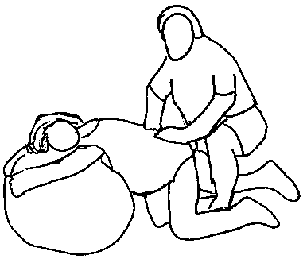Tests of fetal well-being: Kick counts, NST, CST

First Stage Interventions

What if first stage labour is moving really slowly?

Patience versus Augmentation

AROM and Pitocin

I’m throwing up a lot during labour. What should I do?

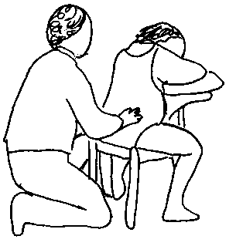Second Stage Interventions

Second stage is going slowly. What can I do? What might doctor do?

Refresher: normal length of labour, position changes

Episiotomy, Forceps and Vacuum Extractor

Caesarean Birth

Why would I need to have a caesarean section? Are there alternatives?

What are the risks of caesarean surgeries?

What is a caesarean?? How does it work? Video.

What is recovery like after caesarean?

What can I do to help avoid a caesarean birth?

Break

Back Labour and Convincing Posterior Babies to Rotate

What should I do if I’m feeling contractions in my back?

What other signs are there that my baby might be posterior? Video.

Labour Scenarios: Small group discussion, “practicing” how to deal with some of the variations that may come up in your labour process.

Homework: Chapter 14, 15. Write up birth plan, discuss with physician.

As preparation for writing your birth plan, look at the online birth plan tools at [www.birthplan.com](http://www.birthplan.com) or [www.epregnancy.com](http://www.epregnancy.com) these provide a good framework for you and your partner to discuss your desires and explore the options. However, I would not recommend giving this big and complex birth plans to your caregivers. Instead, take the most important, “big picture” concepts of how you want your birth to go, and write a short one page, “Introduction to Us, and Our Hopes for this Birth.”

# Some Helpful Tips for Minimizing Interventions (e.g. Induction, Episiotomy, Forceps, Vacuum Extractor, Caesarean Section)

# During Pregnancy

* Focus on good nutrition. Well-nourished tissues adapt better to the stresses of labour.
* Optimal Fetal Positioning: In the last six weeks, spend more time sitting up straight or leaning forward than you spend leaning back or reclining on your back.
* Know your options. The more you know about the range of options available to you, the better able you are to make the right decisions for you and your baby.
  + Educate yourself: Take classes, read books, ask questions.
  + With your doctor or midwife, discuss interventions, and what they do to avoid them. If you’re not comfortable with answers, consider changing caregivers.
  + Take a tour of the hospital. Ask lots of questions about routine interventions and standard policies, so you know what options are available to you.
* Practice positions, breathing, comfort techniques so you’re comfortable with them. Try to imagine what labour will be like, and how you will react. Do Kegel exercises.
* If doctor recommends induction, explore alternatives: is it possible to wait a few more days? Is your cervix favourable for induction? Are there tests for fetal well-being which would indicate how necessary induction is?

During Early Labour

* Stay at home as long as possible: your early labour will progress best if you are comfortable and relaxed, which is simply easier to do at home than in the hospital.
* Eat light meals throughout early labour: noodles, rice, crackers, non-acidic fruit, eggs, nuts, non-fat dairy products. Drink LOTS of water. Go to the bathroom every hour.
* Alternate rest, relaxation, and labour-stimulating activities.

After you arrive at the hospital

* Be active! Change positions frequently.
* Delay pain medication as long as possible. Wait till *at least* 5 cm dilated.
* Avoid/delay interventions associated with an increased risk of c-section: continuous electronic fetal monitoring, pitocin augmentation, artificial rupture of membranes.

During Pushing Stage

* Change positions frequently. Try hands and knees, semi-squatting, kneeling.
* Push 6-8 seconds at a time. No purple pushing: holding breath/straining for 10 seconds.

Throughout labour:

* Doctors may recommend a variety of interventions to speed labour along: induction to start labour, Pitocin or breaking your water to augment labour, forceps, vacuum, or episiotomy to speed second stage. If doctor recommends interventions, ask if there are alternatives. Ask if there is a reason why labour needs to be rushed. If you and baby are doing fine, it might be possible to avoid or delay these interventions.
* Be patient! Everyone’s labour is different, and having faith in your body and faith in the natural process of your labour is important. If you don’t think you’ll be able to be calm and confident, consider hiring a doula, or asking a friend or relative to help out during labour. Choose someone who supports your choices and has confidence in you!

Class 6 – Newborn Care and Feeding your Baby

Introductions: Tell me a little about your experience with taking care of babies, and also your familiarity with breastfeeding (friends and family?)

What do I need to do before the baby comes?

Get supplies: Car seat, diapers, and a few simple outfits. A sling. Place for baby to sleep.

Make decisions: Baby’s doctor. Cord blood donation. Circumcision? Breast or bottle?

What happens right after the baby is born?

Suctioning, APGARS, Cord-Cutting, Eye Care, Blood tests. Bathing and Measuring.

What do newborns look like?

Swollen genitals, stork bites, “cone heads”, birthmarks, milia, pimples. Jaundice.

What do newborns act like?

“12 months of pregnancy”. Baby Communication: Learning the language.

Can you teach us how to change diapers?

Diaper Changing Practice, Swaddling Practice

Discussion of: Meconium, breastfed baby poop, formula fed baby poop, diaper rash, etc.

How much will my baby cry? What can I do to help him stop crying?

A discussion of “typical” cry patterns, colic, and the effect of carrying baby on crying

“The Window of Opportunity”: Avoiding over stimulated, stressed babies.

How much will my baby sleep? What can I do to help him sleep better at night?

Frequent waking is a protective mechanism, which helps ensure survival.

Differences in sleep pattern based on where baby sleeps at night.

Break

Breastfeeding is supposed to be natural / instinctive. Why do we have to learn about it now?

How do breasts make milk? How much milk do they make?

Anatomy and Physiology. Supply and Demand.

How do I breastfeed my baby? How do I bottle feed my baby?

Positions, Latch. Switching sides, burping. Video.

When do I feed my baby? How often? How do I know it’s time?

Hunger Cues. Signs that Baby is Done.

How do I know my baby is getting enough milk?

6-10 wet diapers a day, gaining weight. Remember rules of supply and demand!

When should I first breastfeed my baby? When do I wean my baby from breastfeeding?

What are the early days of breastfeeding like? What problems might come up?

When do I introduce a bottle? How do I pump? How long can I store milk?

Homework: Chapter 13. Practice positions and breathing. Nurture your relationship!

Next week: Postpartum: Physical, Emotional, and Relationship Effects. Labour Rehearsal.

Getting Started with Breastfeeding

Day 1-5: Baby is getting colostrum. It’s low in volume, but has everything a newborn needs. There is no need to supplement with water or formula. Baby may be fussy or sleepy on day 3 or 4. This is normal; just nurse often to help your mature milk come in.

Day 5 or so. Mature milk begins to come in. After this, baby should have 5 or more wet diapers in every 24 hour period.

Breastfeed at least every three hours during the daytime, at least every 4 hours overnight. Some babies may want to eat much more often than this. That’s fine: feed on demand. Breastfeed for at least 5 minutes on each breast. May be 15 or 20 minutes per breast before baby falls asleep or loses interest in eating.

Hunger cues: rooting, tongue thrusting, sucking, wiggling. Crying is a late hunger cue!

Nipple care: Remember to break suction before taking baby off of breast. After nursing, hand express a little breast milk and rub that into your nipples to moisturize. Keep nipples dry between nursing, try to expose to fresh air and/or sunlight for at least 15 minutes a day.

Sore nipples: many women have sore nipples at some point in the first month. Check with lactation consultant to make sure your position and latch are good, follow nipple care recommendations above, and KEEP Nursing! (Nurse more frequently, for shorter periods.)

Getting Help with Breastfeeding

* La Leche League - information and support for breastfeeding women. Monthly group meetings and phone counselling. www.lalecheleague.org
* Call your local hospital or the Public Health department to find a lactation consultant.

Newborn Warning Signs

* Doesn't pass a greenish-black stool within 36 hours after birth
* Diarrhoea. Unusually frequent and very watery stools; blood or mucus in stools
* Fewer than five wet diapers in 24 hours (after day 4 or 5, when mom’s milk has come in)
* Dehydration: if you pinch the baby’s skin, it stays pinched up; wrinkled, crepe paper-like skin; dry mouth; dark yellow urine; sunken fontanel
* Fever higher than 100.4 degrees F, rectally, or above 99.5 degrees F, under the arm
* Jaundice: whites of the eyes are turning yellow; skin below the nipple line turning yellow
* White patches on the tongue or inside the mouth that don’t wipe off easily.
* Umbilical cord problems; Any redness around cord, foul odour or pus, bright red bleeding.
* Circumcision issues: bright red bleeding, swelling, foul discharge, unable to urinate
* Vomiting: forcefully or more frequently than usual (more than just spitting up).
* Feeding problems: repeatedly refuses feedings for more than 6 to 8 hours
* excessively or uncharacteristically fussy or irritable; unusually lethargic or sleepy
* Problems with breathing: signs such as blue lips, struggling to breathe, flaring nostrils, or deep indentations of the chest when breathing.

**If you see any of these in a baby less than 1 month of age, contact the baby’s doctor.**

Class 7: Postpartum adjustment, Labour rehearsal

Introductions: Tell me a story about a Physical Challenge that you have overcome, or about a physical skill that was hard for you to learn but that you mastered over time. How do you feel about this experience now?

Telling your Birth Story: In 5 Words or Less, what do you want your birth to be like?

How will I feel physically after the baby is born?

Physical Recovery from Birth: Lochia, Involution, Care of the Perineum, Elimination

How will I feel emotionally after the baby is born?

Lack of sleep makes everything harder to cope with: sleep when the baby sleeps!

Changes in your Self-Image, Changes in Priorities

Easy to feel out of control. Pushes you past all your normal coping mechanisms

Power of Peer Support!

Baby Blues / Postpartum Depression. Abuse. Reaching out for support.

What will happen to our relationship after the baby is born?

Division of Labour: What tasks need to happen, and who will do them?

Supporting your Relationship: Quality Time

Sex After the Baby Comes

Break with potluck snacks

Labour Rehearsal: A chance to practice your skills, and put together the information you have learned throughout the class.

Class Evaluations

Time for Questions

Schedule Reunion

**Postpartum Warning Signs:** Call doctor if you have these in first month after birth.

* Passage of a blood clot larger than a lemon. Heavy bleeding: soaks a maxi pad in an hour.
* Fever of 100.4 or higher.
* Problems with urination: Burning, or blood in urine, inability to urinate.
* Very foul or fish-like odour to vaginal discharge.
* Increased pain at site of episiotomy or tear.
* Swollen, red, hot, painful area on the leg, especially the calf.
* Sore, reddened, hot, painful area on breast, along with fever or flu-like symptoms.

**Postpartum Emotional Concerns**

|  |  |  |
| --- | --- | --- |
| **Baby Blues** | **Postpartum Depression (PPD)** | **Postpartum Psychosis** |
| 25-50% of new moms have baby blues.  Severity: Low. Seek support from friends and family. | 10-15% of new moms.  Severity: medium - high. Seek treatment promptly (support groups / counselling) | .1 – .2% of new moms.  Severity: High, possibly life-threatening. Seek immediate treatment! |
| May not be able to sleep well.  May cry a lot, over little things.  May seem irritable.  May feel inadequate.  May not feel like yourself. | Any baby blues symptoms, **plus**  May seem tired all the time  May feel unable to concentrate  May express guilt / inadequacy  May seem anxious, can’t cope  May not show interest in the baby.  May be hyper concerned about baby  May worry about harming self or baby  May have headaches / chest pains  May not care about appearance | Any of the other symptoms, **plus**  May not want to eat.  May seem confused.  May have severe mood swings.  May feel hopeless or ashamed.  May talk about suicide / hurting baby.  May seem hyperactive or manic.  May talk quickly or incoherently.  May act suspicious or fearful of everything.  May have delusions or hallucinations. |
| May start 3-5 days after birth. Fades after a few weeks. (After 2 weeks, may be PPD) | May begin 6-12 weeks after baby is born, or anytime in first year. | May begin anytime in the first year, or when breastfeeding baby is weaned. |

**Resources for New Parents**

General Information and Referrals

* + Children’s Hospital Resource Line
  + ……………

Education and Support for New Parents

Parent Education Programs for Parents and Children