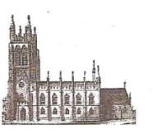
St Mary’s in the Marketplace
Well what is there to say, this Sunday (29th July) is the last time you will see St Mary’s in its present format.
After the service we will be clearing the north aisle ready to hand-over that area of the Church to Lambert Walker first thing Monday morning.
The builders compound will appear (where it was for previous works), scaffolding will be placed on the corners of the tower, over the nave roof and upwards to the tower roof in preparation for works to begin.
During the week the north aisle will be covered in, an electrical supply will be run to the temporary hospitality area in the south aisle and toilet facilities
placed outside the Church (location to be advised when we re-open next week). At the same time in the region of 50 pews will be moved into storage and items such as the grand piano re-located within the Church.

Everyone should be aware by now that St Mary’s will be closed from Monday, 30th July through to Saturday 4th August to allow Lambert Walker full access to the Church and for us to prepare to re-open on Sunday, 5th April for our 10.30am service (including Baptism) and we’ll be all decked out for the Olympics.
A busy week ahead…. Get your advanced copy of the August parish magazine for further details
More news next week!
