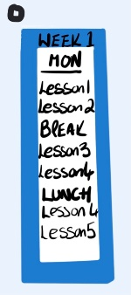
Timetable Fob
Two sets for if there is a
week 1 & 2 Timetable
Mon
Lesson 1
Lesson 2
Break
Lesson 3
Lesson 4
Lunch
Lesson 5
Lesson 6
Tue
Lesson 1
Lesson 2
Break
Lesson 3
Lesson 4
Lunch
Lesson 5
Lesson 6
Weds
Lesson 1
Lesson 2
Break
Lesson 3
Lesson 4
Lunch
Lesson 5
Lesson 6
Thurs
Lesson 1
Lesson 2
Break
Lesson 3
Lesson 4
Lunch
Lesson 5
Lesson 6
Fri
Lesson 1
Lesson 2
Break
Lesson 3
Lesson 4
Lunch
Lesson 5
Lesson 6

Mon
Lesson 1
Lesson 2
Break
Lesson 3
Lesson 4
Lunch
Lesson 5
Lesson 6
Tue
Lesson 1
Lesson 2
Break
Lesson 3
Lesson 4
Lunch
Lesson 5
Lesson 6
Weds
Lesson 1
Lesson 2
Break
Lesson 3
Lesson 4
Lunch
Lesson 5
Lesson 6
Thurs
Lesson 1
Lesson 2
Break
Lesson 3
Lesson 4
Lunch
Lesson 5
Lesson 6
Fri
Lesson 1
Lesson 2
Break
Lesson 3
Lesson 4
Lunch
Lesson 5
Lesson 6

Type out timetable, print out, cut out each day, stick on card and laminate, punch hole in the top, put on key fob.

