Nutrition Plus, Inc.
121 Mays Rd., Winfield, KS. 67156
Emily Roark Patti Brenn Susan Morrell
(620) 221-2777 (620) 218-1811 (785) 230-7441
roark2@cox.net pattibrenn@cox.net smorrell12@gmail.com
www.nutritionplusinc.com
October is:
National Apple Month
National Biscuit Month
National Country Ham Month
National Dental Hygiene Month
National Dessert Month
National Pasta Month
National Pizza Month
National Popcorn Poppin' Month
National Pork Month
National Pretzel Month
National Seafood Month
Vegetarian Awareness Month

Important Dates:

5th – Claim due
29th – Checks/direct deposits go out
31st – Happy Halloween!

Dental Hygiene Month
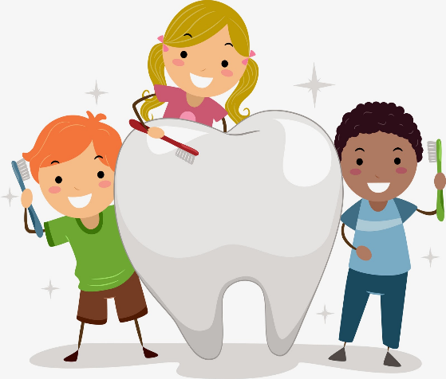
October 2021

Tooth decay is the most common chronic disease among youth in the United States according to the American Dental Hygienists’ Association (ADHA). A life skill every child needs to learn, is brushing his or her teeth. Helping them get in the habit of brushing is not easy, but getting creative can help, and it’s crucial for their long-term dental health. If you think you’re busy, try being a kid. In addition to school, activities and family time, they’re learning how to take care of themselves and others in new ways every single day. Here’s how to help them get started in a routine they’ll take with them forever!

*Start a routine and stick to it! Brush after breakfast in your daycare every day, so this becomes a natural part of their daily ritual.
https://www.mouthhealthy.org/en/kids-brushing-playlist Here is a link to songs you can sing or play while monitoring the brushing. YouTube has some as well. Always monitor brushing to avoid any excess swallowing of toothpaste.
*Reward Good Brushing Behavior! Stickers and a calendar are a great way to show the kids their progress. Set a length of time, number of days in a row, or a certain date to celebrate how well they’re doing at this lesson. You can celebrate with a party when they reach their goal.
*Avoid added sugars and drink more water. This may be a perfect time to help educate the kids on why these are important, since they’ll be dialed-in to oral health and its importance. One way to spot tooth decay early is to look for white spots on teeth. If left untreated, tooth decay can lead to pain, loss of teeth and serious infections.
*Have them bring their own daycare toothbrushes so they’ll be excited to use them. Remember to have them replace them every 3-4 months.
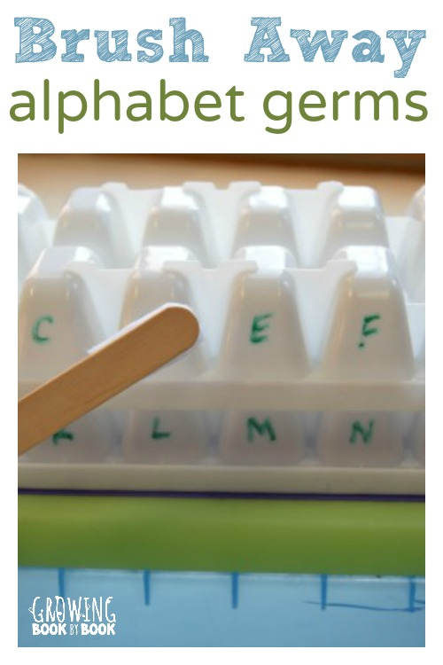
Materials Needed:
2 white ice cube trays
dry erase marker
craft stick
small piece of white felt
glue
- The ice cube trays represent the teeth. With a dry erase marker, write a letter of the alphabet on each “tooth”.
- Create a toothbrush by gluing a small piece of white felt onto the top of the craft stick.
- Time to play! Tell your child that the teeth are covered in alphabet germs and that it is their job to brush away the germs. Sing the song below as you play.

“I’ve Got All These Teeth In My Mouth”
(to the tune “He’s Got the Whole World In His Hands”)

I’ve got all these teeth in my mouth.

I’ve got all these teeth in my mouth.

I’ve got all these teeth in my mouth.

I’m going to brush them every day.

I’m going to brush the top teeth in my mouth.

I’m going to brush the bottom teeth in my mouth.
Dot’s Hashbrown Casserole

You Will Need: 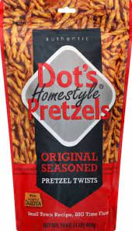
2 pounds frozen diced hash browns
1 1/2 stick butter
1/4 t pepper
1 teaspoon salt
1/2 cup onion
1 can cream of chicken soup (10 oz)
2 cups sour cream
2 cups shredded sharp cheddar cheese
2 cups Dot’s Homestyle Pretzels®, crushed

Directions
1. Preheat oven to 350 degrees.
2. In a large bowl, combine thawed hash browns with 1/2 cup melted butter and all the ingredients except the Pretzel Rub. Spread into a 9x13 baking dish.
3. Mix 1/4 cup melted butter and crushed Dot’s Pretzels and sprinkle over the top of the casserole.
4. Bake at 350 degrees, uncovered for 1 hour.
5. Serve hot.

You all have done a great job of keeping spirits up during this uncertain time. The kids’ mental health is as important as ours. We appreciate all you do to keep going every day.

