Carol & Nik White
The Old Vicarage, Station Road
Lowestoft. Suffolk
NR32 4QF
(01502) 450059
www.carolandnik.com

11th February 2021

Hey guys,

How are we all enjoying these snowy days? We love them (apart from the playhouse door fiasco of course!!) So many fab opportunities for play and learning with the little ones.

The Great Outdoors

We wanted to say a massive thank you to you all for your help with selling tickets and supporting our fundraising raffle at Christmas, we are pleased to say that we have booked a date in March for the installation of the artificial grass in the children’s play area which is going to make such a huge difference to the way we can use the outdoor space.

Early Years Funding

For those of you that are eligible for the 30 hours of Early Years Funding please don’t forget that you have to check and renew your eligibility every term for the following term. You should receive reminders from SCC but we know from experience that these don’t always come through. If you are new to the whole Early Years Funding situation and need any help or advice then please don’t hesitate to ask.

Children that Attend Multiple Settings

We’ve had a few conversations recently about sharing children’s funded hours between more than one setting. During normal times this would not present a problem however current DfE guidance which we are required (quite rightly) to follow states that children should not be attending more than one Early Years setting each week in order to keep virus transmission levels as low as possible. When this guidance will change is anyone’s guess, we don’t think anyone believed that this situation would have lasted this long, due to the way that Early Years Funding works the only sensible way to assess this is on a termly basis.

Attendance

We have been working with the Early Years Team at SCC to find ways to reduce the amount of physical back and forth with paperwork. Obviously, we developed our own electronic version of the Daily Diaries which, for the most part, seems to work quite well (when Nik isn’t trying to send them all quickly and sends the wrong ones!!!). This week we have received confirmation from SCC that we are no longer required to obtain signatures from you all to confirm the children’s attendance so as to further reduce the chances of virus transmission. We will of course continue to keep a record of everyone’s attendance as it is a requirement that we have that information for every child until they are 21 years old (You should see the number of boxes we have in storage!!)

Lateral Flow Covid-19 Testing

Illness

Holidays

Learning Journ eys

It’s been a busy few weeks getting all of the children’s

Much Love

Carol & Nik

Term Dates (for Early Years Funded Children)

Spring Term Begins – Monday 4th January
Spring Half Term – Monday 15th February to Friday 19th February
Last Day of Spring Term – Friday 26th March

First Day of Summer Term – Monday 12th April

Holiday Dates

Monday 10th May 2021 – Friday 21st May 2021

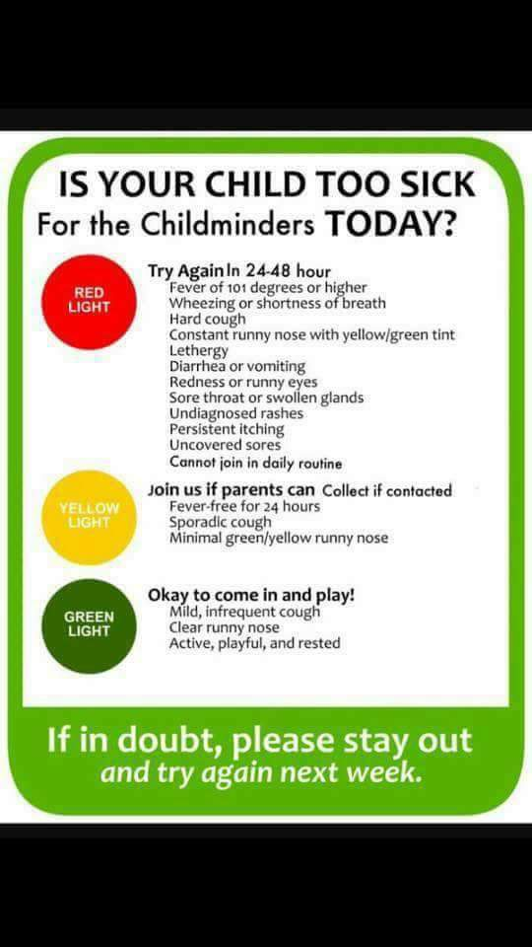
We will let you know the rest of our dates as soon as we have confirmed them.

