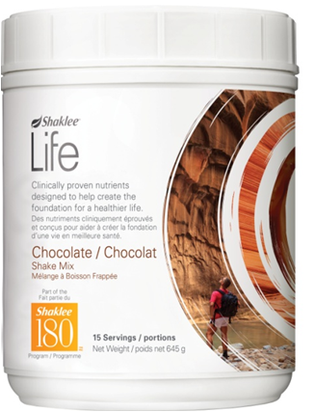
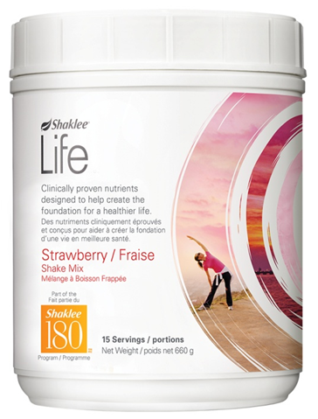
Shaklee Life Smoothie Mix

The Perfect Meal Shake from Shaklee

A Healthy, Delicious, Complete Meal

Keeps your ENERGY HIGH!
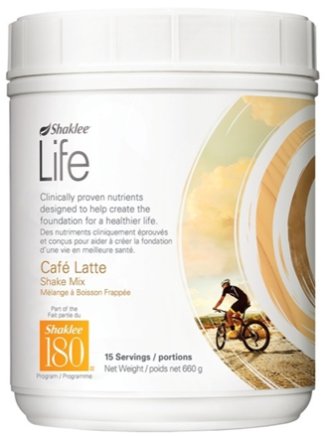
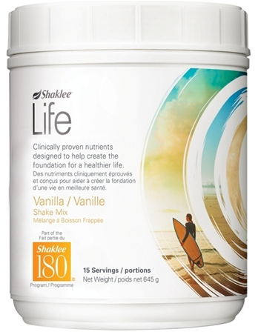
Four delicious FLAVOURS:


- Vanilla
- Chocolate
- Café Latte
- Strawberry

Available in a 15 serving canister or single-serving packets

1 scoop = a Healthy Snack ... 2 scoops = a Healthy Meal

Features:

- 24 grams of protein per serving when mixed as directed
- Powered by leucine (preserves and builds lean muscle)
- 23 vitamins and minerals
- 6 grams of dietary soluble fibre
- Calories: 260
- low glycemic (perfect for diabetics)
- Gluten free
- Lactose free
- Non-GMO soy protein
- No artificial flavours, colour or sweeteners

Shaklee Life Smoothies contain a proprietary formula of
Protein Amino Acids including LEUCINE

Say Good-bye to Cellulite!
Leucine deficiencies are often to blame for the build-up of FAT (the adipose tissue that
adds extra layers to the surface of the body. Increased leucine levels signal the body to shed this stubborn surface fat.

Build & Preserve LEAN MUSCLE!
Leucine stimulates protein synthesis and suppresses protein breakdown. Therefore, it helps preserve and build lean muscle. The body has more than 640 muscles, including your heart, arteries, capillaries, digestive system, etc. Leucine is a wonderful gift to every muscle of the body.

The amount of SOLUBLE FIBER in ONE SERVING of

SHAKLEE Life SMOOTHIE equals 6 grams … the amount in 2 ½ bowls of Oatmeal

Soluble Fibre acts like a “SPONGE” and absorbs:
- Toxins and takes them out in waste, thereby, helping to DETOXIFY the body
- Cholesterol and triglycerides and takes them out in waste … a natural answer to the #1 heart health problem today.

Who would Use Shaklee Life Smoothies?
People who want to loose weight
- The two-year-old’s mother who gained a little more than she wanted to when pregnant
- People with middle-aged spread
- The man down the street who can barely bend over to pick up his paper in the morning

People who are too busy
- Working people who rush off to work without breakfast every morning … students who often don’t take time for breakfast
- People on the run who “miss meals”
- Busy mom’s with little kids who take care of everyone else but themselves

People who want to lower cholesterol
- The six grams of fibre in the Shaklee 180 Smoothee acts like a sponge to absorb cholesterol and triglycerides and take it out of the body in waste

People who don’t eat well
- The elderly person who has great nutritional needs, but no appetite
- The sickly who have no appetite, but need excellent nutrition for health recovery.
- Children who are picky eaters

Diabetics
- People looking for a high protein / high fibre breakfast
- People who want to control carbohydrate cravings



Leucine signals the body to hold onto muscle while you lose fat.

- On traditional diets you lose both muscle and fat
- Fat takes up more space than muscle, so when you retain your muscle and lose fat, your shape can change much more dramatically than the number on the scale.
- Muscle powers your metabolism and determines how many calories you burn, so when you lose muscle, your metabolism slows down and you burn fewer calories.
- When you go off your diet it is very easy to regain your weight & you end up in a worse place than when you started, because 1 pound of fat burns ONLY 2 calories per day, and 1 pound of muscle burns 50 calories per day.
- Therefore, a smoothee with leucine to maintain 100% of lean muscle mass is a very excellent and wise choice.
- That’s why people talk about “the Myth of the Scale”. Let your favourite pair of jeans be your guide to gauging real progress.

Shaklee 180 Life Smoothies …

A Key to Weight Management & Hunger Satisfaction
Excess weight is not simply an issue of vanity, but a matter of life and death, since it increases the risk for diabetes, cancer, heart disease and hypertension! The American Cancer Society says that 90,000 cancer deaths could be prevented annually if people lost weight.

There is an endless assortment of diet regimens, books, and web sites all promising to take off excess weight for life. Although many diets are effective in the short term, nearly all ultimately fail because they don’t tackle the root causes of recurring hunger and cravings that lead to overeating.

Shaklee 180 Smoothies are part of Shaklee’s LOW-GLYCEMIC APPROACH to Weight Management, which differs significantly from low-carbohydrate diets because it encourages the consumption of many types of low glycemic carbohydrates, along with lean protein foods and heart-healthy fats.

Glycemic Index for each flavour of Shake (“Low” Glycemic is any food under 55)
 Chocolate – 37  Vanilla (Soy) – 31  Strawberry - 35  Café Latte - 34  Vanilla (Whey) - 32

