Strongest Keto Diet Pills : Advanced Fast Weight Loss Formula for Men and Women (60 Capsules / 2 Month Supply)

About this item
- Keto Plus+ is a scientifically backed and potent fat burning supplement
- Ideal for both men and women who are seeking rapid weight loss
- Unique formulation simultaneously speeds up the metabolism, suppress appetite and burns fat
- Proven To Work: Average Fat Loss Of 4-6lbs A Week!
- Manufactured within an FDA and MHRA approved facility for your highest level of safety.

Important information

Ingredients:
Advanced Keto Formulation:
Bitter Orange Extract (300mg per serving); Caffeine Anhydrous (110mg per serving); L-Phenylalanine (50mg per serving); Guarana (20mg per serving); Green Tea Extract 10:1 (50mg per serving); N-Acetyl-L-Carnitine (10mg per serving).

Product Description

Achieve Your Goals With Products Based On Science!
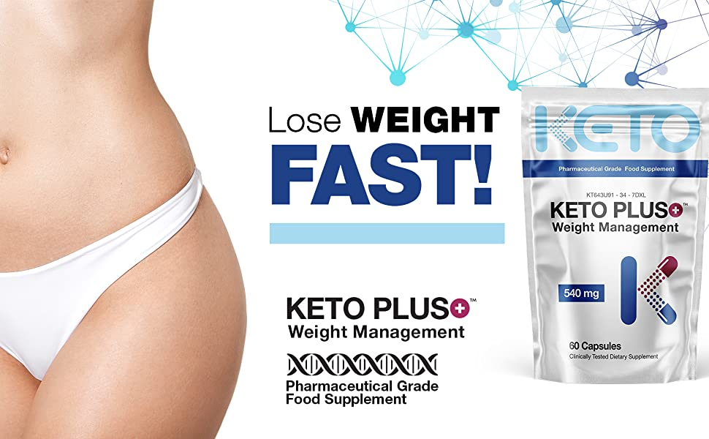
All ingredients are clinically proven to stimulate the mechanisms of ketosis and induce the complex systemic and powerful metabolic changes that speed up the metabolism, suppress appetite and burn fat! Combined the result is a dietary supplement essential for fast weight loss!
Keto Plus+ is formulated to facilitate optimal fat loss during ketosis. Under normal conditions, insulin enables glucose from the bloodstream to enter cells to generate energy. Keto Plus+ shifts the body's metabolism away from carbs and towards fat stores as a primary source of energy. Your body is able to burn through your fat rapidly by enhancing these fat burning pathways!
- Keto Friendly
- No Prescription required
- Formulated for Rapid Weight Loss *
* While this product has been specifically formulated to facilitate rapid weight loss. If you find yourself losing more than 7 pound per week, health care professionals recommend decreasing the dose.

Benefits

Reduced Hunger  Another advantage of Keto Plus+ is the ability to suppress appetite and hunger. It can effectively decrease levels of ghrelin - one of the body's main hunger hormones. By reducing ghrelin levels your body is tricked into believing that it's not hungry! Keto Plus+ is ideal on its own or can facilitate fasting! | Faster Metabolism  Keto Plus+ shifts the body's metabolism away from carbs and towards fat stores as a primary source of energy. By super charging the metabolism, Keto Plus+ enables the body to burn through your fat stores rapidly but most importantly, this enhanced formulation decreases the body's ability to store fat. | Enhanced Mental Performance  When in ketosis, the brain doesn't require dietary carbs. It is fueled around the clock by ketones alone with a smaller quantity of glucose synthesized in the liver. Using fat stores as an energy source, the flow is steady and you are able to avoid spikes and crashes with blood sugar swings. | Increase Physical Endurance  By accessing vast amounts of energy in fat stores, physical endurance will be increased. The body can only store carbs (glycogen) to facilitate a couple of hours of intense exercise, but fat stores can provide unlimited energy as long as there is fat to be burnt!
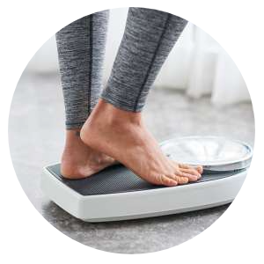

Results for Everyone - Every Time
One of the biggest benefits of to Keto Plus+ is the ability to inhibit an enzyme called amylase - a digestive enzyme that helps the body break down carbs to be easily absorbed. By inhibiting the breakdown of bonds in carbs and starch - when consumed they pass into the large intestine without being broken down and absorbed!
Keto Plus+ can drastically reduces carbohydrate absorption and launches the body into a ketosis metabolic state. When the body is in ketosis, ketones sever as an alternative, primary and more efficient energy source that are produced from the breakdown of fats. This happens because there is not enough carbs and glucose to meet the body's energy requirements.
The enhanced formulation then stimulates the complex systemic and powerful metabolic changes that speed up the metabolism, suppress appetite and burn fat! For anyone looking to lose weight fast, the improvement and stimulation of these natural processes is highly crucial and incredibly beneficial for weight loss.

Superior Standards
 |  | 
Directions For Use  This is an extremely potent product and should always be used responsibly.  Take one (1) capsule once per day. Ideally the dose should be taken in the morning on an empty stomach or at least 1 hour after eating, to increase absorption.  For an additional energy boost one (1) additional capsule can be taken 30 - 45 minutes before physical activity or exercise.  Do not exceed the stated dose. | Premium Quality Supplement  Every bottle is manufactured in a fully licensed facility, using only premium graded ingredients.  Rest assured that we would never consider manufacturing an item that did not fully meet these requirements. | Advanced Multi-Complex Formula  Keto Plus+ weight management capsules contain pharmaceutical grade ingredients that are recommended by leading health professionals for enhanced weight loss.  Each capsule has the absolute maximum potency concentration allowed for consumption under dietary supplement laws.

