Developing a Submariner’s Ontology (to appear in the winter, 2011 issue of Undersea Warfare)
Robert Arp, Ph.D.

Especially in times of strife, it is vital that submariners are able to exchange data and information quickly and accurately so as to perform their specific duties most optimally. Often times—strife or not—submariners, like most people, depend upon computer systems, databases, the World Wide Web, and various forms of information technology to retrieve, share, and re-use data and information. And again, like most people, they not only want to automate as many data exchanges as possible, but they also want to have computers do much of the reasoning concerning information that would normally require many hours of manual parsing and thinking. In the U.S. Naval domain there is an incredible amount of data dealing with personnel, day-to-day operations, surveillance missions, training events, wartime engagements, and other activities that need to be defined, kept track of, and secured in databases. One cutting edge approach that the U.S. Navy and other U.S. Armed Forces (as well as many businesses, organizations, industries, groups, and university researchers all of over the world) is using to categorize, classify, code, and curate data and information has to do with the development of ontologies.

Philosophical Ontology
The English word ontology is derived from two Greek words (ontos, meaning “being” and logos, meaning “science of”), and the modern-day usage of ontologies in information sharing and retrieval actually has a history rooted in Western philosophy. Dating back to philosophers such as Plato (429-347 BCE) and Aristotle (384-322 BCE), ontology in this traditional philosophical sense is a branch of metaphysics. From this metaphysical perspective, ontology seeks to provide a definitive and exhaustive classification of entities and relationships in all domains or spheres of being, along the lines of what Porphyry (234-305 CE) attempted with his now famous Porphyrian Tree, a section of which is illustrated in figure 1.

Figure 1: The Porphyrian Tree
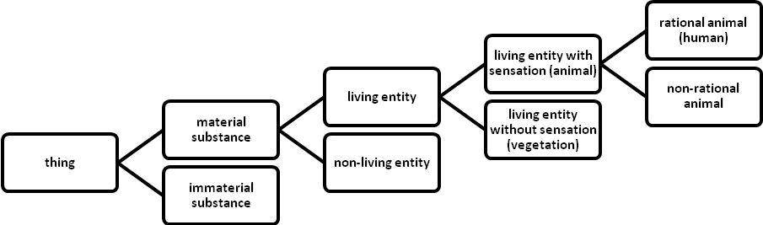

Notice in the figure that the Tree is a kind of taxonomy, a graph-theoretic, representational artifact that is organized into subsumed hierarchical relations with leaves or nodes (representing classes or types) and branches or edges (representing the is_a or is a kind of relation). Thus, rational animal is_a (kind of) living entity with sensation; living entity with sensation is_a living entity; living entity is_a material substance; material substance is_a thing.

In fact, people are naturally philosophical ontologists of one sort or another since all of us form systems of classification as we try to understand, navigate, control, and predict the complex workings of this universe. For example, we sort things into genus/species hierarchical relationships of greater and lesser degrees of complexity. Consider, too, all of the models, illustrations, schematizations, flow charts, and other pictorial renditions—like Linnean Cladistics (the biological kingdoms) in biology and the Periodic Table of the Elements in chemistry—that utilize a philosophically ontological categorization in order to capture the classification of entities and their relationships to one another.

Domain Ontology
Related to this philosophical sense, for the past twenty years (or so) ontology also has come to be understood as a structured, taxonomical representation of the entities and relations existing within a particular domain of reality such as geography, ecology, law, biology, medicine, aviation, or naval warfare. Domain ontologies, thus, are contrasted with ontology in the philosophical sense, which has all of reality as its subject matter.

A domain ontology, too, is a graph-theoretical representation, comprising a backbone taxonomic tree whose nodes represent classes (or types/kinds) of entities and relations. These nodes are connected by edges representing principally the is_a (is a kind of) relation, but also are supplemented by other edges representing binary relations such as part_of (meaning “is a part of”), preceded_by (meaning “is preceded by”), has_participant (meaning “has as a participant”), inheres_in (meaning “inheres in”), and further relations holding between these classes of entities. The following are examples of assertions found in domain ontologies linking classes together by means of such relations, complete with visual representations of the graphed linkages:
- cell nucleus located_in cell, meaning “The cell nucleus (as a type) is located in the cell (as a type).”
cell nucleus
cell
located_in

- X-ray test has_participant patient, meaning “The X-ray test has as a participant the patient.”
has_participant
X-ray test
patient

- verdict preceded_by court trial, meaning “The verdict is preceded by the court trial.”
verdict
court trial
preceded_by

- petroleum jelly transformation_of petroleum, meaning “The petroleum jelly is a transformation of the petroleum.”
petroleum jelly
petroleum
transformation_of

Figure 2 represents part of a graphed ontology devoted to the domain of MRI tests in the radiological sciences where we can see, for example, MRI test preceded_by referral and MRI test has_participant patient.
Figure 2: The Beginnings of an Ontology for MRI Tests

Further, the domain ontology contains properties and axioms that are designed to enable algorithmic reasoning on the basis of these relationships, so that new information about the underlying instances that comprise the domain of study might be inferred. For example, properties associated with is_a and part_of are transitive, enabling inferences such as:

- brain part_of nervous system, and
- nervous system part_of body,
  - therefore, brain part_of body.

- West Texas Intermediate petroleum is_a petroleum, and
- petroleum is_a flammable liquid,
  - therefore, West Texas Intermediate petroleum is_a flammable liquid.

- flask’s function is_a artifactual function, and
- artifactual function is_a function,
  - therefore, flask’s function is_a function.
In line with the goal of improving retrieval and dissemination of information, the purpose of a domain ontology is to make the information in the corresponding discipline more easily searchable by human beings and more efficiently and reliably processable by computational systems. Also, ontologies are designed to ensure that the different bodies of information collected by different researchers in the same domain should all be represented in the same way, which assists interoperability and shareability of that information.

Ontologies and the Semantic Web
It is now commonplace to find ontologies on the World Wide Web (W3), and they are the primary means of data exchange through what has come to be known as the Semantic Web (SW). Whereas the W3 consists of millions of Web pages all potentially linked together and accessible through search engines, interfaces, and Web services, the SW consists of millions of pieces of data (usually from Web pages) all potentially linked together and accessible through ontologies constructed using the Web Ontology Language (OWL), the Resource Description Framework (RDF), and the SPARQL Protocol and RDF Query Language (SPARQL). In fact, the SW is known as what it is—i.e., semantic—precisely because of the meaning, expressivity, and basic reasoning provided by OWL, RDF, and SPARQL.

Web Ontology Language (OWL) and Resource Description Framework (RDF)
OWL refers to a set of languages that are utilized to assist in the representation of ontologies on the SW, and, as such, contain a formal semantics and RDF-based rules specified for the SW. RDF is a data modeling approach that is based on the idea of modeling entities and relationships with a simple Subject-Predicate-Object format known as triples. Taking an earlier example, here is how this triple format is made manifest:

 | Subject | Predicate | Object
English sentence: | “The cell nucleus... | is located in... | the cell.”
Computational form: | cell nucleus | located_in | cell
Graph representation: | cell nucleus | located_in | cell

The resource part of RDF refers to the fact that the subjects, predicates, and objects of triples each have their own Uniform Resource Identifier (URI) that can be utilized to locate them on the W3 or in some database consisting of such URIs. Figure 3 shows some RDF and a graph associated with a description of Bob Dylan’s 23rd studio album, Empire Burlesque, released by Columbia Records in 1985. Here, the URI for the CD in this “fake” CD shop is “http://www. recshop.fake/cd#”, while the following triples are found:

 | Subject | Predicate | Object
English sentence: | “This CD... | has as its artist... | Bob Dylan.”
RDF rendering: | cd | artist | Bob Dylan
English sentence: | “This CD... | was produced in the country... | USA.”
RDF rendering: | cd | country | USA
English sentence: | “This CD... | was produced by the company... | Columbia.”
RDF rendering: | cd | company | Columbia
English sentence: | “This CD... | has as its price... | 10.90.”
RDF rendering: | cd | price | 10.90
English sentence: | “This CD... | has as its year of production... | 1985.”
RDF rendering: | cd | year | 1985

Figure 3: Example RDF and Graph

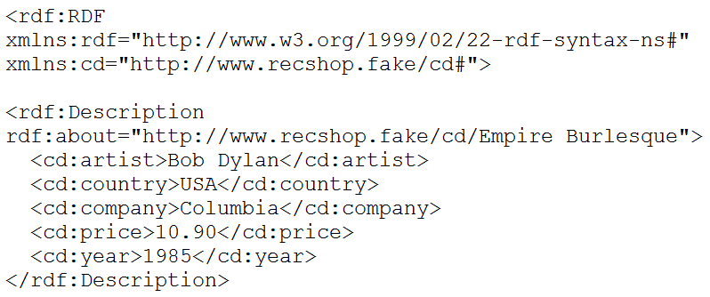
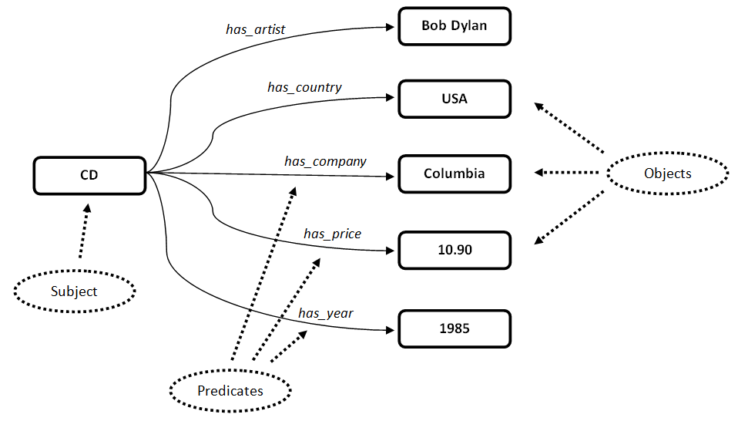

A machine can be set up to “read” and “reason with” the RDF, so to speak, and someone who works at the “fake” CD shop can query an RDF-based database set of triples and receive detailed information about Dylan’s recording. Further, because the subjects, predicates, and objects are tagged with URIs, this information can be placed on the W3 so that anyone in the world could query the fake CD shop’s inventory and database to learn about Dylan’s recording. In fact, because information about this recording—or about anything in any domain—is captured, modeled, and stored in a database in this common-sense Subject-Predicate-Object way, computational systems are achieving a kind of expressivity and scalability unheard of just ten years ago.

Essentially, an ontologist or other data modeler translates the entities and relationships from a domain into RDF triples, and then links all of these triples together through the formal semantics and rules specified by OWL so that the triples may be processed by computational systems or Web-based services. Fortunately, there are ontology-building tools that exist—such as Protégé and TopBraid—that make this job much easier.

SPARQL Protocol and RDF Query Language (SPARQL)
In conjunction with OWL, ontologists utilize SPARQL to query the RDF triples so as to make inferences about the ontology that are not readily apparent by a human or machine reasoner. For example, pretend that a new building has been built by a construction company, and an ontology was set up to model the construction company’s infrastructures of the buildings they construct, which all follow a similar floor plan. In the ontology of the floor plan, it is claimed that “fire alarm sensor X located_in Room 100” and “Empire Room located_in East Wing.” It is also claimed somewhere in the ontology that “Room 100 is_same_as Empire Room.” The concierge, Mary, whose desk is at the front of the building, has all of this information regarding the floor plan available through her computer’s database, but she is new employee since, after all, the building was just opened. Because Mary is a new employee, she does not know that Room 100 is the same room as the Empire Room.

Now pretend that fire alarm sensor X goes off in Room 100 and, within minutes, firemen arrive to put out the blaze that they understand to be in the Empire Room. So, they ask Mary, “Where is the Empire Room located?” Now, Mary has never heard of this room, but she’s quick and sharp. She does a SPARQL Subject-Predicate-Object query of her database’s ontology (composed of RDF triples) asking for “all of the rooms where Room (as a Subject) is_same_as Room (as an Object).” The SPARQL query comes back with “Room 100 (as a Subject) is_same_as Empire Room (as a Object),” and she quickly infers that the Empire Room (again, same as Room 100) is located in the East Wing of the building and directs the firemen there to put out the fire. This SPARQL query would look something like the following:
SELECT ?s ?o
WHERE {
?s is_same_as ?o
}

Further, since it was claimed somewhere in the ontology that “Room 100 is_same_as Empire Room,” a SPARQL query could have been utilized to infer that “fire alarm sensor X located_in East Wing” (since “fire alarm sensor X located_in Room 100,” “Room 100 is_same_as Empire Room,” and “Empire Room located_in East Wing”). Also, the results of the SPARQL queries can then be added to the ontology, making for greater expressivity of information to be found in the ontology.

OWL, RDF, and SPARQL offer an advance in the quest for artificially intelligent systems since, through their combined power and utilization, computational systems are not only able to exchange data and information quickly and accurately, but they can also be utilized to do some basic reasoning so as to discover new data points.
Beginnings of a Submariner’s Ontology
As noted already, the U.S. Naval domain is no different from any other domain in that there is an incredible amount of data and information that need to be defined, kept track of, and secured in databases. An ontologist utilizing OWL, RDF, and SPARQL can work with submariner specialists, for example, to model entities and relationships in the ways specified thus far in this article.

One of the first things that can be done to model the submariner domain is to create a graph of basic entities and relationships, along with definitions of the terms that represent those entities and relationships. Below I have begun a list of terms and definitions, which intentionally has been left incomplete.

A Few Classes or Types of Things:
- platform: the military’s generic term for any combat vehicle, be it a warship, a tank, or a plane. A vehicle is a mechanical means of conveyance, a carriage or transport.
- ship: a large vessel that moves through the water which has at least one continuous water-tight deck extending from bow to stern.
- submarine: a ship that is capable of independent operation below the surface of the water.
- strategic ballistic missile submarine (SSBN): a submarine that is equipped to launch ballistic missles.
- fast attack submarine (SSN): a submarine that is designed for a broad spectrum of open-ocean and littoral missions.
- land vehicle: …
- aircraft:
- surface combatant:
- fin:
- hull:
- propeller:
- crew: a body or a class of people who work at a common activity, generally in a structured or hierarchical organization
- submarine crew: a crew who work on a submarine.
- person: a human being capable of mental states, language, rational thought, full moral responsibility, and full rights and privileges in some society.
- yeoman: a role performed by a person in the U.S. Navy whereby that person is responsible for secretarial and clerical work.
- culinary specialist: a role performed by a person in the U.S. Navy whereby that person is responsible for managing and operating messes and living quarters.
- machinist’s mate: …
- electronics technician:
- And there are many other classes or types of things…

Figure 4: A Graph of the Beginnings of a Submariner’s Ontology

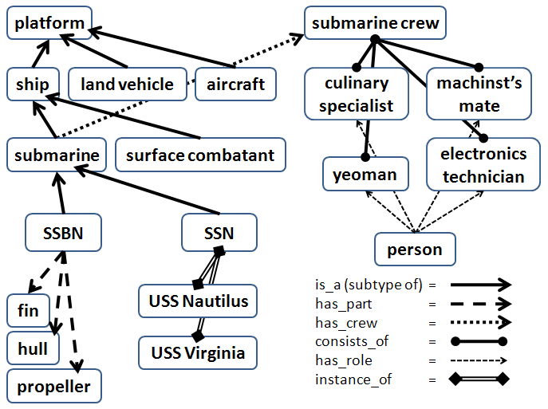

A Few Relations that Hold Between Classes
- is_a (subtype of): meaning “is a subtype or kind of”
- has_part: meaning “has as a part”
- has_crew: meaning “has as its crew”
- consists_of: meaning “consists of”
- has_role: meaning “has a role as”
- instance_of: meaning “is an instance or example of”
- And there are many other relations…

These classes, relations, and a couple of instances are represented in the graph in figure 4 where, for example the following RDF triples can be found:
- USS Nautilus (Subject) instance_of (Predicate) SSN (Object)
- submarine has_crew submarine crew
- submarine crew consists_of yeoman
- person has_role yeoman

Notice in the graph, too, that since “USS Nautilus instance_of SSN” and “SSN is_a submarine,” it follows that “USS Nautilus is_a submarine.”

A Submariner Ontology and a Data Environment
What has been presented of a submariner’s ontology thus far is quite simple and limited in scope. Once a fairly robust submariner’s ontology has been constructed utilizing OWL, RDF, and SPARQL, the RDF triples would likely be stored in a data warehouse in a secured data environment (given the sensitive nature of the data), along with the domain ontology OWL files. The OWL files not only give meaning to the data in the warehouse, but also can be used to query, and engage in some reasoning about, the data. Then, if an authorized person—or even an authorized system—wants to access data in the warehouse, the ontology can assist in the effectiveness of that access.

Figure 5: A Query Sent to a Submariner Ontology in a Data Environment

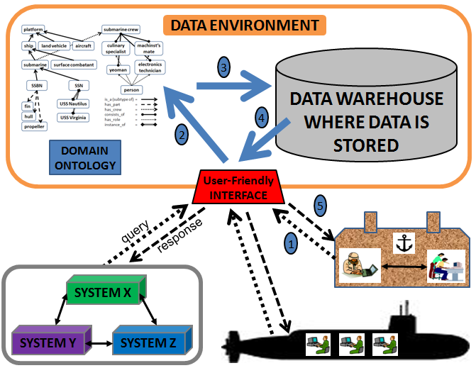

Figure 5 illustrates how a system, submariner, or naval officer would send a query through some user interface to the data environment. The dotted line next to oval 1 represents a query being sent to the data environment by a naval officer at her desk through the user-friendly interface on her computer. Of course, there would likely be a series of authentications and certifications he would have to go through to even be able to access the data environment in the first place. Let’s say his query is this: “Who are the typical members of the crew that comprise a fast attack submarine (SSN)?”

The processing in the data environment occurs behind the scenes, so to speak, and the thick blue line next to oval 2 represents the query being sent to the ontology in the data environment. Next, a SPARQL query would work with the ontology to find the appropriate RDF triples in the data warehouse that would be relevant to the query, and the thick blue line next to oval 3 represents this process. Then, a response would be generated and sent to the user-friendly interface in the form of RDF triples, and the thick blue line next to oval 4 represents this process. Finally, the dashed line next to oval 5 represents a response being sent back to the naval officer through the user-friendly interface on her computer. A similar query-response process would occur for systems or submariners during active duty, as is also illustrated in the figure.

Important Work to be Accomplished
For many years now, the U.S. Department of Defense has been proffering the idea of net-centric operations whereby a networked community of machines and humans contributes to information sharing, common situational awareness, collaboration, synchronization, and, hence, speed of command and control resulting in mission effectiveness. There are communities of practice, communities of interest, integrated product teams, and others in the U.S. Armed Forces that are in the process of building ontologies with OWL, RDF, and SPARQL, including the Maritime Domain Awareness community of practice (see, for example, http://www.dhs.gov/ xlibrary/assets/HSPD_MDAPlan.pdf). These groups already realize the importance of net-centricity, no doubt. However, these groups are just now beginning to realize the importance of ontologies in making net-centricity a reality.

For readers who are interested in finding out more about ontologies and the Semantic Web, see Semantic Web for the Working Ontologist, by Dean Allemang and Jim Hendler (San Francisco: Morgan Kaufmann, 2008). This is a standard text utilized by working ontologists, and Dean Allemang gives regular courses based on the book through his company, TopQuadrant.

For readers who are interested in OWL as a standard offered by the members of the W3C, see http://www.w3.org/TR/owl-features/. For RDF standards put forward by the W3C, see http://www.w3.org/TR/2004/REC-rdf-syntax-grammar-20040210/. For SPARQL standards put forward by the W3C, see http://www.w3.org/TR/rdf-sparql-query/.

For readers who are interested in finding out more about the history of ontologies with respect to information science, start with this seminal paper by Tom Gruber from 1993: “A Translation Approach to Portable Ontology Specifications.” Knowledge Acquisition (1993) 5(2): 199-220.

