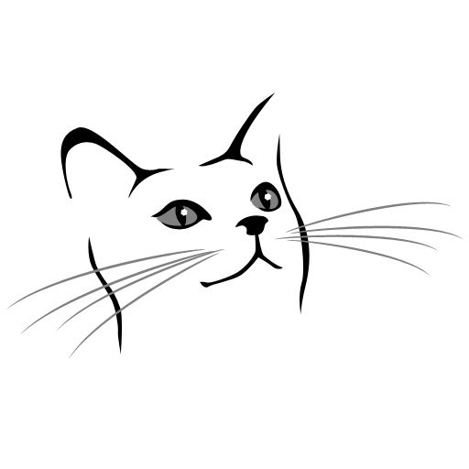
Focus On Ferals, Inc.
P.O. Box 56
Uncasville, CT 06382
Focusonferalsincct.org (website)
Focusonferalinc66@gmail.com (email)
(860) 884-1439

KITTEN/CAT ADOPTION APPLICATION

WE ONLY NOTIFY YOU IF YOU HAVE BEEN APPROVED
WE DO NOT GIVE OUT REASONS WHY APPLICATIONS ARE DENIED
ONCE PAID THE ADOPTION FEE AND/OR HOLD DEPOSIT ARE NONREFUNDABLE

ADOPTION PROCESS:

- Complete the application. Please make sure to answer ALL questions completely. We notify you within 3 business days only if you are approved.

- If your application is approved, a Meet and Greet appointment will be made with you.

- If the cat or kitten you are interested in is not fully vetted or needs vetting under special circumstances before the final adoption, a Foster To Adopt Contract will be executed. (Will be explained in detail during a phone conversation or at the Meet and Greet).

- If your application is approved and the cat or kitten you wish to adopt is fully vetted, we deliver the cat to your home and execute an Adoption Contract at that time.

- If for any reason, the cat or kitten is not a good match for your family, the cat or kitten MUST be returned to Focus On Ferals, Inc.

- The adoption fee is nonrefundable.

Name of cat(s)/kitten(s) you are interested in: ________________________________________

How did you hear about us? ______________________________________________________

YOUR FULL NAME(S) _______________________________________________________

STREET ADDRESS __________________________________________________________

CITY/STATE/ZIP ____________________________________________________________

PHONE NUMBER(S) _________________________________________________________

EMAIL(S) ___________________________________________________________________

EMPLOYER(S) ______________________________________________________________

EMPLOYER(S) PHONE NUMBER(S) ___________________________________________

Do you OWN or RENT? OWN RENT

If RENT, please provide landlord name and phone number:

______________________________________________________________________________

Are all members of the household in agreement to adopt? YES NO

Please list the NAMES AND AGES OF ALL ADULTS, INCLUDING YOURSELF, AND HOW THEY ARE RELATED TO THE ADOPTER in the home:

_____________________________________________________________________________

_____________________________________________________________________________

Please list the NAMES AND AGES OF ALL CHILDREN in the home:

_____________________________________________________________________________

_____________________________________________________________________________

Please list any CURRENTLY OWNED PETS LIVING IN THE HOME (include name,
species/breed, if they are spayed or neutered, color and age):

_____________________________________________________________________________

_____________________________________________________________________________

_____________________________________________________________________________

Please list any PREVIOUSLY OWNED PETS (include name, species/breed, if they were
spayed/neutered, color and age) and what happened to them:

_____________________________________________________________________________

_____________________________________________________________________________

_____________________________________________________________________________

Presently owned kitten(s)/cat(s): (circle all that apply) indoor only indoor/outdoor

Previously owned cats: (circle all that apply) indoor only indoor/outdoor

Kitten(s)/cats(s) you wish to adopt: (circle all that apply) indoor only indoor/outdoor

Are/were any of your kitten(s)/cat(s) declawed? If so, what is the reason why?

Do you plan to declaw? If so, why?

Please describe the personality of the kitten(s)/cat(s) you are looking for and what you feel is the ideal kitten/cat for your home:

VETERINARY INFORMATION

PLEASE PROVIDE BELOW THE NAME(S) AND PHONE NUMBER(S) OF ALL VETERINARIAN(S) USED FOR ALL PAST AND PRESENTLY OWNED PETS. WE REQUIRE A COMPLETE VETERINARY HISTORY, NOT JUST INFORMATION FROM YOUR LAST VISIT.

PLEASE CONTACT YOUR VETERINARIAN(S) TO GIVING THEM AUTHORIZATION TO SPEAK WITH US TO VERIFY VET REFERENCES. FAILURE TO DO SO WILL DELAY THE ADOPTION PROCESS.

__________________________________________________________________________________________

__________________________________________________________________________________________

__________________________________________________________________________________________

Please read and initial below to better understand our adoption process:

I understand choosing a pet is an important decision for my entire family and I will work with Focus On Ferals, Inc. to choose the kitten(s)/cat(s) who are the best fit for my family. _____intials

I understand the adoption process includes: a completed application, a check of your vet references, permission from landlord (if applicable), home ownership verification (if applicable), in person interview in order to meet kitten(s)/cats(s) wishing to adopt, and a home visit with all family members present. _____initials

I understand my responsibilities as an adopter includes: providing my new pet with future veterinary care, including check-ups (which may include bloodwork if applicable), vaccinations or titer tests, flea/tick preventative medications, etc. I will be solely responsible for the health, safety, and behavior of my new pet. _____initials

I understand that yearly general expenses for food, veterinary care, enrichment materials, etc., per year, can range anywhere from a minimum of $1,000.00 and up, depending on veterinary care needed, especially as my kitten/cat ages, which may include, in addition to routine yearly physicals and vaccines, dental procedures and bloodwork. _____initials

If approved, I understand Focus On Ferals, Inc. delivers the adopted kitten(s) and/or cat(s) to the new home. ______initials

By completing and signing this document, I/we agree to all terms listed herein.

Applicant Signature____________________________________________ Date__________

Applicant Signature ____________________________________________Date__________

For internal use only

