Estrogens made by the Human Body:

The body makes several estrogens … Three main estrogens (Estone, Estriol and Estradiol + micro amounts of approximately 9 other estrogens).

The focus is on the three main estrogens:
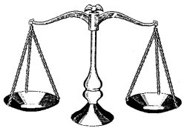

- Estrone - E1 10%
- Estriol – E3 80%
This BALANCE is critical
- Estradiol – E2 10%

WARNING!
Most traditionally prescribed estrogen hormones contain 100% ESTRADIOL!
(examples: birth control pill, premarin, estrace, estraderm, estrogel, etc.)

Symptoms & Side Effects of this IMBALANCE which is NOT in Harmony with Nature!

Obvious Symptoms
- Depression / irritability / anxiety
- Headaches / dizziness
- Fluid retention
- Weight gain
- Decreased sex drive
- Fatigue
- Nausea
- Loss of scalp hair

Silent Symptoms
- Reduced thyroid performance
- Liver dysfunction
- Rise in blood pressure & blood clots
- Gallstones
- Lower DHEA (acceleration of aging)
- Cancer (35-50% increased risk after 5 to 7 years)

NOTE: Among the three estrogens, ESTRADIOL is most stimulating to the breast and ESTRIOL the least. ESTRADIOL IS 1000x MORE POTENT IN ITS EFFECTS ON BREAST TISSUE than estriol. Over exposure to estradiol increases one’s risk of breast cancer, whereas estriol is protective.
NOTE: usually a woman will notice and complain about 4 to 6 of the OBVIOUS symptoms

… but she is often totally oblivious of the SILENT symptoms

