**Fitness Tips**

**Prepared by: Jeanne Warren, HDCCW Member**

1. Don’t overdo it! If you haven’t been regularly exercising, start with 30 minutes 3 times a week and increase your time each week.
2. Invest in a good pair of walking or running shoes. Old shoes can negatively affect your joints and ligaments.
3. Warm up and cool down. Warm up with some good stretches before your workout to help prevent injuries. Cool down with stretching afterwards.
4. Keep hydrated. Drink plenty of water before and after exercising. Sports drinks and coconut water are also good. Signs of dehydration are: feeling very thirsty, dry mouth, dry skin, dizziness and muscle cramps.
5. If you injure a joint apply ice for 20 minutes, and elevate it. If necessary, call your doctor.
6. If you are having trouble getting motivated, find a walking buddy. Make sure you keep proper social distance.
7. Have fun! Exercise is a great stress reliever; fresh air is good for you and you will be healthier.

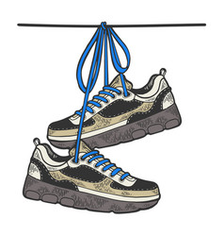**Walk to**

**Bethlehem**