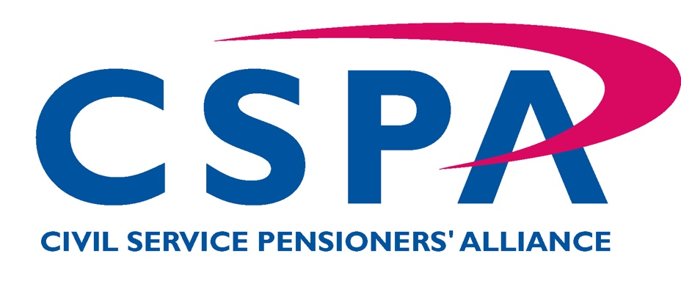

Northern Ireland Branch

APPLICATION FOR CSPA FULL MEMBERSHIP

Please complete in BLOCK LETTERS and return to:
Freepost BE 719, (No stamp is required)
Civil Service Pensioners’ Alliance- Northern Ireland Branch,
54 Wellington Park
Belfast
BT9 6DP

Applicant’s Details
Title: | Forename: |  | Other initials: |  | Surname: |  | Nat Ins No:
Date of  Birth: / / |  | Date of  Retirement: / / |  |  |  | Pensioner Reference No:
Address: ______________________________________________________________

___________________________________________________ Postcode: _________

Email Address: |  |  |  | Telephone Number:

Members are encouraged to make payments by standing order/direct bank transfer/internet banking to the Branch’s account using the following details:

AIB/First Trust Bank, 11-15 Donegal Sq North, Belfast BT1 5GB
Account: Civil Service Pensioners Alliance (NI Branch)
Sort Code: 938623
Acccount no: 01595030

Please quote your SURNAME AND POSTCODE as reference.
If alternate payment methods are required please contact our membership secretary Roisin Lilley.

(Please delete one of the following options)

I wish to join the Civil Service Pensioners’ Alliance and I authorise until further notice deduction of subscriptions from my pension for payment to the Civil Service Pensioners’ Alliance, the sum of £1:50 per month via the Department of Finance and Personnel, Duke Street, Londonderry.
I agree that the deduction rate may be varied if subscription rates alter.
Or
I wish to join the Civil Service Pensioners’ Alliance and I have set up an annual standing order/bank transfer of £18:00 to the Civil Service Pensioners’ Alliance

I agree to the use of my personal contact details to enable CSPA to make marketing calls, send texts or emails about membership benefits to be notified to me.
Tick here
(Please tick box to indicate agreement)

Signature: |  | Date:

I also enclose a donation of £ to assist in the work of the Alliance
(This is entirely voluntary)

