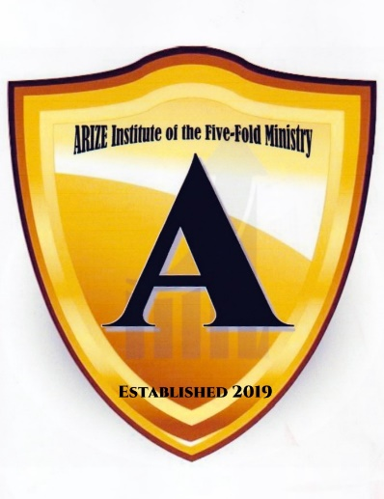

Arize Institute of the Five-Fold Ministry

Honorary Doctor (explanation extended)

At ARIZE we have captured what has been done more than 500 years ago to build relationships with people of character, missions, those who aid the poor, etc.
An honorary degree is not an academic degree for which a school of higher learning, namely ARIZE waives all of the usual requirements, such as matriculation, attendance, course credits, a dissertation, and the passing of comprehensive examinations. For this Institute of the Five-Fold Ministry an Honorary Doctor Degree know in the phrase honoris causa or ad honorem typically is less or commonly, among others degrees such as a master's degree, is awarded to someone who has no prior connection usually with this academic institution or no previous postsecondary education.
We at ARIZE Institute of the Five-Fold Ministry honor those with Honorary Degree because of several reasons: - not to just to give someone a piece of paper stating that they are an Honorary Doctor or Master of some field. We do it because it is:

- An acknowledgment of good work done in a field in which the ARIZE Institute
of the Five-Fold Ministry is engaged.
- Provides the person with a notoriety of their achievements and gives merits to such. Witnessing merits to what they have done in a religious arena (For the work of Christ) or in their community, state, or abroad.
- A recognition of his/her contribution in some generous and commendable ways/skills to society through his/her involvement in business, research, art and through gifts-giving, and many other avenues.

