FUND RAISER
GOAL: $10,000.00 to launch the Family Solution Finder Learning Centers “Mobile Seminar Library Trailer”
CONCEPT: To bring a tangible experience into the realm of family of learning about their journey with substance use disorders. Our Mobile Seminar Family Library Trailer” will raise awareness that empowerment through knowledge is possible and available. It will address stigma and increase prevention while building community collaboration. In the end we hope to excite the idea of sharedness in this epidemic. We will meet the family where they are, schools, Community Events, Sporting Events everywhere they go we can now goes, because this drug epidemic is everywhere, so to needs to be knowledge. We will suffocate is through proactive learning and family education.

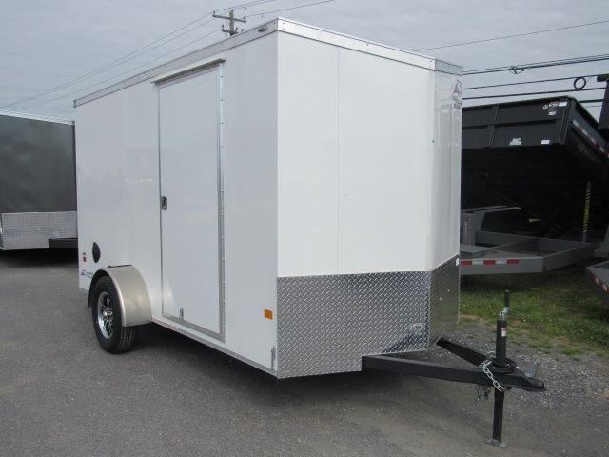

The Family Solution Finder Learning Centers
“Mobile Seminar Family Library Trailer”.

Discover the Family Journey with Substance Use Disorders

Mobile Seminar Family Library Trailer

Graphic for Right Side of Trailer Panels
EDUCATION FOR FAMILIES
DEALING WITH ADDICTIONS
FamiliesImpactedByOpioids.Com
Cleveland, Ohio
440.385.7605

Graphic for Left Side of Trailer Panels
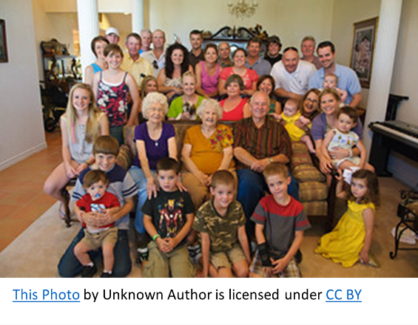
EDUCATION FOR FAMILIES
DEALING WITH ADDICTIONS
FamiliesImpactedByOpioids.Com
Cleveland, Ohio
440.385.7605

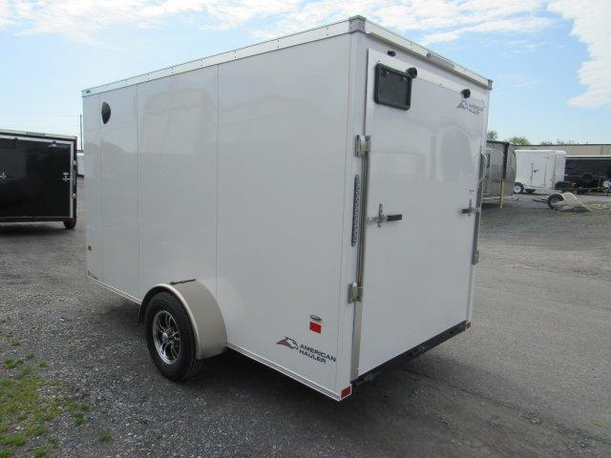

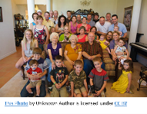

Graphic For Back of Trailer Panel

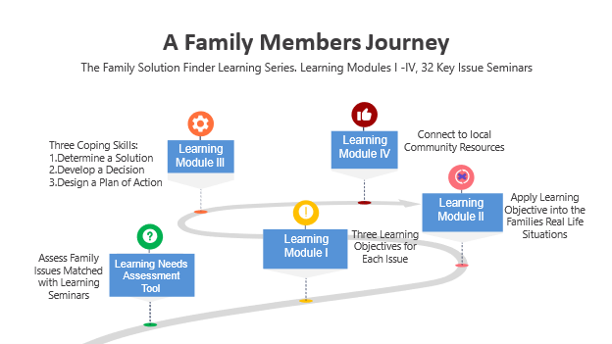
Familiesimpactedbyopioids.Com
440.385.7605

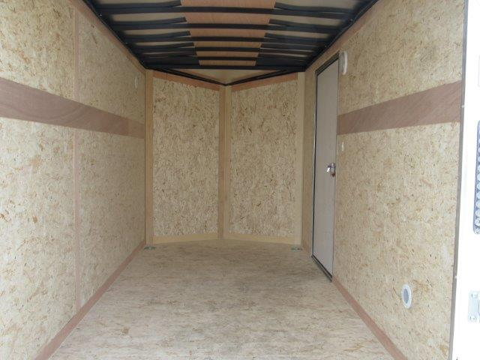

Colors for Walls
- Left Side: Color Pastel Green
- Front: With a Shelf for Flat Screen TV and Laptop: Pastel Purple
- Right Side: Pastel Yellow
- Ceiling: Sky Blue

Inside Purpose: Educate the family about their journey and the issues, visually gaining access to their other senses, touch, sight, emotion, sound, Smell.

PRIMARY MESSAGE: This is The Families Life Journey when living with substance use disorders.
Knowledge is Empowerment

Stepping inside the trailer, these are the wall displays

STATION ONE GRAPHIC, inside Left wall back of Trailer
Left Side Color Pastel Green
Message “Impact on the Family, Creates a Need for Knowledge”
Top of Wall: The Family Journey Timeline
- The substance user Timeline is a lifelong journey: Using has become known / Their Behavior / Police or Emergency Room Overdose / Drug Court or Jail / Treatment Center / Relapse / Financial Stress / Lifelong Recovery or Bereavement
Bottom of Wall: The Family Learning Timeline
- The Family Members Lifelong Journey Timeline of Learning:
Family Dynamics / The Disease / Community and Family / / Plan of Action

STATION TWO GRAPHIC, inside Left wall front of Trailer
Ham Reduction & NARCAN display, Get Organized Message.

STATION THREE GRAPHIC, Inside Point Front of Trailer
Front Point of Trailer: Large Flat Screen with a short looping video about the impact to a family with a Video on reinforcing the family as a system with knowledge.

Inside Floor: Light Gray Paint, Porch Paint brand

STATION FOUR, Inside Right Side front of trailer
Message: “Educate the Community Stakeholders about the Families”
Community Stakeholder Books.
From Coach, Employer, Counselor, Police, Courts, Community Agency, Pastor to family table 12 seminar books.

STATION FIVE, Inside Right Side Back of Trailer

Invest in the Family Ministry Program: THEAM The Churches have a role to play.
Specialty Court Program THEAM the courts are a place where families are engaged.

On inside Ramp Door Floor: Color Dreamy Cloud Gray with slip prevention strips.

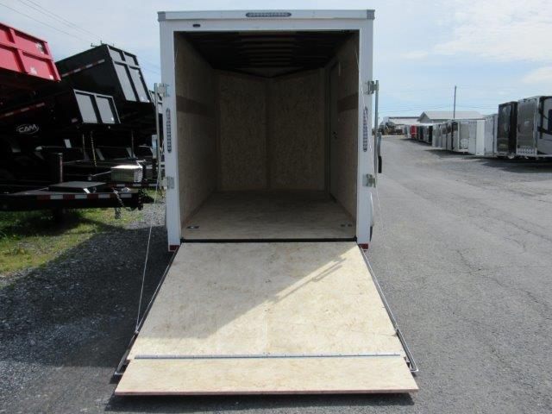

Traffic Cones placed around the trailer.
Table, chairs and carpet outside trailer for discussions when the exit. Orange Tent over outside area with banner. Ice Chest with water with water. Cell with Pandora Radio playing music.

Inside Colors:

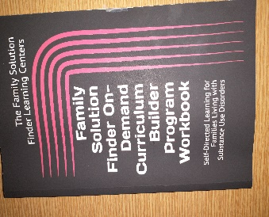
Upon exiting through the side door is a sitting area with a table, cooler with water bottles, and a trailer attendant ready to discuss the Family Solution Finder Curriculum Builder Program. They can take an assessment, determine with issues to view and leave with a curriculum ready to start when they arrive home.

BUDGET:
- Trailer: $6,300.00
- Outside Trailer Graphics: $ 1,700
- Inside Remodeling: $1,500
- Annual fees for storage $600 $50 / Month
$10,100.00

