Amelia-Nottoway Technical Center
ANTC STUDENT SPOTLIGHT!
Ta’shauri Coleman, NHS Senior
Medical Assistant II
What brought you to ANTC? I came to ANTC for the Medical Assistant Program.
What is your dream job? General Surgeon (Trauma Unit)
What is your favorite class that you have taken so far? Why? Medical Assistant because I’ve got to interact with medical professionals and really test my abilities in the medical field.
What is the best advice you have been given by your instructor at ANTC? You’re going to be great, just try your hardest.
What is your favorite memory at ANTC? Almost every day was fun, but my favorite memory has to be when we finally got the dummy arms and practiced taking blood.
What was the first feeling you had when you attended ANTC? Will I do good in this class?!
What words of wisdom do you have for other students? Take your time and try your hardest. You might not like it at first, but if you keep pushing through it will definitely be worth it in the end.
ANTC ALUMNI HIGHLIGHT!
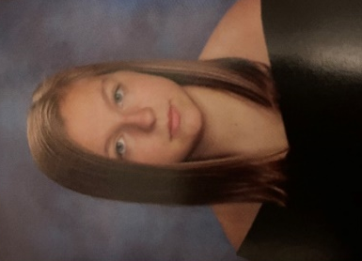
Leann Clarke
High School: Amelia County High School
ANTC Program: Medical Assistant
Career: Attending Ultimate Medical Academy
Future: Certified Professional Coder

DID YOU KNOW?
ANTC Auto Partnerships
Napa (Amelia) - has donated a paint mixing bank and also discounts parts and supplies

7th Gear Auto Body (Amelia) - provides access to the school with tools needed that the school may not have. Also provided access to their mixing bank for special colors.

Baldwins Auto Sales (Crewe) - provides non-structural damage vehicles with parts. Students obtain real world repairs.

Auto Body Specialty (Chase City) - gives the school a discount on supplies and donates all out-of-date supplies. Donated supplies include fillers, paints, glues, and etc...

)

ANTC serving our Alumni!

Black History & Career and Technical Education

February 27th, 2014 David R. Jones

CAREER AND TECHNICAL EDUCATION HELPS MALE STUDENTS OF COLOR
When my father Justice Thomas R. Jones was growing up in Brooklyn in the 1920’s, my grandfather forbade him from working with tools, fearing that he might become a “mechanic” rather than a black intellectual. My grandfather’s viewpoint was fueled by the “Great Debate,” between Booker T. Washington, and WEB Dubois.
Now may be the time to revisit the debate, focusing primarily on young men of color who are either dropping out of school or graduating without the necessary skills to acquire well-paying jobs in our labor market. Now is the time to advocate for the expansion and upgrading of what is known as Career and Technical Education (CTE). Not too long ago, CTE schools and programs were part of a second-class system known as vocational education and populated by students for whom we had the lowest expectations. Times have certainly changed.
CTE schools include programs relevant to vibrant and emerging fields - graphic and architectural design, aviation maintenance, culinary arts, computer science, and video production, just to name a few. The ultimate goal of CTE is to provide young people with the basic skills to move into well-paying jobs. CTE programs should act as a pipeline to apprenticeships and good jobs.
The Department of Education should continue to expand these programs, while studying what is making them so effective for young men. At the same time, the next step in the growth of CTE is to raise the bar past graduation to improved college readiness. In order to shed the reputation as an alternative to college preparation programs, CTE schools must place a stronger emphasis on equipping students to excel at the next educational level.
Program: Auto Body l & II; Amelia and Nottoway

Skills: Proper use of Tools, Equipment, and Supplies Organization

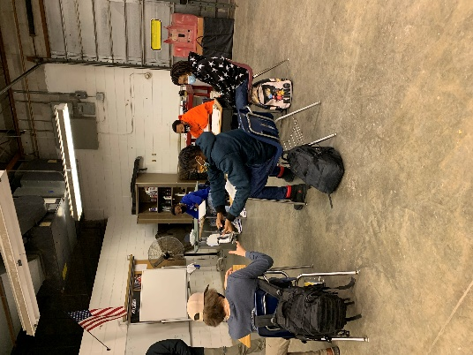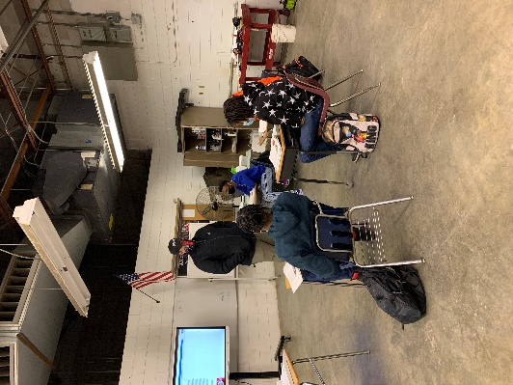
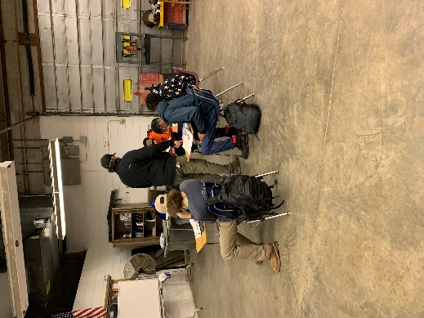
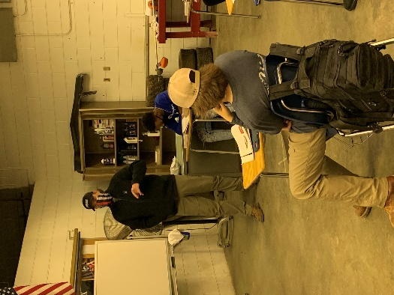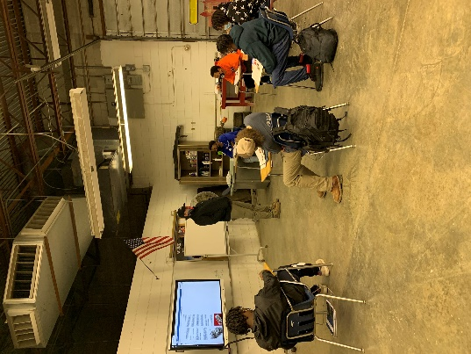
Program: Cosmetology l & II; Amelia, Cumberland and Nottoway

Skills: Graduated and Uniform Layered Hair Cuts

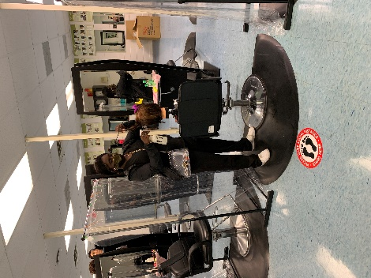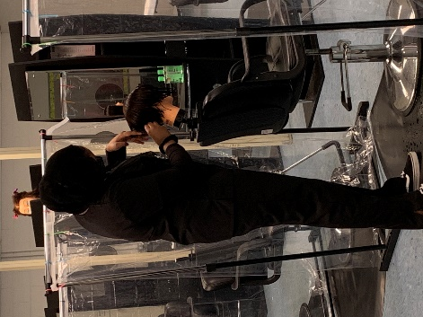
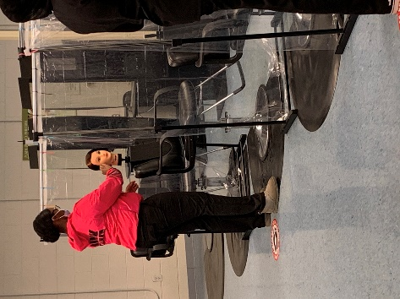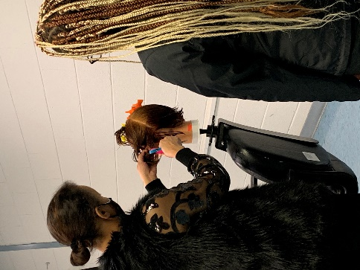

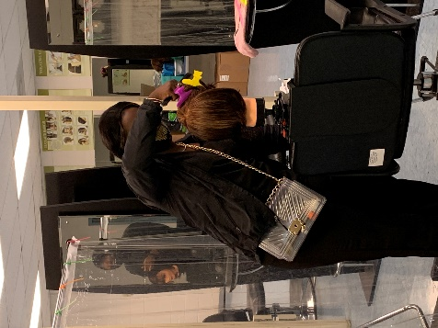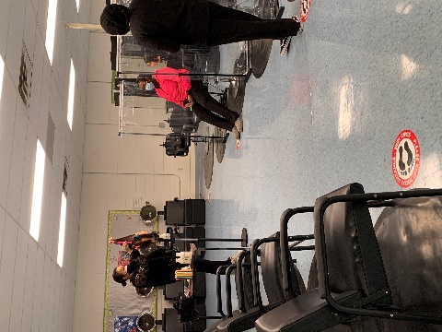

Program: Medical Assistant I & II; Amelia and Nottoway

Skills: Role Playing, Scenarios, Vocabulary, Medical Abbreviations, Coding the systems

