Answers
ACROSS: 1, Planet. 4, Rugged. 7, True. 8, Augustus. 9, Attitude. 13, Bed. 16, Participation. 17, War. 19, Hillside. 24, Baldhead. 25, Bede. 26, Census. 27, Arisen.
DOWN: 1, Path. 2, Adulterer. 3, Tract. 4, Rigid. 5, Gust. 6, Exude. 10, Irish. 11, Uriel. 12, Esau’s. 13, Blindness. 14, Deny. 15, Spew. 18, Awake. 20, Ideas. 21, Lydia. 22, Odes. 23, Lean.

Service times at St Mary’s

Sunday: 10:30am Holy Communion
or Morning Prayer
Normally the first and third Sunday is Holy Communion with Morning on the second and fourth. Baptisms by arrangement with the Rector.

Tuesday: 10.00am Holy Communion
12.15pm Lunch-time Service

Readers contributions to the magazine are always welcome. Hard copy (hand written if easier) to the Rectory address or by email: to : st.marysstockport@gmail.com
Editorial discretion with regard to content and space available will apply.
St Mary’s in the Marketplace
St Mary’s Rectory, 24 Gorsey Mount Street,
Stockport, SK1 4DU.
0161 429 6564 www.stmarysinthemarketplace.com.
St Mary’s in the Marketplace
Parish Magazine
March 2014

50p
From the Rector’s “ i-pad”
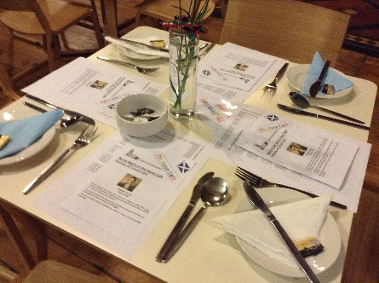
Dear Reader
We are all given choices in life. The direction of our lives is sometimes clearly marked, while at other times it seems to be very confusing. When asked for his advice about the future, and how decisions might be made a wise Christian said to me " Roger, you only need a choice of ONE!" I have found that to be very true in my life ever since, and the move from one parish to another over the last 32 years has been greatly blessed by those few words " you only need a choice of one". Jesus said " I AM THE WAY THE TRUTH AND THE LIFE . NO ONE COMES TO THE FATHER EXCEPT THROUGH ME" John 14:6
Since 1983 I have been privileged to serve God as Chaplain in Switzerland, mostly in the winter, though occasionally in the summer months, through the mission of the Intercontinental Church Society. It was through meeting a chaplain in Zermatt , a Swiss alpine resort, that I came to a living faith in Christ. His name was Colin Still. I have never forgotten the time he gave me as we walked together in the stunningly beautiful snow covered valley beneath the iconic mountain peak, the Matterhorn. He must have said something which prepared me to make that choice, to give my whole life to God, to commit my heart to Him. That was a decision which I was to take back in London a few weeks later. It changed the course of my life. It was a decision I never regretted and one which I commend to you, dear Reader. Colin Still has had a rich and varied ministry and has been retired, he recalls for 18 years, though in his words , in an interview he gave recently to the Church Times newspaper,
"I'm just as busy as I was before retirement. The great joy is that now I don't have to go out in the evenings, or attend lots of meetings". Having neither seen nor heard of this man, who had played such a significant role in my life so many years ago, though he did but know it, I saw his name in an article about a BBC television film "The Cruise: a life at sea", which recorded his life as a chaplain on board MS Balmoral on a four month world cruise, during which the ship visited 33 ports and 20 countries. You may have seen more of the programme than I did, but what I saw of it was very engaging.
Burns Night at St Mary’s
Many thanks to everyone who
supported our Burns Night Supper.

Special thanks to Angus Butterworth (reciting the “Address to the Haggis”), Catronia Smith (speech “The Immortal Memory”), Jean Walton (reading of poems) and all those who braved the “dance floor”.

Although these events are not held purely for “profit”
(but rather the opportunity to meet socially) the evening
did raise £ 130.00 towards church funds.
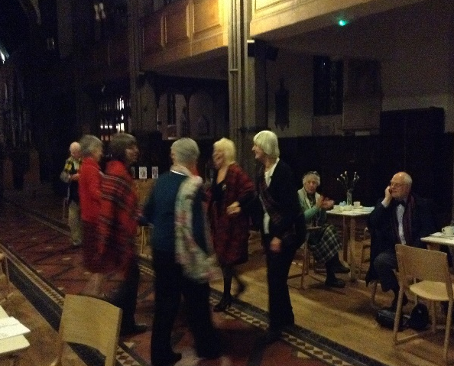
The Nave Café team hope that you
will join us again at our next event.

1st March
St David’s Day – time for daffodils
St David’s Day, and it’s time for the Welsh to wear daffodils or leeks. Shakespeare called this custom ‘an honourable tradition begun upon an honourable request’ - but nobody knows the reason. Why should anyone have ever ‘requested’ that the Welsh wear leeks or daffodils to honour their patron saint? It’s a mystery!
We do know that David - or Dafydd - of Pembrokeshire was a monk and bishop of the 6th century. In the 12th century he was made patron of Wales, and he has the honour of being the only Welsh saint to be canonised and culted in the Western Church. Tradition has it that he was austere with himself, and generous with others - living on water and vegetables (leeks, perhaps?!) and devoting himself to works of mercy. He was much loved.
In art, St David is usually depicted in Episcopal vestments, standing on a mound with a dove at his shoulder, in memory of his share at an important Synod for the Welsh Church, the Synod of Brevi.

A big THANK YOU from David Hardman
To those who attended the Tuesday service on the 11th February (when we were fortunate enough to hear David Hardman speak about his work) the retiring collection for Christian Aid raised £92.00 before Gift Aid. Thank You.
We very much hope that David will be able to visit us again for one of our Christian Aid “Super Soup” lunches.
David Hardman is the Senior Regional Coordinator for Christian Aid North West
The Chaplain is on a mission, to make Christ known in word and deed, and that mission is more welcomed by some than others. The Sunday services, morning and evening , can attract quite a good congregation, more so in the evening than in the morning, owing to skiing or other sporting commitments such as curling. Again, personally speaking ,over the years I have gained much encouragement from meeting Christian folk at church, from around the world and of course from around the British Isles, and well as from the EU at services.
The mission of the chaplain is , though, more than just to take services, to keep the show going as it were. Our calling is to seek out the lost, to help the afflicted and the downcast, to comfort the injured and the bereaved, to encourage those who are seeking , in their search for God and for meaning in life. Our mission is to preach the Word in and out of season, and to challenge our listeners by our preaching. This is no picnic, no easy choice, no freebie holiday, as some have made it out to be over the years. A chaplain who is serving conscientiously will give at least half of his or her time to chaplaincy duties, for which I am granted funds towards my journey costs, and a free evening meal at a hotel, to which I am invited to dine for a week at a time. .
Naturally as a skier, I ski during most of each day, for which I am required ,like anyone else, to pay the going rate; although I have a certain age advantage nowadays which gives me a reasonable concession, at last! If I was a mountaineer, I would climb mountains. If I were a walker, I would take advantage of the magnificent winter walks around the snowy mountain pathways prepared specially for hikers. The great outdoors awaits every chaplain. As the chaplain of St. Bernard's Church this month I hope and pray that God , who has called me to this work, will give me opportunities to do all these things in the strength which He provides, and the courage to speak for Him, as I am commanded to do. Having been a chaplain since 1983 ,the year of my ordination , I am aware that the world has changed greatly since then, and that the secularisation of society has made being a chaplain much more difficult than it used to be. I am therefore all the more aware of the need for prayer support for my mission to the village and the ski slopes of Wengen during these days. PLEASE PRAY FOR ME ! Rev. Roger Scoones
STOCKPORT YOUTH ORCHESTRA

Sunday 23rd March 2014 7pm

As a Patron to the Stockport Youth Orchestra I am absolutely delighted that Tim Crookes, the Musical Director has agreed to bring the SYO back to
St. Mary's to perform in our splendid newly created surroundings. I am certain that it will be a fantastic evening, and I wish the SYO a successful and happy evening with us. I hope that this concert will be one of many and that our talented young musicians will receive the support they need and deserve on this very special occasion" Rev. Roger Scoones

Tuesday, 25th March

& Tuesday, 8th April
Although we aim to serve “super soup” at the Nave Café
every day we are open, all proceeds from the sale of soup on the above days will be donated to Christian Aid.

A recipe for fighting poverty.
Christian Aid’s partner STARS provides
support to vulnerable groups in Afghan
society. In particular, it focuses on improving conditions for rural communities, aiming to reduce migration to urban slums. Its main activities support skills development and income generation. STARS also works closely with Afghan women. With funding from Christian Aid it has been able to provide:
Literacy Classes / Sheep, goats and animal husbandry training / Kitchen gardens / Training to weave traditional Afghan carpets.
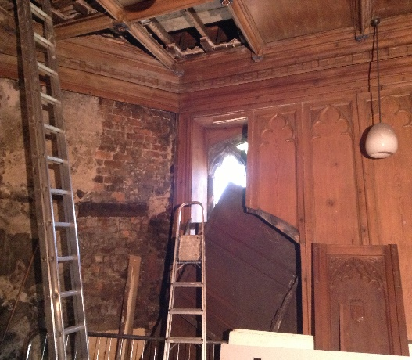
Project 2014 (Phase 6)
Restoration and Conservation of
The Rector’s Vestry
and the Choir Vestry
Progress is continuing to be made with our plans to have restoration and conservation work undertaken on the Rector’s Vestry and the Choir Vestry.
You will have seen posted outside the Church as well as inside, the public notice we were required to give stating our intentions. Necessary planning approvals
from the Council have also been received. Our application for a faculty has been deposited with the Diocesian Registrar and our Architect has been busy preparing tender and other documents. The St Mary’s Planning Team continue to work with the Heritage Lottery Fund to secure the necessary funding, although we do know that we have a short-fall – a gap that we will need to fill ourselves - in the region of £10,000. Once again any assistance you can give us will be much appreciated – either directly or indirectly (fund raising activities welcome).
The Meaning of Lent Quiz
The word Lent derives from an Anglo-Saxon word meaning?
(a) Fasting (b) Suffering or (c) Spring
How long does the Lenten season last?
(a) One lunar month (2) 40 days (3) It varies
What is the first day of Lent called?
(a) Ash Wednesday (b) Good Friday (c) Mardi Gras
The ashes sometimes used in Ash Wednesday services are from burning what?
(a) Pages of scripture (b) Cedars of Lebanon (c) Palm branches
What do the marks on worshipper’s foreheads mean?
(a) repentance and mourning (b) salvation (c) peace of mind
What is the week before Easter called?
(a) Holy week (b) Passion week (c) Advent
Maundy Thursday recalls what event?
(a) The crucifixion of Jesus (b) Jesus’ resurrection (c) The Last Supper
What colour is associated with Lent?
(a) Red (b) White (c) Purple
The first day of Lent can be as late as 10th March or as early as
(a) 22nd Jan (b) 4th Feb (c) 29th Feb in a leap year
To remember the suffering of Jesus, Christians do what during Lent
(a) Go on Pilgrimages (b) Eat chocolate bunnies (c) Fast

Answers: Spring, 40 days, Ash Wednesday, Palm branches, repentance and mourning, Holy week, The Last Supper, Purple, 4th February, Fast
If you haven't been down to St.Mary's on a Sunday evening recently, then this account of things may not mean much to you. But I have! I have seen it for myself! I meet these men and women every week! And , guess what, they are people just like you and me, with a story to tell, and a hunger that needs to be met. As you sit in your comfortable warm ,centrally heated home on a Sunday evening, please spare a thought and a prayer for the Team from Chelwood Baptist Church,Rev320 and supporting members of St. Mary's congregation who are serving The Lord faithfully and giving St. Mary's Parish Church a new lease of life! And come to think of it, we could always write to Edwina,and tell her what good we are doing!
Rev. Roger Scoones
Rector, St.Mary's Stockport

Women’s World Day of Prayer
Friday, 7th March 2014
2.00pm
Special Service to be held at St Mary’s in the Marketplace
Egypt – Streams in the Desert

The Lord says: I will pour water on the thirsty land,
and streams on the dry ground.
I will pour my spirit upon your descendants,
and my blessing on your offspring.
It's not often that Stockport gets a well known national politician visiting us and making a fuss. Last month a former MP, though still a familiar face and, it seems , a controversial figure , Edwina Currie came to town. She came at the request of Marc Godwin,who runs the food banks at Chelwood Baptist Church, Rev320 and Brinnington Community Church. Seeing these operations for herself, Edwina Currie was reported in the Stockport Times as saying that " some people who use food banks have addictive problems. If you give them free food, the rest of their money will go on drink and drugs". In an article in the Spectator in January she said that free food " subsidises the black economy " and " pauperises" those seeking help". That seemed rather harsh judgement to me and I have seen something of this work at first hand. Since before Christmas Chelwood Baptist Church, Rev320 and other Christians have been providing free food, hot and cold, together with hot drinks as well as clothing,to these very people whom Edwina Currie mentions. And this team of volunteers are doing so from within the warm and comforting surroundings of St. Mary's in the Marketplace, at the heart of our community, every Sunday evening, from 6.15 to 7.15 pm! The food, which looks delicious, has been lovingly prepared in people's homes and is brought to church, where people are waiting to be helped in this way. Every week a growing number of men and women, young and older, come into the tower, collect a bowl of hot stew or pie, bread , biscuits and sandwiches and a hot cuppa , and then sit down on the benches in the tower or in the cafe area, for a chat and to enjoy this welcome meal . There is no rush. Someone said to me, " we really like it in here; its really peaceful".
We stopped having a Sunday evening service at St. Mary's many years ago. But today we are giving a much greater Sunday evening service to the community every week, with the gracious and sacrificial help of our fellow Christians in Stockport, who have responded to The Lord's command " to love your neighbour as you love yourself". In St. Matthew's Gospel we read the words of Jesus "For I was hungry and you gave me something to eat, I was thirsty and you gave me something to drink, I was a stranger and you invited me in, I was naked and you clothed me, I was sick and you looked after me, I was in prison and you came to visit me". It may be that Edwina Currie, on her recent visit to Stockport, said many positive and encouraging things, which were not reported in the local press. I am certain that if she were to have come to St. Mary's on a Sunday evening and had seen the good Christian folk, who had laboured long and hard to prepare the food, and if she had met some of the most needy folk in our community , who had come to the door of St. Mary's with open hands and hearts, willing to accept whatever was given to them ,In their time of need, then she would have said THIS IS GOOD ! THIS IS REAL FAITH AT WORK! THIS IS WHAT JESUS MEANT! WELL DONE YOU GOOD AND FAITHFUL PEOPLE!
Electoral Roll .
If you are not already on the Electoral Roll for St Mary’s and wish to be included you need to complete the necessary form and return it no later than the 16th March.
Forms are available in Church and should be returned to the Electoral Roll Officer (Margaret Forster). You can leave them in Church or post to the Rectory Office, St Mary’s Rectory, 24 Gorsey Mount Street, Stockport, SK1 4DU.
Telephone: (0161 429 6564). Email: st.marysstockport@gmail.com.

Provisional Notice
of the Meeting of Parishioners &
Annual Parochial Church Meeting
It is anticipated that the Meeting of Parishioners & APCM will be held in St Mary’s in the Marketplace on Sunday, the 13th April 2014 following the morning service. Confirmation or the date/time will be given nearer the time when the PCC have met to receive the Accounts.

Are you interested in standing for election as a member of the Parochial Church Council? Would you be interested in being a Sides-person? Let us know. Elections for Deanery Synod representative(s) also take place this year.

Crossword

Across
1 The earth is one (6)
4 ‘On a hill far away stood an old — cross’ (6)
7 ‘I am the — vine and my Father is the gardener’ (John 15:1) (4)
8 The Caesar who was Roman Emperor at the time of Jesus’ birth(Luke 2:1) (8)
9 ‘Your — should be the same as that of Christ Jesus’(Philippians 2:5) (8)
13 Jesus said that no one would put a lighted lamp under this(Luke 8:16) (3)
16 Involvement (1 Corinthians 10:16) (13)
17 Armed conflict (2 Chronicles 15:19) (3)

19 Where the Gaderene pigs were feeding (Mark 5:11) (8)
24 What jeering youths called Elisha on the road to Bethel (2 Kings 2:23) (8)
25 The Venerable — , eighth-century Jarrow ecclesiastical scholar (4)
26 8 Across issued a decree that this should take place (Luke 2:1) (6)
27 Come into prominence (Deuteronomy 13:13) (6)
Down
1 Where some of the seed scattered by the sower fell (Matthew 13:4) (4)
2 Sexually immoral person whom God will judge (Hebrews 13:4) (9)
3 Gospel leaflet (5)
4 Physical state of the boy brought to Jesus for healing (Mark 9:18)
5 Tugs (anag.) (4)
6 To put forth (5)
10 Nationality associated with St Patrick (5)
11 Leader of the descendants of Kohath (1 Chronicles 15:5) (5)
12 ‘After this, his brother came out, with his hand grasping — heel’ (Genesis 25:26) (5)
13 At Dothan the Lord struck the Arameans with — at Elisha’s request (2 Kings 6:18) (9)
14 ‘Peter, before the cock crows today, you will — three times that you know me’ (Luke22:34) (4)
15 Spit out (Psalm 59:7) (4)
18 ‘When I — , I am still with you’ (Psalm 139:18) (5)
20 Concepts (Acts 17:20) (5)
21 Thyatira’s dealer in purple cloth (Acts 16:14) (5)
22 Does (anag.) (4)
23 The second set of seven cows in Pharaoh’s dream were this (Genesis 41:19) (4)

CHAPLAIN NEEDS PRAYER
On March 10 a morning flight to Zurich will carry me on the first leg of a familiar journey to the Swiss Alps, where the Chaplaincy to the English Church will have been functioning since just before Christmas. The previous chaplain will now be on his way back to the UK having done his two week "tour of duty", organised by the Intercontinental Church Society aka ICS and licensed to officiate by the Bishop in Europe. The journey to Wengen involves a short, 2 hour flight followed by a 3 hour train journey, involving three different railway companies, all very exciting if you like trains, and all very scenic even if you don't! The Chaplain has a small but comfortable apartment in which to live and work, and its free of course. It has a lovely views of the mountains. It now has wifi, and a telephone naturally. Every day I shall be expected to unlock and lock up the delightful little church, beautifully maintained and easily accessible on foot from the centre of the village. First duties include putting up photos of oneself in designated frames, to tell people who the resident chaplain is, ME! It helps with immediate recognition in the street or on the ski slopes. A tour of the village to introduce oneself to the hotels, and to check the current publicity, especially at Christmas time and nearing Easter, is expected of the new chaplain, however familiar he or she may feel they are with the village. The profile of the chaplain depends very much on each individual. Personally speaking, I pop in and out of shops saying hello, and talking to ski instructors and anyone I may see in the street who is familiar to me, and introducing myself to some of those who are not! It all helps to make one feel one is at home and part of the " working" community. As a long standing member of the skiing community ( I was fortunate to have learnt to ski in Wengen as a young man, back in 1973) and a member of the famous Downhill Only Club aka DHO, which was founded in Wengen in 1915, I naturally make a visit to the new Club rooms a first priority, to say " I'm here", which is always appreciated by fellow Club members, many of whom will not be seen at church on Sunday, it has to be said, though some are very faithful churchgoers in Wengen. .

Shrovetide – the days before Lent
Shrovetide covers the last three or four days before the beginning of Lent. Egg Saturday (Shrove Saturday) Quinquagesima Sunday (Shrove Sunday) The fiftieth day before Easter Collop Monday (Shrove Monday) named after the traditional dish of the day: collops (a collop is a chunk or slice) of bacon served with eggs. Pancake Day (shrove Tuesday) The day on which all fats and cream has to be used up.
The Nave Café .
We will combine the old traditions of Shrove Saturday and Collop Monday by offering for sale on Saturday, 1st March – bacon and egg butties or if you are hungry a full English breakfast! 09.30am – 12.00 noon.

Shrove Tuesday

4th March 2014
Join us for pancakes at the Nave Café with a variety of fillings - available from 12noon to 2pm
===========================================================
You are invited to our annual
Evening Pancake Party St Mary’s Rectory
[24 Gorsey Mount Street] 6pm
RSVP for catering purposes
[donations towards church funds appreciated]

Good News…. Thanks to constant lobbying of the Council by members of the Stockport Heritage Trust
Improved pedestrian links between St Mary’s (and the adjacent car park) to the market hall and market place areas, are at last being put in place.
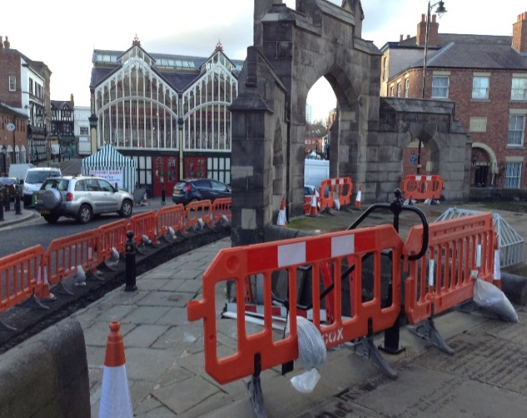
Well it is a bit of a mess as work is ongoing, and will take around five weeks to complete, but we must surely be grateful for Traffic Services making arrangements for safer crossing arrangements outside St Mary’s.
The improvement works involve widening the footway directly adjacent to St Mary’s Church steps and also at the junction of Millgate / Shawcross Fold. As part of the works, any damaged or uneven natural stone flags within the footpath adjacent to the church are to be taken up and relayed to provide a safer walking surface for pedestrians. There are a few other traffic restrictions being implemented (the introduction of a weight limit and revised waiting times), but on the whole this must be of benefit to us and make the journey across the road a much safer one.
For those of us not too good on the old “pins”, with difficulty walking up and down steps, there is more good news – plans to include in the scheme the provision of a new handrail on the steps adjacent to the bus stop. Good News indeed…

As a result of this publicity, I decided to ring the man in the article and to enquire whether or not he was the same man I had encounter all those years ago, and sure enough it was the very same Colin Still. Being able to share with him briefly the story of my life and calling into the ordained ministry since we had first met, when he was a chaplain , was a great privilege and a joy. Christian ministry is a privilege , because it brings one into contact with so many people from all walks of life and of all ages. And the stream of life never seems to end. It's like standing under a waterfall of humanity. Life goes on all around one, but for a moment in time one sees another human being in sharp focus and glorious technicolor. When the time comes for me to do what Colin Still did 18 years ago, to retire, I am absolutely certain that what I shall take with me is not so much the images of the beautiful, historic church buildings in which it has been my privilege to work and to worship, but rather it will be the intimate memory of the people, the congregations and the wider communities to whom I have been called to pastor and to serve as Curate, Chaplain, Padre, Vicar and Rector, in this country and abroad. And all the people I have met, over the years!
We all have to make choices in life, and I can honestly say that I am eternally grateful to God and to the then - Bishop of Stockport, who invited me to move to St. Mary's ,that I made that choice. The decision to leave a comfortable and lively parish set in the delightful Cheshire countryside and come to
a great town centre church was not a difficult one, but it was certainly a momentous one and a life changing one too! There was only one choice, and the wisdom of the late Rev. Hugh Silvester, given to me all those years before, bore fruit on that day. " You only need a choice of one, Roger". I hope that by sharing this part of my life story with you, dear Reader, that you might know God's Blessing and Guidance in your life too.
PS I once saw those words of Jesus on a poster, half way up a Swiss mountain railway, at a railway station, printed in German of course. " Ich bin der Weg, die Wahrheit , und das Leben "! Tell the world I say! It's true; and He is, and He will, if you ask Him to be so, to you! It's YOUR choice.
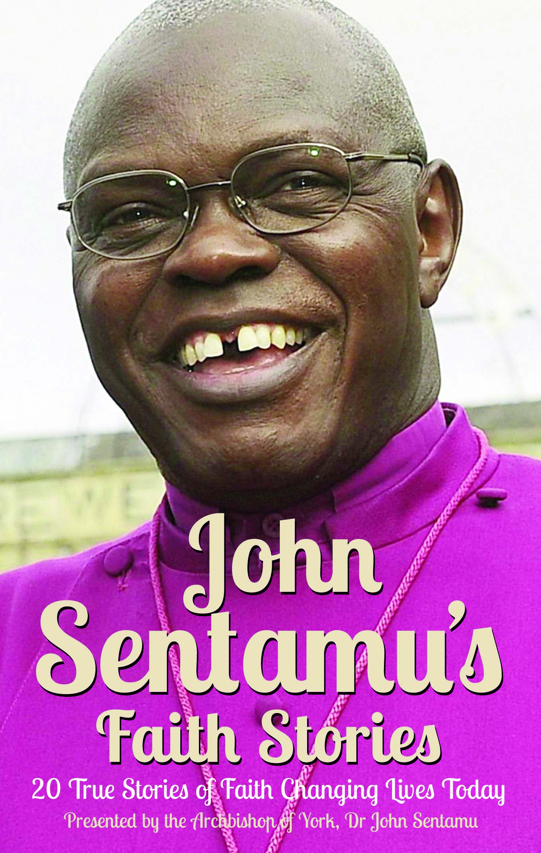
Archbishop John Sentamu's Faith Stories
20 True Stories of Faith Changing Lives Today
A book to read on holiday? All that was needed was something light, something readable, something short but meaningful. John Sentamu's book was there on the shelf right at the front of CLC , our very own local Christian bookshop. Just the thing for a holiday. It proved to be more than just right; it was inspirational, and shareable too. Every day a new chapter, a new true story, a new thought provoking account of faith changing lives. One story stood out. A widow's story of how she had coped with her husband's sudden death at 48, and how her positive approach had helped her to come to terms not only with her own grief, but had also begun to help others experiencing grief. ..
Being on holiday one meets people, whom one finds one can talk to in a way that's somehow different to talking to one's friends at home. And so it was that such an encounter with a widow took place, in that quiet hour before dinner was served in the hotel dining room; a deep and revealing conversation, sitting in front of a roaring, comforting fire, touching on many aspects of story in the book. Next day the book itself found its way to the guest concerned, with a commendation to read chapter one of John Sentamu's book, Faith Stories. .
We don't know what such acts of sharing can lead to, but this book is certainly one to be shared. God speaks through the pages, through the lives and through the words of each man and woman who has found it to be true, that faith in God changes lives. The Archbishop's introduction to each story is itself an inspiration, and an easy read. No need to wait for a holiday. Available now at CLC, STOCKPORT. Rev Roger Scoones.

St Mary’s Spring Fayre

Saturday, 29th March 2014
Our theme is very much “open” as we prepare for Easter with
a range of “goodies” some made by our own craft group. Volunteers to help on the stalls will be most welcome. If you are able to provide us with homemade cakes, jam, marmalade, lemon curd etc. or plants for the garden – again that would be greatly appreciated. No books or bric-a-brac on this occasion please. We will however have some items of jewellery available on the day (we even aim to make some as part of the craft group) and various soaps and sprays – ideal Mothers Day gifts for the children to buy. Knitted items and much more.

We are open to suggestions from anyone wishing to hold a stall of their own (for a fixed fee or percentage of takings).

Come and join us – from 10.30am – Special Nave Café Menu items

Sunday, 30th March 2014

A Special Mothers Day Service
at 10.30am
[Remember the clocks will have changed
as British Summer time begins]

