Rapid Test

ROTAVIRUS-Ag
Colloidal gold rapid test for detection of Rotavirus Group-A antigens in stool samples
INSTRUCTIONS FOR USE , 2011

This test card, with high sensitivity and specificity, adopts Immunochromatographic Colloidal Gold system for qualitative detection of group A Rotavirus in human fecal samples. The operation is easy and safe, and the result is reliable. The whole operational process takes only 10 minutes. It is intended for clinical diagnosis in hospitals, clinics, and remote areas .No special equipments or instruments are required for this assay.

INTENDED USE

SUMMARY
Rotaviruses are one of the major causes of pediatric gastroenteritis and diarrhea worldwide. The improvement of food, water, and hygiene has done nothing to decrease the incidence of rotavirus disease. Almost every child on the planet may get infected by age 5. Scientists say that families of the 900,000 young children around the world who die each year from rotaviruses. Many of them get it between December and April in the temperate climates of the northern hemisphere. Most of these deaths occur in developing countries. The infection usually begins with a fever. Soon the little one begins to vomit and has a nasty tummy-ache. The vomiting goes away, followed by watery diarrhea that lasts from 3 to 9 days. Most of the time, kids recover with little difficulty. Sometimes, severe dehydration results. The extreme dehydration that can be caused by rotaviruses is second only to the dehydration caused by cholera. The infection starts suddenly and lasts for an average of four to six days. Rotaviruses are extremely contagious. Only a very few particles are needed to transmit infection. They originate in the stool, but are found throughout the environment wherever young children spend much time, especially during the winter months. They are resistant to disinfectants used to clean surfaces and to anti-bacterial hand-washing agents. Rotavirus particles remain active on human hands for at least 4 hours, on hard dry surfaces for 10 days, and on wet areas for weeks. Untreated, rotavirus infection may result in severe illness with dehydration and disturbances of the body’s normal electrolyte balance, especially in babies and preschool children. Rotavirus is the cause of up to 50% of the hospitalized cases of diarrheal illness in infants and young children. Rotavirus induced dehydration is a major cause of infant morbidity in both developed and underdeveloped countries, and a major cause of infant mortality in the developing countries. The highest prevalence of the disease is experienced in temperate climates during the cooler months of the year. In tropical climates, rotavirus infection can occur all year round. The age groups most susceptible to the disease are that of infants and children.
In this test card, goat antibodies to Rotavirus are bound onto nitrocellulose membrane (NC) in Test Zone (T), goat anti-murine antibodies are bound onto the NC membrane in Control Zone (C) and conjugate of gold coated with monoclonal antibodies to rotavirus (Ab-Au) at the end of the membrane. During testing, if present, group A Rotavirus from the fecal samples and the conjugate will form particles (RV-Ab-Au). These particles will chromatographically migrate through the lateral CN membrane and will be captured by goat antibodies in the Test Zone (T) as a double-antibody-sandwich immunocomplex. If the fecal sample is positive, one clear red line will appear respectively in the Test Zone (T) and Control Zone (C). For testing of the Negative samples, only a red line appears in the Control Zone (C), while no lines appears in the Test Zone (T). A red line will always appear at the Control Zone (C), which serves as a procedural indicator showing the validity of the test.

COMPONENTS

 Ten Tests

Test Cassette with desiccant in a pouch 10pc.
Sample collection device 10pc.
Package Inserts 1copy

STORAGE AND STABILITY
This test can be stored at room temperature (2-30℃, do not freeze!) for 18 months from the date of manufacture (see label on strip pouch). Use immediately after opening.
PRECAUTIONS AND SAFETY

For in-vitro diagnostic use only  FOR PROFESSIONAL USE ONLY
- Never use the test kit beyond the expiry date indicated on each pouch.
- The test device is disposal item; never use the same test card twice.
- Read the results within 10 minutes. Results obtained after 10minutes can lead to incorrect interpretations.
- In order to perform the test correctly, all Test Procedures must be closely followed up.
- Always keep the desiccant and aluminum pouch away from the children.
- If the sample of this assay is positive, confirmation testing by another analytical system is recommended.
- All the sample and materials used or attached for this test should be considered to be potentially biohazards. It is not allowed to pipette by mouth or contact with open wounds. Care must be taken when handling the sample and decontamination measures must be taken after the assay.

ASSAY PROCEDURE

- Collect sufficient volume of sample with the provided sample collection device. Please the sample inside the conteiner and tightly close the device cap. Shake vigorously until the sample is completely mixed and disolved into the sample buffer inside the device.
- Brake the cap of the sample collection device.
- Open the sealed pouch of the test cassette by teasing along the notch. Remove the test card from the pouch.
- Prepare a label for the test with patient name or identity No.
- Point the sample collectin devise into the cassette's sample window and add 2-3drops of liquid.
- Place the cassette on horizontal flat surface at room temperature(18-30℃).
- Read results within 10 minutes (Note: A strong positive sample can be detected within 1-3minutes). Never read results after 10 minutes.

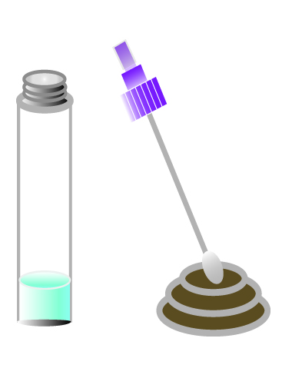
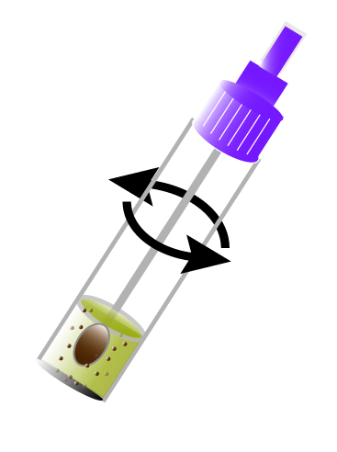
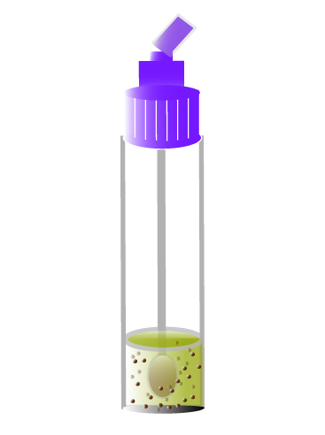
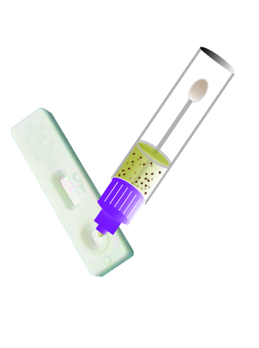
COLLECT
SAMPLE
MIX THE SAMPLE
BRAKE THE CAP
ADD SAMPLE

Negative: One red line appears on the Control Zone (C)

RESULTS
Positive: In addition to the red line on the Control Zone (C),a distinct red line will also appear in the Test Zone (T).
Quality Control: One red line will always appear next to the Control Zone (C) indicating the validity of the test. If no red line appears, the test is invalid - discard the test and repeat with new sample and new cassette.
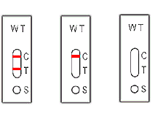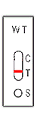

POSITIVE NEGATIVE INVALID

CLINICAL DATA

In a clinical evaluations of the performance of the this RV Rapid Test using 207 confirmed negative and 97 positive samples, sensitivity was 94.8% (92/97) and specificity, 98.95% (204/207). Overall agreement with the reference test is 96%. Accuracy, tested in a panel of Quality Control standards is 95%.

Study 1 | ROTAVIRUS RAPID TEST
REFERENCE  ELISA |  | + | -
REFERENCE  ELISA | + | 92 | 3
REFERENCE  ELISA | - | 5 | 204
Overall agreement : (92+204)/304 = 97%

Study 2 | ROTAVIRUS RAPID TEST
Nucleic acid separation by electrophoresis (PAGE) |  | + | - | Total
Nucleic acid separation by electrophoresis (PAGE) | + | 127 | 10 | 137
Nucleic acid separation by electrophoresis (PAGE) | - | 96 | 47 | 143
Nucleic acid separation by electrophoresis (PAGE) | Total | 223 | 57 | 280
PAGE positive rate : 45.36%(137/280)
ROTAVIRUS RAPID TEST positive rate: 76.64%( 223/280)

Study 3 | ROTAVIRUS RAPID TEST
Reference latex agglutination rapid test |  | + | - | Total
Reference latex agglutination rapid test | + | 95 | 3 | 96
Reference latex agglutination rapid test | - | 20 | 172 | 192
Reference latex agglutination rapid test | IND | 6 | 0 | 6
Reference latex agglutination rapid test | Total | 121 | 175 | 296
Overall agreement : = 97.6%
LIMITATIONS

- This is a qualitative rapid test for group A Rotavirus and only tells the result either of positive, negative or invalidity of the assay.
- The specificity of this test card does not preclude the possible bacterial gastroenteritis. Therefore, it is suggested to test the fecal sample for bacterial diarrheal pathogens as well.
- Fecal sample with preservatives or detergents will lead to incorrect test result.
- To achieve best performances of the test, it is important to collect samples within 3-5 days after appearance of symptoms of rotavirus infection.
- If the samples are not to be used within 48 hours, they should be stored at -20℃ or below. Repeated freezing or thawing must be avoided.

References:
- Al-Yousif, Y., J. Anderson, C. Chard-Bergstrom, A. Bustamante, M. Muenzenberger, K. Austin, and S. Kapil. 2001. Evaluation of a latex agglutination kit (Virogen Rotatest) for detection of bovine rotavirus in fecal samples. Clin. Diagn. Lab. Immunol. 8:496-498
- Bellinzoni, R. C., J. Blackhall, H. R. Terzolo, A. R. Moreira, N. Auza, N. Mattion, G. L. Micheo, J. L. La Torre, and E. A. Scodeller. 1990. Microbiology of diarrhea in young beef and dairy calves in Argentina. Rev. Argent. Microbiol. 22:130-136.
- Bendali, F., H. Bichet, F. Schelcher, and M. Sanaa. 1999. Pattern of diarrhea in newborn beef calves in southwest France. Vet. Res. 30:61-74.
- Benfield, D. A., I. J. Stotz, E. A. Nelson, and K. S. Groon. 1984. Comparison of a commercial enzyme-linked immunosorbent assay with electron microscopy, fluorescent antibody, and virus isolation for the detection of bovine and porcine rotavirus. Am. J. Vet. Res. 45:1998-2002.
- Chinsangaram, J., G. Y. Akita, A. E. Castro, and B. I. Osburn. 1993. PCR detection of group A bovine rotaviruses in feces. J. Vet. Diagn. Investig. 5:516-521.
Wantai BP CO., LTD.

Latest revision 09.05.2011




ATLAS LINK, INC
No. 811 Zeyang Plaza, No.166 Fushi Road
Shijingshan Dist., Beijing 100043, China
Tel: 86-10-88909112 Fax: 86-10-88909115
USA Headquarters:
10758-A Ambassador Drive
MANASSAS, VA 20109 USA
Tel: 703-3663851

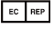
CIRIANO GLOBAL S.L. (UNILATEX GROUP)
CIF: B50927532 C/Blancas 4-6, 1 B Oficina 1
50001 Zaragoza Spain
Tel: 34-976910399

